Assignment 6 Submitted by Arnav

1)​ MPI_Gather() & MPI_Scatter()

#include <stdio.h>
#include <stdlib.h>
#include <time.h>
#include <mpi.h>
#include <assert.h>
// Creates an array of random numbers. Each number has a value from 0
//- 1
float *create_rand_nums(int num_elements) {
float *rand_nums = (float *)malloc(sizeof(float) * num_elements);
assert(rand_nums != NULL);
int i;
for (i = 0; i < num_elements; i++) {
rand_nums[i] = (rand() / (float)RAND_MAX);
}
return rand_nums;
}
// Computes the average of an array of numbers
float compute_avg(float *array, int num_elements) {
float sum = 0.f;
int i;
for (i = 0; i < num_elements; i++) {
sum += array[i];
}
return sum / num_elements;
}
int main(int argc, char** argv) {
if (argc != 2) {
fprintf(stderr, "Usage: avg num_elements_per_proc\n");
exit(1);
}
int num_elements_per_proc = atoi(argv[1]);
// Seed the random number generator to get different results each
//time
srand(time(NULL));MPI_Init(NULL, NULL);
int world_rank;
MPI_Comm_rank(MPI_COMM_WORLD, &world_rank);
int world_size;
MPI_Comm_size(MPI_COMM_WORLD, &world_size);
// Create a random array of elements on the root process. Its total
// size will be the number of elements per process times the number
// of processes
float *rand_nums = NULL;
if (world_rank == 0) {
rand_nums = create_rand_nums(num_elements_per_proc *
world_size);
}
// For each process, create a buffer that will hold a subset of the
//entire
// array
float *sub_rand_nums = (float *)malloc(sizeof(float) *
num_elements_per_proc);
assert(sub_rand_nums != NULL);
// Scatter the random numbers from the root process to all
//processes in
// the MPI world
MPI_Scatter(rand_nums, num_elements_per_proc, MPI_FLOAT,sub_rand_nums,num_elements_per_proc, MPI_FLOAT, 0, MPI_COMM_WORLD);
// Compute the average of your subset
float sub_avg = compute_avg(sub_rand_nums, num_elements_per_proc);
// Gather all partial averages down to the root process
float *sub_avgs = NULL;
if (world_rank == 0) {
sub_avgs = (float *)malloc(sizeof(float) * world_size);
assert(sub_avgs != NULL);
}
MPI_Gather(&sub_avg, 1, MPI_FLOAT, sub_avgs, 1, MPI_FLOAT, 0,
MPI_COMM_WORLD);
// Now that we have all of the partial averages on the root,
//compute the
// total average of all numbers. Since we are assuming each process
//computed
// an average across an equal amount of elements, this computation
//will
// produce the correct answer.
if (world_rank == 0) {
float avg = compute_avg(sub_avgs, world_size);
printf("Avg of all elements is %f\n", avg);
// Compute the average across the original data for comparison
float original_data_avg = compute_avg(rand_nums, num_elements_per_proc * world_size);
printf("Avg computed across original data is %f\n",
original_data_avg);
}
// Clean up
if (world_rank == 0) {
free(rand_nums);
free(sub_avgs);
}
free(sub_rand_nums);
MPI_Barrier(MPI_COMM_WORLD);
MPI_Finalize();

}
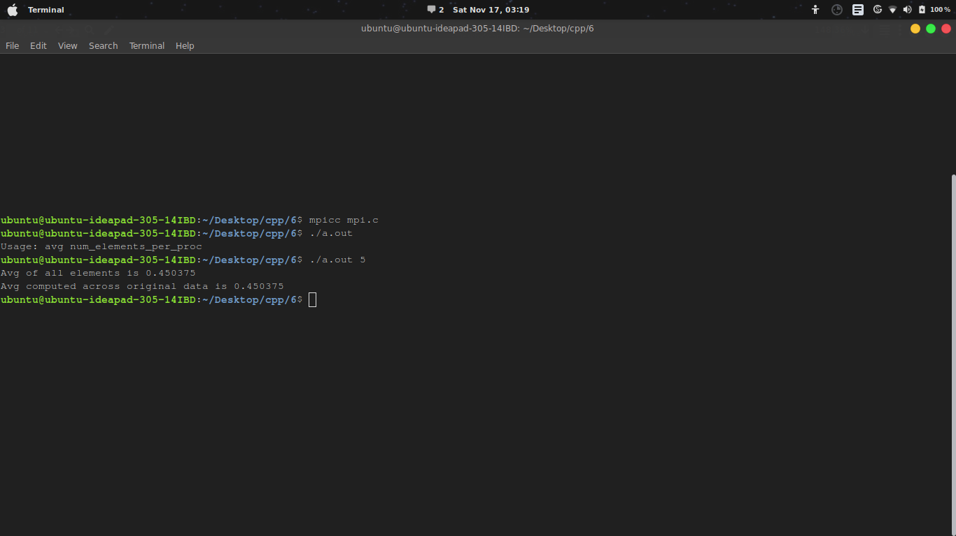

2) ​ MPI_Get_count()

#include <mpi.h>
#include <stdio.h>
#include <stdlib.h>
#include <time.h>int main(int argc, char** argv) {
MPI_Init(NULL, NULL);
int world_size;
MPI_Comm_size(MPI_COMM_WORLD, &world_size);
if (world_size != 2) {
fprintf(stderr, "Must use two processes for this example\n");
MPI_Abort(MPI_COMM_WORLD, 1);
}
int world_rank;
MPI_Comm_rank(MPI_COMM_WORLD, &world_rank);
int number_amount;
if (world_rank == 0) {
const int MAX_NUMBERS = 100;
int numbers[MAX_NUMBERS];
// Pick a random amont of integers to send to process one
srand(time(NULL));
number_amount = (rand() / (float)RAND_MAX) * MAX_NUMBERS;
// Send the amount of integers to process one
MPI_Send(numbers, number_amount, MPI_INT, 1, 0, MPI_COMM_WORLD);
printf("0 sent %d numbers to 1\n", number_amount);
} else if (world_rank == 1) {
MPI_Status status;
// Probe for an incoming message from process zero
MPI_Probe(0, 0, MPI_COMM_WORLD, &status);
// When probe returns, the status object has the size and other
// attributes of the incoming message. Get the size of the
message.
MPI_Get_count(&status, MPI_INT, &number_amount);
// Allocate a buffer just big enough to hold the incoming numbers
int* number_buf = (int*)malloc(sizeof(int) * number_amount);
// Now receive the message with the allocated buffer
MPI_Recv(number_buf, number_amount, MPI_INT, 0, 0,
MPI_COMM_WORLD,
MPI_STATUS_IGNORE);
printf("1 dynamically received %d numbers from 0.\n",
number_amount);
free(number_buf);
}
MPI_Finalize();
}

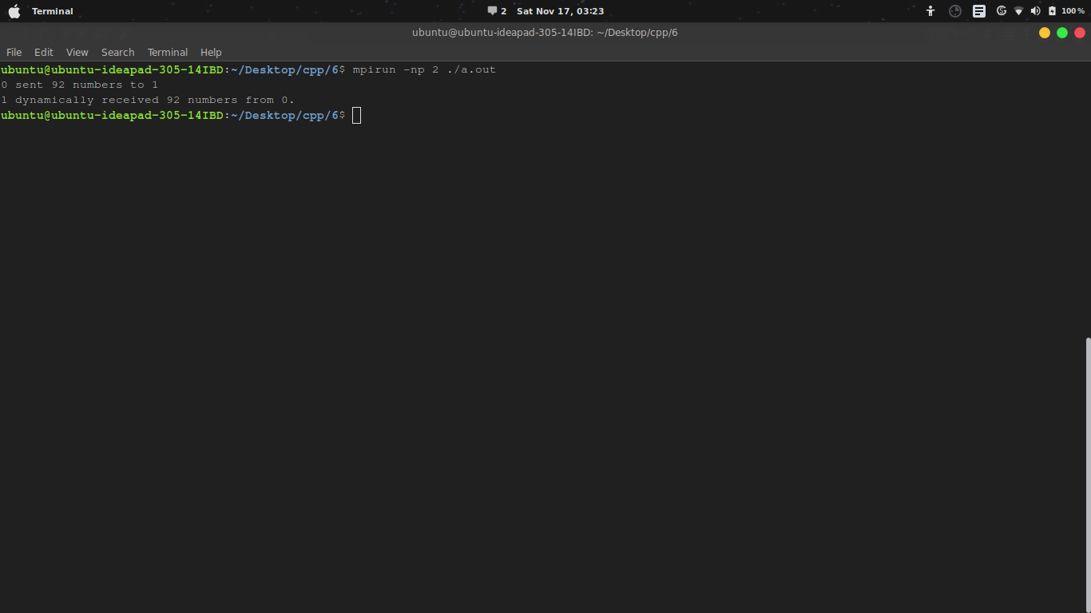

3) ​ MPI_Issend() & MPI_Irecv()

#include "mpi.h"
#include <stdio.h>
int main(int argc, char *argv[])
{
int myid, numprocs, left, right,i;
int buffer[10], buffer2[10];
MPI_Request request, request2;
MPI_Status status;
MPI_Init(&argc,&argv);
MPI_Comm_size(MPI_COMM_WORLD, &numprocs);
MPI_Comm_rank(MPI_COMM_WORLD, &myid);
right = (myid + 1) % numprocs;
left = myid - 1;
if (left < 0)
left = numprocs - 1;
MPI_Irecv(buffer, 10, MPI_INT, left, 123, MPI_COMM_WORLD,
&request);
MPI_Issend(buffer2, 10, MPI_INT, right, 123, MPI_COMM_WORLD,
&request2);
for(i=0;i<10;i++)
printf("Value is:%d\n",buffer[i]);
MPI_Wait(&request, &status);
MPI_Wait(&request2, &status);MPI_Finalize();
return 0;
}

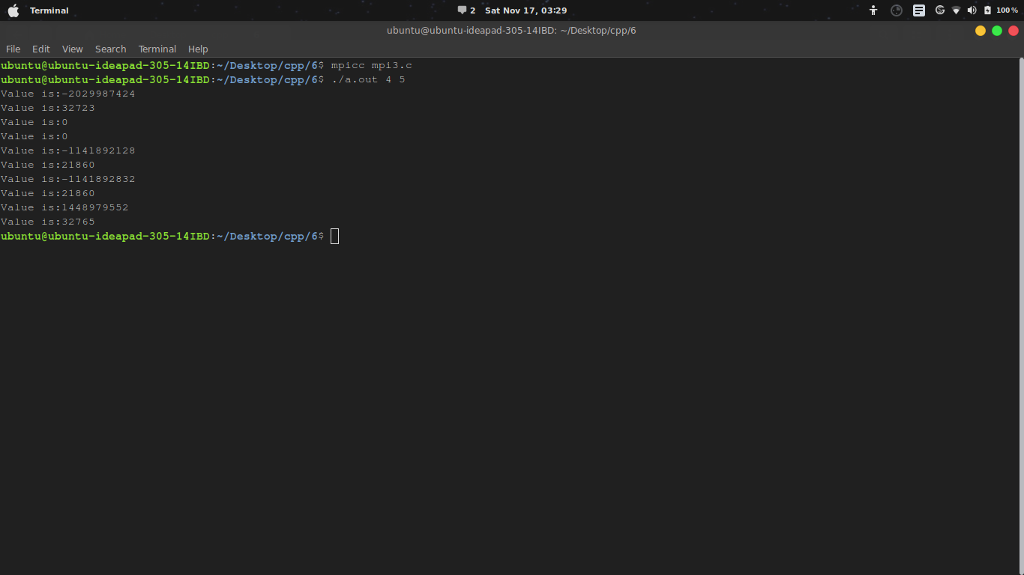

5) ​ MPI_Test()

#include <stdio.h>
#include <mpi.h>
#include <sys/time.h>
int main(int argc, char *argv[])
{
int rank, size;
MPI_Status status;
/* Init */
MPI_Init(&argc, &argv);
MPI_Comm_rank(MPI_COMM_WORLD, &rank);
MPI_Comm_size(MPI_COMM_WORLD, &size);
if (rank != 0) { // Slaves
int buf;
if (rank == 1)
buf = 1;
MPI_Send(&buf,
}
if (rank == 2)
buf = 2;
MPI_Send(&buf,
}
{
1, MPI_INT, 0, 0, MPI_COMM_WORLD);
{
1, MPI_INT, 0, 0, MPI_COMM_WORLD);
}
else { // Master
int sum = 0;
int flag = -1, res;
MPI_Request request;
MPI_Status status;
while (1) {
if(flag != 0)
{
MPI_Irecv(&res, 1, MPI_INT, MPI_ANY_SOURCE, MPI_ANY_TAG,
MPI_COMM_WORLD, &request);flag = 0;
}
MPI_Test(&request, &flag, &status);
if (flag != 0) {
printf("recv : %d, slave : %d\n", res, status.MPI_SOURCE);
if (status.MPI_SOURCE != -1)
sum += res;
flag = -1;
}
if (sum == 3)
break;
}
printf("sum : %d\n", sum);
}
MPI_Finalize();
return 0;
}

6) ​ MPI_Allgather()
#include <stdio.h>
#include <stdlib.h>
#include "mpi.h"
struct mystruct{
int sendarray[4];
int a;
char array2[4];
};
typedef struct mystruct struct_t;int main (int argc, char ** argv)
{
int rank, size;
struct_t fd;
struct_t recv;
int i, j;
MPI_Init(&argc, &argv);
MPI_Comm_rank(MPI_COMM_WORLD, &rank);
MPI_Comm_size(MPI_COMM_WORLD, &size);
// init
for (i=0;i<4;i++){
fd.sendarray[i] = 0;
fd.array2[i] = 0;
recv.sendarray[i] =999;
recv.array2[i] = 99;
}
recv.a =999;
// put some stuff in your array
fd.sendarray[rank] = rank*10;
fd.array2[rank] = (char)(rank*20);
fd.a = rank;
printf("My rank is %d, fd.sendarray[%d]
fd.sendarray[rank]);
is %d\n", rank, rank,
// gather data from all now.. send the int:
MPI_Allgather (&(fd.sendarray[rank]), 1, MPI_INT,
recv.sendarray, 1, MPI_INT, MPI_COMM_WORLD);
// then the char
MPI_Allgather (&(fd.array2[rank]),
1, MPI_CHAR, recv.array2,
1, MPI_CHAR, MPI_COMM_WORLD);
// check if correct data has been received
if (rank == 0) {
printf("Received:\n");
printf("---\n");
printf("int array: ");
for (j=0; j<4; j++) printf("%3d ", recv.sendarray[j]);
printf("\nchar array: ");
for (j=0; j<4; j++) printf("%3d ", (int)(recv.array2[j]));
printf("\n");}
MPI_Finalize();
return 0;
}

7) ​ MPI_Alltoall()
#include <stdio.h>
#include "mpi.h"
int main( int argc, char **argv )
{
int send[4], recv[3];
int rank, size, k;
MPI_Init( &argc, &argv );
MPI_Comm_rank( MPI_COMM_WORLD, &rank );
MPI_Comm_size( MPI_COMM_WORLD, &size );
if (size != 4) {
printf("Error!:# of processors must be equal to 4");
printf("Programm aborting....");
MPI_Abort(MPI_COMM_WORLD, 1);
}
for (k=0;k<size;k++)
send[k] = (k+1) + rank*size;
printf("%d : send = %d %d %d %d\n", rank, send[0], send[1],
send[2], send[3]);MPI_Alltoall(&send, 1, MPI_FLOAT, &recv, 1, MPI_INT,
MPI_COMM_WORLD);
printf("%d : recv = %d %d %d %d\n", rank, recv[0], recv[1],
recv[2], recv[3]);
MPI_Finalize();
return 0;
}

