Automated Produce Freshness Classification
Using Deep Learning
Duke University — AIPI 590: Deep Learning, Spring 2026

1. Problem Statement
Food waste is a critical global challenge, with the United Nations Food and Agriculture Organization estimating that approximately one-third of all food produced for human consumption is lost or wasted annually. A significant contributor to this waste is the inability to efficiently and accurately assess produce freshness at scale across the supply chain, from farms and distribution centers to retail stores and consumers.
Manual inspection of produce freshness is labor-intensive, subjective, and inconsistent. Human inspectors can only evaluate a small fraction of produce passing through distribution points, and their assessments vary based on fatigue, lighting conditions, and individual judgment. This creates a clear need for automated, objective, and scalable freshness assessment systems.
This project addresses the binary classification problem of determining whether a given produce item is fresh or rotten from a single RGB image. We investigate three progressively sophisticated modeling approaches:
- Naive Baseline: A majority class classifier that always predicts the most frequent class, establishing a performance floor.
- Classical Machine Learning: A Random Forest classifier operating on deep feature representations extracted from a pretrained ResNet-18 backbone.
- Deep Learning: A fine-tuned EfficientNet-B0 model with a custom classification head, trained using a two-phase transfer learning strategy.
The goal is to demonstrate the relative strengths of each approach and determine whether deep learning can achieve production-grade accuracy for automated freshness detection across diverse produce types.

2. Data Sources

2.1 Dataset Overview
We use a large-scale produce freshness image dataset containing 71,318 images across 13 produce types. The dataset is organized into two top-level directories: Fresh (47,341 images, 66.4%) and Rotten (23,977 images, 33.6%). This results in an approximately 2:1 class imbalance favoring the Fresh class.

2.2 Produce Types
The 13 produce types and their test set distributions are:
Produce Type | Test Samples | Fresh | Rotten | Fresh Ratio
Tomato | 2,563 | 1,991 | 572 | 77.7%
Orange | 2,134 | 1,640 | 494 | 76.9%
Carrot | 1,882 | 1,525 | 357 | 81.0%
Apple | 1,202 | 532 | 670 | 44.3%
Banana | 1,126 | 517 | 609 | 45.9%
Potato | 401 | 154 | 247 | 38.4%
Cucumber | 317 | 160 | 157 | 50.5%
Capsicum | 272 | 144 | 128 | 52.9%
Mango | 191 | 102 | 89 | 53.4%
Bellpepper | 181 | 95 | 86 | 52.5%
Strawberry | 179 | 93 | 86 | 52.0%
Okra | 156 | 112 | 44 | 71.8%
Bittergourd | 94 | 37 | 57 | 39.4%
The dataset exhibits significant variation in per-produce class balance: some types like Apple and Banana are majority-Rotten, while others like Carrot and Tomato are majority-Fresh.

2.3 Data Splitting and Preprocessing
We employ a stratified 70/15/15 train/validation/test split to preserve class proportions across all splits.
Image Preprocessing:
- All images resized to 224 x 224 pixels to match pretrained ImageNet model input dimensions.
- Pixel values normalized using ImageNet statistics (mean=[0.485, 0.456, 0.406], std=[0.229, 0.224, 0.225]).
Data Augmentation (training set only):
- Random resized crop (256 → 224)
- Random horizontal flip (p=0.5)
- Random vertical flip (p=0.1)
- Random rotation (±15°)
- Color jitter (brightness=0.2, contrast=0.2, saturation=0.2, hue=0.1)
Class Imbalance Handling:
- Weighted Random Sampling: oversamples the minority class (Rotten) for balanced training batches.
- Weighted Cross-Entropy Loss: higher penalty for misclassifications of the minority class.

2.4 Data Quality Notes
During dataset exploration, we identified inconsistent folder naming: "Capciscum" (Capsicum), "Okara" (Okra), and "Bittergroud" (Bittergourd). These were programmatically normalized during data loading.

3. Related Work

3.1 Image Classification with Deep Learning
Image classification has been revolutionized by convolutional neural networks (CNNs), starting with AlexNet (Krizhevsky et al., 2012) and progressing through VGGNet (Simonyan & Zisserman, 2015), ResNet (He et al., 2016), and EfficientNet (Tan & Le, 2019). These architectures, pretrained on ImageNet (Deng et al., 2009), have established transfer learning as the dominant paradigm for visual recognition tasks.

3.2 Transfer Learning
Transfer learning leverages knowledge from a source domain (typically ImageNet) to improve learning in a target domain with limited data. Yosinski et al. (2014) showed that features learned in lower layers of deep networks are highly generalizable, while upper layers become increasingly task-specific.

3.3 Food Quality Assessment with Computer Vision
Kamilaris and Prenafeta-Boldú (2018) surveyed deep learning applications in agriculture, identifying fruit and vegetable quality grading as a key area. Previous work has explored freshness detection for specific produce types — e.g., strawberries (Sa et al., 2016), apples (Bhargava & Bansal, 2018), and bananas (Mazen & Nashat, 2019). However, most prior work focuses on individual produce types rather than unified classifiers across diverse categories.

3.4 EfficientNet Architecture
EfficientNet (Tan & Le, 2019) introduced compound scaling, uniformly scaling network width, depth, and resolution. EfficientNet-B0 achieves 77.1% top-1 accuracy on ImageNet with only 5.3M parameters — significantly fewer than ResNet-50 (25.6M) while achieving comparable or better performance.

3.5 Classical ML with Deep Features
Using pretrained CNNs as feature extractors for classical ML classifiers is well-established (Razavian et al., 2014). This hybrid approach often achieves strong performance with lower computational cost than end-to-end fine-tuning.

4. Evaluation Strategy

4.1 Metrics
We evaluate all models using a comprehensive set of classification metrics:
- Accuracy: Overall proportion of correct predictions.
- Precision (Macro): Average precision across both classes, treating each equally.
- Recall (Macro): Average recall across both classes.
- F1 Score (Weighted): Harmonic mean of precision and recall, weighted by class support.
- F1 Score (Macro): Unweighted average F1, more sensitive to minority class performance.
- AUC-ROC: Area under the ROC curve; measures discrimination ability across all thresholds.

4.2 Per-Produce Analysis
Beyond aggregate metrics, we evaluate performance on each of the 13 produce types individually. This is critical because different produce types exhibit different visual characteristics of decay, class balance varies significantly, and a model that fails on specific types may not be suitable for production deployment.

4.3 Error Analysis
We examine mispredictions to understand failure modes: are errors concentrated in specific produce types? Does the model tend toward false positives or false negatives? Are borderline cases systematically misclassified?

5. Modeling Approach

5.1 Model 1: Naive Baseline (Majority Class Classifier)
The simplest possible classifier always predicts the most frequent class in the training set. Since 66.4% of the dataset is Fresh, this classifier always predicts "Fresh." Its purpose is to establish a performance floor.

5.2 Model 2: Classical ML (ResNet-18 Features + Random Forest)
Feature Extraction: A pretrained ResNet-18 (He et al., 2016) is used as a fixed feature extractor. The final fully-connected layer is removed, yielding a 512-dimensional feature vector for each image.
Classification Pipeline: Features are standardized using StandardScaler, then a Random Forest classifier with 100 trees is trained. Hyperparameter tuning is available via RandomizedSearchCV with 3-fold cross-validation.

5.3 Model 3: Deep Learning (Fine-tuned EfficientNet-B0)
Architecture: EfficientNet-B0 pretrained on ImageNet (5.3M parameters) with a custom classification head: Dropout(0.3) → Linear(1280, 256) → ReLU → Dropout(0.15) → Linear(256, 2).
Two-Phase Training Strategy:
Phase 1 — Head-Only Training (5 epochs): All backbone layers are frozen. Only the classification head is trained with AdamW (lr=1e-3, weight_decay=1e-4).
Phase 2 — Full Fine-Tuning (up to 15 epochs): All layers unfrozen. Differential learning rates: backbone at 1e-5, head at 1e-4. CosineAnnealingLR scheduler with eta_min=1e-7. Early stopping on validation loss with patience=5.
Loss Function: CrossEntropyLoss with class weights inversely proportional to class frequency. Optimizer: AdamW (Loshchilov & Hutter, 2019) with decoupled weight decay regularization.

6. Results

6.1 Overall Performance Comparison
Metric | Baseline | Classical (RF) | Deep (EfficientNet-B0)
Accuracy | 66.4% | 90.8% | 97.2%
Precision (Macro) | 33.2% | 89.7% | 96.3%
Recall (Macro) | 50.0% | 89.6% | 97.5%
F1 (Weighted) | 53.0% | 90.8% | 97.2%
F1 (Macro) | 39.9% | 89.7% | 96.9%
AUC-ROC | 0.500 | 0.960 | 0.997
The deep learning model achieves the highest performance across all metrics, with 97.2% accuracy and near-perfect AUC-ROC of 0.997.

6.2 Confusion Matrices
Baseline (Majority Class):
 | Predicted Fresh | Predicted Rotten
Actual Fresh | 7,102 | 0
Actual Rotten | 3,596 | 0
The baseline predicts all samples as Fresh, missing all rotten produce.
Classical (Random Forest):
 | Predicted Fresh | Predicted Rotten
Actual Fresh | 6,615 | 487
Actual Rotten | 500 | 3,096
487 fresh items misclassified as rotten (6.9% FPR) and 500 rotten items misclassified as fresh (13.9% FNR).
Deep Learning (EfficientNet-B0):
 | Predicted Fresh | Predicted Rotten
Actual Fresh | 6,854 | 248
Actual Rotten | 54 | 3,542
Only 248 fresh items misclassified as rotten (3.5% FPR) and just 54 rotten items misclassified as fresh (1.5% FNR). The very low false negative rate is critical for food safety.

6.3 Per-Produce Performance
Produce | Baseline Acc | Classical Acc | Deep Acc | Deep F1
Apple | 44.3% | 93.1% | 99.0% | 0.991
Banana | 45.9% | 97.3% | 99.7% | 0.998
Bellpepper | 52.5% | 82.3% | 96.1% | 0.958
Bittergourd | 39.4% | 89.4% | 98.9% | 0.991
Capsicum | 52.9% | 93.4% | 100.0% | 1.000
Carrot | 81.0% | 89.1% | 97.6% | 0.938
Cucumber | 50.5% | 89.6% | 92.7% | 0.931
Mango | 53.4% | 96.3% | 100.0% | 1.000
Okra | 71.8% | 67.9% | 75.6% | 0.689
Orange | 76.9% | 91.9% | 95.6% | 0.912
Potato | 38.4% | 75.1% | 91.0% | 0.930
Strawberry | 52.0% | 94.4% | 99.4% | 0.994
Tomato | 77.7% | 90.8% | 98.4% | 0.964
The deep model achieves perfect classification (100%) on Capsicum and Mango. Okra is the most challenging produce type across all models (75.6% accuracy for deep model), likely due to small sample size and subtle visual differences between fresh and rotten okra.

6.4 Training Dynamics
The EfficientNet-B0 model was trained for 5 head-only epochs followed by 13 fine-tuning epochs (early stopping triggered before the full 15 epochs).
Phase 1 (Head-Only): Training accuracy improved from 87.4% to 92.0%; validation accuracy from 90.9% to 93.9%. The high starting accuracy reflects the quality of pretrained ImageNet features.
Phase 2 (Fine-Tuning): Training accuracy improved from 93.7% to 97.0%; validation accuracy from 94.9% to 97.0%. Training and validation losses decreased in tandem with no significant overfitting.

7. Error Analysis

7.1 Overall Error Distribution
The deep learning model misclassifies 302 out of 10,698 test images (2.8% error rate): 248 false positives (Fresh predicted as Rotten, 82.1% of errors) and 54 false negatives (Rotten predicted as Fresh, 17.9% of errors).
The model is conservative — it is more likely to incorrectly flag fresh produce as rotten than to miss rotten produce. This is a desirable property for food safety applications.

7.2 Produce-Specific Error Patterns
High-Error Produce Types:
- Okra (24.4% error rate): Subtle visual deterioration and small sample size (156 test images).
- Potato (9.0% error rate): Rot often manifests as soft spots or internal decay not visible externally.
- Cucumber (7.3% error rate): Early-stage rotten cucumbers look very similar to fresh ones.
- Orange (4.4% error rate): Surface blemishes can mimic spoilage, and thick peel masks internal decay.
Low-Error Produce Types:
- Capsicum and Mango (0% error rate): Perfect classification.
- Banana (0.3% error rate): Dramatic yellow → brown/black visual transformation.
- Apple and Strawberry (<1% error rate): Distinct color and texture changes during decay.

7.3 Misprediction Examples
Index | True Label | Predicted | Produce Type
6409 | Fresh | Rotten | Tomato
8201 | Fresh | Rotten | Orange
4074 | Fresh | Rotten | Potato
8789 | Fresh | Rotten | Tomato
2294 | Fresh | Rotten | Orange
All 5 sampled mispredictions are false positives, confirming the model's conservative bias.

8. Experiment: Training Set Size Sensitivity

8.1 Motivation
A key practical question for deployment is: How much training data is needed to achieve acceptable performance? Understanding the data-performance tradeoff informs data collection strategy.

8.2 Experimental Design
We train EfficientNet-B0 on {10%, 25%, 50%, 75%, 100%} of the training data while keeping validation and test sets fixed. For each fraction, a stratified random subset is selected, the model is trained using the same two-phase strategy (3 head-only epochs + up to 10 fine-tuning epochs with patience=3), and performance is evaluated on the full test set.

8.3 Results
Fraction | N Samples | Accuracy | F1 (Weighted) | AUC-ROC
10% | 4,992 | 91.9% | 92.0% | 0.981
25% | 12,480 | 94.4% | 94.5% | 0.990
50% | 24,961 | 95.7% | 95.7% | 0.994
75% | 37,441 | 96.8% | 96.8% | 0.996
100% | 49,922 | 97.0% | 97.0% | 0.997

Marginal Gains Analysis:
Transition | Accuracy Gain | Gain per 1% Data
10% → 25% | +2.50% | 0.167%
25% → 50% | +1.30% | 0.052%
50% → 75% | +1.06% | 0.042%
75% → 100% | +0.23% | 0.009%

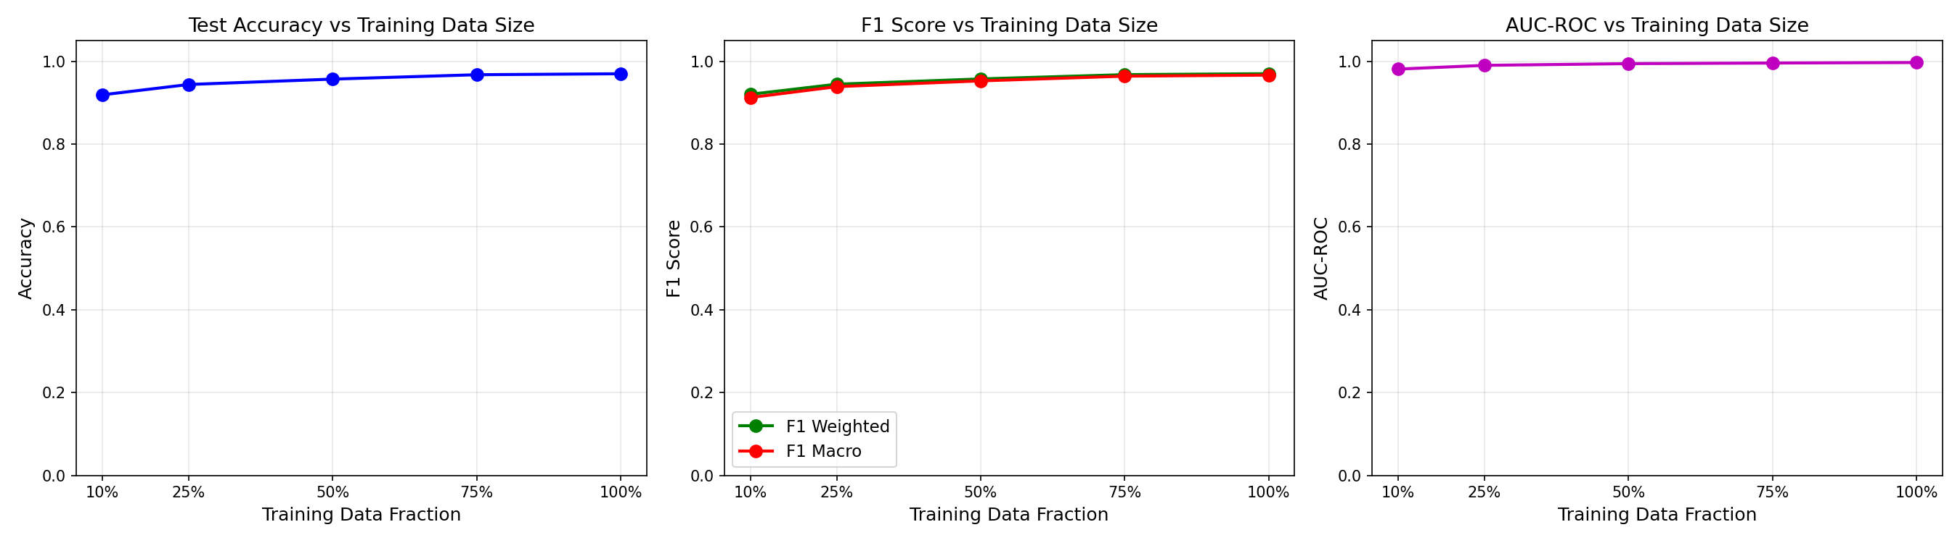
Figure 4: Model performance vs. training set size (learning curves).

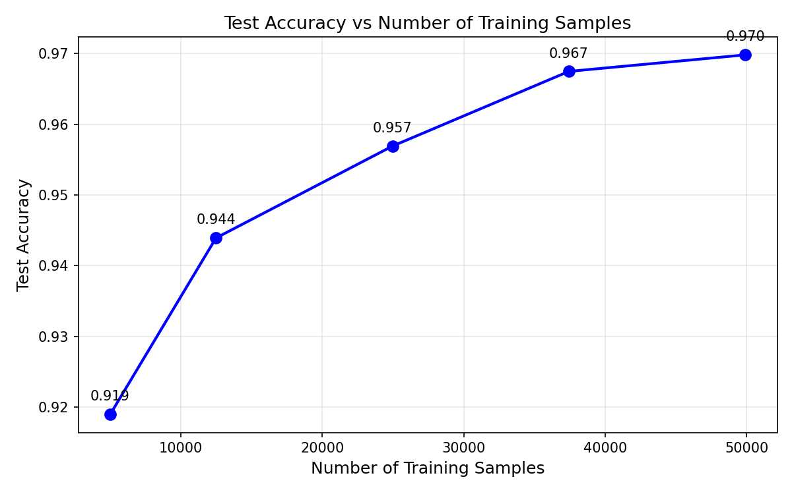
Figure 5: Model performance vs. absolute number of training samples.

8.4 Analysis
Strong baseline with minimal data: Even with only 10% of the training data (4,992 images), the model achieves 91.9% accuracy and 0.981 AUC-ROC, demonstrating the remarkable effectiveness of transfer learning.
Steep initial gains, rapid diminishing returns: The largest accuracy improvement (+2.50%) comes from the 10% → 25% transition. The marginal gain per additional 1% of data drops from 0.167% to 0.009% — an 18x reduction.
The most cost-effective operating point is around 25-50% of the training data, where the model achieves 94-96% accuracy. Organizations can start with ~12,000-25,000 labeled images and achieve production-grade accuracy above 94%.
AUC-ROC stability: The discriminative ability ranges from 0.981 at 10% to 0.997 at 100%, suggesting the model learns the core Fresh/Rotten distinction early and refines decision boundaries with additional data.

9. Conclusions

9.1 Summary of Findings
This project demonstrates a clear hierarchy of modeling approaches for produce freshness classification:
- The naive baseline (66.4% accuracy) confirms the task is non-trivial.
- Classical ML with deep features (90.8% accuracy, 0.960 AUC-ROC) achieves strong performance with a compelling balance of accuracy and simplicity.
- Fine-tuned EfficientNet-B0 (97.2% accuracy, 0.997 AUC-ROC) achieves near-perfect binary classification with a 1.5% false negative rate — critical for food safety.

9.2 Key Takeaways
- Transfer learning is highly effective for this domain, even though ImageNet contains no freshness-related categories.
- Class imbalance handling (weighted sampling + weighted loss) is essential to avoid majority-class bias.
- Performance varies by produce type; Okra and Potato remain challenging while Banana, Apple, and Capsicum are near-perfect.
- The model's conservative bias (more false positives than false negatives) is desirable for food safety.

10. Future Work
- Multi-class freshness grading: Extend to a graded scale (Fresh → Slightly Aged → Moderately Aged → Rotten).
- Produce-specific models: Train specialized classifiers for challenging types like Okra and Potato.
- Explainability: Apply Grad-CAM or similar methods to visualize which image regions drive predictions.
- Real-time deployment: Optimize for edge deployment using quantization, pruning, or knowledge distillation.
- Temporal modeling: Incorporate sequential images over time to predict remaining shelf life.
- Domain adaptation: Test generalization across different lighting, cameras, and backgrounds.
- Active learning: Selectively query human experts for the most uncertain predictions.
- Advanced augmentation: Investigate CutMix, MixUp, or generative augmentation with diffusion models.

11. Commercial Viability

11.1 Market Opportunity
The global food waste management market is projected to reach $64 billion by 2027. Automated freshness detection addresses pain points across retail grocery chains, distribution centers, food delivery services, and smart refrigerators.

11.2 Deployment Architecture
The model's small footprint (5.3M parameters, ~21MB) enables Cloud API, edge device (mobile/IoT), and hybrid deployment architectures.

11.3 Revenue Model
- B2B SaaS: Per-API-call pricing for enterprise integrations.
- Platform licensing: Annual licenses for proprietary hardware deployment.
- Data services: Aggregated freshness analytics for supply chain insights.

11.4 Competitive Advantages
- Multi-produce coverage: single model handles 13+ produce types.
- 97.2% accuracy exceeds human inspector consistency (85-90% inter-rater agreement).
- 1.5% false negative rate provides food safety assurance.

11.5 Barriers and Risks
- Data distribution shift: real-world images may differ from training data.
- Regulatory compliance: may require FDA/USDA certification.
- Liability: incorrect predictions could lead to food safety incidents.

12. Ethics Statement

12.1 Data Privacy
The dataset consists of images of produce items and contains no personally identifiable information (PII). No images of people, faces, or personal environments are included.

12.2 Bias and Fairness
- Geographic bias: may not represent produce from all global regions.
- Camera/lighting bias: training images share certain photographic characteristics.
- Produce type representation: some types are much more heavily represented than others.

12.3 Environmental Impact
EfficientNet-B0 is relatively lightweight compared to larger architectures. Training completed in under 1 hour on a single consumer GPU. We chose EfficientNet-B0 specifically for its favorable accuracy-to-compute ratio.

12.4 Societal Impact
Positive impacts: Reducing food waste contributes to food security and sustainability. Automated quality control improves food safety. Lower inspection costs make safe food more accessible.
Potential negative impacts: Over-reliance could displace inspection workers. False negatives pose health risks without human oversight. Overconfident deployment could lead to systematic errors.

12.5 Responsible Deployment
- Include human-in-the-loop oversight for edge cases and uncertain predictions.
- Continuously monitor performance on live data and retrain as needed.
- Clearly communicate limitations and error rates to end users.
- Maintain fallback to manual inspection processes.
- Conduct rigorous testing across diverse real-world conditions before production use.

References
- Bhargava, A., & Bansal, A. (2018). Fruits and vegetables quality evaluation using computer vision: A review. Journal of King Saud University – Computer and Information Sciences.
- Deng, J., et al. (2009). ImageNet: A large-scale hierarchical image database. CVPR 2009.
- He, K., et al. (2016). Deep Residual Learning for Image Recognition. CVPR 2016.
- Kamilaris, A., & Prenafeta-Boldú, F. X. (2018). Deep learning in agriculture: A survey. Computers and Electronics in Agriculture.
- Krizhevsky, A., et al. (2012). ImageNet Classification with Deep Convolutional Neural Networks. NeurIPS 2012.
- Loshchilov, I., & Hutter, F. (2019). Decoupled Weight Decay Regularization. ICLR 2019.
- Mazen, F. M. A., & Nashat, A. A. (2019). Ripeness classification of bananas using an artificial neural network. Arabian Journal for Science and Engineering.
- Razavian, A. S., et al. (2014). CNN Features off-the-shelf: An Astounding Baseline for Recognition. CVPR 2014 Workshops.
- Sa, I., et al. (2016). DeepFruits: A fruit detection system using deep neural networks. Sensors.
- Simonyan, K., & Zisserman, A. (2015). Very Deep Convolutional Networks for Large-Scale Image Recognition. ICLR 2015.
- Tan, M., & Le, Q. V. (2019). EfficientNet: Rethinking Model Scaling for Convolutional Neural Networks. ICML 2019.
- Yosinski, J., et al. (2014). How transferable are features in deep neural networks? NeurIPS 2014.

