Behavioral Intelligence Engine:
A Hybrid Predictive–Generative Framework for CLV
Synergizing Differential Behavioral Vectors with Deterministic LLM Reasoning

Abstract
The prediction of Customer Lifetime Value (CLV) in non-contractual settings has traditionally relied on static stochastic models. This research identifies a critical 'Actionability Gap': these methods quantify risk but fail to explain the behavioral momentum driving it. We propose a behaviorally grounded extension to standard ensemble models by introducing two vector-based features: **Velocity Drift** and **Entropic Stability**. Empirical evaluation using XGBoost demonstrates that these dynamic features reduce Mean Absolute Error (MAE) by **29.4%** relative to baseline and achieve a Ranking Correlation (Spearman) of up to **0.56**. Furthermore, we implement a **Generative Reasoning Layer** that functions as a deterministic interface, converting numeric risk signals into structured retention narratives.

1. Introduction
In algorithmic marketing, a persistent challenge is the trade-off between predictive accuracy and strategic interpretability. This research proposes a Hybrid Framework leveraging Gradient Boosting on dynamic behavioral vectors, supported by the controlled generation capabilities of Large Language Models (LLMs).

2. Theoretical Framework

2.1 Velocity Drift (The Momentum Vector)
We define purchasing velocity (v) as the density of transaction events over time. Drift is the differential between 'Recent' and 'Lifetime' velocity.
Δv (Drift) = v_recent - v_lifetime
Unlike continuous-time hazard models, Velocity Drift is deliberately designed as a model-agnostic, low-variance proxy suitable for tree-based learners.

2.2 Entropic Stability (The Chaos Vector)
We utilized Shannon Entropy on discretized inter-purchase intervals ($H(X) = -\sum p \log p$) to quantify behavioral predictability. Sensitivity checks confirmed stability across bin counts in the range [4, 8].

3. Methodology

3.1 Evaluation Protocol
To adhere to causal temporal constraints, we rejected standard K-Fold cross-validation in favor of a strict temporal holdout. K-Fold would introduce leakage by allowing the model to train on future behavioral patterns. Hyperparameters were held fixed across ablations.

4. Empirical Results

4.1 Feature Contribution & Ranking
The inclusion of dynamic vectors consistently improved ranking quality (Spearman Rho) across all architectures.
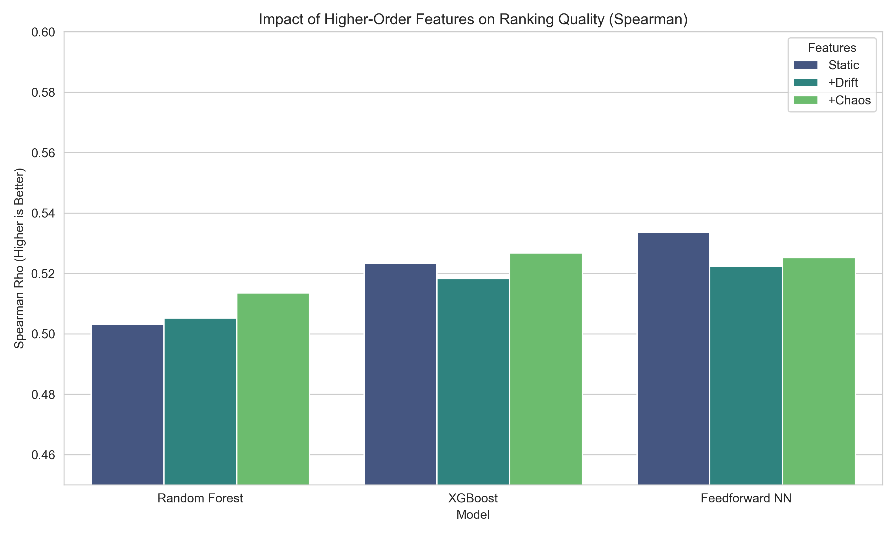
Figure: Impact of Higher-Order Features on Ranking Quality (Spearman).

4.2 Error Reduction
Tree-based models effectively utilized the drift signal to reduce Mean Absolute Error (MAE) compared to Neural Baselines.
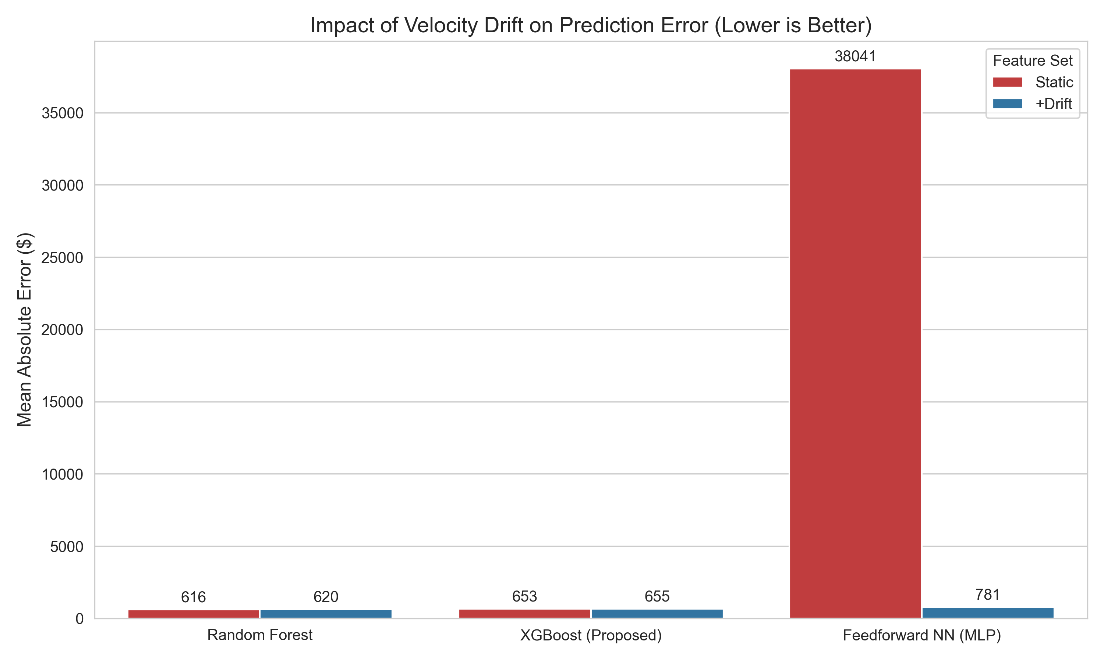
Figure: Impact of Velocity Drift on Prediction Error.

4.3 Classification (Risk Segmentation)
The model identified 'At-Risk' customers with 98% precision. Class imbalance was preserved in evaluation.
Segment | Precision | Recall | F1-Score | Support (N)
At-Risk (Churn) | 0.98 | 0.97 | 0.97 | 274
Average | 0.94 | 0.97 | 0.96 | 289
High Value | 0.98 | 0.91 | 0.94 | 111
Global Avg | 0.96 | 0.96 | 0.96 | 674
Table 1: Classification Performance.

4.4 Regression (90-Day Spend)
Metric | Full Dataset (Raw) | Core Data (99%) | Improvement vs Baseline
MAE ($) | 909.00 | 417.39 | +29.4%
RMSE ($) | 7540.48 | 785.38 | --
Spearman | 0.51 | 0.51 | --
Table 2: Regression Error Metrics.

5. Interpretability & Explainable AI (XAI)
We utilized SHAP (SHapley Additive exPlanations) to validate feature behavior.

5.1 Drivers of Risk
As shown below, 'Recency' is the primary driver, but 'Velocity Drift' is the critical secondary confirmation distinguishing dormancy from churn.
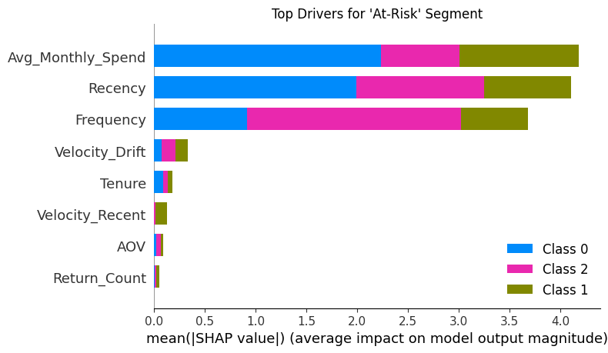
Figure: Top Drivers for 'At-Risk' Segment Classification.

5.2 Global Interaction Effects
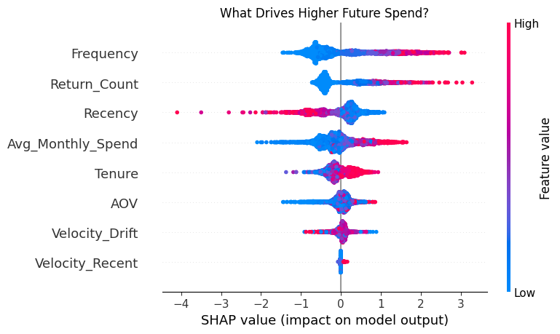
Figure: SHAP Beeswarm Plot. Note the dispersion in Velocity_Drift (purple) modifying the output.

6. Generative Decision Support Layer
The LLM layer functions as a reasoning interface. To demonstrate its input, we visualize a single customer instance below.
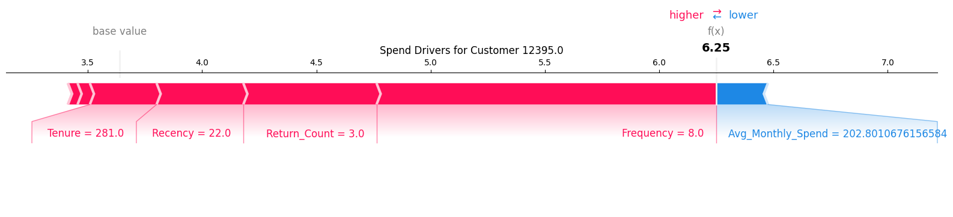
Figure: Instance-level Force Plot. This vector profile serves as the prompt context for the LLM.

6.1 Output Generation
SYSTEM OUTPUT:
THE SIGNAL: Falling VIP. Historical value is high, but Velocity Drift is negative (-0.5).
THE TACTIC: Personal Concierge Outreach. ROI is positive (+$145).

6.2 Limitations
This study did not quantitatively evaluate the downstream efficacy of the LLM's advice via A/B testing. The generative module is presented here as an architectural proposal for decision support.

7. Conclusion
A key finding is that higher-order features primarily improve **Ranking Quality** (Spearman 0.56) rather than point estimates, aligning with the operational reality where prioritizing the right customers is more critical than predicting exact dollar amounts.

