How to create Article pages:

**Images:**

Images will go in <img src=”img/example.jpg”…> tag. Following images need to be changed:

1. Screenshots : class=”article-img” size=”640x300 px”
2. Box art : class=”boxart” size=”460x563 px”
3. Cover photo : class=”review-banner” size=”1350x400px”

All above images are saved in location “web/img/”

1. Rating Section Background : class=”rating-bg” size=”1350x760px”

Above images are saved in location “web/css/img/”

Use Photoshop to edit downloaded pics/screenshots to convert them to desired resolution. Crop image or resize to achieve this.

Save the image in the desired format whether .jpg or .png. with an appropriate name to it.

Go to the <img> tag and paste the path into the src attribute as given.

Only for the Rating section background go to style.css and Find “rating-bg” using Ctrl+F and paste the path in the background-image’s url attribute. Remember to put this image in Web/css/img and not in Web/img/

**Text:**

Text go in tags like <p> for article content, <a> for hyperlinks , <h1>,<h2>,….<h6> for headings and titles. Simply copy paste the text required in between the tags.

Heading and subheading: class=”article-heading ”

Article date: class=”article-date”

Article type: class=”article-type”

Details about the game such as platforms, developer, release date are provide in the game info section with class=”game-info”. Simply edit the text.

Special article texts:

1. Quotation tag=”blockquote” For quotations from people
2. Highlights class=”highlights” For highlighted text
3. Hyperlinks class=”ref-links”
4. Captions class=”caption” for text under screenshots
5. Tips & Tricks class=”tips” For tips such as playing own music in gta5. These are step by step instructions and thus have to be put into bullet points. So each point goes into one <li>….</li> tag which stands for list items.

**Rating Section:**

Rating section has these elements:

1. Game title: class=”editor-rating-title”
2. Pros: id=”pros” Simply replace the text already there
3. Similarly for Cons. Id=”cons”
4. Editor’s Rating: Class=”rating-wrapper”

**Hyperlinks**

**Inter-page links** (Example: Jumping from one section of TOU to another)

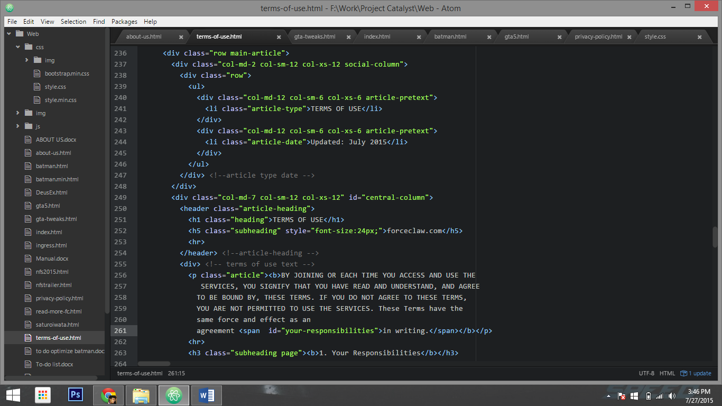

1. Notice in the first paragraph the last word has a span tag with an id attribute set to the name of the section that follows. So the last word of the paragraph before “Your responsibilities” has the id ‘your-responsibilities’.
2. This is to make sure that when the Link in the content of TOU is clicked the page scrolls down to this word specifically and hence the Paragraph/Section after that word is visible to the user to read.
3. (I have done this because the header of the site is transparent and floating so if I set the ID of the tag to the heading of the section it would be hidden behind the header on scroll down like this:

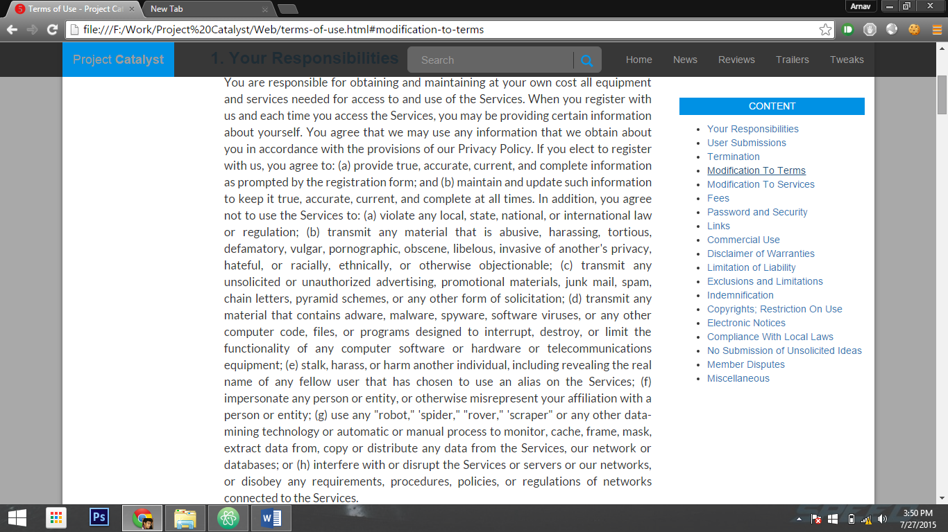

**Hyperlinking different pages:**

1. In order to hyperlink any link to a certain page on the website simply type in the name of the html file in the href attribute of the link.
2. Example: <a href=”gta5.html” > would create a link that leads to gta5 article page.

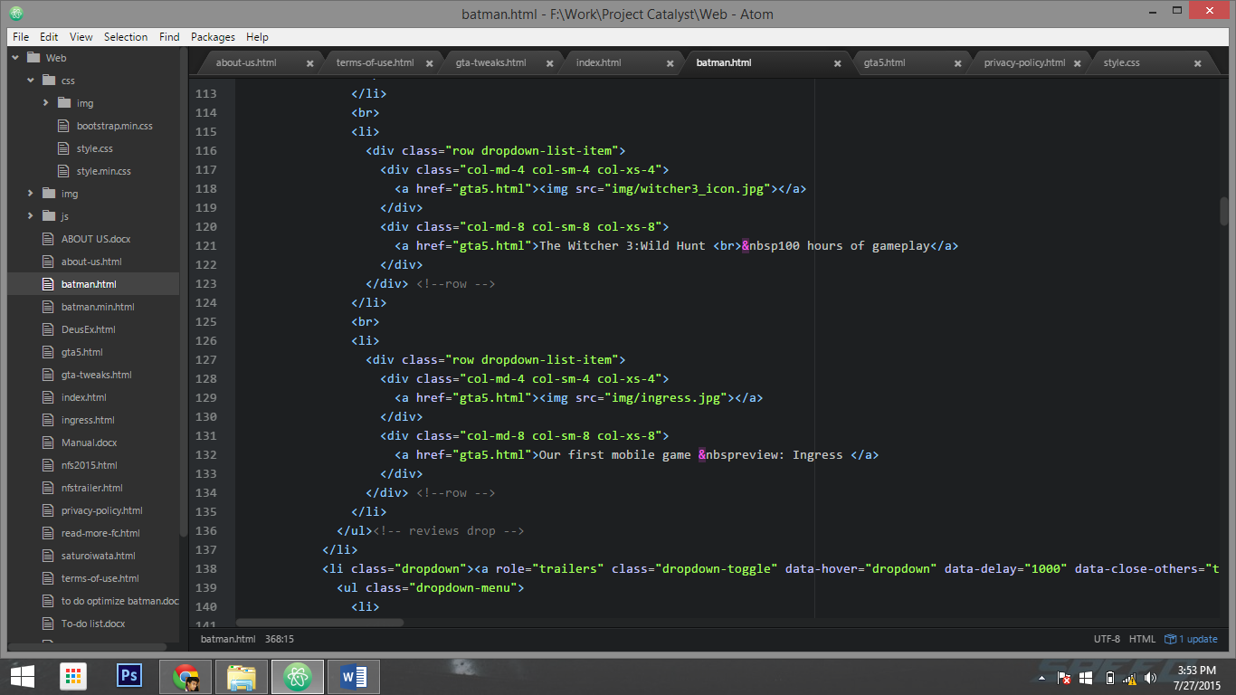All the <a> tags above are hyperlinks to the gta5 articles.

List of elements in webpage that have hyperlinks:

1. Dropdown Menu list items. Class=”dropdown-list-item” Such the ones given above.

They contain an image icon along with the article title. Both are made to work like hyperlinks. So both <img> tag and title text have hyperlinks.

1. More gaming news section class=”more-news-content” has three tags: (a) Image icon (b) Title text link (Class=”more-news-title”) (c) Read more text-link (Class=”read-more”). All of them have hyperlink tag <a>
2. Also Read Section Class=”recommendations” has two types of links: (a) Image icon in <img> tag(b) Text title in <h5> tags. Always change the href attributes already provided. **Never add new code**.
3. **Index page/Home page:** This page has article links in the form of Image thumbnail class=”icon” and Text Title class=”title”.
4. The links for TOU , PP and Read about us is present in the footer element enclosed in footer tags at the last. These are present in a <li> list. Add the links of the html files in href=””.
5. After we have launched Social networking pages for Forceclaw.com we will have to add them in the <li> href links in the class=”social-container” in all pages.