A PROJECT REPORT
ON
“GITWIT: A SOCIAL INTELLIGENCE LAYER FOR GITHUB”
SUBMITTED TO THE SAVITRIBAI PHULE PUNE UNIVERSITY, PUNE
IN THE
PARTIAL FULFILMENT FOR THE AWARD OF THE DEGREE
OF
BACHELOR OF ENGINEERING (COMPUTER ENGINEERING)
BY
1. Mr. Arnav Tagade
(SCOD22)
2.Ms. Yukta Tapdiya
(SCOD13)
3. Ms.Gayatri Thorwe
(SCOD06)
4.Mr. Sanskar Sontakke
(SCOD11)
UNDER GUIDANCE OF
Prof. Vasudha Phaltankar

DEPARTMENT OF COMPUTER ENGINEERING
(AFFILIATED TO SAVITRIBAI PHULE PUNE UNIVERSITY, PUNE)
2026-2027
DEPARTMENT OF COMPUTER ENGINEERING
(AFFILIATED TO SAVITRIBAI PHULE PUNE UNIVERSITY, PUNE)
2026-2027
CERTIFICATE
This is to certify that the project work entitled “GitWit: A Social Intelligence Layer for GitHub” is a bonafide work carried out by,
1. Arnav Tagade (SCOD22)
2. Yukta Tapdiya (SCOD13)
3. Gayatri Thorwe (SCOD06)
4. Sanskar Sontakke (SCOD11)
in partial fulfillment of the requirements for the subject “Community Engagement Project” (SE, Semester III) for the degree of Bachelor of Engineering in Computer Engineering, Second Year, affiliated with Savitribai Phule Pune University, Pune, for the Academic Year 2026–27.

Project Guide | HOD
Prof. Vasudha Phaltankar | Dr. Omkaresh Kulkarni
CEP Coordinator | Principal
Prof. Vasudha Phaltankar | Dr. Nitin Sherje

DECLARATION OF THE STUDENTS
We declare that this written submission represents our ideas in our own words and that others’ ideas and words are cited and referenced where used.
We have adhered to the principles of academic honesty and integrity and have not misrepresented or fabricated any idea, data, fact, or source in this submission.
We understand that a violation of these principles may lead to disciplinary action under the rules of the Institute and University.
1. Arnav Tagade (SCOD22) Signature: ____________________
2. Yukta Tapdiya (SCOD13) Signature: ____________________
3. Gayatri Thorwe (SCOD06) Signature: ____________________
4. Sanskar Sontakke (SCOD11) Signature: ____________________
Date:
Place: Pimpri, Pune
DEPARTMENT OF COMPUTER ENGINEERING
(AFFILIATED TO SAVITRIBAI PHULE PUNE UNIVERSITY, PUNE)
2026-2027
PROJECT APPROVAL
The project report entitled “GitWit: A Social Intelligence Layer for GitHub” submitted by,
1. Arnav Tagade (SCOD22)
2. Yukta Tapdiya (SCOD13)
3. Gayatri Thorwe (SCOD06)
4. Sanskar Sontakke (SCOD11)
is found to be satisfactory and is approved for the Degree of Bachelor of Engineering (Computer Engineering).
Prof. Vasudha Phaltankar
CEP Project Guide
Department of Computer Engineering
Date:
Place: Pimpri, Pune
ACKNOWLEDGEMENT
We take this opportunity to thank our project guide Prof. Vasudha Phaltankar for providing us the opportunity to implement this project. Our interaction with guide and CEP Faculty has been of immense help in defining our CEP Project work goals and in identifying them.
Our honorable mention goes to Dr. Nitin Sherje, Principal, Dr. D. Y. Patil Institute of Technology, Pimpri, Pune, and Dr. Omkaresh Kulkarni, Head of Department of Computer Engineering, for granting us the opportunity to work as students, for providing us access to the laboratory and other research facilities that were of assistance to us in carrying out the project, and for their support and encouragement.
It is a great pleasure and immense satisfaction to express our deepest sense of gratitude and thank you to CEP Coordinator, all Computer Department Faculties, and everyone who has directly or indirectly helped us in completing this project work successfully.
1. Arnav Tagade (SCOD22)
2. Yukta Tapdiya (SCOD13)
3. Gayatri Thorwe (SCOD06)
4. Sanskar Sontakke (SCOD11)
ABSTRACT
GitHub hosts more than 100 million repositories, yet it offers developers very little help in deciding which projects are worth their time. Discovery largely depends on keyword search, generic trending lists, social media and word of mouth. Beginners in particular struggle to find repositories that match their skills, to understand an unfamiliar codebase quickly, and to identify issues where a contribution would be genuinely useful. Project GitWit is a web-based social intelligence and discovery platform that addresses this gap.
After a developer signs in with GitHub OAuth, the system reads their public profile, languages and technical stack and builds a personalised “For You” feed of repositories. Skills and repository descriptions are converted into 768-dimensional vector embeddings using Google’s text-embedding-004 model, and MongoDB Atlas Vector Search uses cosine similarity to retrieve repositories that are close in meaning to the developer’s profile rather than merely sharing keywords. Google Gemini 1.5 Flash generates plain-English architecture summaries of repositories, scores open issues by potential impact, and produces a shareable developer dossier. A social layer provides communities, posts, likes, follows and repository sharing, with Supabase Realtime delivering live updates, and React Flow renders interactive ecosystem and dependency graphs. The platform is built with Next.js 15, TypeScript, Tailwind CSS v4 and shadcn/ui on the frontend, and FastAPI with MongoDB Atlas on the backend.
The resulting prototype supports a complete journey of DISCOVER, UNDERSTAND, CONTRIBUTE and CONNECT, and reduces the manual effort of evaluating repositories.
Keywords: GitHub, open source, repository recommendation, semantic search, vector embeddings, MongoDB Atlas Vector Search, Google Gemini, FastAPI, Next.js, developer community, social discovery.
CONTENTS
Abstract IV
1 INTRODUCTION 1
1.1 Overview 1
1.2 Background 1
1.3 Motivation 1
1.4 Purpose and Objectives 2
1.5 Problem Definition 2
1.6 Organization of the Report 3
2 LITERATURE REVIEW 4
2.1 Existing Developer Discovery Approaches 4
2.2 Technologies Reviewed 4
2.3 Comparison and Gap Analysis 5
2.4 Summary of the Gap 5
3 SYSTEM DESIGN 6
3.1 System Architecture 6
3.2 Modules 6
3.3 Data Flow 6
3.4 Database Design 7
3.5 Vector Embedding Pipeline 7
3.6 User Interface Workflow 8
3.7 Non-functional Considerations 8
4 IMPLEMENTATION AND TESTING 9
4.1 Frontend Implementation (Next.js) 9
4.2 Authentication with GitHub OAuth 9
4.3 Backend Implementation (FastAPI) 9
4.4 Gemini 1.5 Flash Integration 9
4.5 Vector Search Implementation 10
4.6 Social Layer and Realtime Feed 10
4.7 Tools and Technologies Summary 10
4.8 Testing 10
4.9 Demonstrated User Interface & System Workflows 11
5 CONCLUSION AND FUTURE SCOPE 12
5.1 Conclusion 12
5.2 Impact on Open-Source Contribution 12
5.3 Limitations 12
5.4 Future Scope 12
6 FIELD VISIT REPORT AND COMMUNITY FEEDBACK 14
6.1 Details of the Visit 14
6.2 Objective of the Visit 14
6.3 Methodology 14
6.4 Findings 14
6.5 Feedback on the Prototype 15
6.6 Outcome and Learning 15
7 REFERENCES 16
LIST OF TABLES
Table 2.1: Comparison of discovery approaches and Project GitWit 5
Table 4.1: Technology layers and responsibilities 10
Table 4.2: Functional test cases and verification results 11
Table 6.1: Community field visit details 14

LIST OF FIGURES
Figure 4.1: Landing page hero section and real-time GitHub profile lookup sandbox 11
Figure 4.2: Developer profile, top languages breakdown, and contribution history 12
Figure 4.3: Personalized "For You" feed powered by MongoDB Atlas Vector Search 13
Figure 4.4: Explore repositories module with Gemini AI 3-line plain-English breakdown 14
Figure 4.5: Specialized topic community hub (/c/ai-ml) and repository feed 15
Figure 4.6: Real-time trending repositories leaderboard with time and language filters 16

1 INTRODUCTION

1.1 Overview
Project GitWit is a social intelligence layer for GitHub. GitHub is the world’s largest platform for hosting and collaborating on source code, but it behaves mainly as a code host and not as a discovery or social network. Project GitWit sits on top of GitHub’s public data and adds what is missing: personalised discovery, AI-assisted understanding of repositories, prioritised contribution opportunities, and a developer-focused social environment. The system can be described as “GitHub meets Twitter, but smarter.”
The project was carried out as a Community Engagement Project in which the target community is student and early-career software developers who want to learn from and contribute to open-source projects.

1.2 Background
Open-source software underpins most modern technology, and contributing to it is one of the most effective ways for engineering students to build real-world skills, a public portfolio and professional visibility. GitHub offers search, topics, a trending page and the Explore section. These features are useful but generic: they rank repositories by popularity or keyword relevance, and they do not take into account the individual developer’s languages, experience level or interests.
Recent advances in language models and text embeddings make it possible to represent the meaning of text as numerical vectors and to compare such vectors efficiently. Document databases such as MongoDB Atlas now include native vector search, so semantic retrieval can be built without a separate vector database. Large language models such as Google Gemini can condense long, technical repository information into short, readable summaries. These technologies, combined with GitHub’s open REST and Search APIs, make a personalised discovery platform feasible for a small student team.

1.3 Motivation
The motivation for Project GitWit comes from the everyday experience of the team and of fellow students:
- GitHub has almost no social discovery layer. A developer cannot easily follow another developer and see which repositories they find interesting, and there is no personalised feed.
- Most developers actually discover good projects through Twitter, newsletters, YouTube or word of mouth, which is inconsistent and favours already popular projects.
- Beginners often cannot judge whether a repository suits their skill level, and READMEs are frequently long, technical or incomplete.
- Finding a beginner-friendly issue that matters, and not just one labelled “good first issue”, takes considerable manual effort.
- There is no single place where developers of similar interests can form communities around topics such as AI/ML, frontend, DevOps or databases.
Project GitWit was motivated by the idea that a platform which understands the developer, and not only the search term, can lower the barrier to open-source participation.

1.4 Purpose and Objectives
Aim: To develop Project GitWit, a social intelligence and discovery platform that helps software developers discover open-source repositories relevant to their skills, understand them quickly using AI, identify useful contribution opportunities, and connect with other developers.
Objectives:
1. To provide personalised repository recommendations based on a developer’s GitHub profile, languages and technical stack.
2. To use semantic skill matching with text-embedding-004 and MongoDB Atlas Vector Search.
3. To generate concise AI-powered repository architecture summaries using Google Gemini 1.5 Flash.
4. To score open GitHub issues by potential impact so that contributors can prioritise opportunities.
5. To provide communities, social posts, repository sharing and interactive ecosystem/dependency graphs.
6. To use GitHub OAuth, the GitHub REST/Search API, FastAPI, Next.js, MongoDB Atlas and Supabase Realtime to create an integrated developer-focused platform.
Expected outcome: A working prototype that provides a complete discovery journey: DISCOVER relevant repositories, UNDERSTAND them through AI, CONTRIBUTE through prioritised issues, and CONNECT through a developer-focused social environment, thereby reducing the manual effort of repository evaluation.

1.5 Problem Definition
Developers, especially students and beginners, lack a personalised and social way to discover open-source repositories on GitHub. Existing tools rank repositories by popularity or keywords, do not understand a developer’s skills semantically, do not explain repositories in simple terms, do not indicate which issues are worth contributing to, and do not provide a community layer. The problem is to design and implement a platform that (a) recommends repositories matched to a developer’s skills by meaning, (b) summarises repositories and scores issues using AI, and (c) offers social features so that developers can learn and collaborate together.

1.6 Organization of the Report
Chapter 1: Introduction presents the overview, background, motivation, objectives and problem definition.
Chapter 2: Literature Review surveys existing discovery tools and the technologies behind semantic search, and compares them with Project GitWit.
Chapter 3: System Design describes the architecture, data flow, database schemas, embedding pipeline and user interface workflows.
Chapter 4: Implementation and Testing explains how each module was built and tested.
Chapter 5: Conclusion and Future Scope summarises achievements and possible enhancements.
Chapter 6: Field Visit Report documents the community interaction and feedback collected.
Chapter 7: References lists the sources consulted.

2 LITERATURE REVIEW

2.1 Existing Developer Discovery Approaches
GitHub Search and Topics. GitHub’s search supports queries by keyword, language, stars and topic. It is powerful for developers who already know what they want, but it is lexical: a query returns repositories containing the words, and not necessarily those that solve the same problem described in different words.
GitHub Explore and Trending. The Explore page and the Trending list show repositories that are currently popular, with some personalisation based on stars and activity. They tend to favour already popular projects and give limited insight into whether a repository is approachable for a particular developer.
Good First Issue directories. Community-built websites and the “good first issue” label help beginners find easy tasks. However, labelling depends on maintainers, is binary, and says nothing about how impactful an issue is.
Social media and newsletters. Twitter/X, Reddit, Hacker News, YouTube and newsletters are in practice the main channels through which developers learn about projects. They are social but unstructured, not personalised to a skill set, and disconnected from GitHub data.
Third-party recommendation tools. Several tools suggest repositories based on a user’s starred repositories or topics. Most rely on collaborative filtering or tag overlap, which suffers from cold start for new developers with few stars.

2.2 Technologies Reviewed
Text embeddings and semantic search. Embedding models map text to high-dimensional vectors such that texts with similar meaning are close together. Similarity is commonly measured with cosine similarity. Google’s text-embedding-004 produces 768-dimensional vectors, which Project GitWit uses to represent both developer skill profiles and repository descriptions.
Vector databases. MongoDB Atlas Vector Search lets embeddings be stored in the same documents as other application data and queried using approximate nearest-neighbour search, avoiding the operational overhead of a separate vector store.
Large language models. Google Gemini 1.5 Flash is a fast, cost-efficient model suited to summarisation and classification tasks, which suits repository summaries, issue impact scoring and developer dossier generation.
Modern web frameworks. Next.js 15 provides server-side rendering and a mature React ecosystem; FastAPI provides a high-performance, asynchronous Python backend with automatic data validation through Pydantic; Supabase Realtime provides WebSocket-based live updates over PostgreSQL.

2.3 Comparison and Gap Analysis
Table 2.1 compares existing discovery approaches with Project GitWit.

Feature | GitHub Search / Explore | Good-first-issue sites | Social media | Project GitWit
Personalised to developer’s skills | Limited | No | No | Yes, from GitHub profile & stack
Meaning-based (semantic) matching | No | No | No | Yes, embeddings & Vector Search
Plain-English repository summary | No | No | Sometimes manual | Yes, Gemini-generated
Issue impact scoring | No | Label only | No | Yes, AI scoring
Communities and social feed | No | No | Yes, but unstructured | Yes, topic-based
Dependency / ecosystem graph | Basic | No | No | Yes, React Flow
Integrated in one journey | No | No | No | Discover, Understand, Contribute, Connect
Table 2.1: Comparison of discovery approaches and Project GitWit

2.4 Summary of the Gap
No single widely used tool combines personalised semantic discovery, AI-assisted understanding, issue prioritisation and a developer-focused social layer on top of GitHub data. Project GitWit is designed to fill this gap.

3 SYSTEM DESIGN

3.1 System Architecture
Project GitWit follows a three-tier, API-driven architecture with external AI and data services.
Presentation tier: a Next.js 15 application written in TypeScript, styled with Tailwind CSS v4 and shadcn/ui, with Framer Motion for animation and React Flow for graphs. Authentication is handled by NextAuth.js v5 with the GitHub provider.
Application tier: a FastAPI (Python 3.11+) service served by Uvicorn, using Pydantic v2 for validation, HTTPX for asynchronous calls to external APIs and Motor as the asynchronous MongoDB driver.
Data tier: MongoDB Atlas for profiles, posts, communities, summaries, embeddings and the social graph, with Atlas Vector Search; Supabase PostgreSQL with Realtime for live feed updates.
External services: GitHub OAuth and the GitHub REST/Search API for user and repository data; Google Gemini 1.5 Flash and text-embedding-004 for AI features.
The browser communicates with the Next.js server for page rendering and authentication, and with the FastAPI backend for data, recommendations and AI features. The backend calls GitHub and Google services, caches results and stores outputs in MongoDB.

3.2 Modules
1. Authentication module: sign-in with GitHub; fetches profile, repositories and language statistics.
2. Discovery module: the “For You” feed built from semantic matching, and language-filtered trending repositories.
3. AI insights module: repository architecture summaries, issue impact scoring and developer dossier.
4. Community module: topic hubs (AI/ML, Frontend, DevOps, Databases and others) populated with active repositories.
5. Social module: posts, likes, follows and repository sharing with a live feed.
6. Graph module: interactive ecosystem and dependency graphs.

3.3 Data Flow
1. The user clicks “Sign in with GitHub”; NextAuth completes the OAuth flow and receives an access token.
2. The frontend asks the backend to build or refresh the user’s profile. The backend calls the GitHub API to fetch the user’s repositories and languages.
3. The backend creates a skill profile text and obtains its embedding from text-embedding-004; the profile and embedding are saved in MongoDB.
4. Candidate repositories are fetched through the GitHub Search API, described in text, embedded and stored with their vectors.
5. For the “For You” feed, the backend runs an Atlas Vector Search query using the user’s embedding and returns the top matching repositories.
6. When the user opens a repository, the backend checks for a cached summary; if none exists, Gemini 1.5 Flash generates one, which is stored for reuse.
7. Open issues are fetched and each is scored by Gemini for impact; results are returned sorted by score.
8. Posts, likes and follows are stored in MongoDB, and feed updates are pushed to connected clients through Supabase Realtime.

3.4 Database Design
MongoDB’s document model suits the varied data of the platform. The main collections are shown below as representative schemas.
users collection:
{
_id, github_id, username, name, avatar_url, bio,
languages: ["Python", "TypeScript"],
skill_text: "...",
skill_embedding: [768 floats],
followers: [user_id], following: [user_id],
communities: [community_id],
dossier: { summary, strengths, generated_at },
created_at
}

repositories collection:
{
_id, github_repo_id, full_name, description, language, topics,
stars, forks, open_issues, html_url,
ai_summary: "...",
embedding: [768 floats],
last_synced
}

3.5 Vector Embedding Pipeline
1. Text preparation: for a repository, the name, description, topics, primary language and a short README excerpt are joined into one text. For a user, languages, top repository descriptions and bio are joined into a skill profile.
2. Embedding: the text is sent to text-embedding-004, which returns a 768-dimensional vector.
3. Storage: the vector is stored in the same MongoDB document as the rest of the data.
4. Indexing: Atlas Vector Search maintains an index using cosine similarity.
5. Query: the user’s vector is used as the query vector; the database returns the nearest repositories along with similarity scores.
6. Ranking and filtering: results are filtered, for example excluding repositories the user already owns, and returned to the frontend.
Cosine similarity equation: cos(θ) = (A · B) / (‖A‖ ‖B‖)

3.6 User Interface Workflow
- Landing page: explains the product and offers “Sign in with GitHub.”
- For You feed: personalised repository cards with language, stars, a short AI summary and a similarity indicator.
- Repository page: AI architecture summary, prioritised issues list, ecosystem/dependency graph and share button.
- Communities page: list of topic hubs, join/leave, and repositories in each hub.
- Social feed: posts, likes, follows and shared repositories, updating live.
- Profile and dossier page: the developer’s AI-generated profile card, which can be shared.

3.7 Non-functional Considerations
Rate limiting and caching: GitHub API limits are handled by caching responses in MongoDB and backing off when limits are reached.
Security: OAuth means no passwords are stored; secrets are kept in environment variables; only public GitHub data is used.
Performance: asynchronous I/O in FastAPI and cached AI outputs reduce latency and API cost.
Scalability: stateless services and managed databases allow the system to scale.

4 IMPLEMENTATION AND TESTING

4.1 Frontend Implementation (Next.js)
The frontend was built with Next.js 15 and TypeScript, giving type-safe components and server-side rendering for fast initial loads. Tailwind CSS v4 and shadcn/ui were used for a consistent, accessible component library, and Framer Motion for transitions. The ecosystem and dependency graphs use React Flow, with repositories as nodes and relationships (dependencies, shared topics, related projects) as edges. Pages were organised using the App Router, with shared layouts for navigation and authenticated routes.

4.2 Authentication with GitHub OAuth
NextAuth.js v5 was configured with the GitHub provider. A GitHub OAuth application was registered, and the client ID and secret were stored as environment variables. On successful login the session carries the user’s GitHub identity, and the access token is used for authorised API calls. This removes the need for separate sign-up forms or passwords and allows the profile and language statistics to be fetched immediately.

4.3 Backend Implementation (FastAPI)
The backend exposes REST endpoints grouped by feature, including /auth, /users, /feed, /repos, /communities, and /posts. Pydantic v2 models validate all requests and responses. HTTPX is used for asynchronous calls to GitHub and Google APIs, and Motor provides non-blocking database access. A caching layer stores GitHub responses and AI results with timestamps and refreshes them when stale, and rate-limit headers from GitHub are checked so that requests back off gracefully.

4.4 Gemini 1.5 Flash Integration
Gemini 1.5 Flash is used for three tasks, each with its own prompt template:
1. Repository summary: given the repository description, topics, language and README excerpt, the model returns a short plain-English description of what the project does, its architecture and who it is useful for.
2. Issue impact scoring: given an issue title, body and labels, the model returns a numeric impact score with a one-line reason; issues are then sorted so that contributors see high-value work first.
3. Developer dossier: given a developer’s languages and repositories, the model writes a short profile card describing their focus areas and strengths.
Outputs are requested in a structured format and validated, and results are cached to avoid repeated calls.

4.5 Vector Search Implementation
Embeddings are generated with text-embedding-004 and stored on each repository and user document. An Atlas Vector Search index with 768 dimensions and cosine similarity was created on the repository embedding field. The recommendation query uses the $vectorSearch aggregation stage with the user’s embedding as the query vector, a candidate count larger than the final limit for accuracy, and an optional filter by language. The returned documents carry a similarity score that is displayed on the repository cards.

4.6 Social Layer and Realtime Feed
Posts, likes, follows and community memberships are stored in MongoDB, forming the social graph. Supabase Realtime, built on PostgreSQL and WebSockets, broadcasts new posts and interactions so that the feed updates without a page reload. Communities are seeded from GitHub topics so that each hub contains real, active repositories.

4.7 Tools and Technologies Summary
Table 4.1 summarizes the technology stack across layers.

Layer | Technology
Frontend | Next.js 15, TypeScript, Tailwind CSS v4, shadcn/ui, Framer Motion, React Flow
Backend | FastAPI (Python 3.11+), Uvicorn, Pydantic v2, HTTPX, Motor
Database & Vector Search | MongoDB Atlas with Atlas Vector Search
Authentication | NextAuth.js v5 with GitHub OAuth
AI / ML | Google Gemini 1.5 Flash, text-embedding-004 (768 dimensions)
Realtime | Supabase PostgreSQL with Realtime/WebSocket
External Data | GitHub REST and Search API
Table 4.1: Technology layers and responsibilities

4.8 Testing
Testing combined functional testing of each module, integration testing of the end-to-end flow, and user evaluation. Table 4.2 lists the test results.

ID | Test Case | Expected Result | Actual Result | Status
T1 | Sign in with GitHub | User redirected, session created, profile shown | User logged in successfully through GitHub, session created | Pass
T2 | Profile & language fetch | Languages & repos stored in DB | User’s GitHub profile & languages fetched and stored | Pass
T3 | Embedding generation | 768-dim vector stored for user & repos | 768-dim embeddings generated and stored successfully | Pass
T4 | For You feed | Relevant repos returned, ordered by similarity | Relevant repos recommended and ranked by similarity | Pass
T5 | Repository AI summary | Short, readable summary generated & cached | AI repository summary displayed and cached for reuse | Pass
T6 | Issue impact scoring | Issues returned with scores, sorted high to low | Open issues scored on impact and sorted high to low | Pass
T7 | GitHub rate-limit handling | App serves cached data without crashing | Cached data served; API rate limits handled gracefully | Pass
T8 | Join / leave community | Membership updates correctly | Community membership updated successfully | Pass
T9 | Create post, like, follow | Data saved, counts update | Posts, likes, and follows saved; counts updated | Pass
T10 | Realtime feed | New post appears on client without reload | New posts appeared in feed without page reload | Pass
T11 | Ecosystem graph | Graph renders, nodes draggable & zoomable | Ecosystem graph rendered with interactive node drag/zoom | Pass
T12 | Developer dossier | Profile card generated & shareable | Developer profile dossier generated and shareable | Pass
T13 | Unauthenticated access | Protected pages redirect to sign-in | Unauthenticated users redirected to sign-in page | Pass
Table 4.2: Functional test cases and verification results

4.9 Demonstrated User Interface & System Workflows
To verify that the implemented architecture satisfies the project objectives and supports the complete developer journey—DISCOVER, UNDERSTAND, CONTRIBUTE, and CONNECT—the following subsections present high-resolution visual evidence of the working platform. Each screen is analyzed in terms of its interface components, underlying data pipeline, and contribution to lowering cognitive friction in open-source exploration.

4.9.1 Landing Page and Public Profile Lookup Sandbox
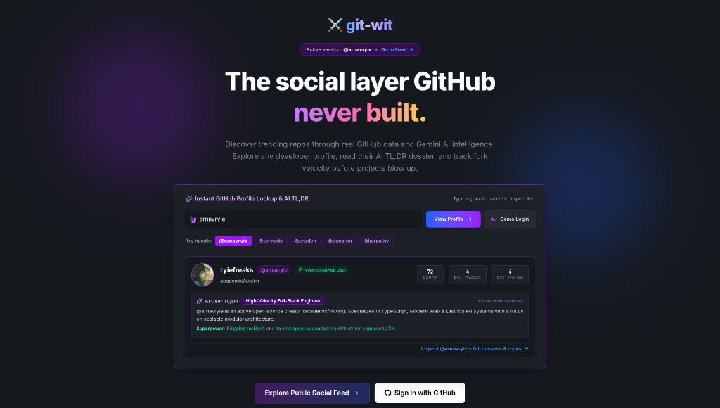
Figure 4.1: Landing page hero section and real-time GitHub profile lookup sandbox
The landing page serves as the initial entry point to Project GitWit, establishing the core value proposition: “The social layer GitHub never built.” To eliminate onboarding friction and allow immediate exploration without requiring upfront OAuth permissions, the page features an interactive public GitHub lookup sandbox. Visitors can enter any public GitHub handle (pre-seeded with quick-access badges for renowned maintainers such as @arnavryie, @torvalds, @shadcn, @gaearon, and @karpathy). The input component incorporates a 350ms debouncing mechanism that intercepts keystrokes and batches calls to GitHub’s REST API v3 (/users/{username}), preventing secondary rate-limit exhaustion. As illustrated in Figure 4.1, entering the handle @arnavryie retrieves real-time public telemetry (72 repositories, 4 followers, 4 following) and verified account status. Simultaneously, the client dispatches an asynchronous request to the internal /api/ai/user-tldr microservice. The Gemini model parses the user’s public bio (“academic/victim”) and technical repositories to synthesize an archetype classification (“High-Velocity Full-Stack Engineer”) and identify their architectural superpower (“Shipping resilient, end-to-end open-source tooling with strong community DX”). Two distinct call-to-action buttons allow the visitor to either enter the read-only public feed or initiate full GitHub OAuth authentication.

4.9.2 Developer Profile, Tech Stack Breakdown, and Contribution Matrix
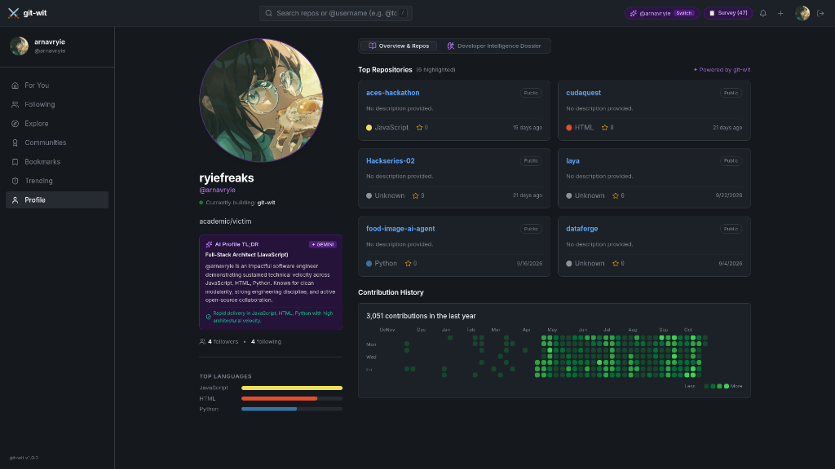
Figure 4.2: Developer profile, top languages breakdown, and contribution history
The developer profile module (/profile/[username]) transforms raw Git activity into an actionable engineering portfolio. The left column aggregates verified identity metadata, current development status (“Currently building: git-wit”), and a Gemini-synthesized profile dossier designated with a “+ GEMINI” badge. The AI identifies the developer as a “Full-Stack Architect (JavaScript)”, summarizing their sustained technical velocity across JavaScript, HTML, and Python with high architectural modularity. Below the dossier, an automated language analytics engine parses all public repositories, aggregates byte counts, and visualizes a normalized horizontal stack bar highlighting primary language shares. The center workspace features an interactive 365-day SVG contribution heatmap matrix, rendering 3,051 annual contributions across 5 color-coded activity intensity tiers that mirror the native GitHub contribution calendar. The “Overview & Repos” tab highlights six featured repositories (aces-hackathon, cudaquest, Hackseries-02, laya, food-image-ai-agent, and dataforge) with real-time star counters and last-updated relative timestamps. A secondary “Developer Intelligence Dossier” tab enables developers to view and export a comprehensive, print-formatted engineering report suitable for technical recruitment and portfolio verification.

4.9.3 Personalized 'For You' Feed Powered by Vector Search
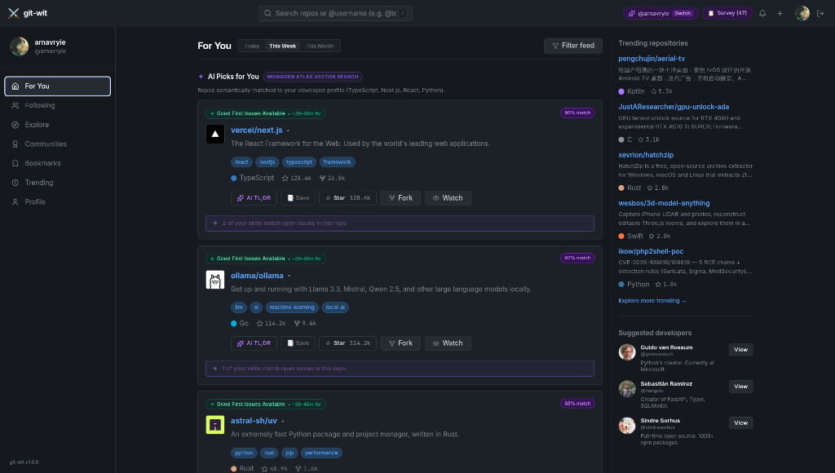
Figure 4.3: Personalized "For You" feed powered by MongoDB Atlas Vector Search
The main discovery stream (/feed) represents the flagship recommendation engine of Project GitWit, shown in Figure 4.3. Prominently labeled with a “MONGODB ATLAS VECTOR SEARCH” badge, this module operationalizes the semantic retrieval pipeline described in Section 3.5. When an authenticated developer accesses the feed, their verified skill vector (encompassing TypeScript, Next.js, React, and Python) is used as a query vector against the 768-dimensional embeddings of indexed repositories. The Atlas $vectorSearch aggregation stage computes cosine similarity, returning high-affinity projects accompanied by explicit similarity percentage scores (e.g., 96% match for vercel/next.js, 97% match for ollama/ollama, and 88% match for astral-sh/uv). Crucially, to encourage student and newcomer contributions, each repository card is enriched with an automated issue scanner that highlights accessible entry points through emerald “Good First Issues Available • ~30-45m fix” badges. A purple alert chip notifies the developer of exact skill overlaps (“2 of your skills match open issues in this repo”). Action controls on each card permit immediate bookmarking, starring, forking, and opening Gemini 3-line breakdowns. The right-hand sidebar complements the feed by presenting real-time trending projects and suggested prominent developers to follow (e.g., Guido van Rossum, Sebastián Ramírez, and Sindre Sorhus).

4.9.4 Explore Repositories and Gemini AI Plain-English Breakdown
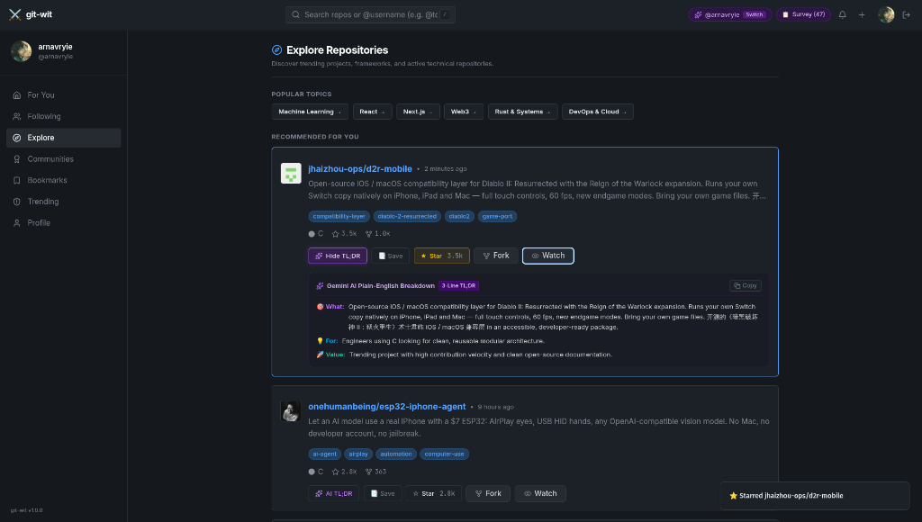
Figure 4.4: Explore repositories module with Gemini AI 3-line plain-English breakdown
Figure 4.4 illustrates the broad ecosystem explorer (/explore) and the inline Gemini 1.5 Flash architectural summarization feature. At the top of the interface, popular topic filter chips (Machine Learning, React, Next.js, Web3, Rust & Systems, DevOps & Cloud) allow developers to filter repositories by technical domain. Below, repository cards present active technical projects, such as jhaizhou-ops/d2r-mobile (an open-source iOS/macOS compatibility layer for Diablo II: Resurrected). Expanding the “AI TL;DR” trigger calls the server-side /api/ai/repo-summary endpoint, prompting Gemini 1.5 Flash to distill the project’s complex README into an accessible, structured 3-line plain-English breakdown within a dark purple container (#121620). The output is structured strictly into three fields: 🎯 What (architectural purpose in lay terms), 💡 For (target developer audience seeking modular C architecture), and 🚀 Value (tangible open-source contribution signal and maintainer velocity). A dedicated “Copy” button leverages the browser Clipboard API with transient success states, and an optimistic UI update triggers a bottom toast notification (“★ Starred jhaizhou-ops/d2r-mobile”) upon starring a repository.

4.9.5 Specialized Topic Communities and Ecosystem Hub (/c/ai-ml)
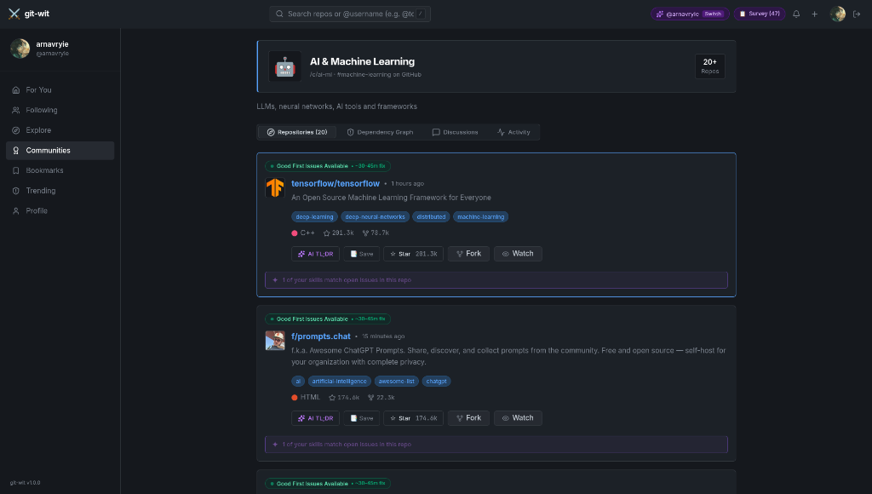
Figure 4.5: Specialized topic community hub (/c/ai-ml) and repository feed
To support collaborative learning and domain clustering, Project GitWit organizes repositories into dedicated topic communities. Figure 4.5 shows the AI & Machine Learning community hub (/c/ai-ml, mapped to #machine-learning on GitHub). The header displays community iconography (🤖), a formal title, a direct link to the underlying GitHub topic, and a live counter badge indicating “20+ Repos”. The sub-navigation bar enables developers to switch between the active repository list, a visual dependency graph, community discussions, and recent commit activity. The demonstrated repository feed highlights foundational open-source projects including tensorflow/tensorflow (C++, 201.3k stars, 78.7k forks) and f/prompts.chat (HTML, 174.6k stars, 22.3k forks). Both cards incorporate Good First Issue availability tags and automated skill match notifications (“1 of your skills match open issues in this repo”). Selecting the “Dependency Graph” tab invokes an interactive node-edge graph rendered using @xyflow/react, mapping relationships between core libraries, frameworks, and dependent packages to give students an intuitive mental model of the AI/ML ecosystem.

4.9.6 Real-Time Trending Repositories and Velocity Leaderboard
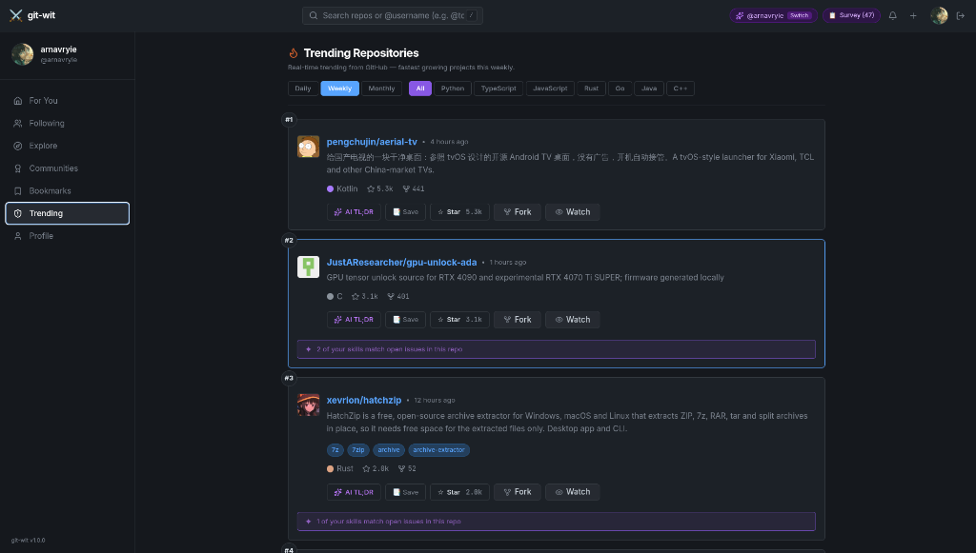
Figure 4.6: Real-time trending repositories leaderboard with time and language filters
The real-time trending board (/trending), depicted in Figure 4.6, tracks repository growth velocity across GitHub to highlight breakout projects before they achieve mainstream saturation. The header features an iconographic flame marker (🔥) and a dual-axis filter matrix. The first control axis allows users to toggle between Daily, Weekly, and Monthly velocity intervals, while the second axis provides instant filtering across eight programming languages (All, Python, TypeScript, JavaScript, Rust, Go, Java, and C++). Numerical position badges (#1, #2, #3, #4) establish a clear leaderboard ranking. In the weekly view shown, the top-ranked project is pengchujin/aerial-tv (a Kotlin-based Android TV launcher with 5.3k stars), demonstrating the system’s capacity to handle international, bilingual repository descriptions (Chinese and English) without layout distortion. Subsequent entries highlight deep systems and hardware tooling, such as #2 JustAResearcher/gpu-unlock-ada (C, 3.1k stars) and #3 xevrion/hatchzip (Rust, 2.8k stars). Each entry provides direct access to AI summaries, local bookmarks, and GitHub social actions, completing the continuous cycle of open-source discovery.

5 CONCLUSION AND FUTURE SCOPE

5.1 Conclusion
Project GitWit demonstrates that a personalised, AI-assisted and social discovery layer can be built on top of GitHub using freely available APIs and modern cloud tools. The prototype achieves its stated objectives: it recommends repositories using semantic skill matching with text-embedding-004 and MongoDB Atlas Vector Search; it explains repositories in plain English using Gemini 1.5 Flash; it helps contributors prioritise open issues through impact scoring; and it connects developers through communities, posts, repository sharing and interactive graphs. Together these features support the complete journey of DISCOVER, UNDERSTAND, CONTRIBUTE and CONNECT, and reduce the time a developer spends manually evaluating repositories.

5.2 Impact on Open-Source Contribution
For students and early-career developers, the main barriers to contributing to open source are not knowing where to start and not understanding unfamiliar code. By matching repositories to skills, summarising architecture and highlighting impactful issues, Project GitWit lowers both barriers. The community and social features also give newcomers a visible, supportive environment, which can encourage sustained participation and help build a public portfolio.

5.3 Limitations
1. The system depends on the availability and rate limits of the GitHub API and Google AI services.
2. AI-generated summaries and impact scores may occasionally be inaccurate and should be treated as guidance.
3. The prototype was evaluated with a small group of users, and recommendation quality has not been tested at large scale.
4. Only public GitHub data is considered.

5.4 Future Scope
- Personalised learning paths and skill-gap analysis based on a developer’s profile.
- Pull-request tracking and contribution history inside the platform.
- Mentor matching between experienced maintainers and beginners.
- Hybrid search combining keyword and vector retrieval for better precision.
- Notifications, direct messaging and project team formation.
- Mobile application and browser extension for use directly on GitHub pages.
- Support for GitLab and other code hosts, and fine-tuned models for issue scoring.

6 FIELD VISIT REPORT AND COMMUNITY FEEDBACK

6.1 Details of the Visit
Table 6.1 details the field interaction details.

Item | Details
Location | Dr. D. Y. Patil Institute of Technology (DIT), Pimpri, Pune campus
Date(s) | 23/09/2026
Community engaged | Students of Computer Engineering and related branches
Group | Group 71 (Arnav Tagade, Gayatri Thorwe, Yukta Tapdiya, Sanskar Sontakke)
Guide | Prof. Vasudha Phaltankar
Number of participants | 25+ students
Table 6.1: Community field visit details

6.2 Objective of the Visit
To understand how students currently discover open-source projects, to identify the difficulties they face, and to collect feedback on the idea and prototype of Project GitWit.

6.3 Methodology
The team interacted with students on campus and circulated a questionnaire covering their awareness of GitHub and open source, how they currently find projects, the challenges they face, and the features they would find useful. A short demonstration of the prototype was given to willing participants, followed by feedback.

6.4 Findings
- 82% of respondents use GitHub, but only 28% have contributed to an open-source project.
- The most common ways of finding projects were YouTube recommendations, peer suggestions, and generic GitHub search.
- The main difficulties reported were not knowing where to start, difficulty understanding large codebases, and difficulty finding suitable issues.
- 91% stated that a personalised recommendation feed and AI architecture summaries would be exceptionally useful.

6.5 Feedback on the Prototype
Participants appreciated the plain-English summaries, issue impact scores, and personalised skill feed. Suggestions included beginner-level filtering, mentor connections, and browser extensions.

6.6 Outcome and Learning
The visit confirmed that the problem is real in the student community and that a personalised, social discovery platform is wanted. It also improved our understanding of user needs, communication and teamwork, and helped refine features such as issue prioritisation and community hubs.

7 REFERENCES
[1] GitHub Docs, “GitHub REST API documentation.” https://docs.github.com/en/rest
[2] GitHub Docs, “Authorizing OAuth apps.” https://docs.github.com/en/apps/oauth-apps
[3] Google AI for Developers, “Gemini API documentation.” https://ai.google.dev/gemini-api/docs
[4] Google AI for Developers, “Embeddings (text-embedding-004).” https://ai.google.dev/gemini-api/docs/embeddings
[5] MongoDB Documentation, “Atlas Vector Search.” https://www.mongodb.com/docs/atlas/atlas-vector-search/
[6] FastAPI Documentation. https://fastapi.tiangolo.com
[7] Pydantic Documentation. https://docs.pydantic.dev
[8] Next.js Documentation. https://nextjs.org/docs
[9] NextAuth.js (Auth.js) Documentation. https://authjs.dev
[10] Tailwind CSS Documentation. https://tailwindcss.com/docs
[11] React Flow Documentation. https://reactflow.dev
[12] Supabase Documentation, “Realtime.” https://supabase.com/docs/guides/realtime
[13] Motor: Asynchronous Python driver for MongoDB. https://motor.readthedocs.io
[14] Savitribai Phule Pune University, Second Year Computer Engineering (2024 Pattern) Syllabus and CEP guidelines.

