**The Scientific Basis Behind G3 (Generalized Multi Asset Model v3.0)**

iCapital Portfolio Analytics,

Quantitative Research Group

Abstract

We develop a returns-based to estimate the performance of alternative investments such as private equity and hedge funds. The model uses hierarchical Bayesian techniques to address challenges posed by limited disclosure, illiquidity, and appraisal-based valuations that are common in alternative asset classes. By jointly estimating latent economic returns and parameters such as systematic factor exposures, we can construct back cast and forecast returns to help investors assess an alternative fund's fit within a broader portfolio. Key contributions include a moving average process to mimic reporting lags, use of time-weighted returns within this context, and stochastic search variable selection (SSVS) to identify significant factor exposures. The model is evaluated through explanatory power and exposure significance tests to ensure meaningful outputs. The paper aims to bring greater transparency to alternative investments and support their integration into multi-asset portfolios as these asset classes continue to grow in importance for institutional and individual investors.

# Introduction and Motivation

Optimal wealth allocation requires data on the risk, return, and covariance of asset classes. Alternative asset classes, however, are largely exempt from public disclosure requirements. The issue is particularly acute with respect to performance metrics based on actual transactions. The limited data impedes the investment process for portfolios containing such assets.

We address this problem and other issues associated with returns on illiquid and alternative investments via our returns-generating process. We devise a returns-based model that uses hierarchical Bayesian modeling techniques to simulate the underlying economic returns for funds on iCapital’s Marketplace. The model helps investors research and educate themselves on the compatibility of a particular fund with their investment needs and risk preferences.

## Why Bayesian?

Bayesian techniques offer a more robust and flexible approach to capture the complex dynamics of alternative investment returns due to their ability to:

* incorporate prior knowledge,
* handle limited data,
* account for illiquidity, and
* update estimates as new information becomes available.

### Short Track Records

Short track records in alternative assets returns is a problem that is well-known in the alternative assets literature. See, for example, Kaplan and Schoar [2005], who show that there is a dearth of performance metrics based on actual transactions. The available time series data often relies on non-market valuations or multiyear internal rates of return (IRR), often segmented by the vintage years of the funds. For investors seeking to optimally allocate their wealth across public securities and alternative assets, the lack of data is a significant barrier.

Bayesian methodologies allow for the integration of prior beliefs or information about specific funds into the estimation of returns. The prior information effectually supplements limited data, such as short track records. The framework aligns well with the unique characteristics of alternative investments, allowing for more accurate and informed returns estimation.

A robust corpus of academic research exists to support the use of these techniques in alternative asset analysis. For instance, Korteweg and Sorensen [2017] develop a Bayesian approach to estimate the risk and return of venture capital investments, addressing the challenges of limited data and selection bias. Ang, et al [2013] use Bayesian techniques to estimate the returns of private equity investments using cash flow data from limited partners. The authors address the challenges of limited disclosure and the irregular timing of cash flows, which are common in private equity investments. Dixon and Chong [2014] show that in the scarcity of information, the complexity of selecting successful portfolio companies, together with the absence of an empirically substantiated general formulaic approach to venture capital and private equity investments, Bayesian methodologies can be used successfully. Avramov and Zhou [2010] illustrate the efficacy of using Bayesian portfolio analysis in the study of hedge fund investing, among other more public asset classes.

One of the strengths of the model’s Bayesian estimation process provides measures of uncertainty around the estimated returns, and this allows the user to decide for themselves the degree to which they can rely on these estimated, time-weighed returns.

### Smoothing

Another well-known issue for alternative asset analysis in the finance practitioner literature that returns from alternative investment such as PE, hedge funds, or real estate funds, are highly serially correlated (see, for example, Getmansky et al. [2004]). In other words, past values correlate with present values. The serial correlation occurs because of the lack of liquidity in the fund itself or some of the assets held within it. For instance, these illiquid assets may not trade frequently, leading to subjective and other- wise noisy valuations. The effect is such that when funds contain illiquid assets, their reported returns may seem steadier than their actual economic returns (returns that consider all available market information about those securities). The positive serial return correlation commonly leads to a downward bias in estimated return variance.

The effect extends to the reported returns of real estate funds (Geltner [1993]). Investors typically demand monthly or quarterly reporting. But valuations of many properties included in the funds are effectively updated only annually. Each quarter some properties have their valuations updated, and others do not. For some properties, the lack of a new valuation within a quarter might result in a carry-over of their last known value into the current quarter.

G3 deals with this issue using a moving average (MA) process with smoothing parameters estimated using a Bayesian linear regression. Note that the MA is defined in an econometric sense, and not in a literal sense, although it may be interpreted as such.

The economic assumption behind the smoothing process is simple: that the observed fund returns are a weighted average of the fund’s economic returns over the most recent periods, including the current period. This restriction is similar to Getmansky et al [2004] where the observed return for some period , is a weighted average of the “true” returns over the most recent periods. In our case the observed returns are the reported returns, the “true” returns are the latent returns generated using the model.

## A Brief Digression Regarding the Choice of Prior Distributions

The influence of well-behaved priors declines as data increases. Priors are, of course, essential in Bayesian analysis. In theory, Bayesian models exhibit a property known as ‘consistency.’ This means that as the sample size grows to infinity, the posterior distribution of the parameter of interest will converge to the “true” parameter value[1], assuming the model is correctly specified. In such a scenario, the choice of prior becomes less critical as the sample size increases.

## Stochastic Search Variable Selection (SSVS)

Integral to the returns-generating process is a type of regression known as SSVS. It is a predictor selection technique. Such techniques commonly focus on which predictors to retain, though they also aim for improved predictive performance through developing an encompassing model, or model simplification without adversely affecting predictive accuracy (Piironen and Vehtari [2017]).

SSVS is a Bayesian approach where selector variables are employed to pinpoint which subsets of predictors are worth considering. It works by identifying those predictors that have a higher chance of being relevant, based on their posterior probability. Gibbs sampling[2] is standard when estimating these models. The MCMC approach samples from the distribution of all possible subsets of predictors. The subsets that show up more often in these samples are considered promising because they have a higher probability of being relevant.

We use the SSVS technique of George and McCulloch [1993], also known as a spike and slab regression. The term was coined by Mitchell and Beauchamp [1988] and referred to the prior for the regression coefficients used in their Bayesian hierarchy. This prior was chosen such that the regression parameters were mutually independent with a two-point mixture distribution made up of a uniform flat distribution (the slab) and a degenerate distribution at zero (the spike).

|  |
| --- |
|  |
| *Figure 4: The probability mass function of a fund’s intercept term from the SSVS (spike and slab) regression. Though we see a spike here, the bulk is in the long right tail representing substantial upside and a significantly greater weight of evidence for a positive alpha. This fund has over two years of history.* |

# Conclusion

Our model represents a significant advancement in the quantitative analysis of alternative investments, such as private equity and hedge funds. By employing hierarchical Bayesian modeling techniques, we effectively address the challenges posed by limited and noisy data, illiquidity, and the need for regular updates as new information becomes available.

The model's ability to estimate unobservable true economic returns and re-smooth them to mimic reported returns provides investors with valuable insights into fund performance, enabling more informed decision-making. The use of time-weighted returns and the incorporation of stochastic search variable selection (SSVS) further enhance the model's robustness and adaptability to various market conditions and investment scenarios.

As alternative investments continue to gain prominence in the portfolios of institutional and individual investors, the need for sophisticated quantitative tools like ours will only grow. By providing a systematic and data-driven approach to evaluating alternative investment funds, we contribute to the democratization of these asset classes and supports the ongoing expansion and liquidity of the alternative investment market.

In conclusion, our model represents a powerful tool for investors, fund managers, and researchers seeking to navigate the complexities of alternative investments. As the model continues to evolve and incorporate new data and insights, it has the potential to become an industry standard, driving innovation and growth in the alternative investment space.

# References

1. Andrew Ang, Bingxu Chen, William N. Goetzmann, and Ludovic Phalippou. 2018. Estimating private equity returns from limited partner cash flows. Journal of Finance, 73 (4): 1751-1783.
2. Matthew Dixon and Jike Chong. 2014. A Bayesian Approach to Ranking Private Companies Based on Predictive Indicators. AI Communications, 7 (2): 173–188
3. Doron Avramov and Guofu Zhou. 2010. Bayesian Portfolio Analysis. Review of Financial Economics, 2:25-47.
4. David Geltner. Estimating market values from appraised values without assuming an efficient market. The Journal of Real Estate Research, 8(3):324–345, 1993.
5. Edward I. George and Robert E. McCulloch. Variable selection via gibbs sampling. Journal of the American Statistical Association, 88(423):881–889, 1993.
6. Mila Getmansky, Andrew W. Lo, and Igor Makarov. An econometric model of serial correlation and illiquidity in hedge fund returns. Journal of Financial Economics, 74(3):529–609, 2004.
7. Hemant Ishwaran and J. Sunil Rao. Spike and slab variable selection: frequentist and bayesian strategies. The Annals of Statistics, 33(2):730–733, 2005.
8. Steven N Kaplan and Antoinette Schoar. Private equity performance: Returns, persistence, and capital flows. The Journal of Finance, 60(4):1791–1823, 2005.
9. Harry M. Markowitz. Portfolio selection. Journal of Finance, 7(1):77–91, 1952.
10. T.J. Mitchell and J.J. Beauchamp. Bayesian variable selection in linear regression. Journal of the American Statistical Association, 83:1023–1036, 1988.
11. Ludovic Phalippou. The hazards of using irr to measure performance: The case of private

equity. 2008. https://papers.ssrn.com/sol3/papers.cfm?abstract_id=1111796.

1. Juho Piironen and Aki Vehtari. Comparison of bayesian predictive methods for model selection. Statistics and Computing, 27:711–735, 2017.
2. Morten Sorensen and Ravi Jagannathan. The public market equivalent and private equity performance, 2013. https://papers.ssrn.com/sol3/papers.cfm?abstract_id=2347972.

# Factor Definitions

|  |  |
| --- | --- |
| Factor Name | Index |
| Alt Commodities | Bloomberg Commodity Index |
| Alt HF Crowding | *Difference Between:*  Barclays Form 13 Filing;  Russell 3000 Total Return Index |
| Alt Oil | *Average of:*  Middle East Crude Oil;  WTI Crude Oil;  Brent Crude Oil |
| Alt Trend | Credit Suisse Managed Futures Index |
| Emerging Markets | *Difference Between:*  MSCI Emerging Markets Index (PR);  MSCI ACWI (PR) |
| Equity Market | MSCI ACWI (TR) |
| Equity Momentum | *Difference Between:*  MSCI ACWI Momentum NR USD;  MSCI ACWI IMI |
| Equity Quality | *Difference Between:*  MSCI ACWI Quality NR USD;  MSCI ACWI IMI |
| Equity SmallCap | *Difference Between:*  S&P BMI Global Small-cap PR;  S&P Global Broad Market PR |
| Equity Value | *Difference Between:*  S&P BMI Global Value PR;  S&P Global Broad Market PR |
| Fixed Credit | *Difference Between:*  Bloomberg US Corporate High Yield Index;  Bloomberg Barclays US Aggregate Bond Index |
| Fixed Duration | Bloomberg U.S. Treasury: 7-10 Year Total Return Index Value Unhedged |
| US Dollar | US Dollar Index |

# Variable Names and Definitions

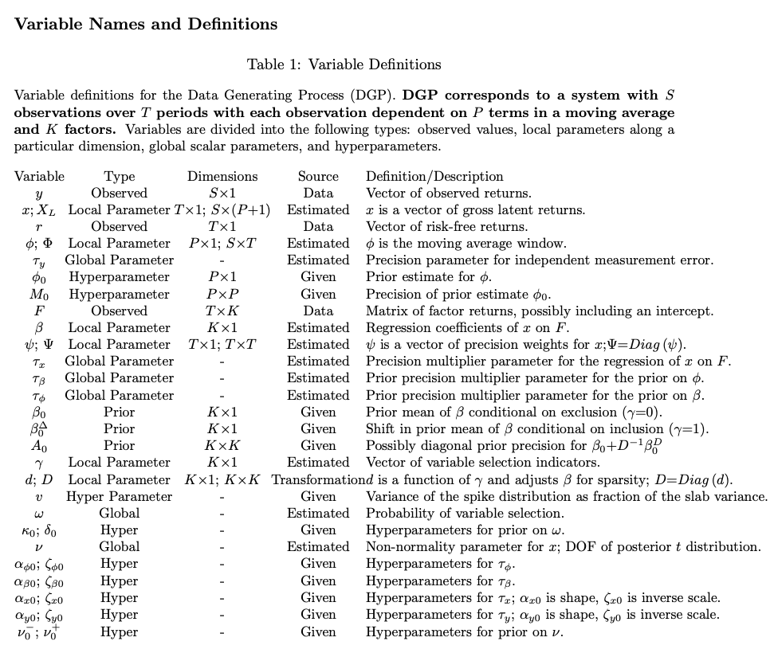

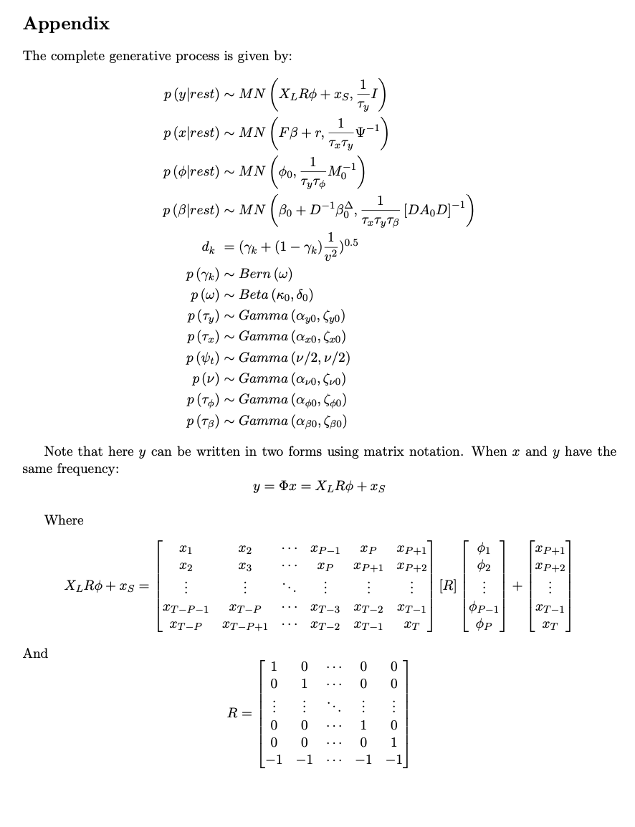

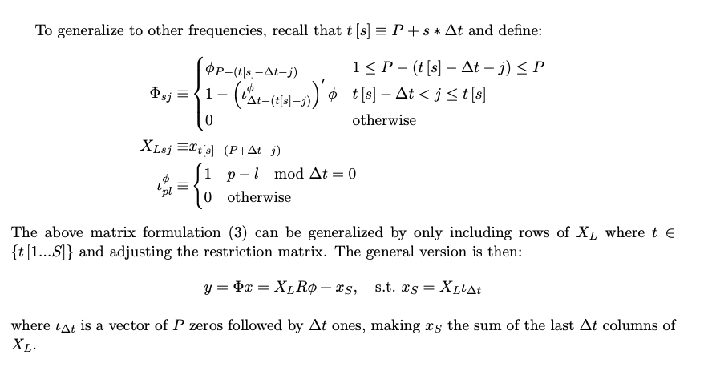

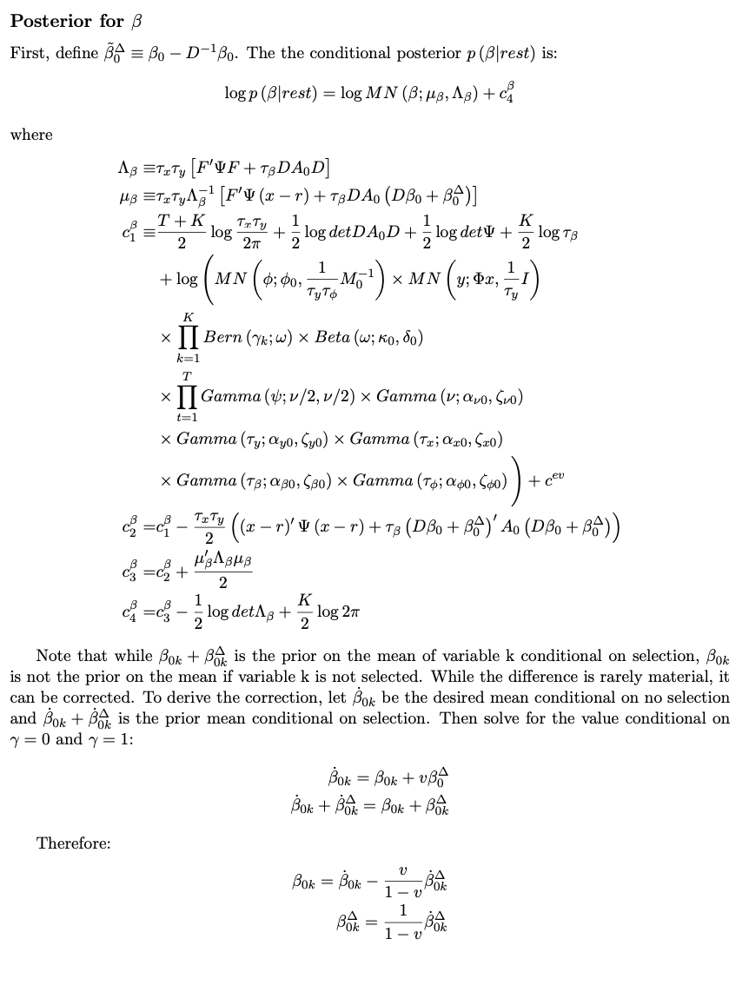

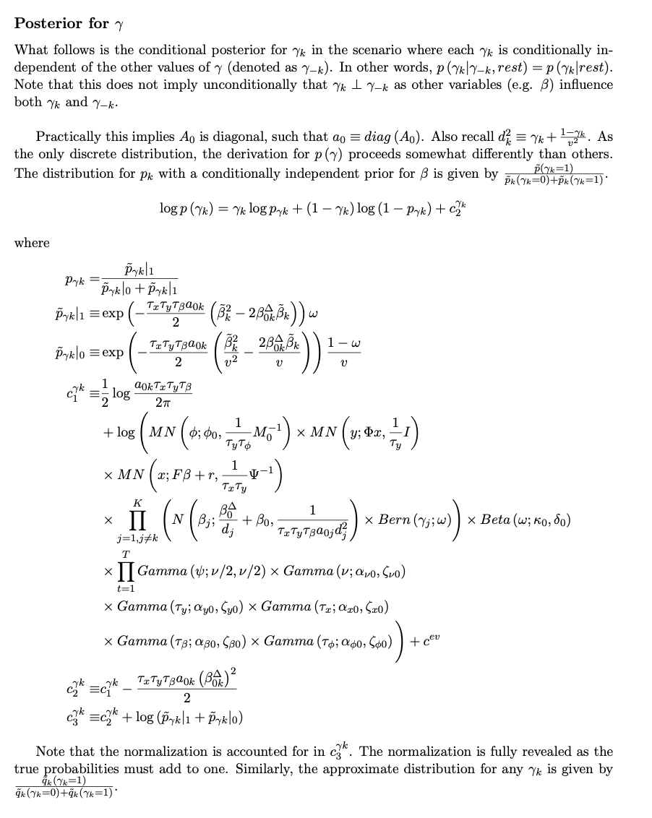



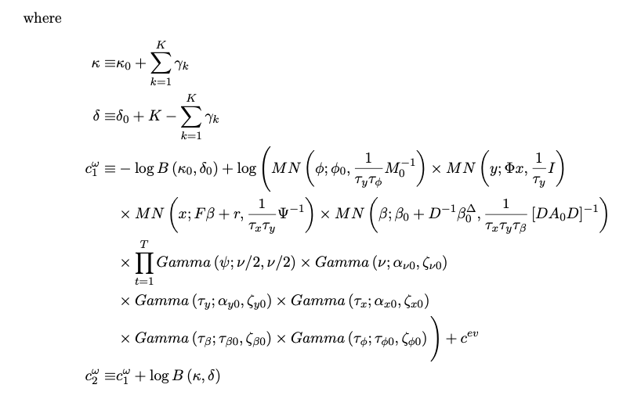

1. In the frequentist sense of the word.
2. Gibbs sampling is a statistical technique used for generating sequences of samples from the probability distribution of multiple variables. It's a kind of Markov Chain Monte Carlo (MCMC) method. It is particularly useful in scenarios where directly sampling from the joint distribution is difficult, but sampling from the conditional distribution of each variable is feasible.