Assignment 1
C Code Bug Analysis
Three snippets: bugs, explanations, corrected code and program output
Snippet A | Missing semicolon and missing & in scanf
Snippet B | Assignment (=) used instead of comparison
Snippet C | Infinite loop caused by count++

Snippet A
Age input program: compile error and a hidden runtime bug

Original code
#include <stdio.h>
int main() {
int age
printf("Enter your age: ");
scanf("%d", age);
printf("Your age is %d\n", age);
return 0;
}

Bug 1: Missing semicolon (compile error)
In C, every declaration and statement must end with a semicolon. Without it, the compiler reads int age printf(...) as one malformed statement and reports a syntax error, usually pointing at the line after the missing semicolon, which can be confusing.

Bug 2: scanf("%d", age) is missing & (the hidden bug)
scanf doesn't receive the value of a variable. It needs the memory address where it should store the input. With %d it expects an int *, but a plain int was passed.
Since age was never initialized, it holds a garbage value. scanf treats that garbage as an address and tries to write the input there. The result is undefined behavior: typically a segmentation fault, or silent memory corruption. The fix is the address-of operator &.

Corrected code and output
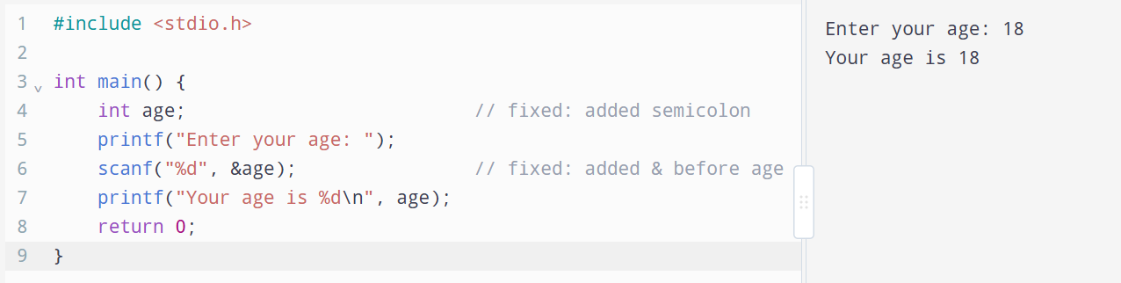

Optional improvements
#include <stdio.h>
int main(void) {
int age = 0; // avoid garbage values
printf("Enter your age: ");
if (scanf("%d", &age) != 1) { // check input was an integer
printf("Invalid input.\n");
return 1;
}
printf("Your age is %d\n", age);
return 0;
}

- Initializing age = 0 means the variable never holds an unpredictable value.
- Checking scanf's return value matters because it returns the number of items read. If the user types abc, it returns 0.
- int main(void) is the more correct form in C when main takes no arguments.
- Tip: compile with gcc -Wall -Wextra file.c; the compiler flags the scanf format mismatch immediately.

Snippet B
Student result checker: assignment used as a condition

Original code
#include <stdio.h>
int main() {
int marks = 35;
printf("Checking student result...\n");
if (marks = 40) {
printf("Student has passed!\n");
} else {
printf("Student has failed.\n");
}
return 0;
}

Bug 1: = instead of == (the hidden bug)
if (marks = 40) is an assignment, not a comparison. It does two things:
- Stores 40 into marks, overwriting the original value of 35.
- Evaluates to 40, which is non-zero and therefore true in C.

So the if branch always runs and the program prints "Student has passed!" even though the student scored 35. The code compiles without errors, so it is easy to miss.
Using == would fix the assignment problem, but marks == 40 only passes students who scored exactly 40. A pass check should use >=.

Bug 2: Broken #include
#include needs a header name. Since the code uses printf, it needs <stdio.h> on its own line. Text in angle brackets is sometimes stripped when pasting, which may be what happened here.

Corrected code and output
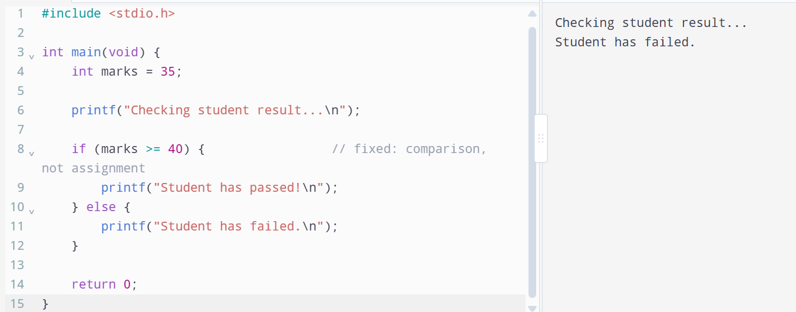
Output: Student has failed. (correct for 35 marks, assuming 40 is the pass mark)

Tips to prevent this class of bug
- Compile with warnings: gcc -Wall -Wextra warns "suggest parentheses around assignment used as truth value."
- Yoda conditions: writing if (40 == marks) turns a typo like if (40 = marks) into a compile error.

Snippet C
Countdown program: infinite loop

Original code
#include <stdio.h>
int main() {
int count = 5;
printf("Starting countdown:\n");
while (count > 0) {
printf("Count: %d\n", count);
count++;
}
printf("Done!\n");
return 0;
}

Bug 1: count++ instead of count-- (infinite loop)
The loop runs as long as count > 0. Since count starts at 5 and increases each iteration (5, 6, 7, ...), the condition never becomes false. The variable moves away from the stopping point instead of toward it.
There is a subtler consequence: eventually count would exceed INT_MAX (usually 2,147,483,647), and signed integer overflow is undefined behavior in C. For a countdown, the variable must decrease: count--.

Bug 2: Broken #include
As in Snippet B, #include has no header name. Since the code uses printf, it needs <stdio.h> on its own line.

Corrected code and output
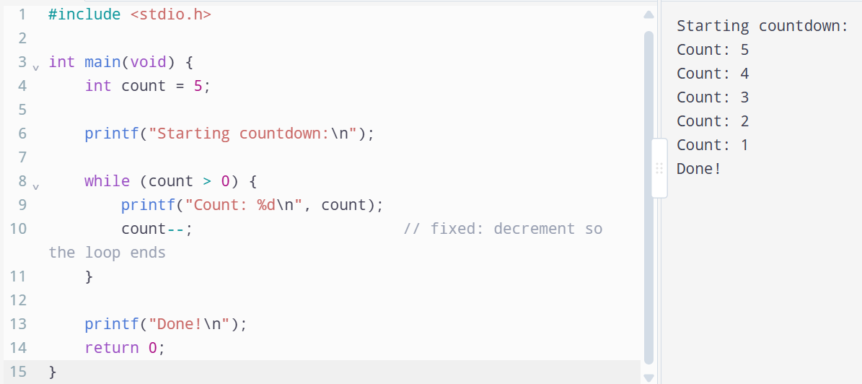

Tips to prevent this class of bug
- Check the loop's progress: for every while loop, ask whether something inside the body moves the condition toward false.
- Consider a for loop when start, condition and update are known up front; it keeps them on one line, which makes mismatches easier to spot:

for (int count = 5; count > 0; count--) {
printf("Count: %d\n", count);
}
- Stopping a runaway program: if you run the buggy version, press Ctrl+C in the terminal to kill it.

