Operating System Lab
Assignment 3
Arnav Samal
122CS0107

Q1.
Code:
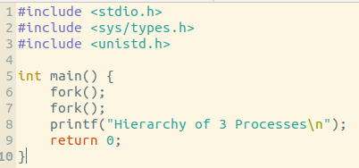

Output:

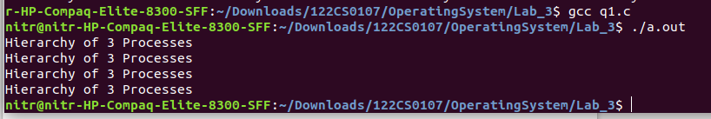
Q2.

Code:
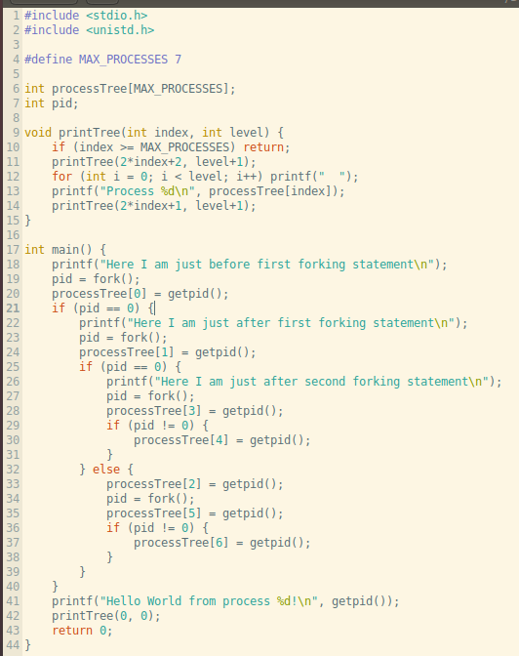

Output:
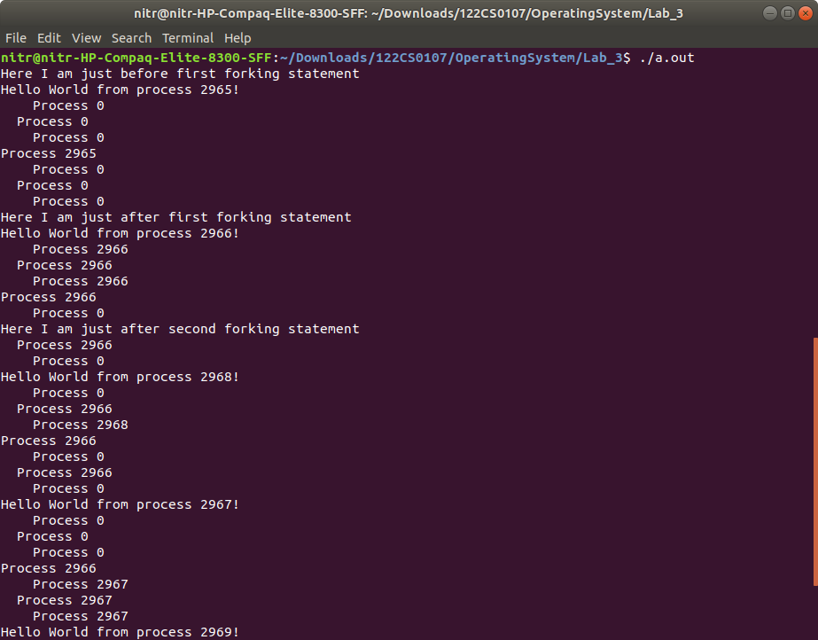
Q3.
Code:
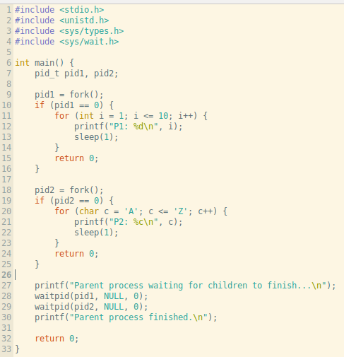

Output:
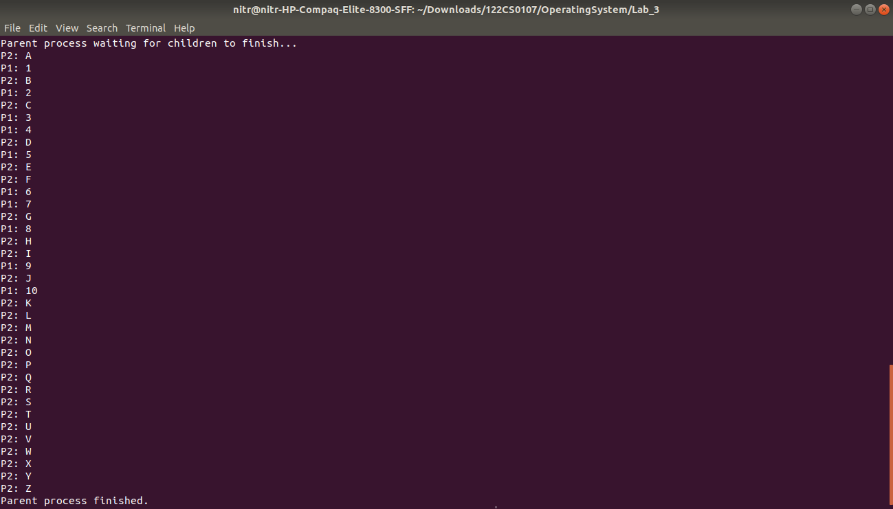
Q4.
Code(given):
#include <sys/types.h>
#include <stdio.h>
#include <unistd.h>

int main(void)
{
int i; for (i=0; i < 3; i++) {
fork();
printf("hello\n");
}
return 0;
}

Output:
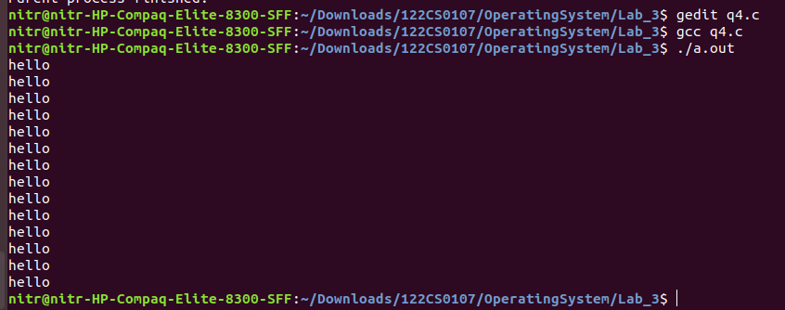
Explanation:

When the code is initially run, it is first forked to make 2 processes child process and copy of parent process. These then print “hello”, and then it is forked again where 4 processes then print “hello”. This goes on one last time where it is forked for 3rd time and then 8 processes then print “hello”. In total 2+4+8 = 14 “hello”s are printed.

