Operating System Lab 4 | Assignment 4
Arnav Samal
122CS0107

Q1. You have an existing program, “input.c,” which prints a welcome message for the currently logged-in user and prints the date and time. The compiled file of this program is “input”. Write another program that calls the compiled file “input” and prints the data entered by the user.

Program: (input.c)
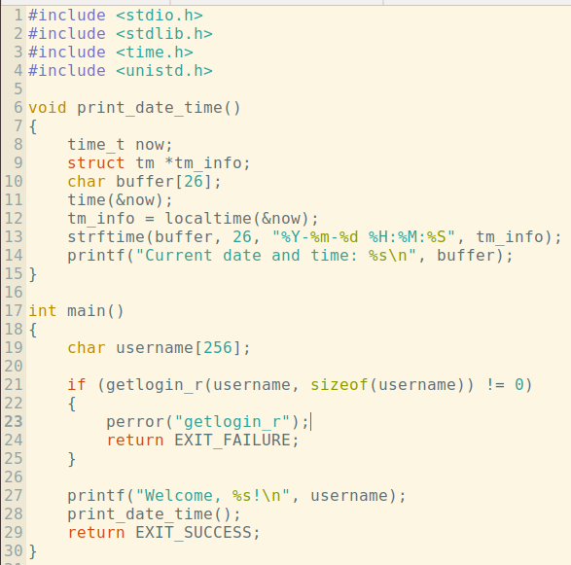

Program: (q1.c)
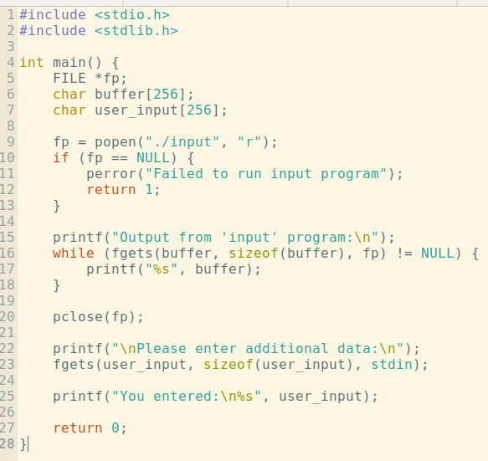

Output:
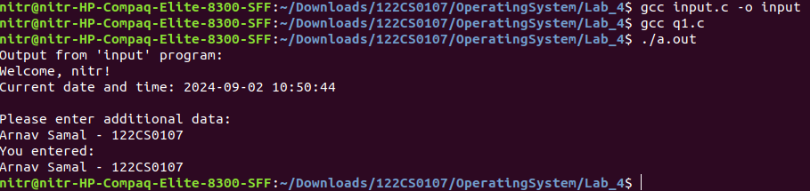
Q2. Create a basic chat application using pipes where the parent and child processes can send and receive messages in a loop until a specific termination message (e.g., "exit") is sent.

Program: (q2.c)
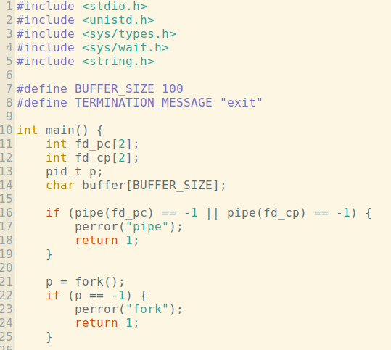

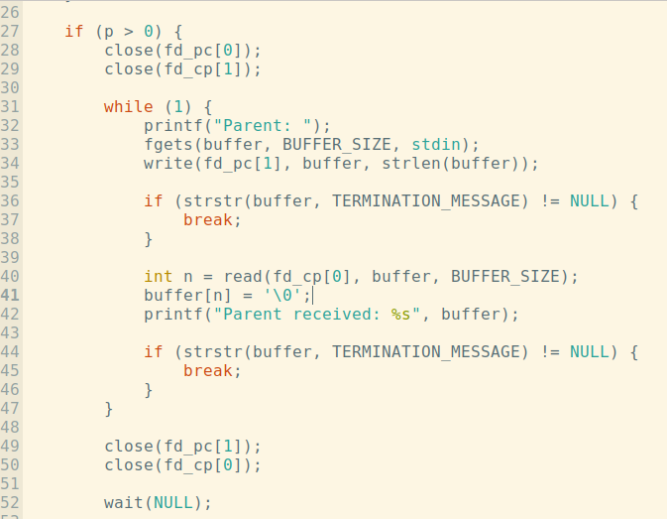

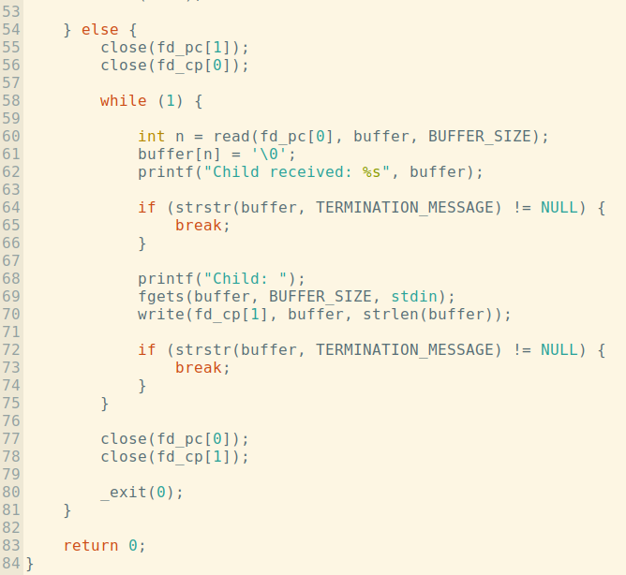
Output:

