Sample input and output for problems 2 and 3 of assignment 4

Sample input and output 1

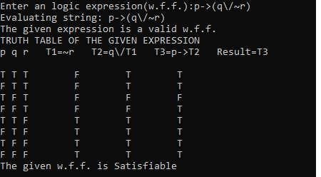

Sample input and output 2

