Q1. Carlos

Cipher text given: STEOMOHPRTROOA

Cryptography deals with mainly cipher text and plain text. The cipher which is inspired by Polybius square is the rail fence cipher, but the ciphertext does not follow Polybius's regulation. The trajectory in Rail Fence forms a zig zag.

Now the cipher is known lets go to <https://www.dcode.fr/en> and search for rail fence and this window will open up

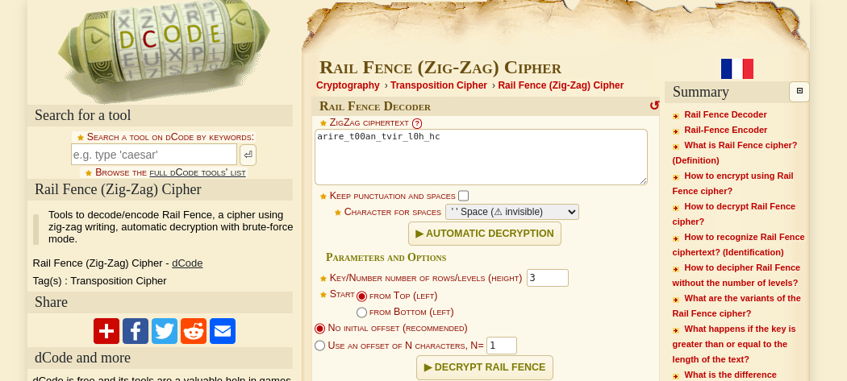

Paste the cipher text and click on automatic decryption.

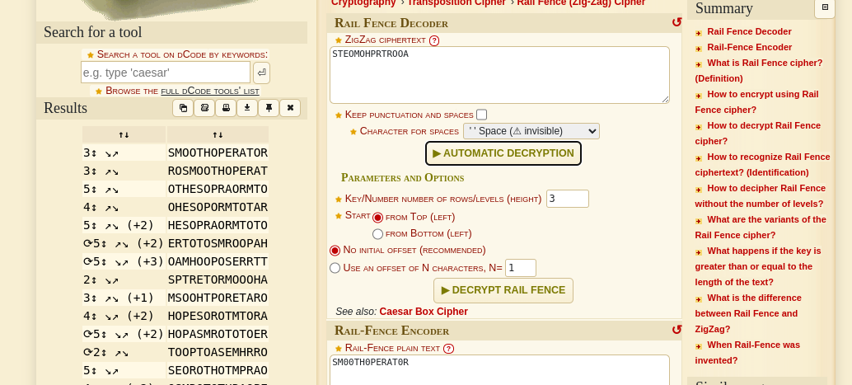

We seem to find a meaningful expression in the first result and the flag is that expression written in the required manner.

Q2. Atlas

In cryptography there is no rule that encryption exists only with a mathematical expression. Encryption is hiding the plain text with something else, it's not exactly hidden from plain sight, but it is written in such a way that nobody can read it easily. Here we find some couple of flags out there. Your first reaction should be since flags are provided the plain text can be made out from the first letter of each flag out there.

Notice one thing: certain flags are repetitive so you know that the same alphabet is repeated. You cannot select each image to find out the country name. Nor can you go through all the countries in the atlas.

Lets get it broken down:

* The first flag is a white flag with a blue cross. Search for a flag of that description. Got the name and place the first alphabet in place of that flag. Put the same character on every place the flag is placed.
* The next flag contains red, white and blue stripes. Find the country whose first alphabet when placed can make a meaningful word. Keep all options ready, You don't know if the next alphabet will go with your findings from the first one.
* Next we have a red flag with a silhouette of a bird. Lets search. Found the country, now place the alphabet.

This is the concept followed in total cipher: identify the description, search for it, hit and try which words make a meaningful expression, then the expression becomes your flag in required format.

Q3. Arragon

Read the text above “*The fire seven times tried this,Seven times tried that judgment is”* Notice there is mentioned seven times, so some kind of cipher is there where 7 is involved or, when it is said *“the fire seven times tried this”* it can also mean that 7 encryption steps are done.

How will you understand what cipher it is,

For that again go to <https://www.dcode.fr/en> and search for identify

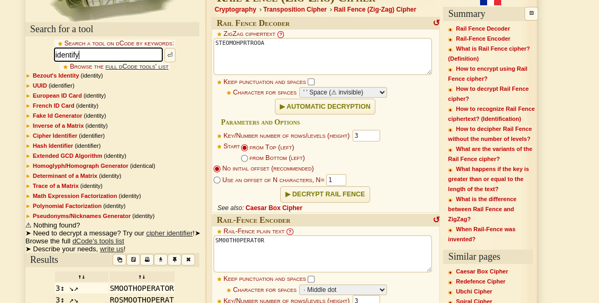

You will see there is a cipher identifier option. Go there and place the cipher there and run it.

Try the cipher with the strongest suggestion. Decrypt using that.

Try using the identifier and decode using the options again and again until you find the flag or an error. If an error is found, try other suggested ciphers.

Remember this tool is not all perfect, Like shown here ciphers involving rotations are not found by such an identifier you should try other rotation decryption tools available and tweak their settings to get the plaintext.