**OSINT CTF Ques**

**Ques1.** Two of our agents were in a mission to find someone but seems that they had a stalker and got us this picture of them both, can you identify the place they were?

**Flag Format: CN{The Name of the place without spaces in lowercase}**

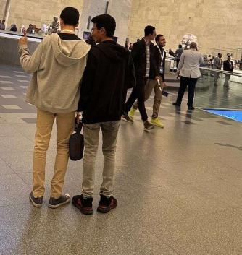

**Ans1.** CN{nationalmuseumofegyptiancivilization}

**Ques2.** Our special agent Rose, has gone missing in action. Now don’t be alarmed by this. Lately the company chat has been the dumpster for GIF wars and edgy memes. Agent Rose was so fed up with this, that she took the company jet and flew to an unknown location. She’s saying it’s a surprise vacation in the Southern part of Asia, and won’t be back for a while. She attached a picture with the above image.Now this behaviour is unacceptable, your job is to find the location of Special Agent Rose.

Hint: The name of the Place might be different from its Popular name.

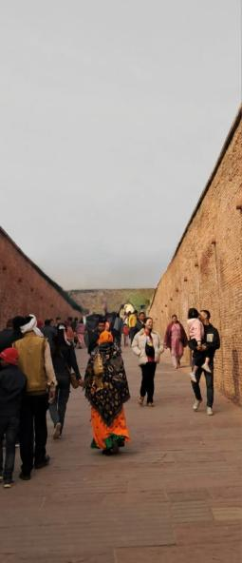

**Flag Format: CN{Country,City,Name of the Place separated by comma with no space and all lowercase}**

**Ans2.** CN{india,agra,qilaagra}

**Ques3.** Greetings, Mission Officer. We have received a report stating that a group of anti-nationals is planning to hold a meeting at a fort in Maharashtra. We have identified three possible locations for the meeting:

Location 1: Torna Fort

location 2: Malhargad killa

location 3: Vairatgad Fort

However, our officers were unable to find any suspicious activity at these sites. We also know that the group leader is currently in Osaka, Japan and has set the meeting time for 6:00 pm. But the fort is closed at the time. Now its upto you to find the fourth fort and the right time for the meeting.

Flag format, if the fort is Malhargad killa and the time is 4.30 pm: CN{malhargad_killa_16:30}

**Ans3.**  CN{purandar_fort_14:30}