DATABASE SYSTEMS

PROJECT REPORT

Made By: - Arnav Suman

RAILWAYOPS

Project Overview: -

RailwayOps offers robust capabilities for scheduling trains along various routes. Users can input parameters such as departure and arrival times. Efficient allocation of locomotives and coaches is critical for maintaining operational efficiency. RailwayOps automates this process by intelligently assigning locomotives and coaches to scheduled trains based on factors such as availability, capacity, and maintenance schedules. This ensures that resources are utilized optimally and prevents overbooking or underutilization of assets.Keeping track of train movements and statuses in real-time is essential for effective railway management. RailwayOps provides a comprehensive dashboard that displays the current status of all trains, including their locations, departure and arrival times. This real-time tracking allows operators to promptly address issues and make necessary adjustments to minimize disruptions and optimize operations. RailwayOps features an intuitive and user-friendly interface designed to facilitate ease of use and accessibility for operators at all levels. The application provides customizable dashboards and reports tailored to the specific needs of different users, whether they are train dispatchers, station managers, or maintenance personnel. Additionally, RailwayOps supports multi-user collaboration, allowing teams to work together efficiently and communicate effectively in real-time.

Overall, RailwayOps is a comprehensive railway operations management solution that combines advanced scheduling, allocation, tracking, and planning tools to streamline operations, enhance efficiency, and improve overall control of railway networks. By providing real-time visibility into operations and automating key processes, RailwayOps empowers railway operators to optimize resources, minimize disruptions, and deliver superior service to passengers and freight customers.

Tools Used: -

The software tools used in developing RailwayOps include Java for the application's logic and user interface, JavaFX for the graphical user interface, and a MySQL database for storing and managing railway-related data.

Conclusion: -

In conclusion, RailwayOps represents a significant advancement in railway operations management, offering a comprehensive solution for planning, scheduling, and tracking. By seamlessly integrating various functionalities such as train scheduling, locomotive and coach allocation, and real-time status tracking, RailwayOps empowers railway operators with the tools needed to optimize their operations for enhanced efficiency and control. This application not only streamlines the planning process but also facilitates smooth execution, allowing operators to adapt to dynamic situations in real-time. With RailwayOps, railway companies can improve resource utilization, minimize delays, and ultimately enhance the overall quality of service provided to passengers and freight clients. By leveraging advanced technology and providing a user-friendly interface, RailwayOps offers a powerful toolset to meet the complex demands of modern railway operations. Its robust features enable operators to make informed decisions, allocate resources effectively, and maintain a high level of operational reliability. In summary, RailwayOps stands as a testament to innovation in railway management software, offering a comprehensive solution that addresses the diverse needs of railway operators while paving the way for increased efficiency, reliability, and customer satisfaction in railway operations.

Contents of the Report: -

The snapshots and working of the project along with the MySQL tables, contents of the table and syntax to create tables in MySQL and ER model of the project.

**HOME PAGE** 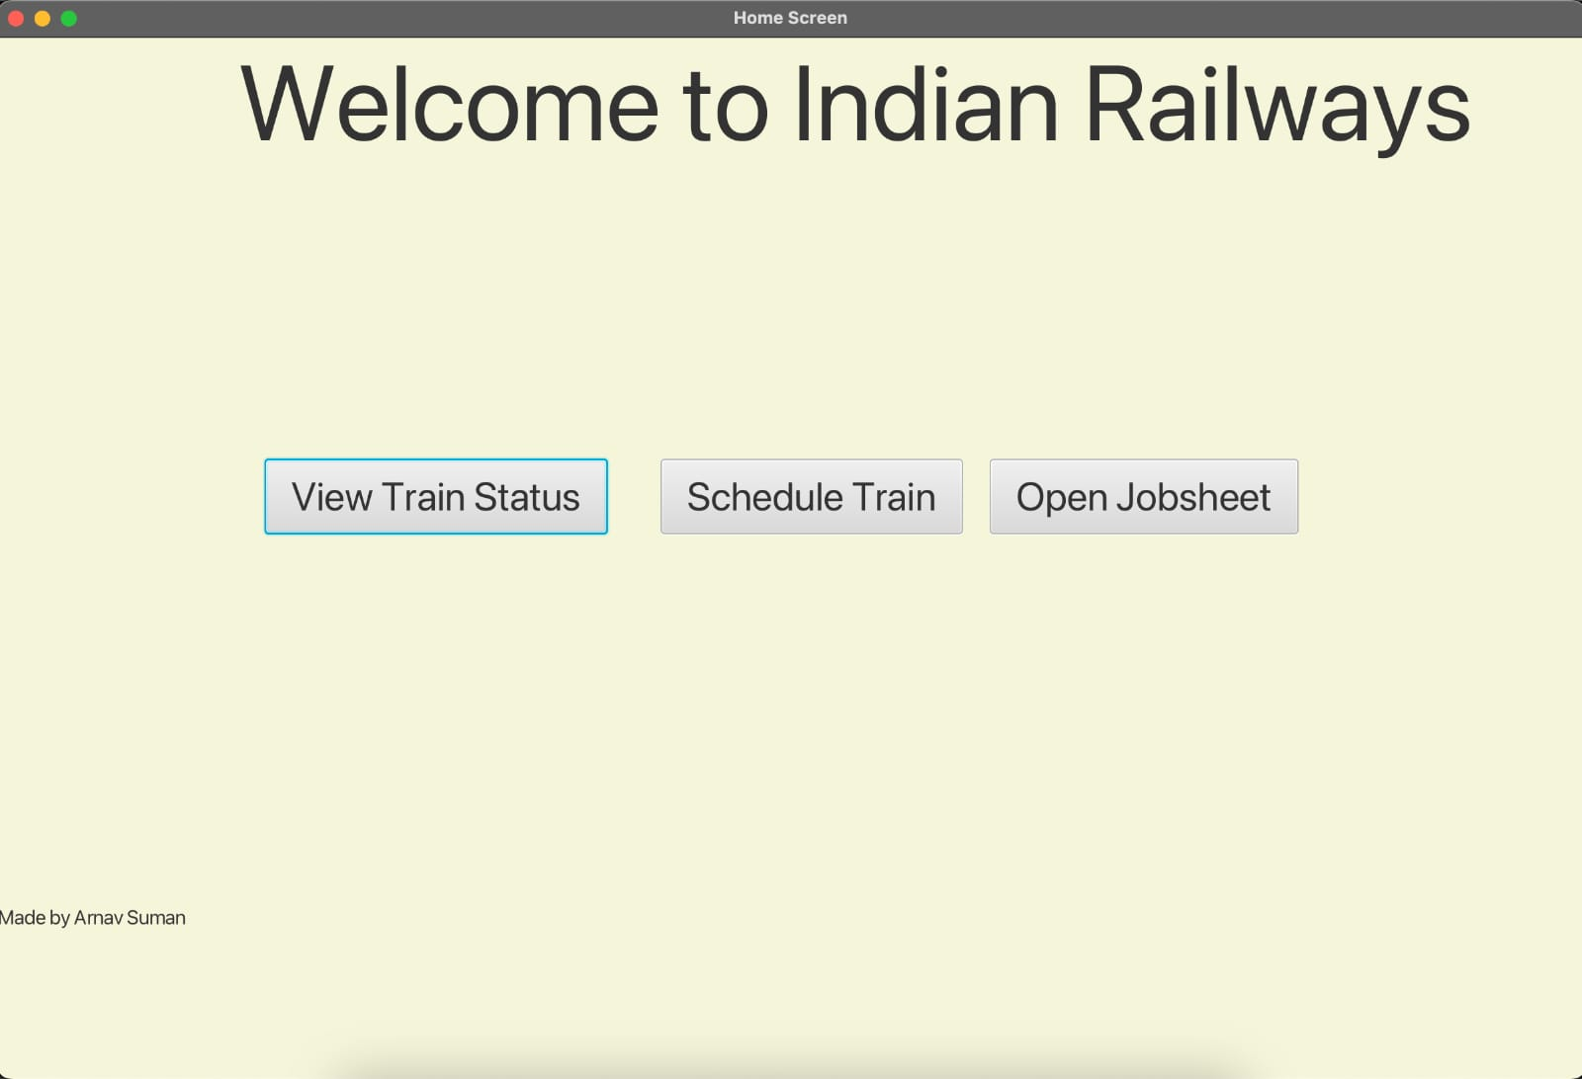

The user has three distinct choices, each tailored to cater to different aspects of railway management:

1. Open JobSheet: This option presents a plethora of job opportunities to the user. Upon selection, the user is provided with essential information such as the job name, number, and a detailed list of tasks that need to be completed. This feature empowers users to make informed decisions about whether to accept a particular job or not, based on their availability and expertise.

2. Schedule Train: With this feature, users can efficiently schedule trains by inputting the Train number/Name along with the associated Jobsheet ID. This functionality ensures smooth coordination between job assignments and train scheduling, optimizing resource utilization and minimizing delays in operations.

3. View Train Status: By selecting this option, users gain access to real-time updates on the current status of trains. From monitoring the train's progress to adjusting its speed, updating information, changing signals, and initiating the train's movement, this feature provides comprehensive control over train operations. Users can proactively manage and track train movements, ensuring timely and efficient transportation of passengers and cargo.

**SCHEDULE TRAIN**

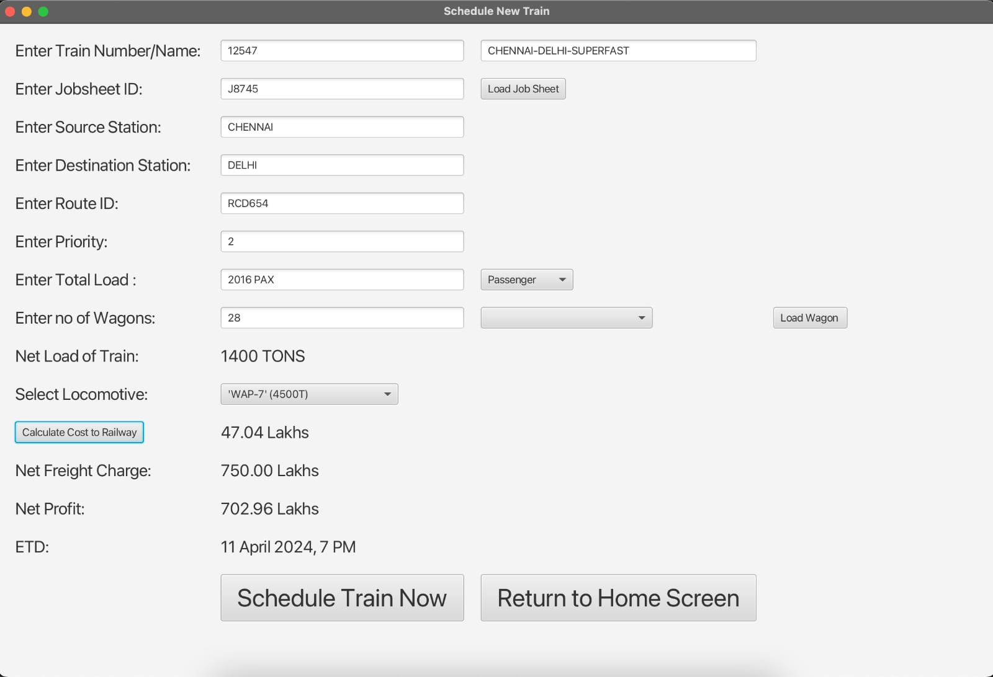

In the Train Scheduling page of RailwayOps users are presented with a streamlined interface to input essential details for scheduling trains and calculating associated costs.

Train Details Update:

Upon entering the train number/name along with the Jobsheet ID, RailwayOps automatically updates the train details, ensuring accuracy and seamlessness in the scheduling process. This feature eliminates the need for manual data entry, saving time and reducing the risk of errors.

Cost Calculation:

RailwayOps empowers users to calculate the cost to the railway, net freight charge, and net profit with ease. By inputting the number of wagons, net total load of the train, and selecting the type of locomotive, users can obtain comprehensive cost estimates tailored to their specific requirements. This functionality provides valuable insights into the financial aspects of train operations, enabling informed decision-making and resource allocation.

Train Scheduling:

Once all necessary data has been entered according to the user's specifications, RailwayOps seamlessly schedules the train. This ensures efficient coordination between job assignments, train scheduling, and resource management. With RailwayOps, users can optimize train schedules, minimize delays, and enhance operational efficiency, ultimately delivering superior service to passengers and clients.

**VIEW TRAIN STATUS**

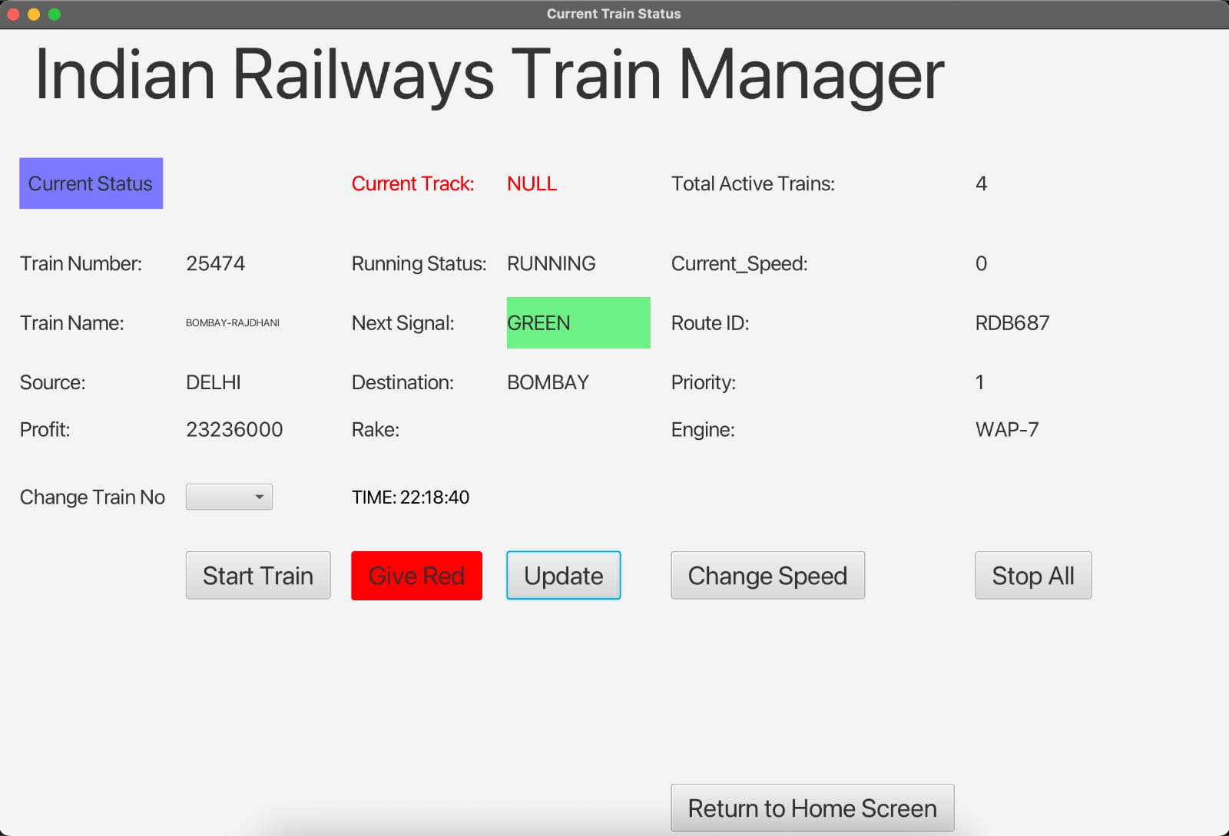

In the Train Status page of RailwayOps users are provided with a comprehensive overview of crucial information essential for effective management of trains.

Train Status Overview:

Upon accessing the Train Status page, users are greeted with a wealth of information about each train in the system. This includes details such as the train number, train name, source, destination, profit generated, total active trains, current speed, route ID, type of engine, status of the signal, and the running status of the train. This holistic view empowers users to assess the status and performance of individual trains at a glance, facilitating informed decision-making and proactive management.

Control Functionalities:

Users have the ability to initiate changes in train operations directly from the interface. They can adjust the signal status, modify the train's speed, initiate the start of a train, or halt its movement as necessary. Additionally, RailwayOps offers a convenient option to stop all trains simultaneously, providing a centralized mechanism for managing operations efficiently.

Real-time Updates:

With real-time updates on the running status of trains, users can stay informed about the progress and movement of each train along its designated route. This dynamic display ensures that users are always aware of the latest developments, allowing them to respond promptly to any deviations or disruptions in the schedule.

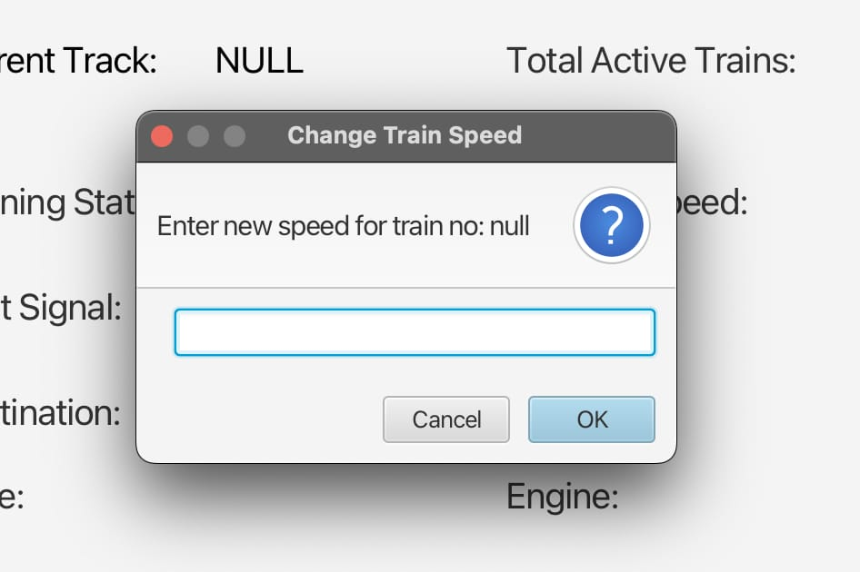

**MYSQL CODES TO CREATE TABLES**

//MYSQL CODE TO CREATE TABLE TRACK

CREATE TABLE TRACK (

TRACK_ID VARCHAR (50), -- T123

LENGTH DECIMAL (10,2) DEFAULT 3.2,

TRACK_SIGNAL VARCHAR (50) DEFAULT 'RED', -- RED OR GREEN

TRACK_EMPTY VARCHAR (50) DEFAULT 'EMPTY', -- EMPTY OR OCCUPIED

NEXT_TRACK_ID VARCHAR (50),

PREV_TRACK_ID VARCHAR (50),

PERMISSIBLE_SPEED INT DEFAULT 120

);

//MYSQL CODE TO CREATE TABLE LOCOMOTIVE

CREATE TABLE LOCOMOTIVE (

LOCO_NO INT,

LOCO_TYPE VARCHAR (50), #PASSENGER OR GOODS OR MIXED

LOCO_NAME VARCHAR (50),

LOCO_FUEL VARCHAR (50) , #DIESEL OR AC CURRENT

TOW_CAPACITY INT,

COST_PER_HOUR INT,

MAX_SPEED INT );

//MYSQL CODE TO CREATE TABLE RAKE

CREATE TABLE RAKE (

RACK_NO VARCHAR (50), #G123 OR P234

RACK_TYPE VARCHAR (50), #PASSENGER OR GOODS OR MIXED

RACK_NAME VARCHAR (50),

NET_WEIGHT INT, #IN TONS

CAPACITY INT, #NO OF PAX OR TONS

COST_PER_HOUR INT,

MAX_SPEED INT

);

//MYSQL CODE TO CREATE TABLE JOBSHEET  
 CREATE TABLE JOBSHEET (

JOB_ID VARCHAR (50), #J123

JOB_TYPE VARCHAR (50), #PAX OR GOODS

TRAIN_NO INT,

TRAIN_NAME VARCHAR (50),

SOURCE VARCHAR (100),

DESTINATION VARCHAR (50),

NET_LOAD INT, #NO OF PAX OF TONS

PRIORITY INT,

INCOME INT,

ROUTE_ID VARCHAR(50),

TIME_TAKEN DECIMAL (10,2)

);

//MYSQL CODE TO CREATE TABLE STATION

CREATE TABLE STATION (

STATION_NAME VARCHAR (50),

TOTAL_PLATFORM INT,

AVAILABLE_PLATFORM INT,

ZONE VARCHAR (50)

);

//MYSQL CODE TO CREATE TABLE TRAIN

CREATE TABLE TRAIN (

TRAIN_NO INT,

JOB_ID VARCHAR (50),

SOURCE_STATION VARCHAR (50),

DESTINATION_STATION VARCHAR (50),

COST_TO_OPERATE INT,

ENG_NAME VARCHAR (50),

RAKE_TYPE VARCHAR (50),

ROUTE_ID VARCHAR (50),

RUNNING_STATUS VARCHAR (50),

CURRENT_SIGNAL VARCHAR (50),

CURRENT_TRACK VARCHAR (50),

CURRENT_SPEED VARCHAR (50),

MAX_SPEED INT,

PROFIT INT,

TRAIN_NAME VARCHAR (50),

PRIORITY INT

);

INSERT INTO TRAIN (TRAIN_NO, JOB_ID, SOURCE_STATION, DESTINATION_STATION, COST_TO_OPERATE, ENG_NAME, RACK_TYPE, ROUTE_ID, RUNNING_STATUS, CURRENT_SIGNAL, CURRENT_TRACK, CURRENT_SPEED, MAX_SPEED, PROFIT)

VALUES

(22696, 'J5474', 'DELHI', 'CHENNAI', 65050000, 'WAP5', 'LHB', 'RDC453', 'RUNNING', 'GREEN', 'D2', '120', 120, 12000000);

//MYSQL CODE TO CREATE TABLE ROUTE

CREATE TABLE ROUTE (

ROUTE_ID VARCHAR (50),

SOURCE_STATION VARCHAR (50),

DESTINATION_STATION VARCHAR (50),

STOP VARCHAR (500), #LIST OF STOPS

JOURNEY_TIME DECIMAL (10,2)

);

**TABLES USED IN THE PROJECT**

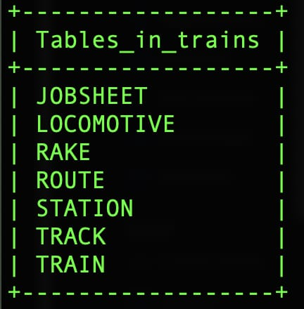

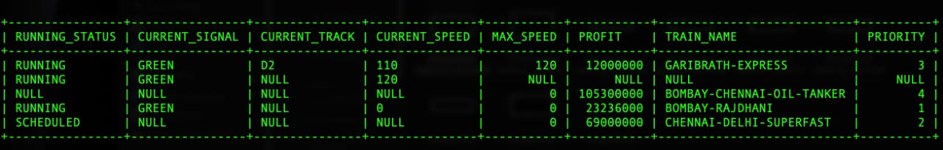

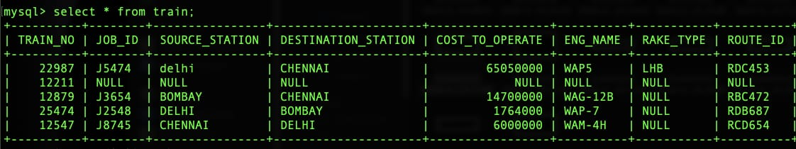

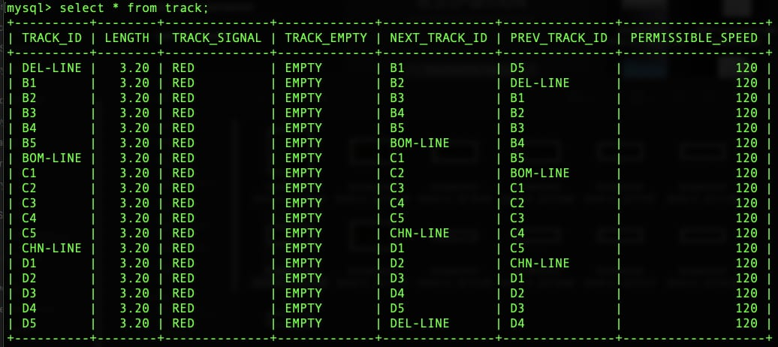

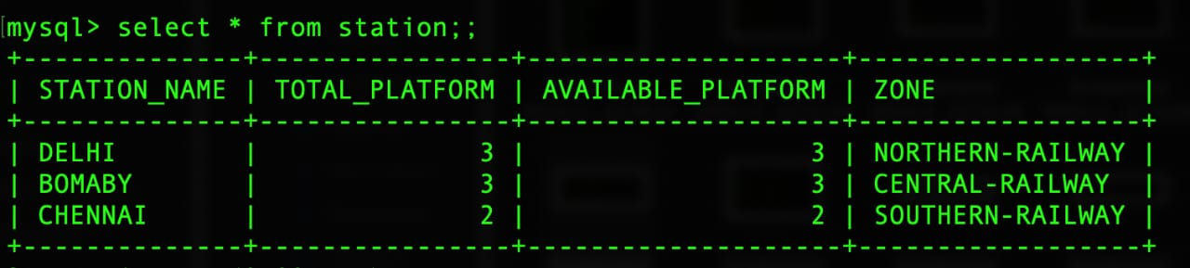

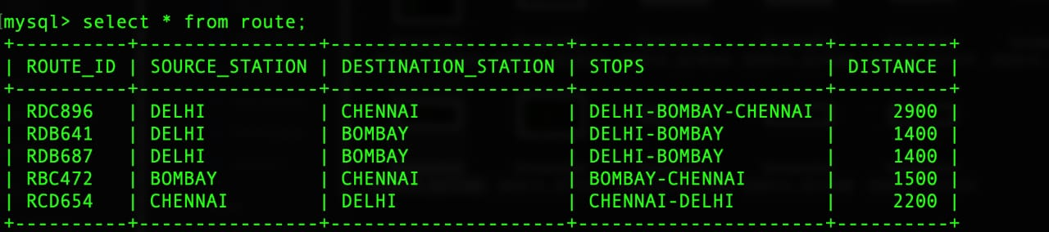

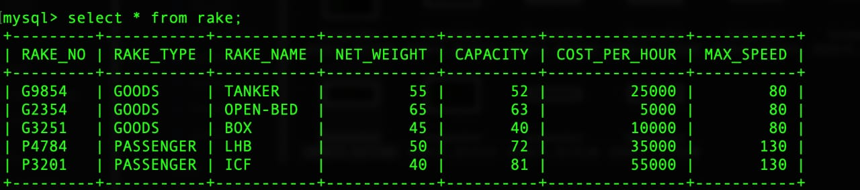

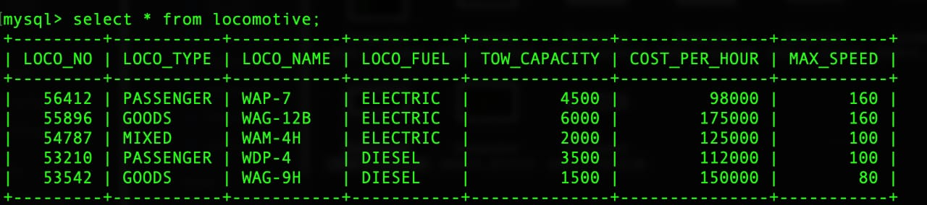

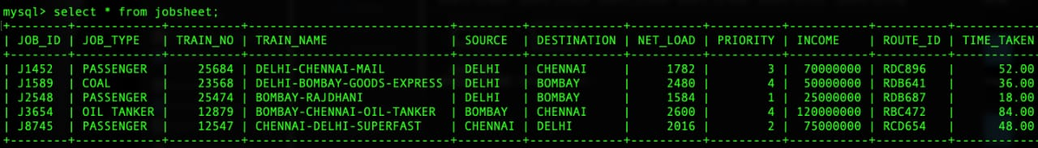

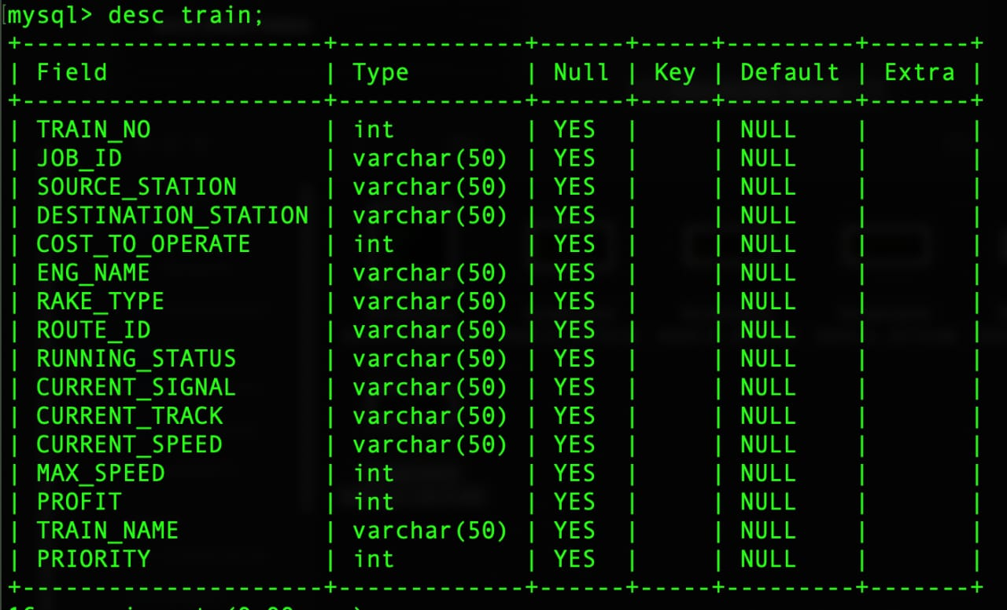

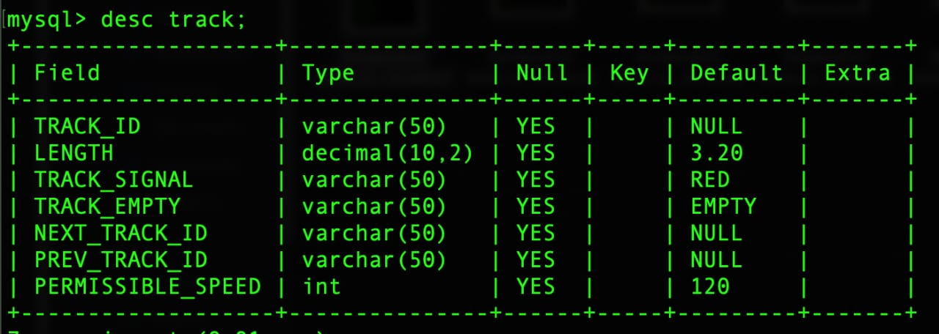

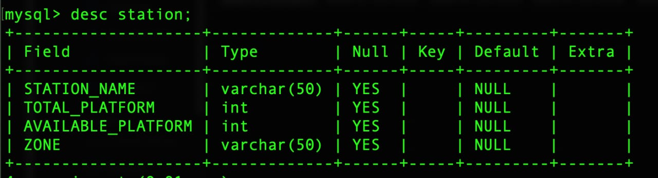

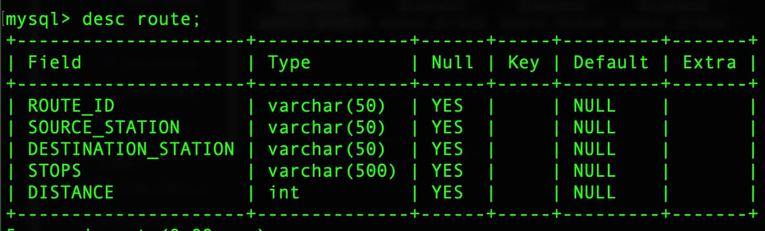

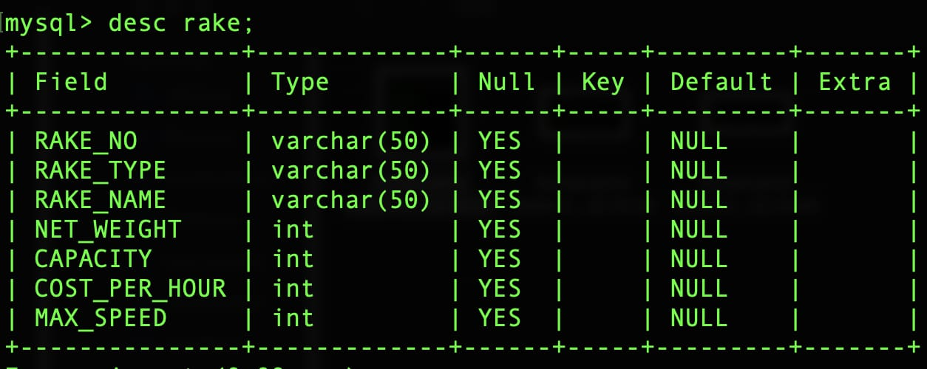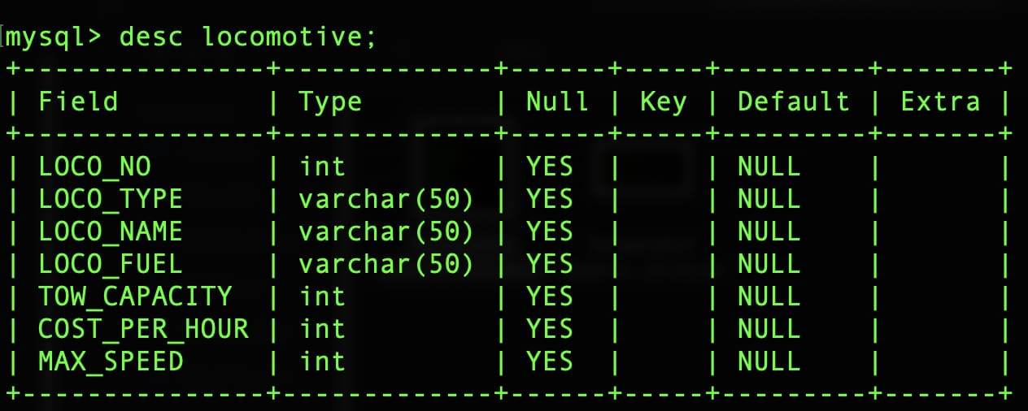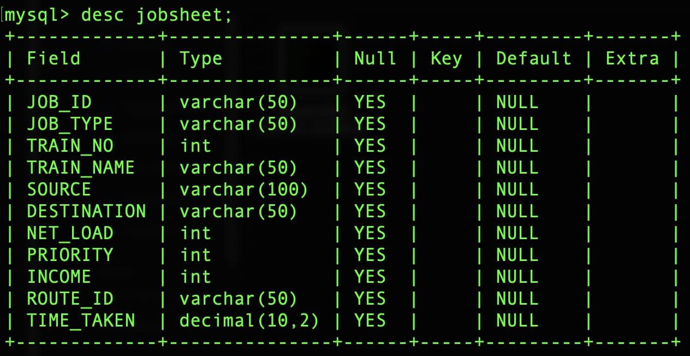

**ER MODEL OF PROJECT**

