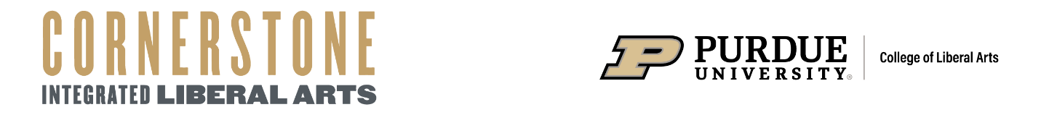

**SCLA 102 Narrative Presentation Rubric**

|  |  |  |  |  |
| --- | --- | --- | --- | --- |
| **Name/Section:** | **Poor** | **Average** | **Good** | **Excellent** |
| **Content – Introduction** |  |  |  |  |
| How well did the speaker begin with impact, grabbing the audience’s attention and interest? |  |  |  |  |
| **Content – Body** |  |  |  |  |
| How well was the story organized? Did it flow? Was it easy to understand and follow? |  |  |  |  |
| How engaging and/or compelling was the story? |  |  |  |  |
| How well did the speaker relate her/his story to the audience? |  |  |  |  |
| **Content – Conclusion** |  |  |  |  |
| How well did the speaker convey the story’s point or lesson? |  |  |  |  |
| How well did the speaker end with impact, continuing to maintain the audience’s attention and interest? |  |  |  |  |
|  |  |  |  | /75 |
| **Delivery** |  |  |  |  |
| How effective was the speaker’s eye contact? |  |  |  |  |
| How effective was the physical delivery (e.g., posture, hand/arm gestures, movement)? |  |  |  |  |
| How effective was the verbal delivery (e.g., volume, rate, fillers, variety)? |  |  |  |  |
| How effectively did the speaker use language (e.g., transitions, personal pronouns, vivid imagery, figures of speech, rhetorical devices)? How appropriate was the language for the audience and occasion? |  |  |  |  |
| How well did the speaker use an extemporaneous style (i.e., conversational)? |  |  |  |  |
|  |  |  |  | /75 |
| **Nuts & Bolts** |  |  |  |  |
| Was the speech within the time limit (2:30-3:30 minutes)? *(15 points)* |  |  |  |  |
| Was a comprehensive working/speaking outline or framework submitted by the official class start time? *(10 points)* |  |  |  |  |
|  |  |  |  | /25 |
| **Total Points Earned/Possible** |  |  |  | **/175** |