Arnav Surve

Devin Bendell

CNIT 270

01/11/2023

Lab 1

Figure 1: SSH Key Fingerprint Security Alert

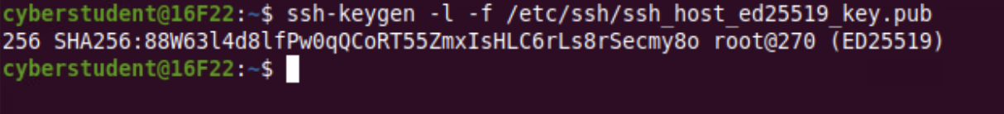

Figure 2: Output of SSH Keygen Command

If the SSH keys displayed in the client program and on the server do not match, a possible non-malicious reason could be that the SSH key generated on the server is using a different algorithm than the client (for example, ECDSA vs ed25519).