

Department of Information Technology

Bharati Vidyapeeth College of Engineering, Navi Mumbai

Academic Year 2023-2024

Mini Project Report

On

**Visual CV using JAVA**

Submitted in partial fulfillment of the requirements of the degree of

Bachelor of Engineering

Supervisor (Guide Name)

**V. B. Pawar**

By

Kirti Patil (2543)

Arnav Tambe (2565)

Devarsh Muthe (2536)

Shruti Netake (2539)



Bharati Vidyapeeth College of Engineering, Navi Mumbai

Department of Information Technology

**CERTIFICATE**

*This is to certify that,*

1. *Kirti Patil (2543)*
2. *Arnav Tambe (2565)*
3. *Devarsh Muthe (2536)*
4. *Shruti Netake (2539)*

*have completed the Mini Project* ***Visual CV (JAVA)*** *Satisfactorily in the Department of Information Technology of as prescribed by the Mumbai University in the academic year 2023-2024.*

Prof. V. B. Pawar

Mini Project Guide

External Examiner

Prof. S. N. Mhatre

H.O.D.

**ACKNOWLEDGEMENT**

We would like to express my sincere gratitude towards Prof. V. B. Pawar Sir for the help, guidance and encouragement, he provided during the Mini Project work. This work would have not been possible without his valuable time, patience and motivation. I thank him for making my stint thoroughly pleasant and enriching. I take the privilege to express my sincere thanks Prof. S. N. Mhatre H.O.D and Dr. S.D. Jadhav, our Principal for providing the encouragement and much support throughout my work.

Student Name

Kirti Patil (2543)

Arnav Tambe (2565)

Devarsh Muthe (2536)

Shruti Netake (2539)

**Contents**

|  |  |  |
| --- | --- | --- |
| Sr.NO | Topic | Page NO |
|  |  |  |
| 1 | Introduction | 6 |
|  |  |  |
| 2 | Literature Review | 8 |
|  |  |  |
| 3 | Problem Statement | 10 |
|  |  |  |
| 4 | Objectives of Work | 11 |
|  |  |  |
| 5 | System requirements | 12 |
|  |  |  |
| 6 | Result and Analysis | 14 |
|  |  |  |
| 7 | Future Scope | 15 |
|  |  |  |
| 8 | Conclusion | 17 |
|  |  |  |
| 9 | References | 18 |
|  |  |  |

**Abstract:**

We all know that job market is getting tougher day by day. 20-33% out of the 1.5 million engineering graduates passing out every year runsthe risk of not getting a job at all. In such scenarios, nobody can ever underestimate how important it is to have a good screening process. A screening interview is a type of job interview that is conducted to determine if the applicant has the qualifications needed to do the job for which the company is hiring.

Nowadays there is a tough competition for getting a job and one of the biggest trials for many job-seekers is creating the perfect resume. The resume is the very first thing that a potential employer encounters regarding an applicant and is used to screen applicants, often followed by an interview.

Resume builder is an innovative and intelligent tool designed to assist individuals in creating professional resumes that effectively highlight their skills, experiences, and qualifications. It offers a user-friendly interface that guides users through each step, ensuring that they include all the essential sections and relevant information necessary to make a strong impression on potential users. The main aim of resume builder is to manage details of resume, qualification, skills etc. It is not only generating resume in a very short time but also generate simple and sensible.

**Introduction:**

A resume builder is a tool designed to assist resume builder in creating effective resumes. It simplifies the process of resume creation. With a resume builder, individuals can easily input their personal information, work experience, education, skills, and achievements, resulting in a resume. Overall, a resume builder can save users significant time and effort, enabling them to create resumes without the need for extensive design or formatting knowledge. It ensures that important details are included and presented in an organized manner.

This application requires less human interruption and a user friendly app. Individuals just have to fill in the required fields of the form such as educational information, interest, skills, work experience and so on. The information given by the user will be stored in the system and generate a resume. Users will be able to create a resume in .txt format.

The proposed application will reduce the manual work of individual as a person can get his resume without any issues just by using this resume builder. It is mainly focused on format by simply choosing the desired template and giving some necessary details to the application and the resume builder app will process this raw information into the finished resume easily.

**Literature Review:**

1. **Rinki Tyagi et al. (2020):**

This study proposes an Android application that generates formal format resumes. Users can choose from various templates and save their resumes in different formats. The application is free and user-friendly, but requires internet. connectivity and is limited to the Android platform.

**Advantages:**

1. It is free of cost.
2. It saves time for users
3. lt helps users to focus on content.
4. In application creation and modification are very simple and user-friendly task.
5. **Bharti Kungwani et al. (2021):**

This web application, "Analytical Resume Builder," provides users with analyzed stats and. resumes of other graduates. This allows users to compare their profiles and gain insights into industry trends. Additionally, the application informs users about upcoming job opportunities. The online resume builder is one of the most fantastic systems for the people who are either recently graduated students in their domain or if they don't have enough idea about the resume or don't have enough time to create the resume of good designs or patterns, then this platform is a very productive place for them.

1. **Resume Builder A web application for creating a resume (2020):**

This application focuses on creating visually appealing resumes using various templates and fonts. It also allows users to add links to their online profiles, such as LinkedIn and GitHub. The application is simple to use but lacks advanced features like skill suggestions or personalized feedback.

**Advantages :**

1. It is free of cost.
2. It saves time for users.
3. It helps users to focus on content.

**Disadvantages :**

1. User needs to have internet connectivity.
2. The Application is only for Android OS user.
3. **Shreekanth Marapaka, Ms.Shweta Ramteke (2017):**

Their zeal to become highly qualified and skilled. The new technologies, specially, an internet has made a huge impact on knowledge management and information dissemination in education.

**Advantages :**

1. The main aim of developing this website was to reduce maximum chances of errors in manual work.
2. Save time for the process.
3. Also, students get notified by the SMS instantly.

**Problem Statement:**

When a company is giving a requirement and requires the resumes, the company receives thousands of resumes. The problem come up here is, it is very difficult for the Manager or the concerned authorities to go through each and every parameter of the resume and then select the candidates, for the interview. It’s also a time consuming process. Difficulties arising on receiving and going through each and every resume, we will overcome the problem.

The existing system is creating resumes manually either by using word or Google doc so there are some issues with the existing system. The existing system was suffering from a series of drawbacks. Since the whole of the system was to be maintained with hands the process of keeping, maintaining and retrieving the information was very tedious and lengthy.

The records were never used to be in a systematic order there used to be lots of difficulties in associating any particular transaction with a particular context. If any information was to be found it was required to go through the different registers, documents there would never exist anything like report generation. There would always be unnecessary consumption of time while entering records and retrieving records.

**Objectives Of Work:**

1. User-Friendly Interface

* Design an intuitive and appealing user interface that allows users to easily navigate through the resume creation process.

2. Basic Resume Structure

* Allow users to fill in basic information such as name, contact details, education, work experience, and skills.

**3. Input Validation**

* Implement simple input validation to ensure that required fields are filled out correctly (e.g., email format).

**4. Save and Load Feature**

* Allow users to save their progress and load previously saved data to continue working on their resumes.

**5. Simple Design**

* Focus on a clean, minimalistic design that emphasizes usability over aesthetics, given the limitations of applets.

**6. Download Functionality**

* Enable users to download their resume as a text file or in a basic formatted version.

**System Requirements:**

Hardware Requirements

1. Processor: Intel Core i3 or above (or equivalent)

2. RAM: 4GB (minimum), 8GB or more recommended

3. Hard Disk Space: At least 500 MB free for IDEs and project files

4. Operating System: Windows 10 or later, macOS, or any Linux distribution

Software Requirements

* 1. Java Development Kit (JDK): JDK 8 or above (latest LTS version preferred, e.g., JDK 23)

• Java Runtime Environment (JRE) is included with the JDK.

* 1. Integrated Development Environment (IDE):

• Eclipse for easier project management, debugging, and testing.

* 1. Database: SQL LITE(if you're using a database for storing billing details).

• For file-based storage, Java's built-in File or BufferedReader/Writer classes can be used.

* 1. Java Libraries/Frameworks:

• Swing or JavaFX (if building a graphical user interface).

• JDBC (if connecting to a database).

* 1. Build Tool: (Optional) • Apache Maven or Gradle to manage dependencies (if needed).

**Result and Analysis:**

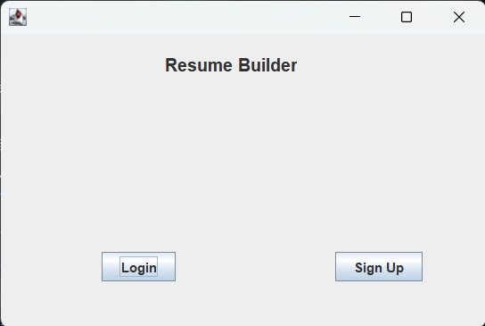

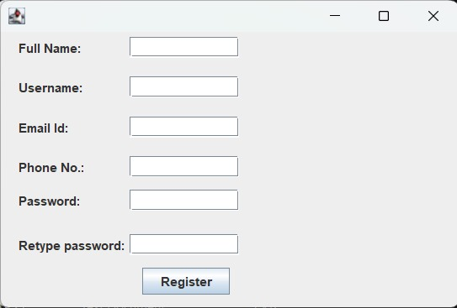

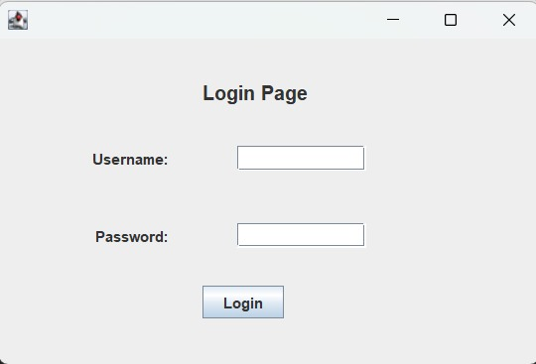

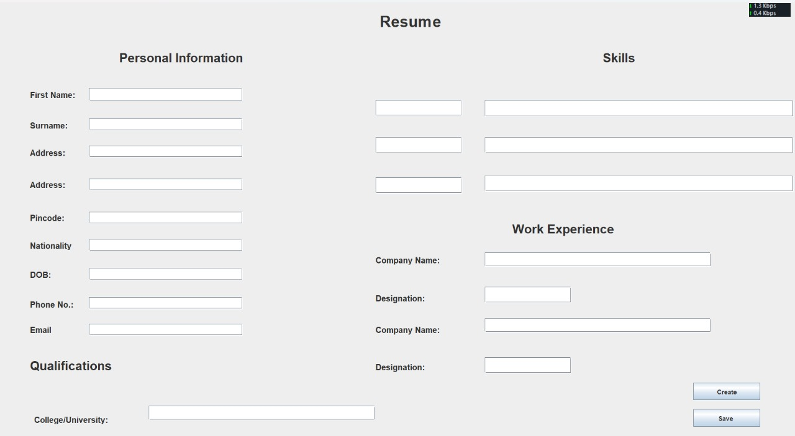

**Future Scope:**

1. Enhanced Templates

* Develop a wider variety of professional templates and styles, allowing users to choose designs that better fit their industry or personal taste.

**2.** CustomizationOptions

* Add more customization options, such as font styles, colors, and layouts, giving users greater control over the appearance of their resumes.

3. Collaboration and Feedback

* Allow users to share their resumes with others for feedback or collaboration, potentially incorporating comments and suggestions.

4. Analytics Dashboard

* Introduce a dashboard that provides insights into resume performance, such as how many times it has been viewed or downloaded.

**Conclusion:**

The development of a resume builder using Java serves as an essential tool for individuals seeking to create professional and tailored resumes efficiently. By focusing on user-friendly design, and basic functionalities like preview and download options, the project lays a strong foundation for users to present their skills and experiences effectively.

Looking ahead, there are numerous opportunities for enhancement, including transitioning to a web-based application, integrating advanced features such as AI-driven suggestions, and expanding the platform’s functionality to include user accounts and collaboration tools. These improvements can significantly elevate the user experience and cater to a broader audience in an increasingly digital job market.

Ultimately, this project not only provides practical value to users but also serves as a stepping stone for further development in software design and user interface innovation. By continuously refining and expanding its capabilities, the resume builder can become a go-to resource for job seekers striving to stand out in their applications.

**References:**

1. Rinki Tyagi, Nihal Singh, Akanksha Baghel, Ankita Singh, “Resume Builder Application”, ISSN: 2321 9653; IC Value: 45.98; SJ Impact Factor:7.429, Volume 8 Issue V May 2020.
2. Bharti Kungwani, Amisha Manglani, Naman Dembal, Hiten Hirani, Laveen Sawlani, “Analytical Resume Builder – A web Application for Creating a resume which gives a best impact in this competitive world”, Annals of R.S.C.B.
3. [https://ieeexplore.ieee.org](https://ieeexplore.ieee.org/)
4. IJCRT- ”RESUME BUILDER- A WEB APPLICATION FOR CREATING A RESUME”, Volume 11, Issue 12 December 2023 | ISSN: 2320-2882.