
ELEMENTS IN AIML

SUBMITTED TO:
Sandeep Kumain Sir
SUBMITTED BY:
Arnav Upperwal
SAP id 590027436
Batch 45

LAB 2: Introduction to Data Analysis and the Pandas Library
1. you can create a Series from a Python list:
import pandas as pd
my_series = pd.Series([10, 20, 30, 40])
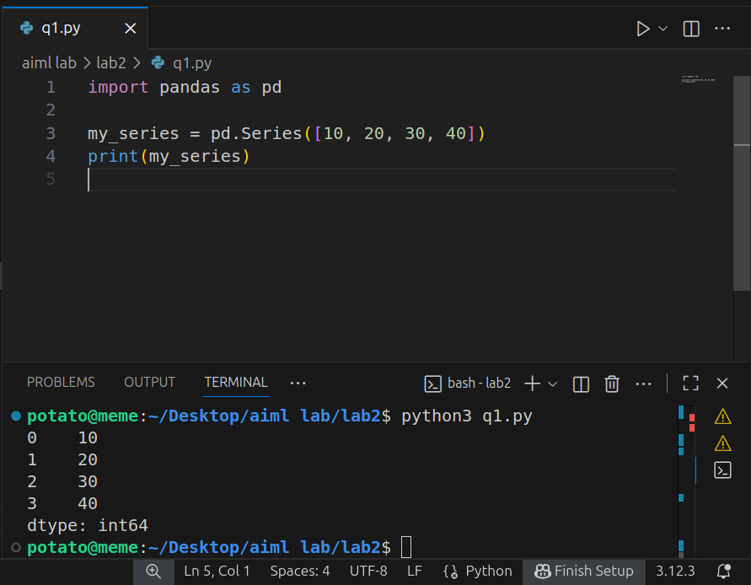
2. Create a dataframe :
import pandas as pd
data = {'Names': ['Mehak', 'Diksha','Yuvan'], 'CGPA': [9, 10, 8.5]}
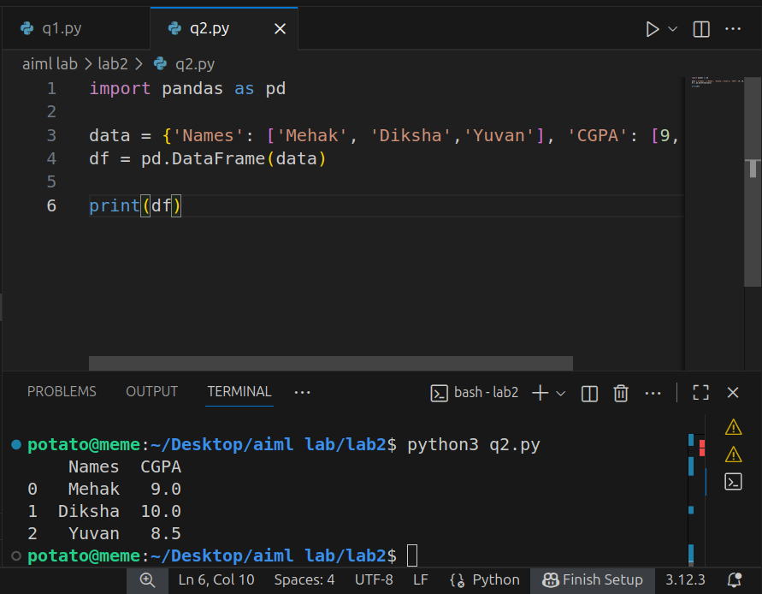
3.Create a dataframe:
import pandas as pd
data = {'A': [1, 2], 'B': [3, 4]}
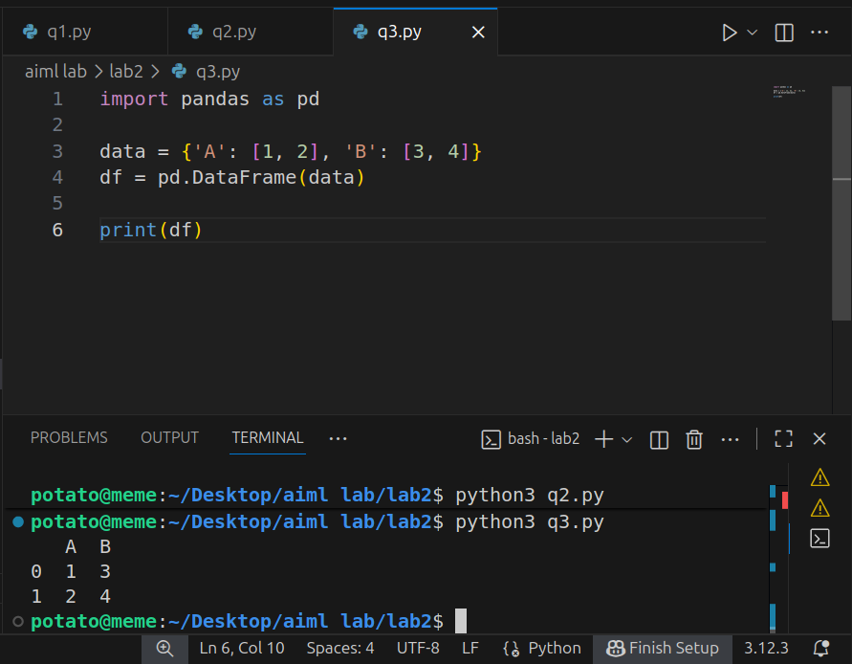
4.How to read a csv file:
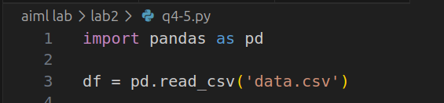
5.More functions like head(),tail()etc.
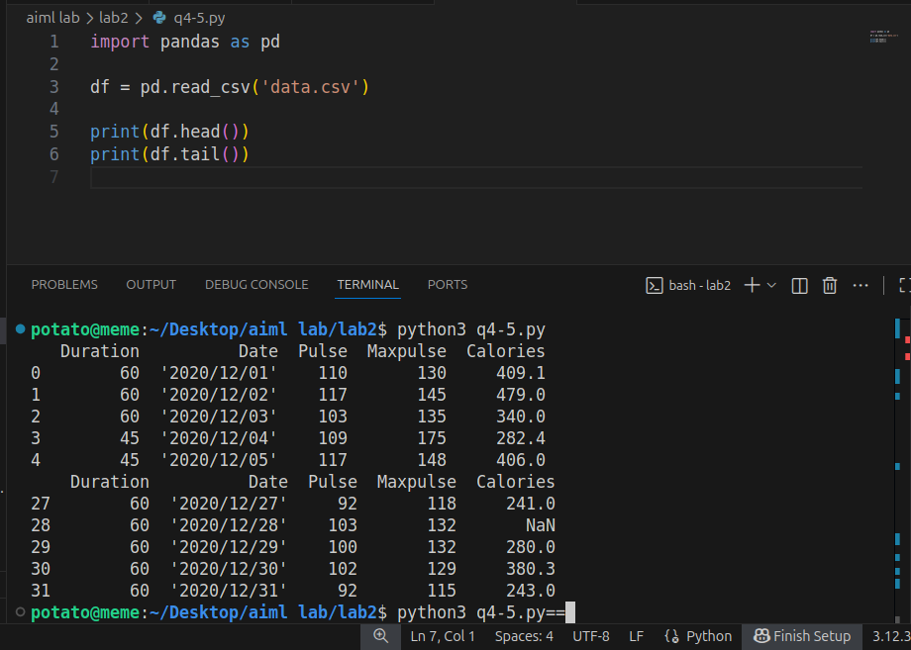
6.using matplotlib for analysing data, plotting graph and their functions like title,label etc:
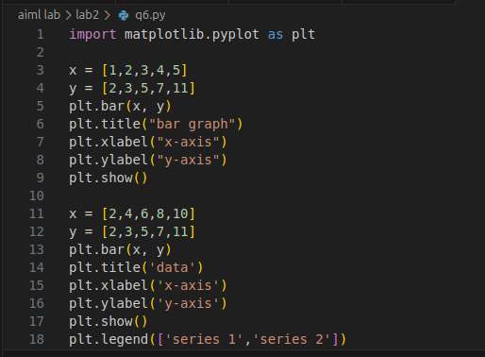
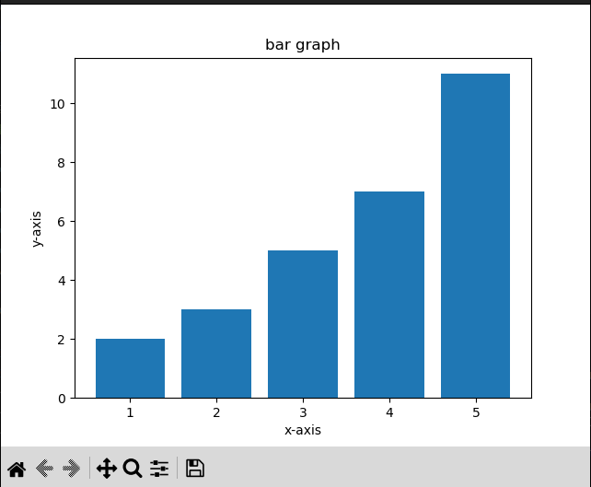
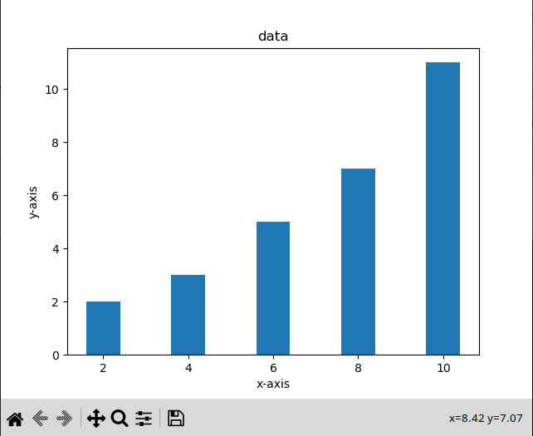
7.plotting a histogram:
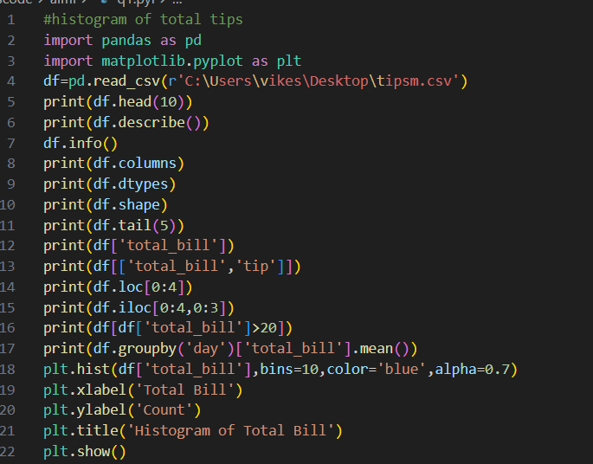
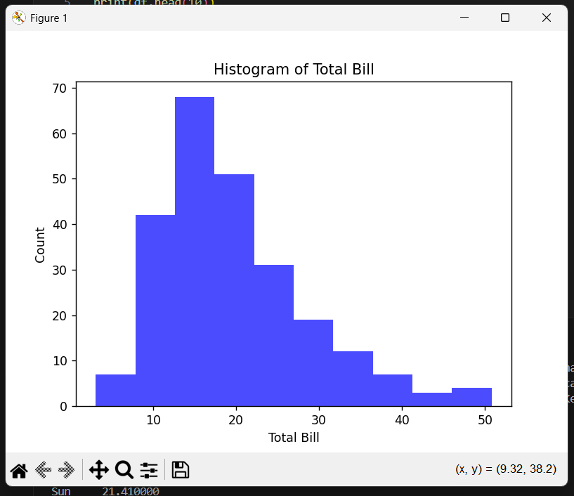
8.plotting bar graph for the same data:
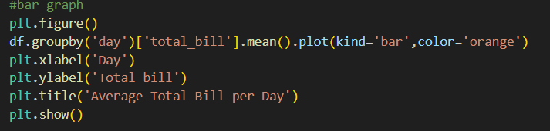
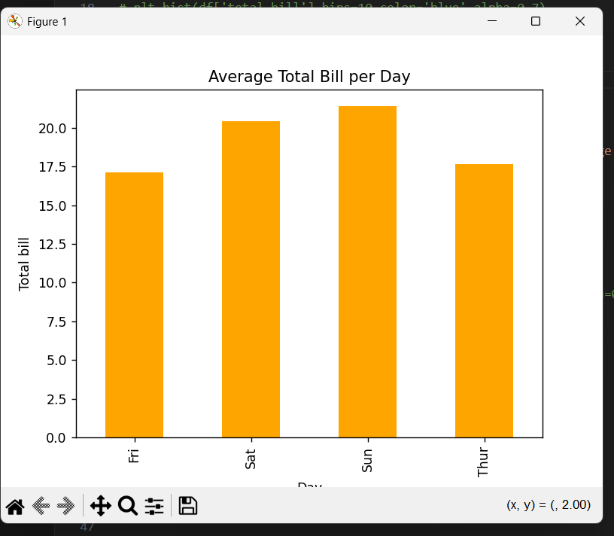
- Scatter plot:
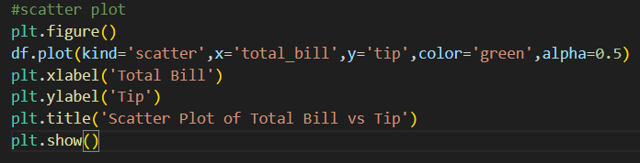

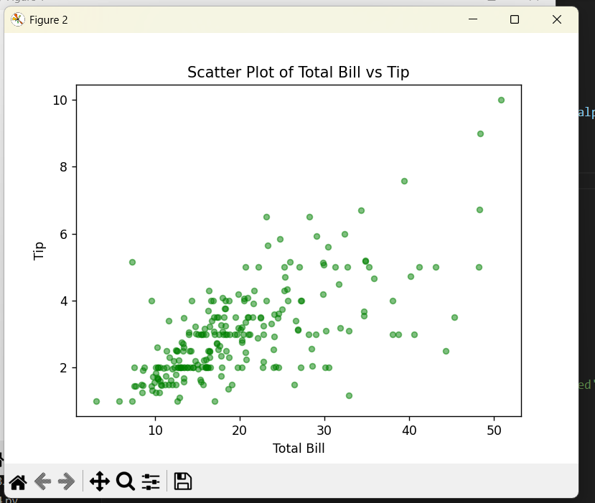

9.Plot a line graph: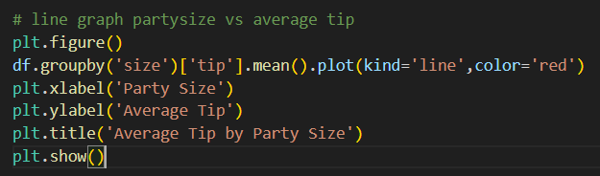

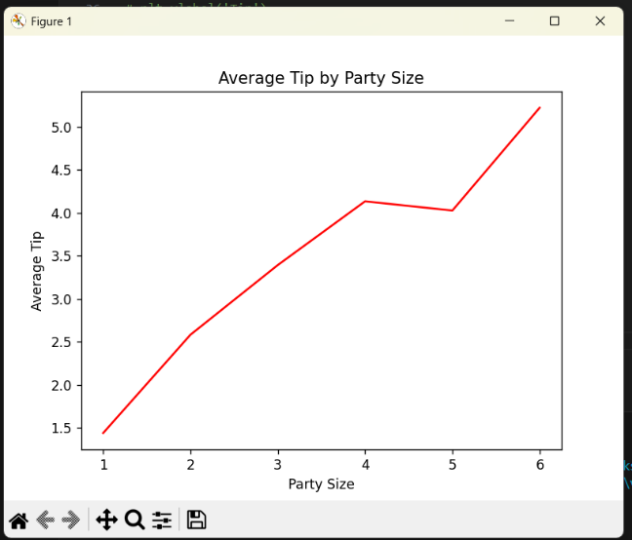
QUIZ RESULT
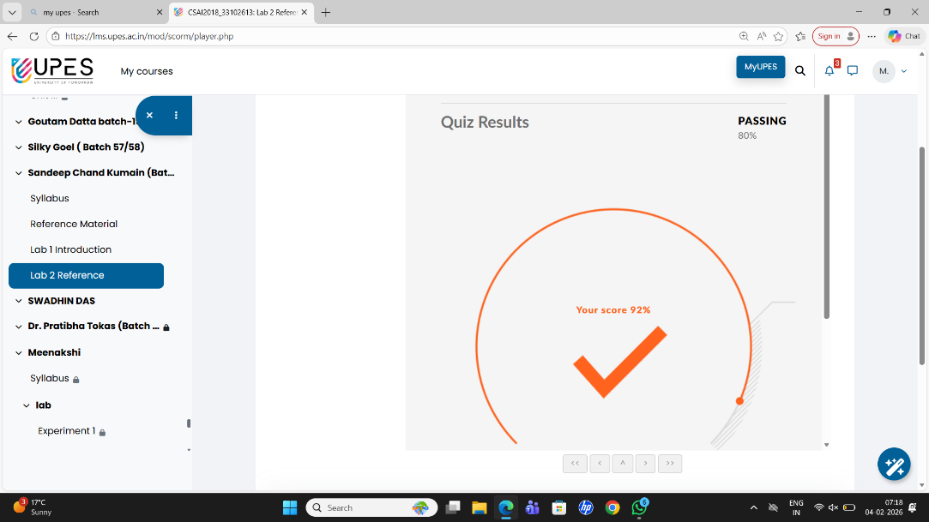

WHAT I HAVE LEARNT FROM THIS?
In this experiment, the tips.csv dataset was imported into Python using pandas and stored in a DataFrame for analysis. The dataset was examined to understand its structure and identify the relevant columns. The total_bill column was selected for analysis, and the data was checked for out-of-range values, such as negative or invalid entries, using conditional filtering in pandas. Any such invalid values were identified and removed to ensure the dataset remained clean and accurate. After cleaning the data, a histogram was plotted using matplotlib to visualize the distribution of the total bill amounts. The histogram helped in understanding how the values were spread across different ranges. This experiment demonstrated how to import a CSV file, examine the dataset, detect and remove invalid values, and visualize the cleaned data using pandas and matplotlib.

