
ELEMENTS IN AIML

SUBMITTED TO:
Sandeep Kumain Sir
SUBMITTED BY:
ARNAV UPPERWAL
SAP id 590027436
Batch 45

Lab 1: Basic Statistical Calculations for Machine Learning
- import statistics data = [10, 20, 30, 40, 50],mean = statistics.mean(data) and print(mean).
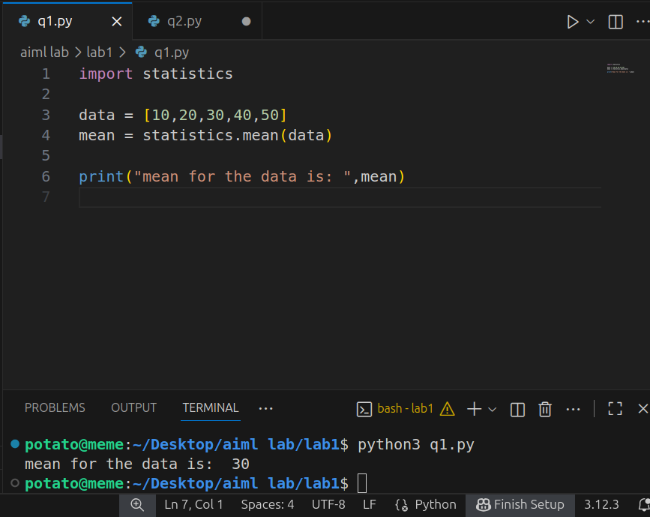
- import statistics data = [10, 20, 30, 40, 50] variance = statistics.variance(data) stdev = statistics.stdev(data) print(variance, stdev).
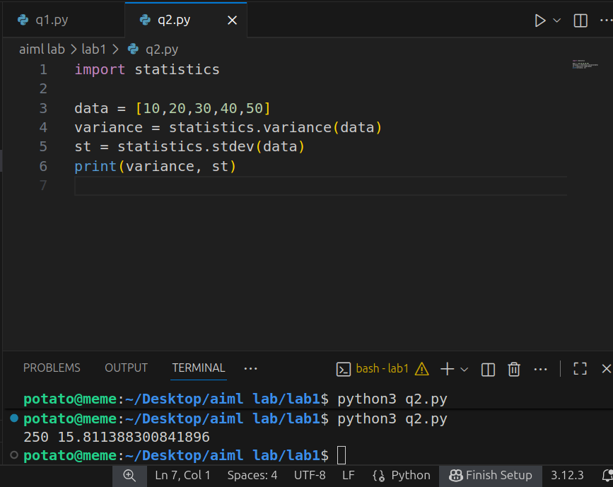
- import matplotlib.pyplot as plt x = [1, 2, 3, 4, 5] y = [2, 4, 6, 8, 10] plt.plot(x, y) plt.show()
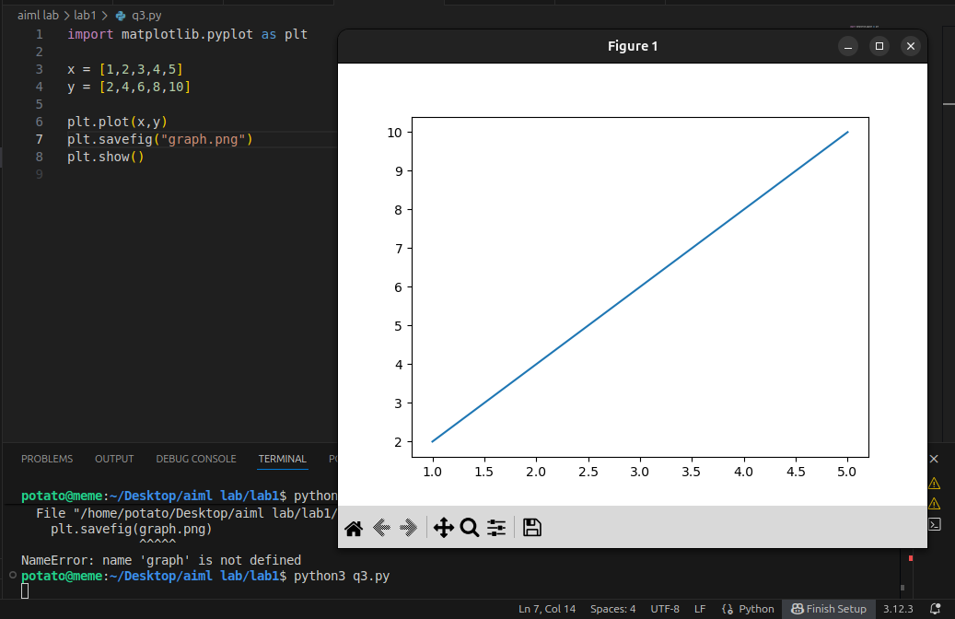
- import matplotlib.pyplot as plt categories = ['A', 'B', 'C'] values = [5, 7, 3] plt.bar(categories, values) plt.show()
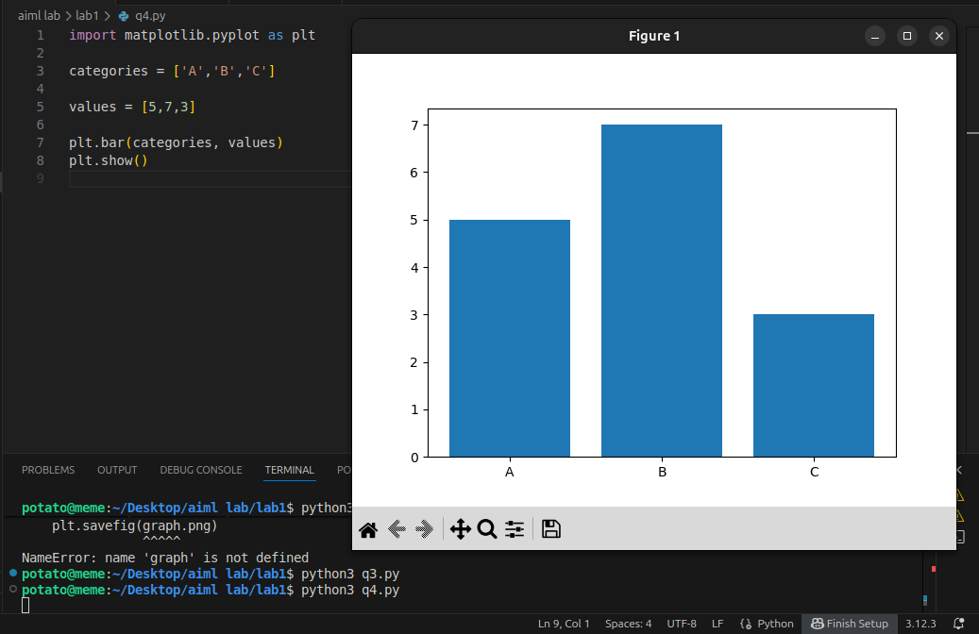
- import matplotlib.pyplot as plt data = [1, 2, 2, 3, 3, 3, 4, 4, 5] plt.hist(data, bins=5) plt.show()
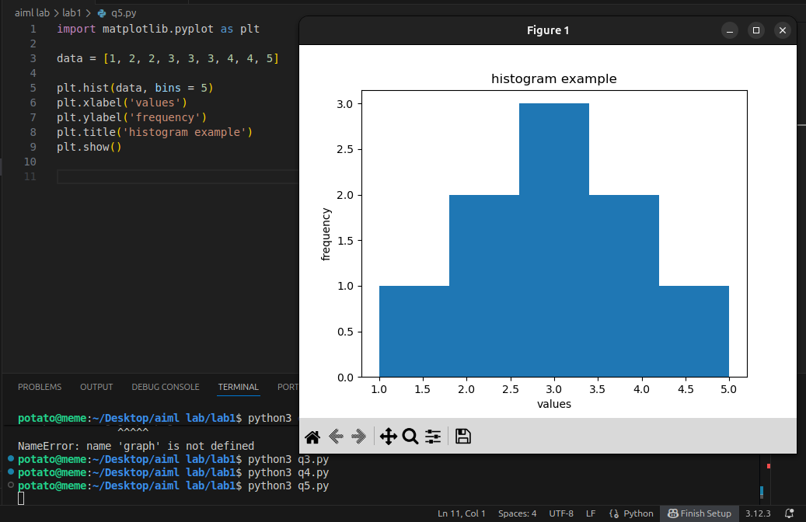

- Using the fuctions of statistics library.
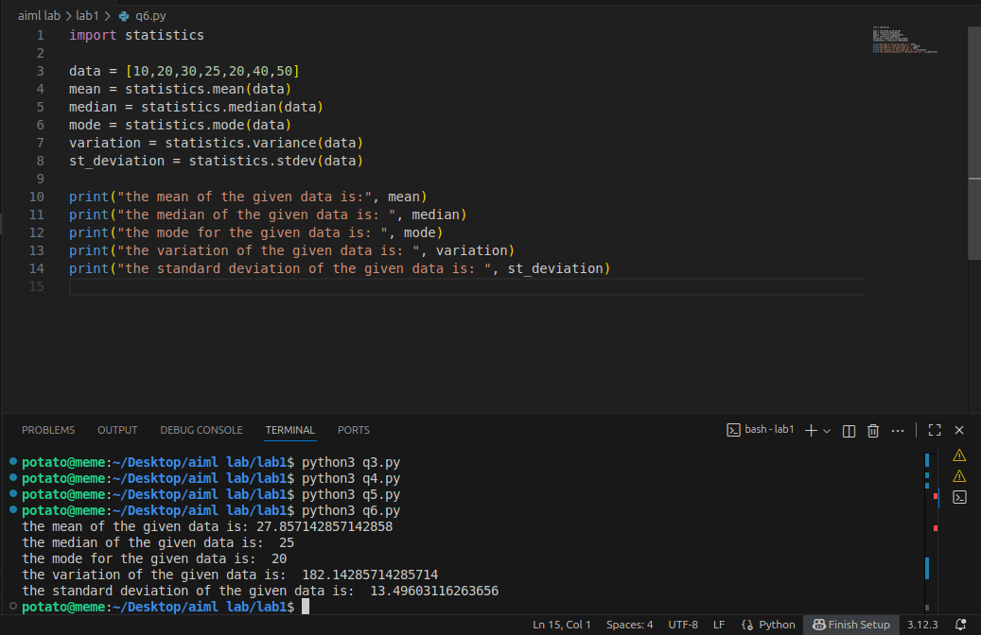

- create a sample of 100 students with marks between 0 to 100 then perform mean median mode on that data and then identify outliers (out of range)and remove those outliers.
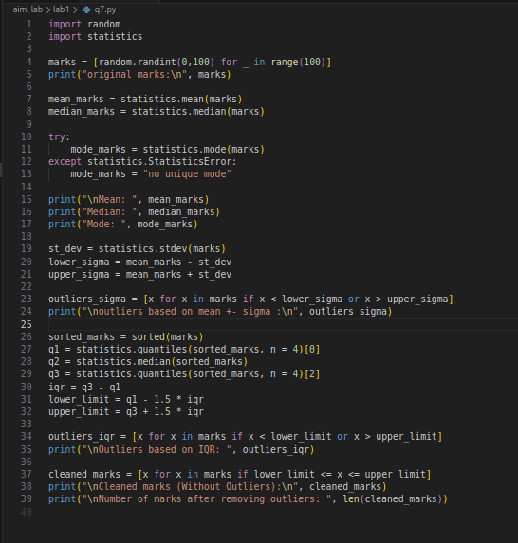

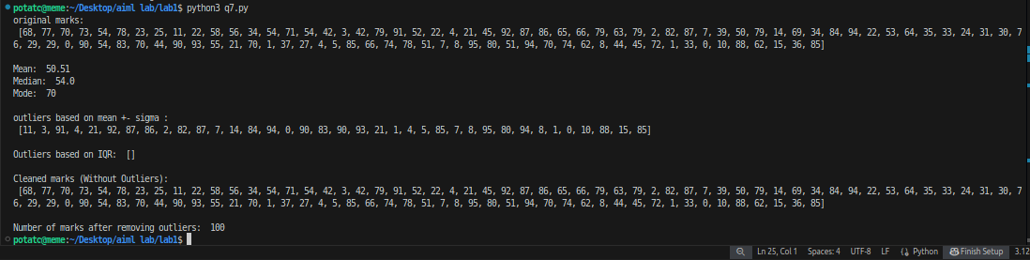

QUIZ RESULT
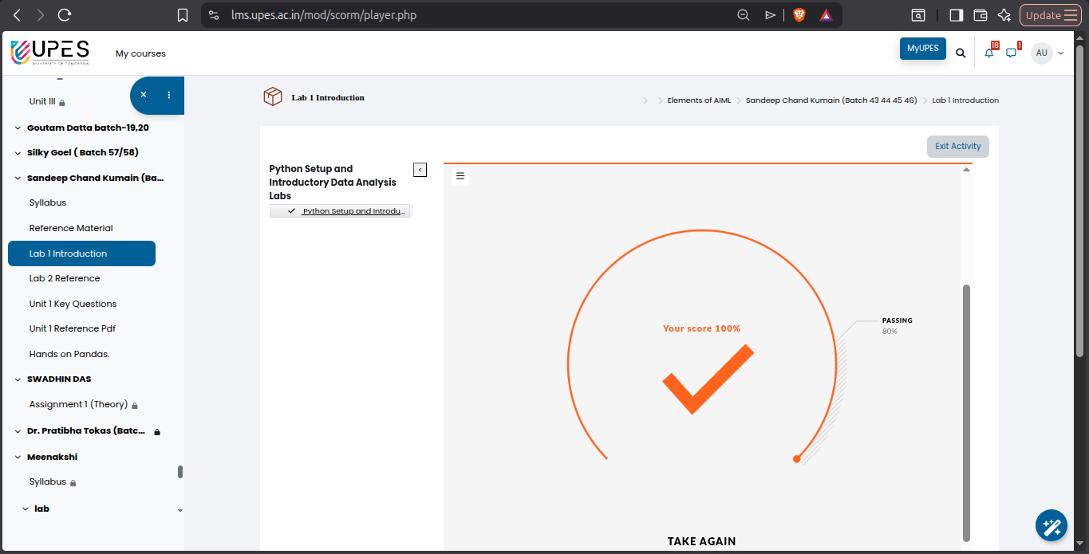

What I have learnt from this?
From this exercise, I have learned how to analyze a dataset using basic statistical methods. I understood how to calculate measures of central tendency like mean, median, and mode, and how standard deviation and interquartile range (IQR) measure the spread of data. I also learned how to identify and remove outliers using mean ± standard deviation and IQR. Additionally, by using graphs such as histograms and boxplots, I was able to visually interpret the distribution of marks, see the central tendency, and easily spot outliers. Overall, this activity taught me the complete process of collecting, analyzing, cleaning, and interpreting data in statistics.

