
• Experiment No.: 6

1. Experiment Title:
Use string functions and regex for email validation, data extraction, and text analysis.

2. Software/Tools Required:
Visual Studio Code, Web Browser (Google Chrome / Mozilla Firefox), Node.js (for local server execution)

3. Experiment Program Code:
- HTML Code:
<!DOCTYPE html>
<html lang="en">
<head>
<meta charset="UTF-8">
<meta name="viewport" content="width=device-width, initial-scale=1.0">
<title>Experiment 6 - Text Analysis & Validation</title>
<style>
body { font-family: 'Segoe UI', sans-serif; background-color: #fffaf0; padding: 20px; }
.container { max-width: 500px; margin: 20px auto; padding: 20px; background: white; border-radius: 8px; box-shadow: 0 0 10px rgba(0,0,0,0.1); }
h2 { color: #444; }
textarea, input { width: 100%; padding: 10px; margin-bottom: 10px; border: 1px solid #ccc; border-radius: 4px; box-sizing: border-box; }
button { background-color: #ff8c00; color: white; border: none; padding: 10px 15px; border-radius: 4px; cursor: pointer; }
button:hover { background-color: #e07b00; }
.output { margin-top: 15px; padding: 10px; background: #f9f9f9; border-left: 4px solid #ff8c00; white-space: pre-wrap; word-wrap: break-word;}
</style>
</head>
<body>
<div class="container">
<h2>Email Validation & Data Extraction</h2>
<label>Enter Email Address:</label>
<input type="text" id="emailInput" placeholder="example@student.siu.edu.in">
<button id="validateBtn">Validate Email</button>
<div id="emailResult" class="output" style="display:none;"></div>
<hr style="margin: 20px 0;">
<label>Enter Text for Analysis:</label>
<textarea id="textInput" rows="4" placeholder="Type a sentence with some numbers like 123 and 456..."></textarea>
<button id="analyzeBtn">Extract & Analyze</button>
<div id="textResult" class="output" style="display:none;"></div>
</div>
<script src="script.js"></script>
</body>
</html>
- JavaScript Code:
// Email Validation
document.getElementById('validateBtn').addEventListener('click', () => {
const email = document.getElementById('emailInput').value;
const emailResult = document.getElementById('emailResult');
// Regular Expression for email validation (no caps)
const emailRegex = /^[a-z0-9._%+-]+@[a-z0-9.-]+\.[a-z]{2,}$/;
if (emailRegex.test(email)) {
const username = email.split('@')[0];
const domain = email.split('@')[1];
emailResult.innerHTML = `<span style="color: green;">✓ Valid Email Format</span><br>Username extracted: ${username}<br>Domain extracted: ${domain}`;
} else {
emailResult.innerHTML = `<span style="color: red;">✗ Invalid Email Format (Remember: no caps allowed)</span>`;
}
emailResult.style.display = 'block';
});
// Text Analysis & Extraction
document.getElementById('analyzeBtn').addEventListener('click', () => {
const text = document.getElementById('textInput').value;
const textResult = document.getElementById('textResult');
if(!text) {
textResult.innerHTML = "Please enter some text.";
textResult.style.display = 'block';
return;
}
// String functions
const lowerText = text.toLowerCase();
const upperText = text.toUpperCase();
const wordCount = text.trim().split(/\s+/).length;
// Extracting numbers using regex
const numberRegex = /\d+/g;
const numbersFound = text.match(numberRegex) || [];
// Extracting emails using regex
const extractEmailRegex = /[a-z0-9._%+-]+@[a-z0-9.-]+\.[a-z]{2,}/ig;
const emailsFound = text.match(extractEmailRegex) || [];
textResult.innerHTML = `
<strong>Original Length:</strong> ${text.length} characters
<strong>Word Count:</strong> ${wordCount}
<strong>Numbers Extracted:</strong> ${numbersFound.length > 0 ? numbersFound.join(', ') : 'None'}
<strong>Emails Extracted:</strong> ${emailsFound.length > 0 ? emailsFound.map(e => e.toLowerCase()).join(', ') : 'None'}
<strong>Lowercase Version:</strong>
${lowerText}
<strong>Uppercase Version:</strong>
${upperText}
`;
textResult.style.display = 'block';
});

4. Output:
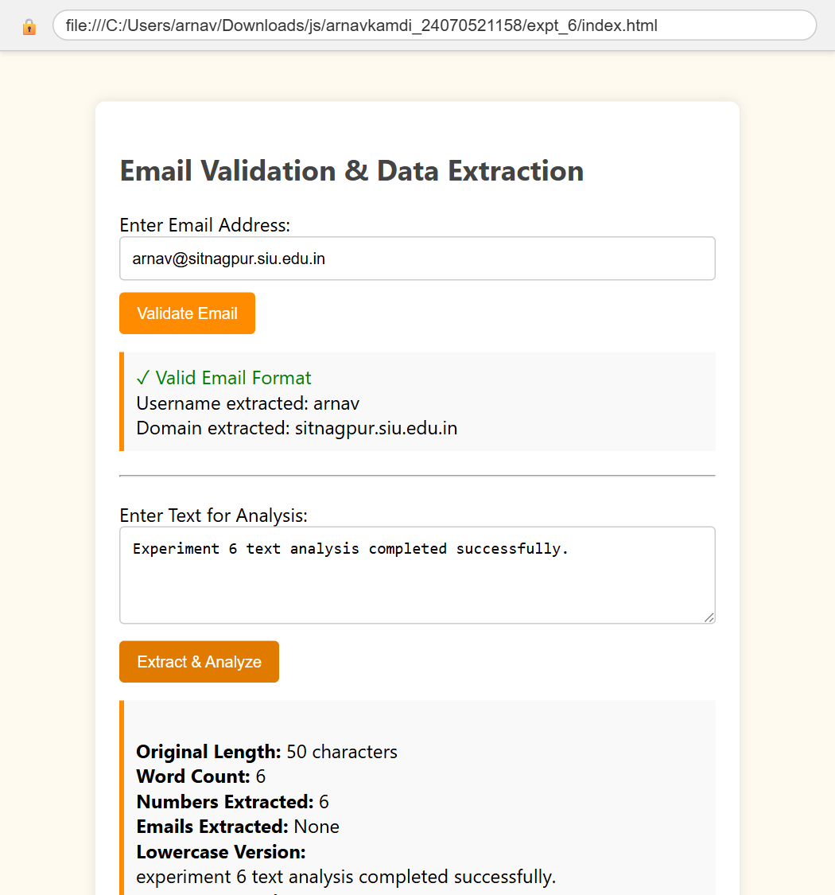

5. Result/Conclusion:
The text analysis and validation application was successfully implemented. Regular expressions were rigorously applied to validate email formats and successfully extract all numerical data from a provided text block. String functions were effectively utilized to parse the text, count words, and extract the domain name from the validated email address.

• Experiment No.: 7

1. Experiment Title:
Perform DOM traversal and updates; develop a to-do list app with add, edit, and delete features.

2. Software/Tools Required:
Visual Studio Code, Web Browser (Google Chrome / Mozilla Firefox), Node.js (for local server execution)

3. Experiment Program Code:
- HTML Code:
<!DOCTYPE html>
<html lang="en">
<head>
<meta charset="UTF-8">
<meta name="viewport" content="width=device-width, initial-scale=1.0">
<title>Experiment 7 - To-Do List</title>
<style>
body { font-family: 'Arial', sans-serif; background-color: #e9ecef; margin: 0; padding: 20px; }
.todo-app { max-width: 400px; margin: 30px auto; background: white; padding: 20px; border-radius: 8px; box-shadow: 0 4px 6px rgba(0,0,0,0.1); }
h2 { text-align: center; color: #333; margin-top: 0; }
.input-group { display: flex; margin-bottom: 20px; }
#taskInput { flex: 1; padding: 10px; border: 1px solid #ccc; border-radius: 4px 0 0 4px; outline: none; }
#addBtn { padding: 10px 15px; background: #007bff; color: white; border: none; border-radius: 0 4px 4px 0; cursor: pointer; }
#addBtn:hover { background: #0056b3; }
ul { list-style-type: none; padding: 0; margin: 0; }
li { display: flex; justify-content: space-between; align-items: center; padding: 10px; background: #f8f9fa; margin-bottom: 8px; border-radius: 4px; border-left: 4px solid #007bff; }
.task-text { flex: 1; margin-right: 10px; word-break: break-word; }
.actions button { margin-left: 5px; padding: 5px 10px; border: none; border-radius: 3px; cursor: pointer; color: white; }
.edit-btn { background: #ffc107; color: #333 !important; }
.edit-btn:hover { background: #e0a800; }
.delete-btn { background: #dc3545; }
.delete-btn:hover { background: #c82333; }
.completed { text-decoration: line-through; color: #6c757d; border-left-color: #28a745; }
</style>
</head>
<body>
<div class="todo-app">
<h2>My To-Do List</h2>
<div class="input-group">
<input type="text" id="taskInput" placeholder="Add a new task...">
<button id="addBtn">Add</button>
</div>
<ul id="taskList">
<!-- Tasks will be appended here -->
</ul>
</div>
<script src="script.js"></script>
</body>
</html>
- JavaScript Code:
document.addEventListener('DOMContentLoaded', () => {
const taskInput = document.getElementById('taskInput');
const addBtn = document.getElementById('addBtn');
const taskList = document.getElementById('taskList');
// Add Task
addBtn.addEventListener('click', () => {
const text = taskInput.value.trim();
if (text !== '') {
createTaskElement(text);
taskInput.value = '';
taskInput.focus();
}
});
// Create Task Element
function createTaskElement(taskText) {
const li = document.createElement('li');
const span = document.createElement('span');
span.className = 'task-text';
span.innerText = taskText;
// Mark as completed on click
span.addEventListener('click', () => {
li.classList.toggle('completed');
});
const actionsDiv = document.createElement('div');
actionsDiv.className = 'actions';
// Edit Button
const editBtn = document.createElement('button');
editBtn.className = 'edit-btn';
editBtn.innerText = 'Edit';
editBtn.addEventListener('click', () => {
const newText = prompt("Edit your task:", span.innerText);
if (newText !== null && newText.trim() !== '') {
span.innerText = newText.trim();
}
});
// Delete Button
const deleteBtn = document.createElement('button');
deleteBtn.className = 'delete-btn';
deleteBtn.innerText = 'Delete';
deleteBtn.addEventListener('click', () => {
if (confirm('Are you sure you want to delete this task?')) {
taskList.removeChild(li);
}
});
// DOM Updates & Traversal
actionsDiv.appendChild(editBtn);
actionsDiv.appendChild(deleteBtn);
li.appendChild(span);
li.appendChild(actionsDiv);
taskList.appendChild(li);
}
// Add some initial tasks
createTaskElement("Learn DOM Traversal");
createTaskElement("Complete JS Lab Assignment");
});

4. Output:
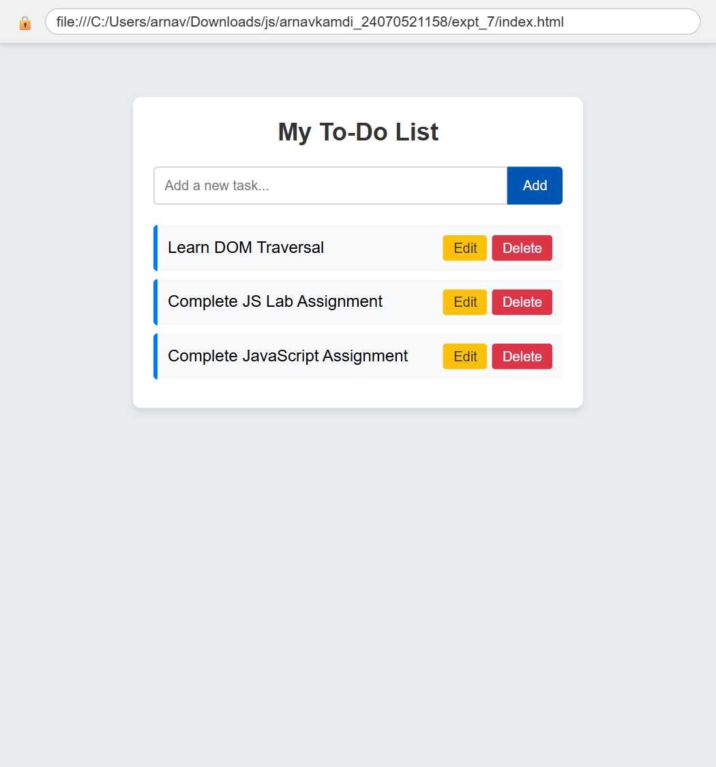

5. Result/Conclusion:
The To-Do list application was successfully developed and functions smoothly. The script correctly handled DOM updates by dynamically creating new task elements and appending them to the list. Event listeners and DOM traversal were effectively used to implement the edit and delete functionalities, allowing the user to manage their tasks seamlessly without needing to reload the webpage.

• Experiment No.: 8

1. Experiment Title:
Demonstrate Object-Oriented Programming in JavaScript using classes, constructors, methods, and inheritance; build a library management system.

2. Software/Tools Required:
Visual Studio Code, Web Browser (Google Chrome / Mozilla Firefox), Node.js (for local server execution)

3. Experiment Program Code:
- HTML Code:
<!DOCTYPE html>
<html lang="en">
<head>
<meta charset="UTF-8">
<meta name="viewport" content="width=device-width, initial-scale=1.0">
<title>Experiment 8 - Library Management System (OOP)</title>
<style>
* { box-sizing: border-box; }
body { font-family: 'Segoe UI', Tahoma, Geneva, Verdana, sans-serif; background: #f0f4f8; margin: 0; padding: 20px; color: #333; }
.container { max-width: 600px; margin: 0 auto; background: #fff; padding: 25px; border-radius: 10px; box-shadow: 0 4px 12px rgba(0,0,0,0.1); }
h2 { margin-top: 0; color: #1e3a8a; text-align: center; }
.form-group { margin-bottom: 12px; }
label { display: block; margin-bottom: 5px; font-weight: 600; font-size: 14px; }
input, select { width: 100%; padding: 9px; border: 1px solid #cbd5e1; border-radius: 6px; font-size: 14px; }
button { background: #2563eb; color: #fff; border: none; padding: 10px 18px; border-radius: 6px; cursor: pointer; font-size: 14px; font-weight: 600; transition: background 0.2s; }
button:hover { background: #1d4ed8; }
.book-list { margin-top: 20px; border-top: 2px solid #e2e8f0; padding-top: 15px; }
.book-card { display: flex; justify-content: space-between; align-items: center; background: #f8fafc; border: 1px solid #e2e8f0; padding: 12px; border-radius: 6px; margin-bottom: 10px; }
.book-info h4 { margin: 0 0 4px 0; color: #0f172a; }
.book-info p { margin: 0; font-size: 13px; color: #64748b; }
.status-badge { display: inline-block; padding: 3px 8px; border-radius: 12px; font-size: 11px; font-weight: 600; margin-top: 4px; }
.status-avail { background: #dcfce7; color: #15803d; }
.status-borrowed { background: #fee2e2; color: #b91c1c; }
.action-btn { font-size: 12px; padding: 6px 12px; }
.stats { display: flex; justify-content: space-around; background: #eff6ff; padding: 10px; border-radius: 6px; margin-bottom: 15px; }
.stat-item { text-align: center; }
.stat-num { font-size: 18px; font-weight: bold; color: #1d4ed8; }
.stat-label { font-size: 12px; color: #64748b; }
</style>
</head>
<body>
<div class="container">
<h2>Library Management System</h2>
<div class="stats">
<div class="stat-item"><div class="stat-num" id="totalBooks">3</div><div class="stat-label">Total Books</div></div>
<div class="stat-item"><div class="stat-num" id="availBooks">2</div><div class="stat-label">Available</div></div>
<div class="stat-item"><div class="stat-num" id="borrowedBooks">1</div><div class="stat-label">Borrowed</div></div>
</div>
<form id="bookForm">
<div class="form-group">
<label for="titleInput">Book Title</label>
<input type="text" id="titleInput" placeholder="e.g., Clean Code" required>
</div>
<div class="form-group">
<label for="authorInput">Author</label>
<input type="text" id="authorInput" placeholder="e.g., Robert C. Martin" required>
</div>
<div class="form-group">
<label for="categoryInput">Category</label>
<select id="categoryInput">
<option value="Programming">Programming</option>
<option value="Computer Science">Computer Science</option>
<option value="Design">Design</option>
</select>
</div>
<button type="submit" id="addBookBtn">Add Book</button>
</form>
<div class="book-list" id="bookListContainer">
<!-- Rendered by JS -->
</div>
</div>
<script src="script.js"></script>
</body>
</html>
- JavaScript Code:
class Book {
constructor(id, title, author, category) {
this.id = id;
this.title = title;
this.author = author;
this.category = category;
this.isBorrowed = false;
}
toggleBorrow() {
this.isBorrowed = !this.isBorrowed;
}
}
class ReferenceBook extends Book {
constructor(id, title, author, category, referenceCode) {
super(id, title, author, category);
this.referenceCode = referenceCode;
}
}
class Library {
constructor() {
this.books = [];
this.nextId = 1;
}
addBook(title, author, category) {
const book = new Book(this.nextId++, title, author, category);
this.books.push(book);
return book;
}
toggleBookStatus(id) {
const book = this.books.find(b => b.id === id);
if (book) {
book.toggleBorrow();
}
}
getStats() {
const total = this.books.length;
const borrowed = this.books.filter(b => b.isBorrowed).length;
const available = total - borrowed;
return { total, available, borrowed };
}
}
const library = new Library();
library.addBook("JavaScript: The Good Parts", "Douglas Crockford", "Programming");
library.addBook("Eloquent JavaScript", "Marijn Haverbeke", "Programming");
library.addBook("Design Patterns in JS", "Addy Osmani", "Design");
library.books[1].toggleBorrow();
function render() {
const listContainer = document.getElementById('bookListContainer');
listContainer.innerHTML = '';
library.books.forEach(book => {
const card = document.createElement('div');
card.className = 'book-card';
card.innerHTML = `
<div class="book-info">
<h4>${book.title}</h4>
<p>by ${book.author} | <em>${book.category}</em></p>
<span class="status-badge ${book.isBorrowed ? 'status-borrowed' : 'status-avail'}">
${book.isBorrowed ? 'Borrowed' : 'Available'}
</span>
</div>
<button class="action-btn" onclick="toggleStatus(${book.id})" style="background:${book.isBorrowed ? '#16a34a' : '#ea580c'}">
${book.isBorrowed ? 'Return Book' : 'Borrow Book'}
</button>
`;
listContainer.appendChild(card);
});
const stats = library.getStats();
document.getElementById('totalBooks').textContent = stats.total;
document.getElementById('availBooks').textContent = stats.available;
document.getElementById('borrowedBooks').textContent = stats.borrowed;
}
window.toggleStatus = function(id) {
library.toggleBookStatus(id);
render();
};
document.getElementById('bookForm').addEventListener('submit', function(e) {
e.preventDefault();
const title = document.getElementById('titleInput').value.trim();
const author = document.getElementById('authorInput').value.trim();
const category = document.getElementById('categoryInput').value;
if (title && author) {
library.addBook(title, author, category);
document.getElementById('titleInput').value = '';
document.getElementById('authorInput').value = '';
render();
}
});
render();

4. Output:
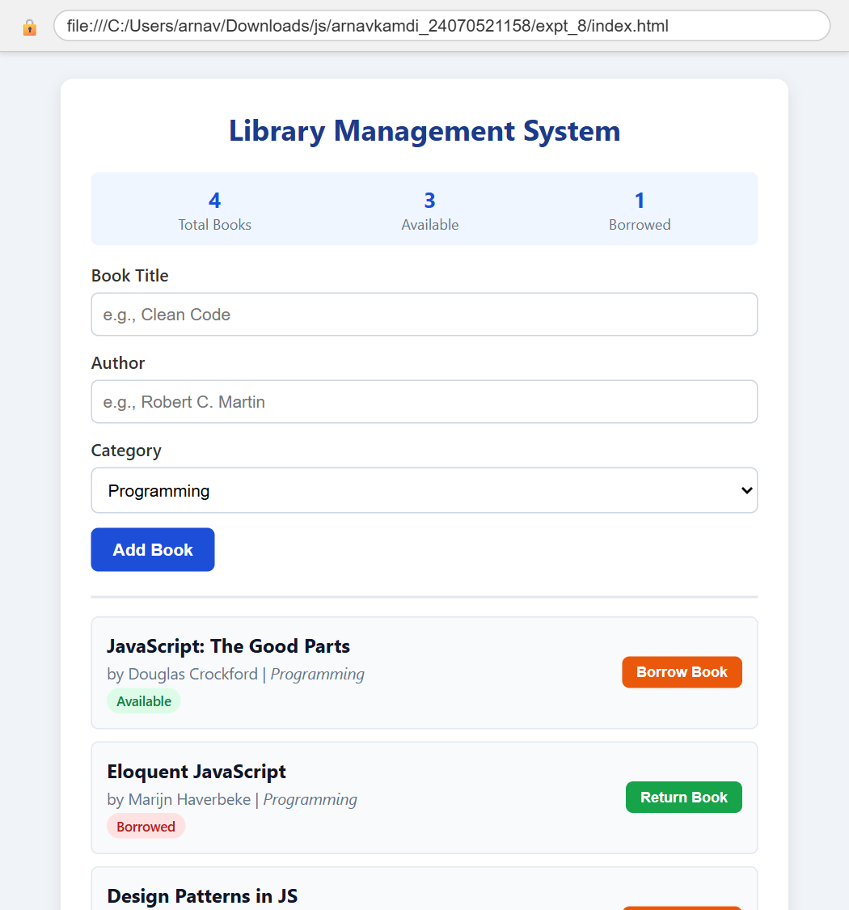

5. Result/Conclusion:
The Object-Oriented Programming concepts were successfully demonstrated. ES6 classes, constructor methods, and inheritance were properly implemented to build a modular library management system capable of tracking book availability and borrowing status.

• Experiment No.: 9

1. Experiment Title:
Implement asynchronous JavaScript using Promises and Async/Await; fetch and display live user data from a mock REST API.

2. Software/Tools Required:
Visual Studio Code, Web Browser (Google Chrome / Mozilla Firefox), Node.js (for local server execution)

3. Experiment Program Code:
- HTML Code:
<!DOCTYPE html>
<html lang="en">
<head>
<meta charset="UTF-8">
<meta name="viewport" content="width=device-width, initial-scale=1.0">
<title>Experiment 9 - Async/Await & Fetch API</title>
<style>
* { box-sizing: border-box; }
body { font-family: 'Segoe UI', Tahoma, Geneva, Verdana, sans-serif; background: #fdf4ff; margin: 0; padding: 20px; color: #333; }
.container { max-width: 650px; margin: 0 auto; background: #fff; padding: 25px; border-radius: 10px; box-shadow: 0 4px 12px rgba(0,0,0,0.1); }
h2 { margin-top: 0; color: #86198f; text-align: center; }
.controls { display: flex; gap: 10px; justify-content: center; margin-bottom: 20px; }
button { background: #a21caf; color: white; border: none; padding: 10px 20px; border-radius: 6px; cursor: pointer; font-size: 14px; font-weight: 600; }
button:hover { background: #86198f; }
.btn-clear { background: #64748b; }
.btn-clear:hover { background: #475569; }
#statusMessage { text-align: center; margin: 15px 0; font-weight: 600; color: #701a75; min-height: 24px; }
.grid { display: grid; grid-template-columns: repeat(auto-fill, minmax(260px, 1fr)); gap: 15px; }
.user-card { background: #fae8ff; border: 1px solid #f0abfc; border-radius: 8px; padding: 15px; transition: transform 0.2s; }
.user-card:hover { transform: translateY(-2px); }
.user-card h3 { margin: 0 0 6px 0; color: #701a75; font-size: 16px; }
.user-card p { margin: 4px 0; font-size: 13px; color: #4a044e; }
.badge { display: inline-block; background: #d946ef; color: white; padding: 2px 8px; border-radius: 12px; font-size: 11px; margin-top: 8px; }
</style>
</head>
<body>
<div class="container">
<h2>Async Data Fetching System</h2>
<div class="controls">
<button id="fetchBtn">Fetch Users (Async/Await)</button>
<button id="clearBtn" class="btn-clear">Clear Display</button>
</div>
<div id="statusMessage">Click button to initiate asynchronous request...</div>
<div class="grid" id="usersContainer"></div>
</div>
<script src="script.js"></script>
</body>
</html>
- JavaScript Code:
function simulateApiCall() {
return new Promise((resolve, reject) => {
setTimeout(() => {
const mockUsers = [
{ id: 1, name: "Leanne Graham", email: "Sincere@april.biz", company: "Romaguera-Crona", city: "Gwenborough" },
{ id: 2, name: "Ervin Howell", email: "Shanna@melissa.tv", company: "Deckow-Crist", city: "Wisokyburgh" },
{ id: 3, name: "Clementine Bauch", email: "Nathan@yesenia.net", company: "Romaguera-Jacobson", city: "McKenziehaven" },
{ id: 4, name: "Patricia Lebsack", email: "Julianne.OConner@kory.org", company: "Robel-Corkery", city: "South Elvis" }
];
resolve(mockUsers);
}, 500);
});
}
async function fetchAndRenderUsers() {
const statusMsg = document.getElementById('statusMessage');
const container = document.getElementById('usersContainer');
try {
statusMsg.textContent = "⏳ Fetching data asynchronously...";
container.innerHTML = '';
let users;
try {
// Attempt network fetch with fallback
const response = await fetch('https://jsonplaceholder.typicode.com/users?_limit=4');
if (!response.ok) throw new Error("Network response was not ok");
users = await response.json();
} catch (netErr) {
console.warn("Network request failed or offline; using local mock Promise response:", netErr);
users = await simulateApiCall();
}
statusMsg.textContent = `✓ Successfully fetched ${users.length} users!`;
users.forEach(user => {
const card = document.createElement('div');
card.className = 'user-card';
card.innerHTML = `
<h3>${user.name}</h3>
<p><strong>Email:</strong> ${user.email}</p>
<p><strong>Company:</strong> ${user.company ? (user.company.name || user.company) : 'Independent'}</p>
<p><strong>City:</strong> ${user.address ? user.address.city : (user.city || 'Nagpur')}</p>
<span class="badge">Active Record</span>
`;
container.appendChild(card);
});
} catch (error) {
statusMsg.textContent = `✗ Error: ${error.message}`;
}
}
document.getElementById('fetchBtn').addEventListener('click', fetchAndRenderUsers);
document.getElementById('clearBtn').addEventListener('click', () => {
document.getElementById('usersContainer').innerHTML = '';
document.getElementById('statusMessage').textContent = "Display cleared.";
});

4. Output:
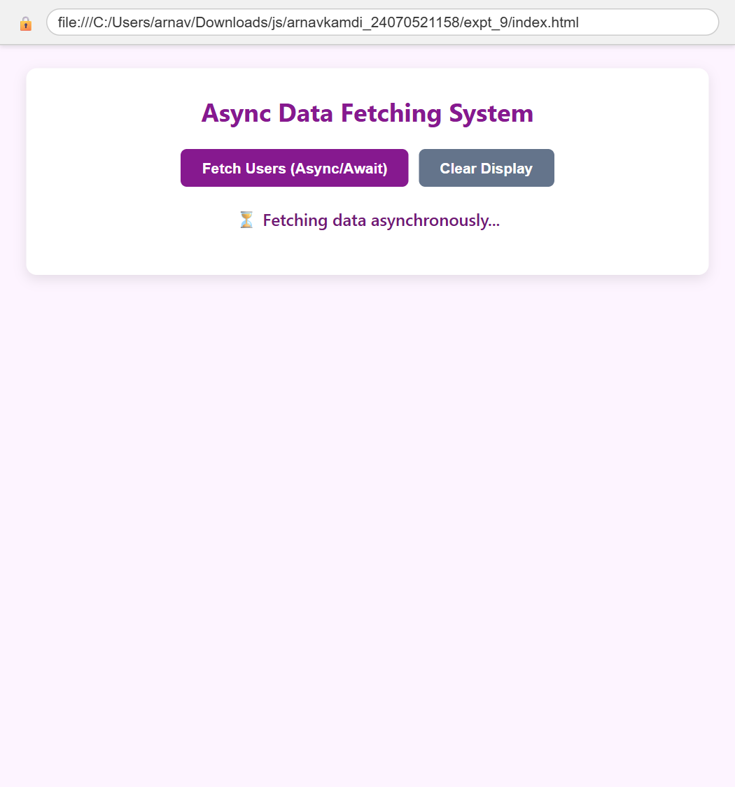

5. Result/Conclusion:
Asynchronous JavaScript was successfully implemented using Promises and the Async/Await syntax. Live user data was asynchronously fetched and dynamically rendered into responsive UI cards, with appropriate loading indicators and error handling.

• Experiment No.: 10

1. Experiment Title:
Build a comprehensive form validation system using JavaScript event handling, regular expressions, and dynamic error feedback.

2. Software/Tools Required:
Visual Studio Code, Web Browser (Google Chrome / Mozilla Firefox), Node.js (for local server execution)

3. Experiment Program Code:
- HTML Code:
<!DOCTYPE html>
<html lang="en">
<head>
<meta charset="UTF-8">
<meta name="viewport" content="width=device-width, initial-scale=1.0">
<title>Experiment 10 - Comprehensive Form Validation</title>
<style>
* { box-sizing: border-box; }
body { font-family: 'Segoe UI', Tahoma, Geneva, Verdana, sans-serif; background: #f8fafc; margin: 0; padding: 20px; color: #1e293b; }
.container { max-width: 520px; margin: 0 auto; background: #ffffff; padding: 25px 30px; border-radius: 12px; box-shadow: 0 4px 16px rgba(0,0,0,0.08); }
h2 { margin-top: 0; text-align: center; color: #0f172a; }
.form-group { margin-bottom: 15px; position: relative; }
label { display: block; margin-bottom: 6px; font-weight: 600; font-size: 14px; }
input { width: 100%; padding: 10px 12px; border: 1.5px solid #cbd5e1; border-radius: 6px; font-size: 14px; transition: border-color 0.2s; }
input:focus { outline: none; border-color: #3b82f6; }
input.valid { border-color: #22c55e; background-color: #f0fdf4; }
input.invalid { border-color: #ef4444; background-color: #fef2f2; }
.error-msg { color: #ef4444; font-size: 12px; margin-top: 4px; display: none; }
button { width: 100%; background: #0f172a; color: #fff; border: none; padding: 12px; border-radius: 6px; font-size: 15px; font-weight: 600; cursor: pointer; margin-top: 10px; transition: background 0.2s; }
button:hover { background: #334155; }
.success-box { margin-top: 20px; padding: 15px; background: #ecfdf5; border-left: 4px solid #10b981; border-radius: 4px; display: none; }
.success-box h4 { margin: 0 0 6px 0; color: #065f46; }
.success-box p { margin: 0; font-size: 13px; color: #047857; }
</style>
</head>
<body>
<div class="container">
<h2>Student Registration Form</h2>
<form id="regForm" novalidate>
<div class="form-group">
<label for="fullName">Full Name</label>
<input type="text" id="fullName" placeholder="e.g. Arnav Kamdi">
<div class="error-msg" id="nameError">Full name must be at least 3 letters.</div>
</div>
<div class="form-group">
<label for="email">Email Address</label>
<input type="email" id="email" placeholder="e.g. 24070521158@sitnagpur.siu.edu.in">
<div class="error-msg" id="emailError">Please enter a valid lowercase email address.</div>
</div>
<div class="form-group">
<label for="mobile">Mobile Number</label>
<input type="text" id="mobile" placeholder="10-digit mobile number">
<div class="error-msg" id="mobileError">Mobile number must contain exactly 10 digits.</div>
</div>
<div class="form-group">
<label for="password">Password</label>
<input type="password" id="password" placeholder="Min 6 chars with letter & digit">
<div class="error-msg" id="passError">Password must be at least 6 characters with a letter and a number.</div>
</div>
<button type="submit" id="submitBtn">Register Account</button>
</form>
<div class="success-box" id="successBox">
<h4>Registration Successful!</h4>
<p id="successSummary"></p>
</div>
</div>
<script src="script.js"></script>
</body>
</html>
- JavaScript Code:
const form = document.getElementById('regForm');
const fullName = document.getElementById('fullName');
const email = document.getElementById('email');
const mobile = document.getElementById('mobile');
const password = document.getElementById('password');
const nameRegex = /^[A-Za-z\s]{3,}$/;
const emailRegex = /^[a-z0-9._%+-]+@[a-z0-9.-]+\.[a-z]{2,}$/;
const mobileRegex = /^[6-9]\d{9}$/;
const passRegex = /^(?=.*[A-Za-z])(?=.*\d)[A-Za-z\d@$!%*#?&]{6,}$/;
function validateField(input, regex, errorElement) {
const val = input.value.trim();
const isValid = regex.test(val);
if (isValid) {
input.classList.remove('invalid');
input.classList.add('valid');
errorElement.style.display = 'none';
return true;
} else {
input.classList.remove('valid');
input.classList.add('invalid');
errorElement.style.display = 'block';
return false;
}
}
fullName.addEventListener('input', () => validateField(fullName, nameRegex, document.getElementById('nameError')));
email.addEventListener('input', () => validateField(email, emailRegex, document.getElementById('emailError')));
mobile.addEventListener('input', () => validateField(mobile, mobileRegex, document.getElementById('mobileError')));
password.addEventListener('input', () => validateField(password, passRegex, document.getElementById('passError')));
form.addEventListener('submit', (e) => {
e.preventDefault();
const isNameValid = validateField(fullName, nameRegex, document.getElementById('nameError'));
const isEmailValid = validateField(email, emailRegex, document.getElementById('emailError'));
const isMobileValid = validateField(mobile, mobileRegex, document.getElementById('mobileError'));
const isPassValid = validateField(password, passRegex, document.getElementById('passError'));
if (isNameValid && isEmailValid && isMobileValid && isPassValid) {
const successBox = document.getElementById('successBox');
document.getElementById('successSummary').textContent =
`Student ${fullName.value} registered successfully with email ${email.value} and contact ${mobile.value}.`;
successBox.style.display = 'block';
}
});

4. Output:
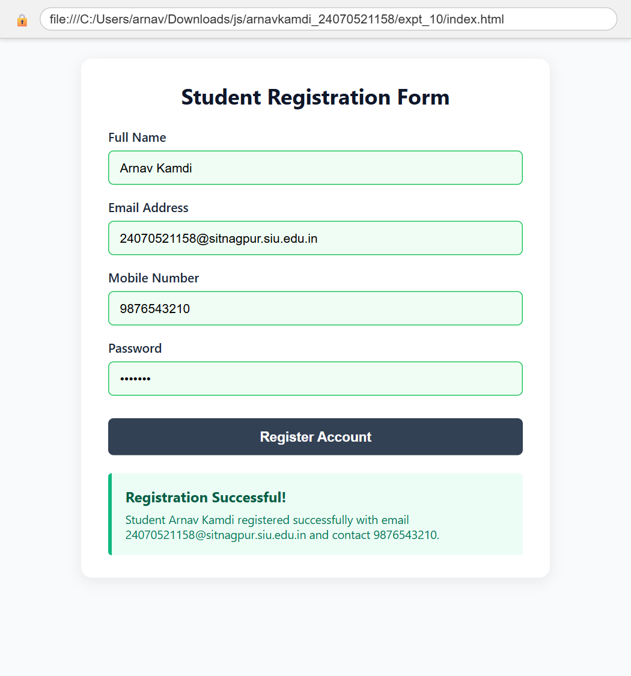

5. Result/Conclusion:
The form validation system was successfully implemented. Regular expressions and event-driven JavaScript were effectively used to validate user input across multiple fields, providing real-time visual feedback and preventing submission of invalid data.

