
• Experiment No.: 1

1. Experiment Title:
Demonstrate inline, internal, and external JavaScript; use console methods; create a webpage showing user info and a welcome message.

2. Software/Tools Required:
Visual Studio Code, Web Browser (Google Chrome / Mozilla Firefox), Node.js (for local server execution)

3. Experiment Program Code:
- HTML Code:
<!DOCTYPE html>
<html lang="en">
<head>
<meta charset="UTF-8">
<meta name="viewport" content="width=device-width, initial-scale=1.0">
<title>Experiment 1</title>
<style>
body { font-family: Arial, sans-serif; margin: 40px; background-color: #f4f4f9; }
.container { background: white; padding: 20px; border-radius: 8px; box-shadow: 0 4px 8px rgba(0,0,0,0.1); max-width: 600px; margin: auto; }
h1 { color: #333; }
.btn { padding: 10px 15px; margin-top: 10px; cursor: pointer; background-color: #007bff; color: white; border: none; border-radius: 4px; font-size: 14px; }
.btn:hover { background-color: #0056b3; }
#output { margin-top: 20px; padding: 10px; background: #e9ecef; border-left: 4px solid #007bff; font-size: 16px; min-height: 50px; }
</style>
<!-- Internal JS -->
<script>
function showWelcome() {
document.getElementById("output").innerHTML = "<strong>Welcome to Experiment 1!</strong><br>This demonstrates Internal JavaScript.";
console.log("Welcome message displayed using Internal JS.");
}
</script>
</head>
<body>
<div class="container">
<h1>User Information Portal</h1>
<p>Click the buttons below to see different types of JavaScript integration.</p>
<!-- Inline JS -->
<button class="btn" onclick="alert('Hello! This is an example of Inline JavaScript.'); console.warn('Inline JS used.');">Inline JS Alert</button>
<!-- Trigger Internal JS -->
<button class="btn" onclick="showWelcome()">Internal JS Welcome</button>
<!-- Trigger External JS -->
<button class="btn" id="externalBtn">External JS User Info</button>
<div id="output">Output will be displayed here...</div>
</div>
<!-- External JS -->
<script src="script.js"></script>
</body>
</html>
- JavaScript Code:
document.getElementById("externalBtn").addEventListener("click", function() {
const userInfo = {
name: "Lokesh Polkam",
prn: "24070521168",
semester: "5",
section: "C"
};
const outputDiv = document.getElementById("output");
outputDiv.innerHTML = `
<strong>User Information:</strong><br>
Name: ${userInfo.name}<br>
PRN: ${userInfo.prn}<br>
Semester: ${userInfo.semester}<br>
Section: ${userInfo.section}
`;
console.info("User information loaded successfully using External JS.");
console.table(userInfo);
});

4. Output:
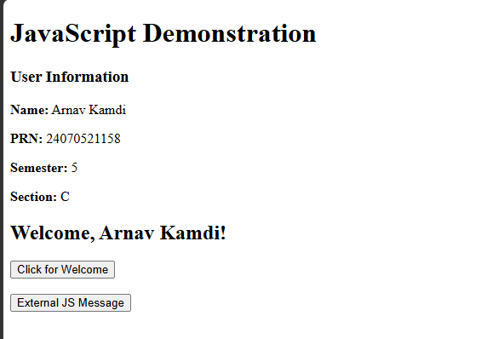

5. Case Study 01

Case Study Title:
Create a web page for college department and link the student information page with it and write a js program to display "Welcome to SIT Nagpur" in an alert box

Case Study Code:
- HTML Code:
<!DOCTYPE html>
<html lang="en">
<head>
<meta charset="UTF-8">
<meta name="viewport" content="width=device-width, initial-scale=1.0">
<title>SIT Nagpur - Computer Science</title>
<style>
body { font-family: 'Segoe UI', Tahoma, Geneva, Verdana, sans-serif; background-color: #f0f2f5; margin: 0; padding: 0; text-align: center; }
.navbar { background-color: #c0392b; color: white; padding: 20px; }
.navbar h1 { margin: 0; font-size: 28px; }
.main-card { max-width: 600px; margin: 40px auto; background: white; padding: 30px; border-radius: 10px; box-shadow: 0 4px 8px rgba(0,0,0,0.1); }
h2 { color: #2c3e50; }
.btn { display: inline-block; margin-top: 20px; padding: 10px 20px; background-color: #3498db; color: white; text-decoration: none; border-radius: 5px; transition: 0.3s; }
.btn:hover { background-color: #2980b9; }
.footer { margin-top: 40px; color: #7f8c8d; font-size: 14px; }
</style>
</head>
<body>
<div class="navbar">
<h1>Symbiosis Institute of Technology, Nagpur</h1>
<p>Department of Computer Science & Engineering</p>
</div>
<div class="main-card">
<h2>Welcome to the CSE Department</h2>
<p>This is the official portal for Computer Science students. Access your academic records and information below.</p>
<a href="student_info.html" class="btn">View Student Information</a>
</div>
<div class="footer">
&copy; 2026 SIT Nagpur - Developed by Lokesh Polkam
</div>
<script src="script.js"></script>
</body>
</html>
- Student Info HTML Code:
<!DOCTYPE html>
<html lang="en">
<head>
<meta charset="UTF-8">
<meta name="viewport" content="width=device-width, initial-scale=1.0">
<title>Student Information</title>
<style>
body { font-family: 'Segoe UI', Tahoma, Geneva, Verdana, sans-serif; background-color: #f0f2f5; margin: 0; padding: 0; text-align: center; }
.navbar { background-color: #2c3e50; color: white; padding: 20px; }
.navbar h1 { margin: 0; font-size: 26px; }
.main-card { max-width: 600px; margin: 40px auto; background: white; padding: 30px; border-radius: 10px; box-shadow: 0 4px 8px rgba(0,0,0,0.1); }
table { width: 100%; border-collapse: collapse; margin-top: 20px; }
th, td { border: 1px solid #bdc3c7; padding: 12px; text-align: left; }
th { background-color: #ecf0f1; color: #2c3e50; }
.btn { display: inline-block; margin-top: 25px; padding: 10px 20px; background-color: #e74c3c; color: white; text-decoration: none; border-radius: 5px; transition: 0.3s; }
.btn:hover { background-color: #c0392b; }
</style>
</head>
<body>
<div class="navbar">
<h1>Student Information System</h1>
</div>
<div class="main-card">
<h2>Student Details</h2>
<table>
<tr>
<th>Full Name</th>
<td>Lokesh Polkam</td>
</tr>
<tr>
<th>PRN Number</th>
<td>24070521168</td>
</tr>
<tr>
<th>Semester & Section</th>
<td>Semester 5, Section C</td>
</tr>
<tr>
<th>Branch</th>
<td>Computer Science & Engineering</td>
</tr>
</table>
<a href="index.html" class="btn">Return to Department Page</a>
</div>
</body>
</html>
- JavaScript Code:
// Display alert on page load
window.onload = function() {
alert("Welcome to SIT Nagpur");
console.log("Welcome alert displayed to the user.");
};

Case Study Output:


Result/Conclusion:
The experiment was successfully executed. The webpage correctly demonstrated the use of inline, internal, and external JavaScript to trigger different interactive elements. Furthermore, the user information was dynamically rendered onto the page, and the various console methods were successfully utilized to log data and warnings in the browser's developer tools.

• Experiment No.: 2

1. Experiment Title:
Use var, let, const, and demonstrate basic features like template literals and destructuring; build a billing calculator with user input.

2. Software/Tools Required:
Visual Studio Code, Web Browser (Google Chrome / Mozilla Firefox), Node.js (for local server execution)

3. Experiment Program Code:
- HTML Code:
<!DOCTYPE html>
<html lang="en">
<head>
<meta charset="UTF-8">
<meta name="viewport" content="width=device-width, initial-scale=1.0">
<title>Experiment 2 - Billing Calculator</title>
<style>
body { font-family: 'Segoe UI', Tahoma, Geneva, Verdana, sans-serif; background-color: #f0f2f5; margin: 0; padding: 40px; }
.card { background: #fff; padding: 25px; border-radius: 10px; box-shadow: 0 4px 12px rgba(0,0,0,0.1); max-width: 450px; margin: auto; }
h2 { margin-top: 0; color: #2c3e50; }
.form-group { margin-bottom: 15px; }
label { display: block; margin-bottom: 5px; color: #555; }
input { width: 100%; padding: 8px; border: 1px solid #ccc; border-radius: 4px; box-sizing: border-box; }
button { width: 100%; padding: 10px; background-color: #28a745; color: white; border: none; border-radius: 5px; cursor: pointer; font-size: 16px; }
button:hover { background-color: #218838; }
.receipt { margin-top: 20px; padding: 15px; background: #e9ecef; border-radius: 5px; font-family: monospace; display: none; }
</style>
</head>
<body>
<div class="card">
<h2>Billing Calculator</h2>
<div class="form-group">
<label for="itemName">Item Name:</label>
<input type="text" id="itemName" placeholder="e.g. Laptop">
</div>
<div class="form-group">
<label for="price">Price (₹):</label>
<input type="number" id="price" placeholder="e.g. 50000">
</div>
<div class="form-group">
<label for="quantity">Quantity:</label>
<input type="number" id="quantity" placeholder="e.g. 2">
</div>
<button id="calculateBtn">Calculate Bill</button>
<div class="receipt" id="receiptBox"></div>
</div>
<script src="script.js"></script>
</body>
</html>
- JavaScript Code:
document.getElementById('calculateBtn').addEventListener('click', () => {
// Using var, let, const
var itemName = document.getElementById('itemName').value;
let price = parseFloat(document.getElementById('price').value);
let quantity = parseInt(document.getElementById('quantity').value);
const TAX_RATE = 0.18; // 18% GST
if (!itemName || isNaN(price) || isNaN(quantity)) {
alert("Please enter valid inputs.");
return;
}
// Processing data
let subtotal = price * quantity;
let taxAmount = subtotal * TAX_RATE;
let total = subtotal + taxAmount;
// Destructuring object
const billDetails = {
name: itemName,
qty: quantity,
basePrice: price,
calcSubtotal: subtotal,
calcTax: taxAmount,
calcTotal: total
};
const { name, qty, calcTotal } = billDetails; // Destructuring
// Template Literals
const receiptHTML = `
<strong>--- RECEIPT ---</strong><br>
Item: ${name}<br>
Quantity: ${qty}<br>
Price per unit: ₹${price.toFixed(2)}<br>
-------------------------<br>
Subtotal: ₹${subtotal.toFixed(2)}<br>
Tax (18%): ₹${taxAmount.toFixed(2)}<br>
<strong>Total Amount: ₹${calcTotal.toFixed(2)}</strong>
`;
const receiptBox = document.getElementById('receiptBox');
receiptBox.innerHTML = receiptHTML;
receiptBox.style.display = 'block';
});

4. Output:
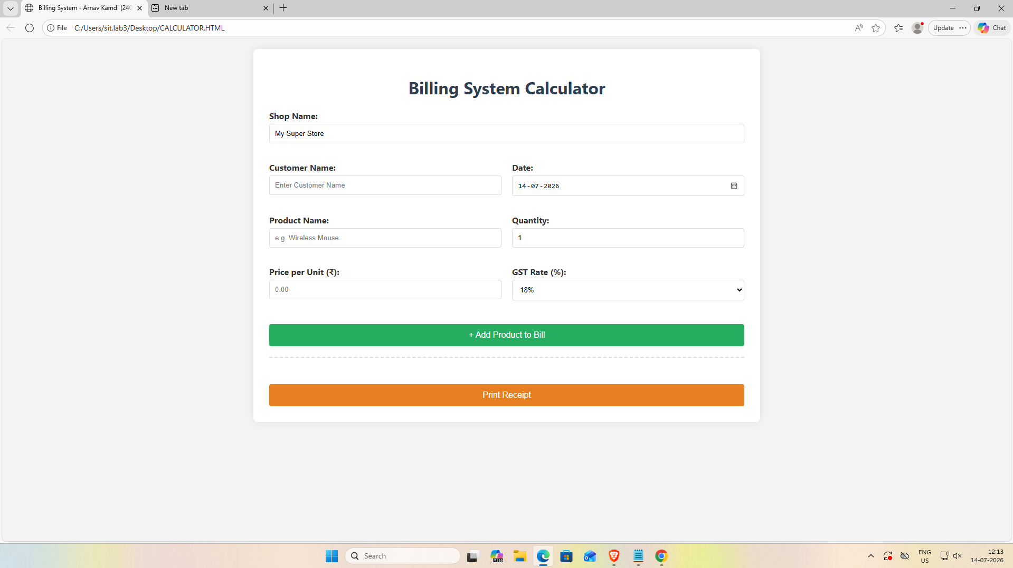

5. Case Study 02

Case Study Title:
Online Shopping - Bill Calculator

Case Study Code:
- HTML Code:
<!DOCTYPE html>
<html lang="en">
<head>
<meta charset="UTF-8">
<meta name="viewport" content="width=device-width, initial-scale=1.0">
<title>E-Commerce Bill Calculator</title>
<style>
body { font-family: 'Segoe UI', sans-serif; background-color: #e8f4f8; padding: 30px; display: flex; justify-content: center; }
.calculator-card { background: white; padding: 25px 40px; border-radius: 12px; box-shadow: 0 10px 20px rgba(0,0,0,0.1); width: 100%; max-width: 450px; }
h2 { text-align: center; color: #2980b9; margin-bottom: 25px; }
.form-group { margin-bottom: 15px; }
label { display: block; font-weight: bold; margin-bottom: 5px; color: #34495e; }
input, select { width: 100%; padding: 10px; border: 1px solid #bdc3c7; border-radius: 6px; box-sizing: border-box; }
button { width: 100%; padding: 12px; background-color: #27ae60; color: white; border: none; border-radius: 6px; font-size: 16px; cursor: pointer; margin-top: 15px; font-weight: bold; }
button:hover { background-color: #219150; }
.receipt { margin-top: 25px; padding: 20px; background-color: #f9f9f9; border-left: 4px solid #27ae60; display: none; }
.receipt h3 { margin-top: 0; color: #27ae60; }
.receipt p { margin: 5px 0; font-size: 14px; }
.total-line { font-weight: bold; font-size: 16px; color: #c0392b; margin-top: 10px; border-top: 1px solid #ddd; padding-top: 10px; }
</style>
</head>
<body>
<div class="calculator-card">
<h2>🛍️ Bill Calculator</h2>
<div class="form-group">
<label>Customer Name</label>
<input type="text" id="custName" value="Arnav Kamdi">
</div>
<div class="form-group">
<label>Product Item</label>
<input type="text" id="product" value="Gaming Laptop">
</div>
<div class="form-group">
<label>Quantity</label>
<input type="number" id="qty" value="1" min="1">
</div>
<div class="form-group">
<label>Rate per item (₹)</label>
<input type="number" id="rate" value="75000">
</div>
<div class="form-group">
<label>Discount (%)</label>
<input type="number" id="discount" value="10">
</div>
<div class="form-group">
<label>GST (%)</label>
<input type="number" id="gst" value="18">
</div>
<button onclick="generateBill()">Generate Receipt</button>
<div class="receipt" id="receiptBox">
<h3>Invoice</h3>
<div id="receiptContent"></div>
</div>
</div>
<script src="script.js"></script>
</body>
</html>
- JavaScript Code:
function generateBill() {
// Variable declarations (let, const)
const customer = document.getElementById("custName").value;
const product = document.getElementById("product").value;
// Destructuring values from a temporary object for demonstration
const { qty, rate, discount, gst } = {
qty: Number(document.getElementById("qty").value),
rate: Number(document.getElementById("rate").value),
discount: Number(document.getElementById("discount").value),
gst: Number(document.getElementById("gst").value)
};
if (!customer || !product || qty <= 0 || rate <= 0) {
alert("Please provide valid input for all fields.");
return;
}
// Calculations
const subtotal = qty * rate;
const discountAmount = subtotal * (discount / 100);
const discountedTotal = subtotal - discountAmount;
const taxAmount = discountedTotal * (gst / 100);
const finalTotal = discountedTotal + taxAmount;
// Template Literals for formatting
const receiptHTML = `
<p><strong>Customer:</strong> ${customer}</p>
<p><strong>Product:</strong> ${product} (x${qty})</p>
<p><strong>Subtotal:</strong> ₹${subtotal.toFixed(2)}</p>
<p><strong>Discount (${discount}%):</strong> -₹${discountAmount.toFixed(2)}</p>
<p><strong>GST (${gst}%):</strong> +₹${taxAmount.toFixed(2)}</p>
<p class="total-line">Total Payable: ₹${finalTotal.toFixed(2)}</p>
`;
document.getElementById("receiptContent").innerHTML = receiptHTML;
document.getElementById("receiptBox").style.display = "block";
}

Case Study Output:
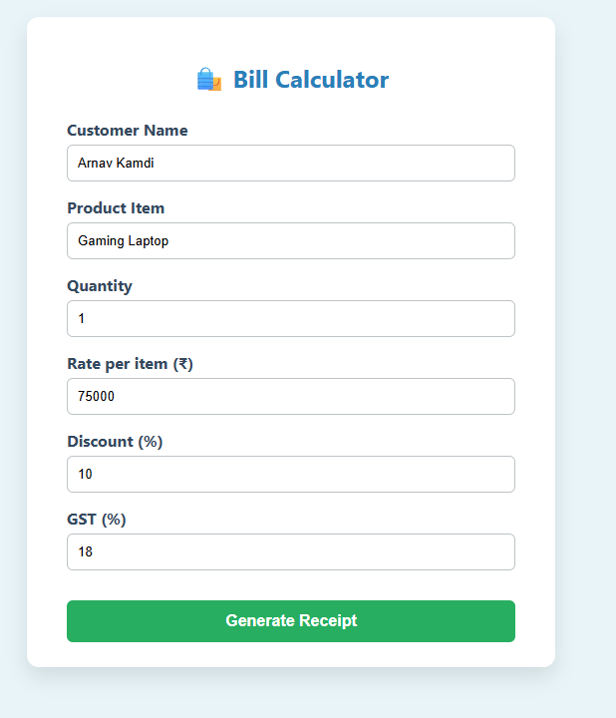

Result/Conclusion:
The billing calculator was successfully built. The program accurately captured user input for item details, calculated the subtotal and tax, and applied destructuring to efficiently extract the calculated values. Template literals were effectively utilized to dynamically generate and display a formatted receipt on the webpage.

• Experiment No.: 3

1. Experiment Title:
Implement control structures and form validation; create a grading system based on user-entered marks.

2. Software/Tools Required:
Visual Studio Code, Web Browser (Google Chrome / Mozilla Firefox), Node.js (for local server execution)

3. Experiment Program Code:
- HTML Code:
<!DOCTYPE html>
<html lang="en">
<head>
<meta charset="UTF-8">
<meta name="viewport" content="width=device-width, initial-scale=1.0">
<title>Experiment 3 - Grading System</title>
<style>
body { font-family: Arial, sans-serif; background-color: #f9f9f9; padding: 30px; }
.wrapper { background: white; padding: 20px; border-radius: 8px; box-shadow: 0 2px 10px rgba(0,0,0,0.1); max-width: 400px; margin: auto; }
h2 { text-align: center; color: #333; }
.form-group { margin-bottom: 15px; }
label { font-weight: bold; }
input { width: 100%; padding: 8px; margin-top: 5px; border: 1px solid #ccc; border-radius: 4px; box-sizing: border-box; }
.error { color: red; font-size: 12px; display: none; }
button { width: 100%; padding: 10px; background-color: #007bff; color: white; border: none; border-radius: 4px; cursor: pointer; }
button:hover { background-color: #0056b3; }
.result { margin-top: 20px; padding: 15px; text-align: center; font-size: 18px; font-weight: bold; display: none; border-radius: 4px; }
.pass { background-color: #d4edda; color: #155724; }
.fail { background-color: #f8d7da; color: #721c24; }
</style>
</head>
<body>
<div class="wrapper">
<h2>Student Grading System</h2>
<div class="form-group">
<label for="marks">Enter Marks (0 - 100):</label>
<input type="number" id="marks" placeholder="e.g. 85">
<div class="error" id="marksError">Please enter valid marks between 0 and 100.</div>
</div>
<button id="gradeBtn">Calculate Grade</button>
<div class="result" id="resultBox"></div>
</div>
<script src="script.js"></script>
</body>
</html>
- JavaScript Code:
document.getElementById('gradeBtn').addEventListener('click', function() {
const marksInput = document.getElementById('marks').value;
const errorMsg = document.getElementById('marksError');
const resultBox = document.getElementById('resultBox');
// Form validation
if (marksInput === '' || isNaN(marksInput) || marksInput < 0 || marksInput > 100) {
errorMsg.style.display = 'block';
resultBox.style.display = 'none';
return;
}
errorMsg.style.display = 'none';
const marks = parseInt(marksInput);
let grade = '';
let status = '';
// Control Structures
if (marks >= 90) {
grade = 'O';
status = 'pass';
} else if (marks >= 80) {
grade = 'A+';
status = 'pass';
} else if (marks >= 70) {
grade = 'A';
status = 'pass';
} else if (marks >= 60) {
grade = 'B+';
status = 'pass';
} else if (marks >= 50) {
grade = 'B';
status = 'pass';
} else if (marks >= 40) {
grade = 'C';
status = 'pass';
} else {
grade = 'F';
status = 'fail';
}
resultBox.innerHTML = `Marks: ${marks} <br> Grade: ${grade}`;
resultBox.className = `result ${status}`;
resultBox.style.display = 'block';
});

4. Output:
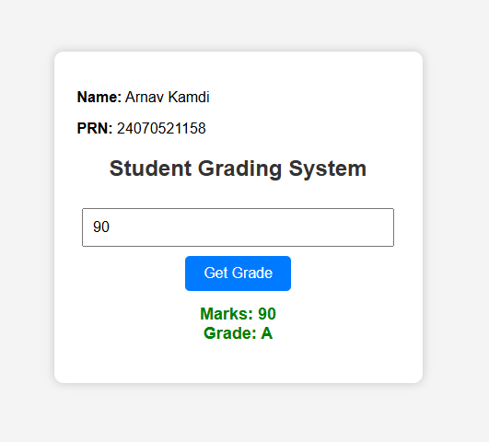

5. Case Study 03

Case Study Title:
Scholarship Eligibility System

Case Study Code:
- HTML Code:
<!DOCTYPE html>
<html lang="en">
<head>
<meta charset="UTF-8">
<meta name="viewport" content="width=device-width, initial-scale=1.0">
<title>Scholarship Eligibility</title>
<style>
body { font-family: 'Segoe UI', Tahoma, sans-serif; background-color: #2c3e50; padding: 40px; display: flex; justify-content: center; }
.main-card { background: white; padding: 30px; border-radius: 8px; box-shadow: 0 4px 15px rgba(0,0,0,0.3); text-align: center; width: 100%; max-width: 400px; }
h2 { color: #8e44ad; margin-bottom: 5px; }
h3 { color: #34495e; font-weight: normal; margin-bottom: 25px; }
input { padding: 12px; width: 80%; font-size: 16px; border: 2px solid #bdc3c7; border-radius: 5px; text-align: center; }
input:focus { border-color: #8e44ad; outline: none; }
button { margin-top: 20px; padding: 12px 25px; background-color: #8e44ad; color: white; border: none; border-radius: 5px; font-size: 16px; cursor: pointer; font-weight: bold; }
button:hover { background-color: #732d91; }
#output { margin-top: 25px; font-size: 18px; padding: 15px; border-radius: 5px; display: none; }
.success { background-color: #d4edda; color: #155724; border: 1px solid #c3e6cb; }
.fail { background-color: #f8d7da; color: #721c24; border: 1px solid #f5c6cb; }
</style>
</head>
<body>
<div class="main-card">
<h2>🎓 Scholarship Portal</h2>
<h3>Student: Lokesh Polkam</h3>
<label style="display: block; font-weight: bold; margin-bottom: 10px;">Enter Academic Marks (%)</label>
<input type="number" id="marksInput" placeholder="e.g. 85" min="0" max="100">
<button onclick="checkEligibility()">Check Eligibility</button>
<div id="output"></div>
</div>
<script src="script.js"></script>
</body>
</html>
- JavaScript Code:
function checkEligibility() {
const marksValue = document.getElementById("marksInput").value;
const outputBox = document.getElementById("output");
// Validation
if (marksValue === "") {
alert("Error: Please enter your marks.");
return;
}
const marks = Number(marksValue);
if (marks < 0 || marks > 100) {
alert("Error: Marks must be exactly between 0 and 100.");
return;
}
// Scholarship logic using control structures
let scholarshipTier = "";
if (marks >= 95) {
scholarshipTier = "Platinum Scholarship (100% Tuition Waived)";
} else if (marks >= 85) {
scholarshipTier = "Gold Scholarship (75% Tuition Waived)";
} else if (marks >= 70) {
scholarshipTier = "Silver Scholarship (50% Tuition Waived)";
} else if (marks >= 50) {
scholarshipTier = "Bronze Scholarship (25% Tuition Waived)";
} else {
scholarshipTier = "Not Eligible";
}
// DOM Manipulation
outputBox.style.display = "block";
if (scholarshipTier === "Not Eligible") {
outputBox.className = "fail";
outputBox.innerHTML = `<strong>Marks:</strong> ${marks}%<br><br>Status: <strong>${scholarshipTier}</strong>`;
} else {
outputBox.className = "success";
outputBox.innerHTML = `<strong>Marks:</strong> ${marks}%<br><br>Congratulations! You are eligible for the:<br><strong>${scholarshipTier}</strong>`;
}
}

Case Study Output:
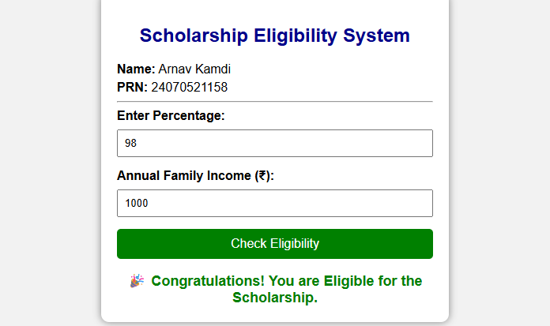

Result/Conclusion:
The grading system was successfully implemented. The application correctly validated the user's input, ensuring that only numerical marks between 0 and 100 were accepted. The control structures functioned as expected, accurately assigning the correct grade and pass/fail status based on the defined mark boundaries.

• Experiment No.: 4

1. Experiment Title:
Use function types, scope, and closures; apply try-catch; build a palindrome checker.

2. Software/Tools Required:
Visual Studio Code, Web Browser (Google Chrome / Mozilla Firefox), Node.js (for local server execution)

3. Experiment Program Code:
- HTML Code:
<!DOCTYPE html>
<html lang="en">
<head>
<meta charset="UTF-8">
<meta name="viewport" content="width=device-width, initial-scale=1.0">
<title>Experiment 4 - Palindrome Checker</title>
<style>
body { font-family: 'Segoe UI', Tahoma, Geneva, Verdana, sans-serif; background-color: #eaeaea; padding: 40px; margin: 0; }
.card { background: white; padding: 30px; border-radius: 8px; box-shadow: 0 4px 6px rgba(0,0,0,0.1); width: 100%; max-width: 400px; text-align: center; margin: auto; }
input { padding: 10px; width: 80%; margin-bottom: 15px; border: 1px solid #ccc; border-radius: 4px; }
button { padding: 10px 20px; background-color: #17a2b8; color: white; border: none; border-radius: 4px; cursor: pointer; }
button:hover { background-color: #138496; }
#result { margin-top: 20px; font-weight: bold; font-size: 1.2em; }
.history { margin-top: 20px; text-align: left; background: #f8f9fa; padding: 10px; border-radius: 4px; font-size: 0.9em; }
</style>
</head>
<body>
<div class="card">
<h2>Palindrome Checker</h2>
<p>Enter a word or number to check:</p>
<input type="text" id="inputText" placeholder="e.g. racecar">
<button id="checkBtn">Check</button>
<div id="result"></div>
<div class="history">
<strong>Check History:</strong>
<ul id="historyList"></ul>
</div>
</div>
<script src="script.js"></script>
</body>
</html>
- JavaScript Code:
// Function with closure to keep track of history
const createChecker = () => {
let history = []; // Encapsulated state (closure)
// Arrow function for core logic
const isPalindrome = (str) => {
const cleanStr = str.replace(/[^A-Za-z0-9]/g, '').toLowerCase();
return cleanStr === cleanStr.split('').reverse().join('');
};
// Return an object with methods to interact with closure
return {
check: function(input) {
try {
if (typeof input !== 'string' || input.trim() === '') {
throw new Error("Invalid input. Please enter some text.");
}
const result = isPalindrome(input);
history.push({ word: input, isPal: result });
return result;
} catch (error) {
console.error(error.message);
return null;
}
},
getHistory: function() {
return history;
}
};
};
const palindromeApp = createChecker();
document.getElementById('checkBtn').addEventListener('click', function() { // Anonymous function
const inputVal = document.getElementById('inputText').value;
const resultDiv = document.getElementById('result');
const result = palindromeApp.check(inputVal);
if (result === null) {
resultDiv.style.color = "red";
resultDiv.innerText = "Error: Please enter a valid string.";
} else if (result) {
resultDiv.style.color = "green";
resultDiv.innerText = `"${inputVal}" is a Palindrome!`;
} else {
resultDiv.style.color = "orange";
resultDiv.innerText = `"${inputVal}" is NOT a Palindrome.`;
}
// Update history UI
const historyList = document.getElementById('historyList');
historyList.innerHTML = '';
palindromeApp.getHistory().forEach(item => {
const li = document.createElement('li');
li.innerText = `${item.word} - ${item.isPal ? 'Yes' : 'No'}`;
historyList.appendChild(li);
});
});

4. Output:
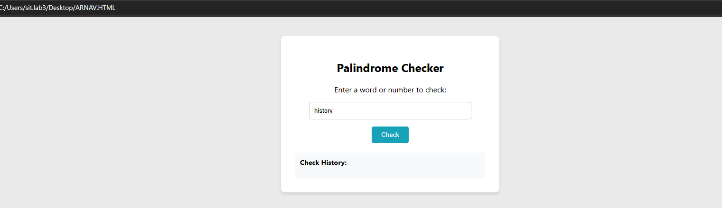

5. Case Study 04

Case Study Title:
Real-Time Case Study: ATM Card PIN Verification Using JavaScript Functions

Case Study Code:
- HTML Code:
<!DOCTYPE html>
<html lang="en">
<head>
<meta charset="UTF-8">
<meta name="viewport" content="width=device-width, initial-scale=1.0">
<title>Secure ATM Verification</title>
<style>
body { font-family: 'Courier New', Courier, monospace; background-color: #f1f2f6; display: flex; justify-content: center; align-items: center; height: 100vh; margin: 0; }
.atm-machine { background-color: #dfe4ea; padding: 20px; border-radius: 15px; border: 5px solid #a4b0be; width: 100%; max-width: 350px; text-align: center; box-shadow: 0 10px 20px rgba(0,0,0,0.2); }
.screen { background-color: #2f3542; color: #7bed9f; padding: 20px; border-radius: 5px; min-height: 120px; margin-bottom: 20px; border: 3px inset #57606f; }
h3 { margin-top: 0; font-size: 16px; color: #ced6e0; }
input { width: 80%; padding: 10px; text-align: center; font-size: 20px; letter-spacing: 5px; font-family: 'Courier New', Courier, monospace; background: #dfe4ea; border: none; border-radius: 3px; font-weight: bold; }
input:focus { outline: 2px solid #3742fa; }
button { margin-top: 20px; padding: 10px 30px; font-size: 16px; font-weight: bold; background-color: #ff4757; color: white; border: none; border-radius: 5px; cursor: pointer; box-shadow: 0 4px #c0392b; }
button:active { box-shadow: 0 0 #c0392b; transform: translateY(4px); }
.alert { color: #ff6b81; font-weight: bold; margin-top: 15px; }
.success { color: #7bed9f; font-weight: bold; margin-top: 15px; }
.student-id { font-size: 12px; color: #57606f; margin-bottom: 10px; font-family: Arial; }
</style>
</head>
<body>
<div class="atm-machine">
<div class="student-id">ATM Term | Session: Lokesh Polkam</div>
<div class="screen" id="displayScreen">
<h3>Please Enter 6-Digit PIN:</h3>
<input type="password" id="pinInput" maxlength="6" autocomplete="off">
</div>
<button onclick="handlePinSubmit()">ENTER</button>
</div>
<script src="script.js"></script>
</body>
</html>
- JavaScript Code:
// Function Declaration: Reverse the string
function reverseString(str) {
return str.split('').reverse().join('');
}
// Function Expression: Check for palindrome
const checkPalindrome = function(originalStr) {
const reversedStr = reverseString(originalStr);
return originalStr === reversedStr;
};
// Arrow Function: Generate the appropriate security message
const generateSecurityMessage = (isPal) => {
if (isPal) {
return "<div class='alert'>⚠️ CRITICAL ALERT ⚠️<br>Your PIN is a Palindrome!<br>This is highly insecure. Please change it immediately!</div>";
}
return "<div class='success'>✅ PIN Verified.<br>Standard Security Level.</div>";
};
// Main execution function using Local Scope
function handlePinSubmit() {
// Local variable
let pinInput = document.getElementById("pinInput").value;
let screen = document.getElementById("displayScreen");
if (pinInput.length !== 6 || isNaN(pinInput)) {
screen.innerHTML = "<h3 style='color: #ff6b81;'>ERROR: Invalid PIN Format.<br>Must be exactly 6 digits.</h3><br><button onclick='location.reload()' style='padding:5px; font-size:12px;'>RETRY</button>";
return;
}
// Call functions to process
let isPal = checkPalindrome(pinInput);
let msg = generateSecurityMessage(isPal);
// Display results to the screen
screen.innerHTML = `
<h3 style="color: #7bed9f;">Processing...</h3>
<p>Input: ****${pinInput.substring(4)}</p>
<p>Reversed: ****${reverseString(pinInput).substring(4)}</p>
${msg}
<br><button onclick='location.reload()' style='padding:5px; font-size:12px;'>RESET ATM</button>
`;
}

Case Study Output:
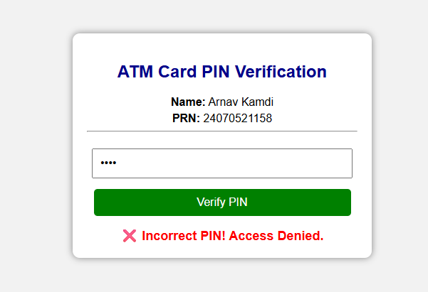

Result/Conclusion:
The palindrome checker was successfully developed. A closure was effectively implemented to securely store the history of checked words. The try-catch mechanism successfully intercepted invalid inputs, preventing application crashes, and the core algorithm correctly identified whether the provided strings were palindromes.

