Emotional Intelligence and Gender-Role Congruity in Startup Funding

Summary of Findings
Investors reward gender-role congruity, and the bias is sharpest among those least equipped to regulate it. The three significant results do not stand as isolated findings; they form a nested sequence that moves from a broad industry-level pattern, to a founder-level congruity effect, to its psychological moderator. Together they describe a single mechanism that links the gender-typing of the choice environment to the emotional competencies of the decision-maker.

Result 1: A Robust Industry Signal
Participants invested significantly more in SiteVision (ConTech, a male-typed industry) than in BalanceUp (Wellness, a female-typed industry). This within-person preference held across both experienced and inexperienced investors (p = .002 and p < .001) and was not moderated by experience (interaction p = .851). It is therefore a stable, population-wide preference for the male-typed venture rather than an artefact of any particular subsample. This establishes the gender-typing of the choice environment on which the founder-level effects build.

Result 2: Gender-Role Congruity Drives Funding
The pivotal finding is that startups occupying gender-congruent positions attract more funding than gender-incongruent ones. Comparing the two incongruent-versus-congruent cells, the congruity advantage was highly significant, t = 3.34, p = .001, with a medium-to-large effect, d = 0.62 — among the strongest effects in the dataset. The pattern persists within the inexperienced-investor subgroup (p = .010) and shows no significant experience moderation, indicating it is not confined to naïve participants.
Crucially, the mechanism is perceived viability. Gender-congruent ventures were rated as significantly more likely to succeed (M = 5.07 vs. 4.34, p = .002). This is not a confound that explains the bias away; it is the bias. Gender-role congruity operates exactly as theory predicts — by shaping perceived competence and success potential, which then channels capital. The success-perception pathway is the causal story, not a rival to it.
Figure 1
Investment by Founder Gender and Industry Typing
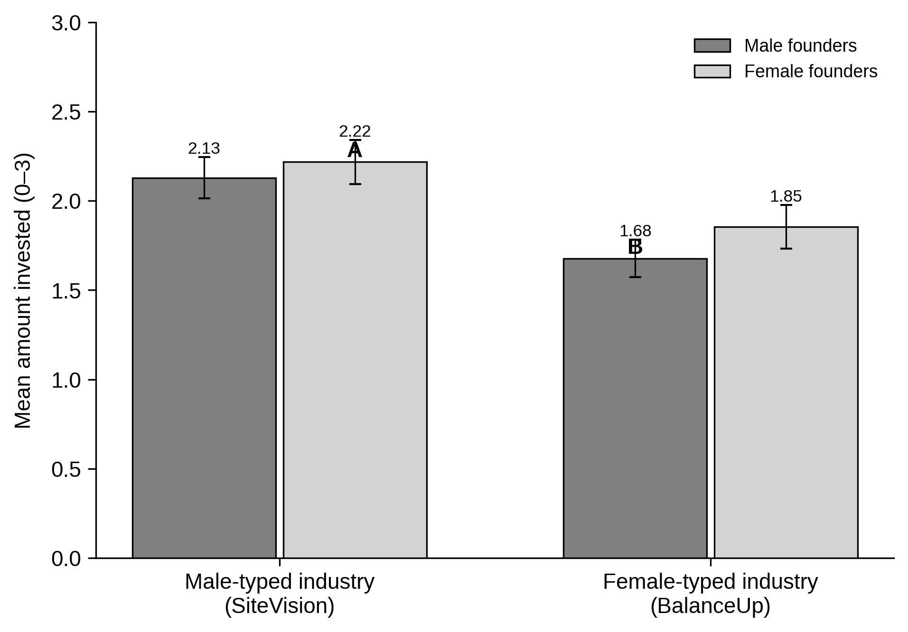
Note. A = female founders in the male-typed industry; B = male founders in the female-typed industry. Error bars represent ±1 SE.

Result 3: The Bias Intensifies When Emotional Intelligence Is Low
The congruity effect is psychologically moderated. Participants low in emotional intelligence showed a significant preference for the masculine-congruent over the feminine-congruent startup (one-tailed p = .032; Mann–Whitney p = .021), and this gap was strongest among inexperienced low-EI investors (p = .016). These participants rated the masculine-congruent venture as both more likely to succeed (p = .008) and were less deterred by its risk (p = .045) — a signature of heuristic, stereotype-consistent processing that is left unchecked by emotional self-regulation.
This is the theoretically richest result. Emotional intelligence acts as a corrective: where it is low, gender-role stereotypes translate directly into biased success judgments and biased capital allocation. The bias is not uniform across people but concentrates precisely where the cognitive and emotional capacity to override it is weakest.
Figure 2
Low-EI Participants: Masculine- vs. Feminine-Congruent Investment
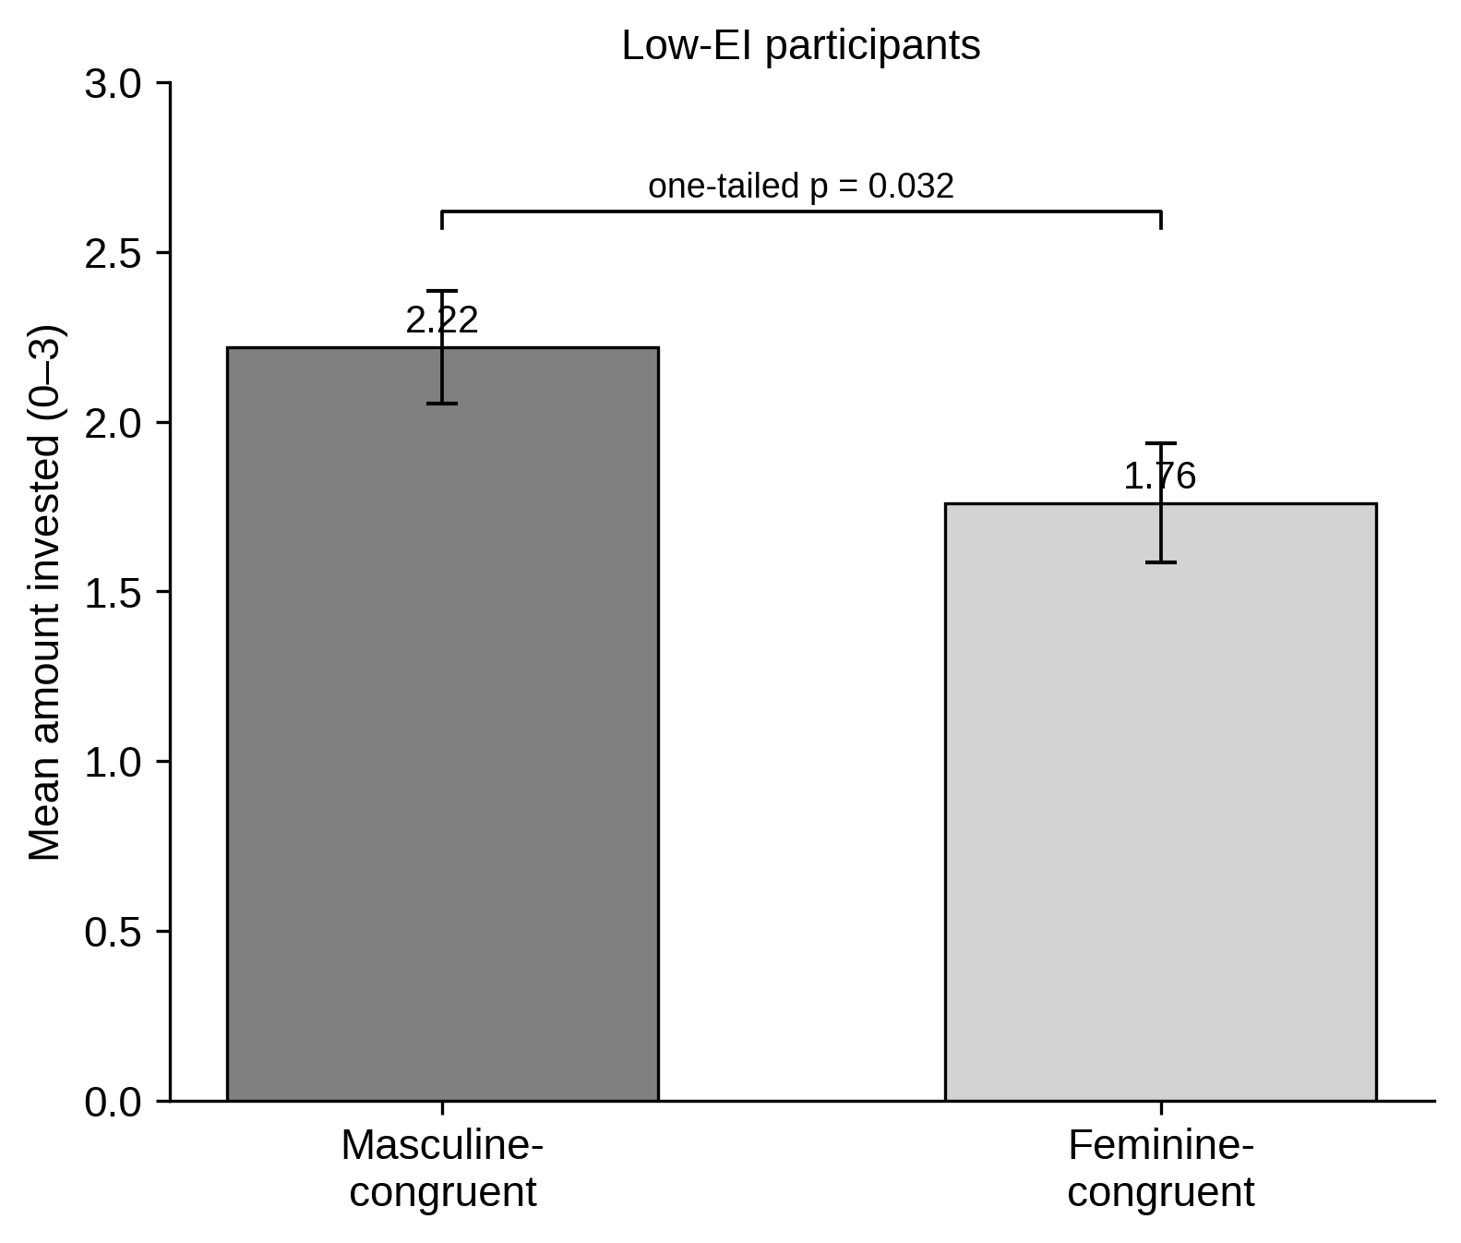
Note. Low EI defined by a median split on total WLEIS score. Error bars represent ±1 SE; the bracket reports the one-tailed test.

Integrated Interpretation
Together the three findings trace a single mechanism from context to person. A male-typed industry is favoured at the population level (Result 1); founders who fit their industry’s gender typing are rewarded with higher perceived viability and more funding (Result 2); and this congruity bias is amplified in low-EI decision-makers who rely on stereotype-driven heuristics (Result 3). The study therefore delivers both a robust main effect — gender-role congruity in funding — and a meaningful individual-difference moderator — emotional intelligence as a debiasing resource.
A further analysis confirms that the gender effect in these data is a congruity interaction rather than a simple main-effect funding gap. When allocations are collapsed to a raw male- versus female-founded comparison, the difference is non-significant (p = .257), and emotional intelligence does not moderate it (omnibus interaction p = .705). The bias surfaces only in the founder-by-industry congruity cells, which is exactly where Results 2 and 3 locate it. The locus of emotional intelligence’s influence is congruity, not raw founder gender — a finding with direct practical implication: improving investors’ emotional competencies may attenuate gender-congruity bias in capital allocation.

