Sample Description
A total of 187 participants were included in the final sample. Of the 230 recorded responses, 43 were excluded because they failed one of two manipulation checks: the correct recall of the start-ups’ industries (Q7) and the correct recall of the founding teams’ gender composition (Q8). Participants who indicated that they could not remember this information were likewise removed. Unless stated otherwise, the percentages reported below are based on the full sample of N = 187; for three variables a small number of participants did not provide an answer, in which case valid percentages and the respective sample size are reported.
The sample comprised a slight majority of female participants. As shown in Figure 1, 100 participants identified as female (53.5%) and 84 as male (44.9%), while 2 participants (1.1%) identified as non-binary and 1 (0.5%) preferred not to disclose their gender.
Figure 1
Gender Distribution of the Sample
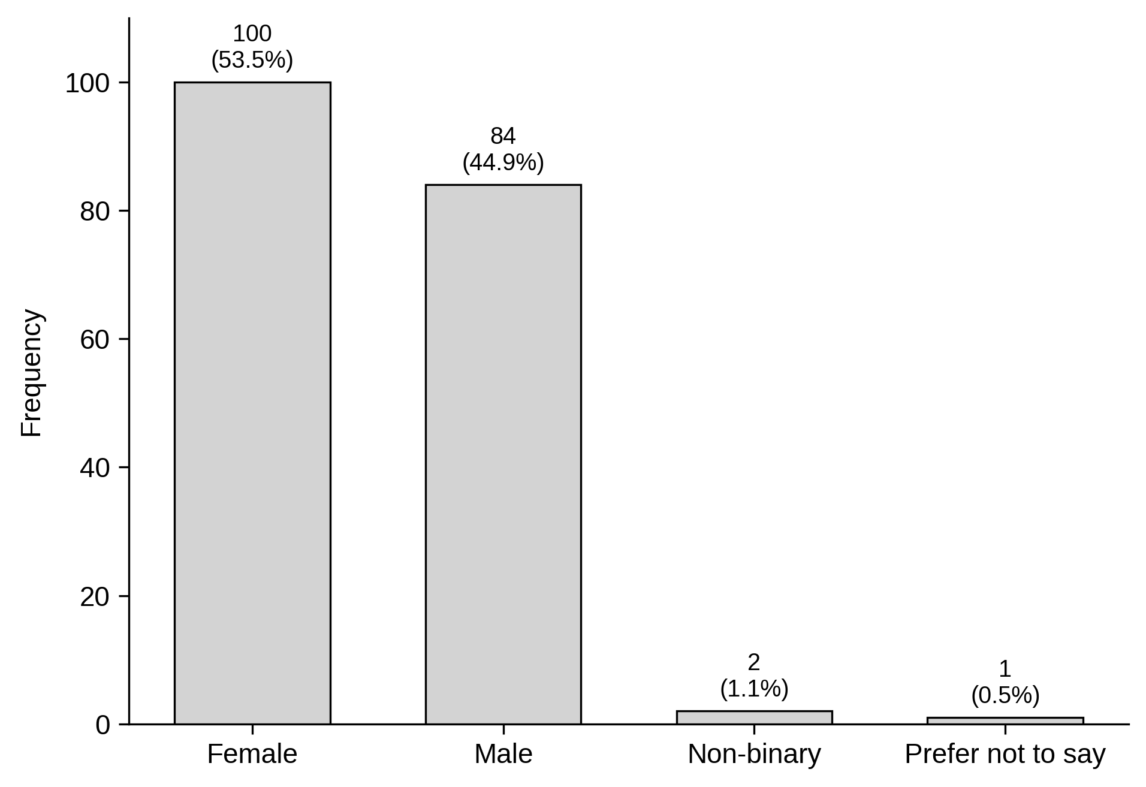
Note. N = 187.
Participants were on average 23.4 years old (SD = 4.8, Mdn = 22), ranging from 17 to 57 years. The majority fell into the 20–24 age bracket (56.1%), followed by the 25–29 group (26.7%), reflecting the predominantly student composition of the sample.
With respect to nationality, the sample was dominated by German (36.4%) and Austrian (26.7%) participants, who together accounted for roughly two thirds of respondents. The remaining third comprised a broad range of nationalities, most notably Ukrainian (5.3%), Bulgarian (4.8%), and Russian (4.3%). The full distribution is reported in Table 2.
In terms of education, most participants reported a higher-education entrance qualification (Matura/Abitur) as their highest completed degree (58.1%), followed by a Bachelor’s degree (34.1%; valid n = 179). Consistent with this, the majority were currently pursuing a Bachelor’s (59.8%) or a Master’s degree (27.4%). The most common field of study was Business Administration/Management (39.6%), and 60.9% of participants were enrolled at the Vienna University of Economics and Business (WU; valid n = 179).
Finally, 60.4% of participants reported prior experience with financial investments, whereas only 11.8% had previously founded or actively participated in founding a company. A complete overview of the sample’s demographic characteristics is provided in Table 1.
Table 1
Demographic Characteristics of the Sample (N = 187)
Characteristic | n | %
Gender
Female | 100 | 53.5
Male | 84 | 44.9
Non-binary | 2 | 1.1
Prefer not to say | 1 | 0.5
Age group
<20 | 22 | 11.8
20-24 | 105 | 56.1
25-29 | 50 | 26.7
30-39 | 7 | 3.7
40+ | 3 | 1.6
Highest completed education (valid n = 179)
Higher ed. entrance qual. (Matura/Abitur) | 104 | 58.1
Bachelor's degree | 61 | 34.1
Master's degree | 13 | 7.3
Vocational training | 1 | 0.6
Degree currently pursued (valid n = 179)
Bachelor's | 107 | 59.8
Master's | 49 | 27.4
PhD / Doctorate | 2 | 1.1
Other education | 3 | 1.7
Not currently pursuing a degree | 18 | 10.1
Field of study
Business Administration/Management | 74 | 39.6
Other | 19 | 10.2
Economics | 18 | 9.6
Social Sciences & Humanities | 16 | 8.6
Business Law | 12 | 6.4
Not currently studying | 12 | 6.4
Natural Sciences | 11 | 5.9
Business Informatics | 9 | 4.8
Engineering / Technical Sciences | 9 | 4.8
Finance | 4 | 2.1
Computer Science | 3 | 1.6
Enrolled at WU Vienna (valid n = 179)
Yes | 109 | 60.9
No | 70 | 39.1
Experience with financial investments
Yes | 113 | 60.4
No | 74 | 39.6
Entrepreneurial experience
Yes | 22 | 11.8
No | 165 | 88.2
Note. Age: M = 23.4, SD = 4.8, range 17–57. Percentages are based on N = 187 unless a valid n is indicated; the 8 participants missing on education, degree, and WU enrolment correspond to an earlier survey version.
Table 2
Nationality of Participants (N = 187)
Nationality | n | %
German | 68 | 36.4
Austrian | 50 | 26.7
Ukrainian | 10 | 5.3
Bulgarian | 9 | 4.8
Russian | 8 | 4.3
Hungarian | 5 | 2.7
Slovak | 4 | 2.1
Italian | 4 | 2.1
Romanian | 3 | 1.6
Polish | 2 | 1.1
Indian | 2 | 1.1
Turkish | 2 | 1.1
Guatemalan | 2 | 1.1
German & Dutch | 1 | 0.5
Chechen | 1 | 0.5
Bosnian | 1 | 0.5
Austrian & Croatian | 1 | 0.5
Serbian | 1 | 0.5
Swedish | 1 | 0.5
Latvian | 1 | 0.5
American | 1 | 0.5
Luxembourgish | 1 | 0.5
Colombian | 1 | 0.5
Albanian | 1 | 0.5
Portuguese | 1 | 0.5
Swiss | 1 | 0.5
Kazakh | 1 | 0.5
Austrian & Dutch | 1 | 0.5
Croatian | 1 | 0.5
Bulgarian & Turkish | 1 | 0.5
Hungarian & German | 1 | 0.5

