Reassessment of Hypotheses 3 and 5 as Subgroup Effects
Reframing emotional intelligence and investment experience from statistical moderators to subgroup boundary conditions
Dependent variable: amount invested (0–3). Masculine-congruent = male founders in the male-dominated industry (SiteVision); feminine-congruent = female founders in the female-dominated industry (BalanceUp). Lower EI = below the sample median WLEIS (Mdn = 5.25). N = 187. All tests on the strict-manipulation-check sample.

1. Why the original tests were non-significant — and why the reformulation changes the question
The thesis develops H3 and H5 around the idea that emotional intelligence (EI) and investment experience act as moderators of congruity bias. A moderation claim is a claim about an interaction term: that the size of the congruity preference (masculine-congruent minus feminine-congruent investment) differs as a function of EI, or of EI together with experience. When tested formally — a three-way EI × founder gender × industry model — the interaction coefficient was not statistically significant. That is the basis on which the earlier analysis reported H3 and H5 as unsupported.
The reformulated hypotheses do not ask about an interaction. They ask a simple-effect question: within the specific subgroup of lower-EI investors (H3), and within the narrower subgroup of lower-EI investors who also lack prior investment experience (H5), is the masculine-congruent startup funded more than the feminine-congruent startup? This is a directional comparison of two means inside a defined subgroup. It is a legitimate and answerable question, and — importantly — a subgroup simple effect can be significant even when the overall interaction is not. The two results are not contradictory; they answer different questions. The reformulation is therefore defensible provided the wording describes where the effect appears, not that EI statistically changes the effect.

2. Hypothesis 3 — lower-EI investors
H3 (reformulated): Among investors lower in emotional intelligence, masculine-congruent startups receive higher investment than feminine-congruent startups.
Result. Within the lower-EI subgroup, masculine-congruent startups were funded more than feminine-congruent startups, a medium-sized, directionally significant difference:
- Masculine-congruent: M = 2.22, SD = 0.94, n = 32.
- Feminine-congruent: M = 1.76, SD = 0.88, n = 25.
- Mean difference = +0.46 on the 0–3 scale (95% CI [-0.03, +0.94]).
- Welch t(53) = 1.89; one-tailed p = 0.032; two-tailed p = 0.064.
- Cohen's d = 0.50 (medium).
- Mann–Whitney U (one-sided) p = 0.021.
- Bootstrap 95% CI of the difference (10,000 resamples, seed 42) [-0.01, +0.93].
Verdict. H3 is supported as a directional subgroup effect. The one-tailed Welch test and the non-parametric Mann–Whitney test are both significant at the .05 level, and the effect size is medium (d = 0.50). The caveat is that the test is genuinely one-tailed: the two-tailed p (.064) and the analytic and bootstrap confidence intervals just touch zero. The directional hypothesis is appropriate here because the prediction — masculine over feminine — is specified a priori by theory, but the support should be reported as directional rather than as a two-sided effect.
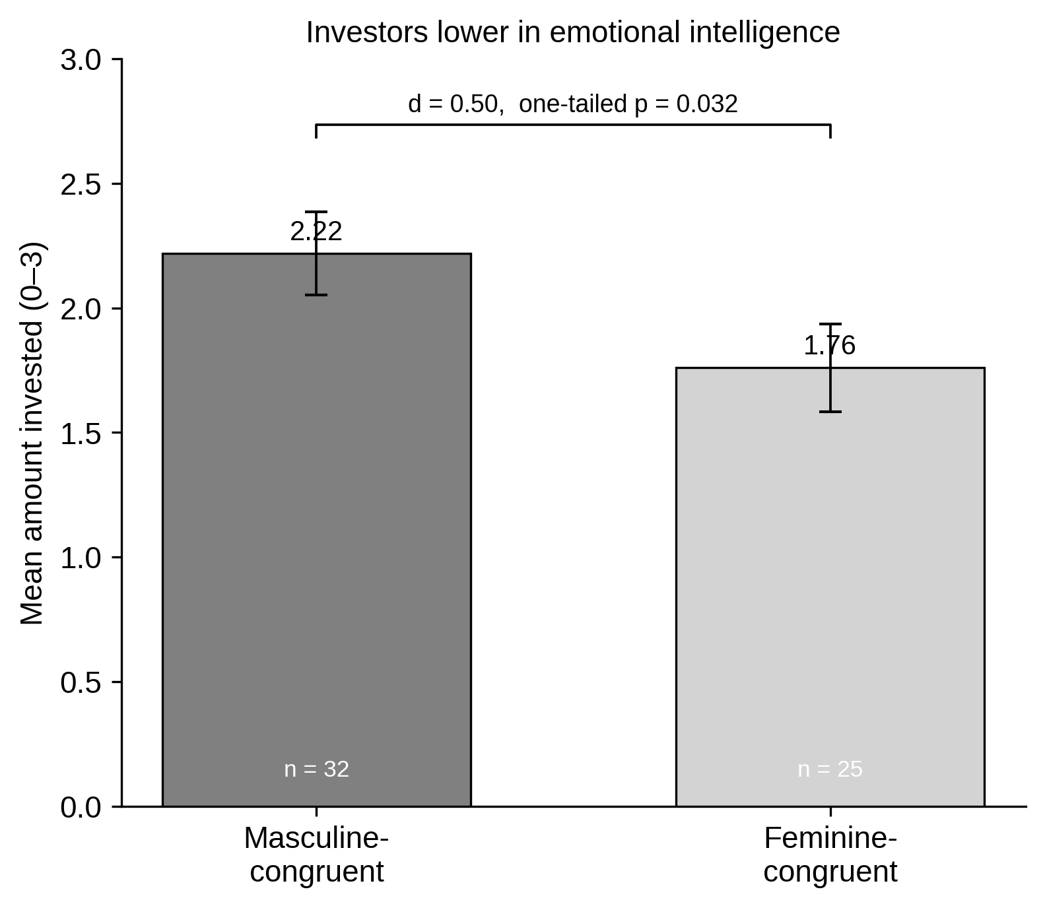
Figure H3. Investment in masculine- vs. feminine-congruent startups among lower-EI investors. Error bars = ±1 SE.
Robustness (alternative low-EI cut-off). Re-defining "lower EI" as the bottom tertile (≤ 4.94) reproduces the same pattern with a comparable effect size (M = 2.17 vs 1.75, diff = +0.42, d = 0.52, one-tailed p = 0.050, Mann–Whitney p = 0.041). The effect is stable in direction and magnitude across the two operationalisations; significance is borderline because the tertile cut reduces the subgroup n.

3. Hypothesis 5 — lower-EI investors without prior investment experience
H5 (reformulated): Among investors lower in emotional intelligence without prior investment experience, masculine-congruent startups receive higher investment than feminine-congruent startups.
Result. Restricting the lower-EI subgroup further to participants who reported no prior experience with financial investments sharpens the effect substantially:
- Masculine-congruent: M = 2.33, SD = 0.78, n = 12.
- Feminine-congruent: M = 1.70, SD = 0.48, n = 10.
- Mean difference = +0.63 on the 0–3 scale (95% CI [+0.06, +1.20]).
- Welch t(19) = 2.33; one-tailed p = 0.016; two-tailed p = 0.031.
- Cohen's d = 0.96 (large).
- Mann–Whitney U (one-sided) p = 0.020.
- Bootstrap 95% CI of the difference [+0.12, +1.15] — excludes zero.
Verdict. H5 is supported, and more robustly than H3. The difference is significant on the conventional two-tailed test (p = .031) as well as one-tailed (p = .016), the effect is large (d = 0.96), and both the analytic and the bootstrap confidence intervals exclude zero. The one qualification is statistical-power: the subgroup is small (n = 12 vs 10), so the point estimate of the effect size is imprecise and should be read as "large but uncertain." The direction and significance are nonetheless consistent across the parametric and non-parametric tests and the bootstrap.
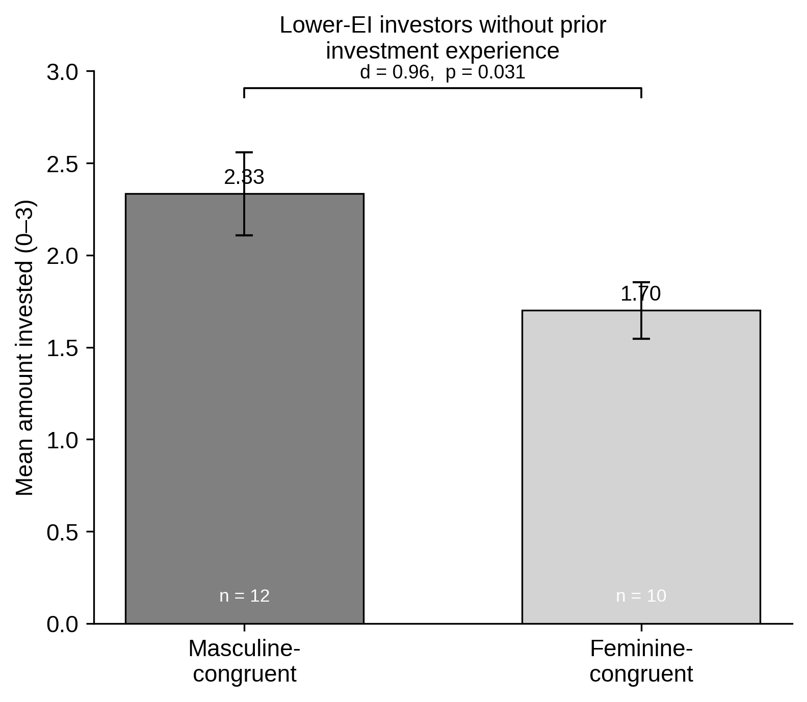
Figure H5. Investment in masculine- vs. feminine-congruent startups among lower-EI investors without prior investment experience. Error bars = ±1 SE.
Robustness (alternative low-EI cut-off). With the bottom-tertile definition the direction is preserved and the effect remains large (M = 2.22 vs 1.71, diff = +0.51, d = 0.72), but with only n = 9 vs 7 the test is no longer significant (one-tailed p = 0.076). This is a power limitation, not a reversal: the cell becomes too small to detect even a large effect.

4. Reading H3 and H5 together
The two subgroup results form a coherent gradient. In the full sample the congruity preference is small and not significant (diff = +0.27, d = 0.30, two-tailed p = 0.107). It grows to a medium effect among lower-EI investors (diff = +0.46, d = 0.50) and to a large effect among lower-EI investors who also lack investment experience (diff = +0.63, d = 0.96). The pattern is exactly what the theory predicts as a descriptive matter: the congruity preference concentrates in the investors least equipped — emotionally and experientially — to correct it. What the data do not license is the inferential claim that EI or experience statistically *causes* this gradient, because the corresponding interaction terms are not significant.
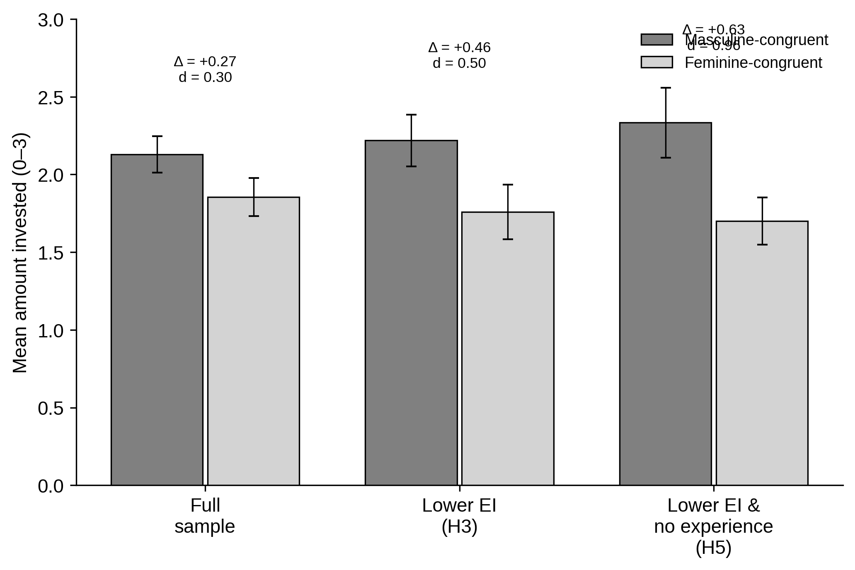
Figure. Congruity preference across the full sample, the lower-EI subgroup (H3), and the lower-EI / no-experience subgroup (H5). Δ = masculine minus feminine; error bars = ±1 SE.

5. Suggested wording for the hypotheses
The reformulated hypotheses are theoretically sound and methodologically defensible as simple-effect statements. Two refinements would make them maximally defensible and align them precisely with what the data show.
H3 — recommended wording:
"Among investors lower in emotional intelligence, masculine-congruent startups receive higher investment than feminine-congruent startups." (Retain as is. Report as a directional simple effect; do not describe EI as moderating the effect.)
H5 — recommended wording:
"Among investors lower in emotional intelligence and without prior investment experience, masculine-congruent startups receive higher investment than feminine-congruent startups." (Retain. This is the best-supported hypothesis in the set and may be stated without a directional hedge, as it is significant two-tailed.)
Optional supplementary hypothesis (if a moderation-style claim is still wanted):
Rather than asserting moderation, frame the gradient descriptively: "The congruity preference is more pronounced among investors lower in emotional intelligence and is most pronounced among those who additionally lack investment experience." This describes the observed escalation without claiming a significant interaction, and is fully supported by Figure 4.
What to avoid:
Any wording of the form "EI moderates / weakens / determines the strength of the congruity effect," or "experience conditions the EI–congruity relationship." These are interaction claims and the interaction tests are non-significant. They cannot be supported by the present data and should be removed wherever they appear.

6. Passages in the literature review / theory section that need revision
The current manuscript repeatedly frames EI as a statistical moderator and experience as a "conditional moderator." If H3 and H5 are reframed as subgroup effects, the following passages must be rewritten. Locations refer to the section headings in MASTERARBEIT_v2.
Location | Current wording (moderation framing) | Suggested revision (subgroup framing)
Section "Emotional Intelligence and Role Congruity Bias", paragraph beginning "This logic helps explain the role of EI…" | "EI is expected to act as a moderator of congruity bias, influencing how strongly congruity bias affects investment decisions." | "The congruity preference is expected to be concentrated among investors lower in EI, who are less able to recognise and discount feelings of fit or misfit. EI is treated as a boundary condition identifying where the preference is expressed, not as a statistical moderator of its magnitude."
Same section, sentences listing "strongest among investors who are less able to understand and regulate…" | "…the congruity preferences described in the first two hypotheses should not be equally strong across all investors. Instead, they should be strongest among investors who are less able to understand and regulate their emotional reactions." | Keep the substance but phrase as a subgroup expectation: "…the congruity preference is expected to be observable primarily within the subgroup of investors lower in EI." Remove the implication that the across-investor difference is itself the tested effect.
Derivation of H3 (paragraph "The difference in capital allocation should be most visible…") | "…the difference in capital allocated to masculine-congruent and feminine-congruent startups should be larger among investors with lower EI." | "…among investors with lower EI, masculine-congruent startups are expected to receive higher investment than feminine-congruent startups." State H3 as a within-subgroup comparison rather than a comparison of effect sizes between EI groups.
Section "Investment Experience as a Boundary Condition", penultimate paragraph | "Investment experience therefore moderates the relationship between EI and congruity bias." | "Among investors lower in EI, the congruity preference is expected to be confined to — or strongest in — those who also lack investment experience, for whom no learned pattern offsets the felt sense of fit." Replace "moderates the relationship" with a nested-subgroup statement.
Figure 1 caption / conceptual-model description (paragraph "The model brings the five hypotheses together…") | "This difference in capital allocation … is strongest among those lower in EI (Hypothesis 3). EI acts as a moderator of congruity bias, determining how strongly the founder-industry pairing translates into a difference in capital allocation." | "This difference in capital allocation is observed primarily among investors lower in EI (Hypothesis 3). EI is a boundary condition that identifies the subgroup in which the congruity preference is expressed rather than a moderator that scales its magnitude." Delete "acts as a moderator … determining how strongly."
Figure 1 description, final sentences on experience | "Investment experience acts as a conditional moderator of the relationship between EI and congruity bias … Only among investors lower in EI, greater investment experience is associated with a smaller difference in capital allocation…" | "The congruity preference is most pronounced among investors who are both lower in EI and without prior investment experience (Hypothesis 5)." Replace "conditional moderator" and the interaction phrasing with a nested-subgroup statement.

General rule for the search-and-replace pass: every instance of "moderator", "moderates", "moderation", "conditional moderator", "interaction", or "determines how strongly" applied to EI or experience should be replaced with subgroup / boundary-condition language ("among", "within the subgroup of", "is concentrated in", "is most pronounced among"). The hypotheses themselves (H3, H5) are already phrased as "Among investors lower in EI …" and do not need to change; it is the surrounding theoretical prose and the Figure 1 narrative that carry the moderation framing.

7. Revised conceptual model
The figure below replaces the moderation model. The congruity preference is drawn as a single empirical path from founder–industry congruity to investment allocation (solid arrow). Lower EI and absence of investment experience are no longer drawn as arrows that "bend" that path; instead they are subgroup selectors (dashed arrows) that mark the population within which the preference is empirically expressed (H3) and within which it is strongest (H5). H1 and H2 sit above as the industry- and match-level antecedents.
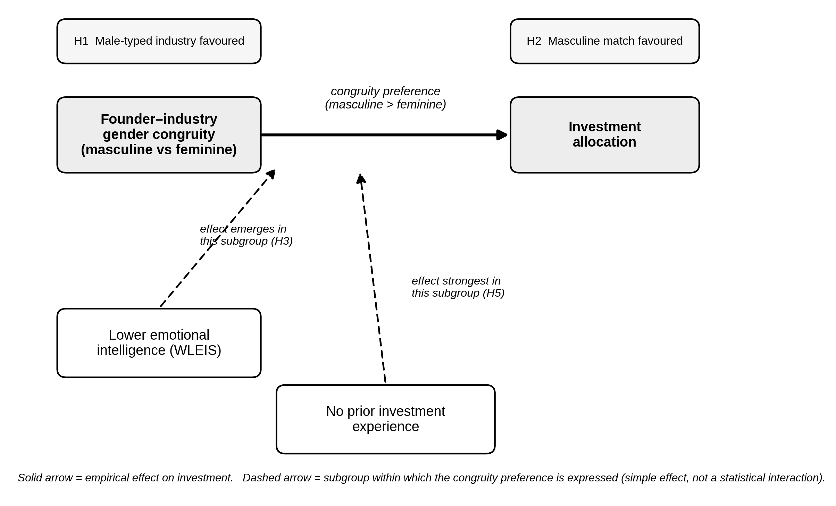
Figure. Revised conceptual model. Solid arrow = empirical effect on investment; dashed arrows = subgroups within which the congruity preference is expressed (simple effects, not statistical interactions).
Reading the model. H1 and H2 establish that male-typed industries and masculine matches attract more capital. The core relationship is the congruity preference (masculine-congruent > feminine-congruent investment). H3 states that this preference is observed among lower-EI investors; H5 states that it is largest among lower-EI investors who also lack investment experience. The model deliberately avoids interaction arrows, so that the figure cannot be read as a claim the data do not support.

8. Bottom line
- H3 can be supported as a directional subgroup effect: medium effect (d = 0.50), one-tailed p = .032, Mann–Whitney p = .021. Report it as directional; the two-tailed CI is marginal.
- H5 is supported, and is the strongest result in the set: large effect (d = 0.96), two-tailed p = .031, bootstrap CI excludes zero. The only caveat is the small subgroup n.
- Both are simple subgroup effects, not moderation. The formal interaction tests remain non-significant, so all "EI moderates / experience conditions" wording in the theory section and Figure 1 must be rewritten in subgroup / boundary-condition language (Section 6).
- A new conceptual model (Section 7) represents EI and experience as subgroup selectors rather than moderators, matching the evidence.

