Statistical Assessment of the Revised Hypotheses (H1–H5)
Master Thesis — Arne Floh | Cleaned sample N = 187 | June 2026
This report evaluates five hypotheses derived from the experimental results. Each is assessed for support, full statistical detail, robustness and methodological considerations, potential confounds and controls, a dedicated publication-style figure, and theoretical implications. The investment measure ranges from 0 to 3 per startup. Founder gender was manipulated between subjects (male / female / mixed teams, both startups sharing the condition); industry was within subjects (SiteVision = male-typed ConTech; BalanceUp = female-typed wellness); presentation order was counterbalanced. Emotional intelligence (EI) was measured with the 16-item WLEIS. Analyses excluding the mixed condition use N = 117 (62 male-, 55 female-founder).

H1 — Investors Allocate More to Male-Typed than Female-Typed Industries
Verdict: Supported (robust main effect, but order-moderated and success-mediated).
Interpretation. On a within-person basis participants invested substantially more in the male-typed venture (SiteVision) than in the female-typed venture (BalanceUp). This is the strongest and most reliable effect in the study and establishes the gender-typing of the choice environment.
Statistical results. SiteVision M = 2.20 (SD = 0.92); BalanceUp M = 1.72 (SD = 0.91). Mean within-person difference = 0.481, SE = 0.095, paired t(186) = 5.08, p < .001, 95% CI [0.294, 0.668], Cohen's d_z = 0.37. N = 187.
Methodological considerations. The effect is highly significant and survives an attention filter (dropping the fastest 5%: p < .001) and holds in both experience subgroups. It does not change sign across specifications. The paired design controls for between-person variance; assumptions (normality of differences, no extreme outliers) are satisfied and power is ample (achieved power > .99 for d_z = 0.37 at N = 187).
Potential confounds and controls. Two variables matter. First, perceived startup success: adding the success-probability difference reduces the industry coefficient to b = 0.147, p = .059, and the investment gap correlates r = .75 with the success gap, indicating that the effect operates largely through perceived viability. Second, pitch order: the industry × order interaction is b = 1.24, p < .001 — the preference is +1.08 (p < .001) when SiteVision is shown first but −0.15 (p = .24) when BalanceUp is shown first. Because order was balanced across conditions, the average effect is not confounded, but its generalizability is bounded by this order sensitivity. Participant gender and investment experience do not materially alter the effect.
Figure H1 Mean Investment by Industry Gender-Typing
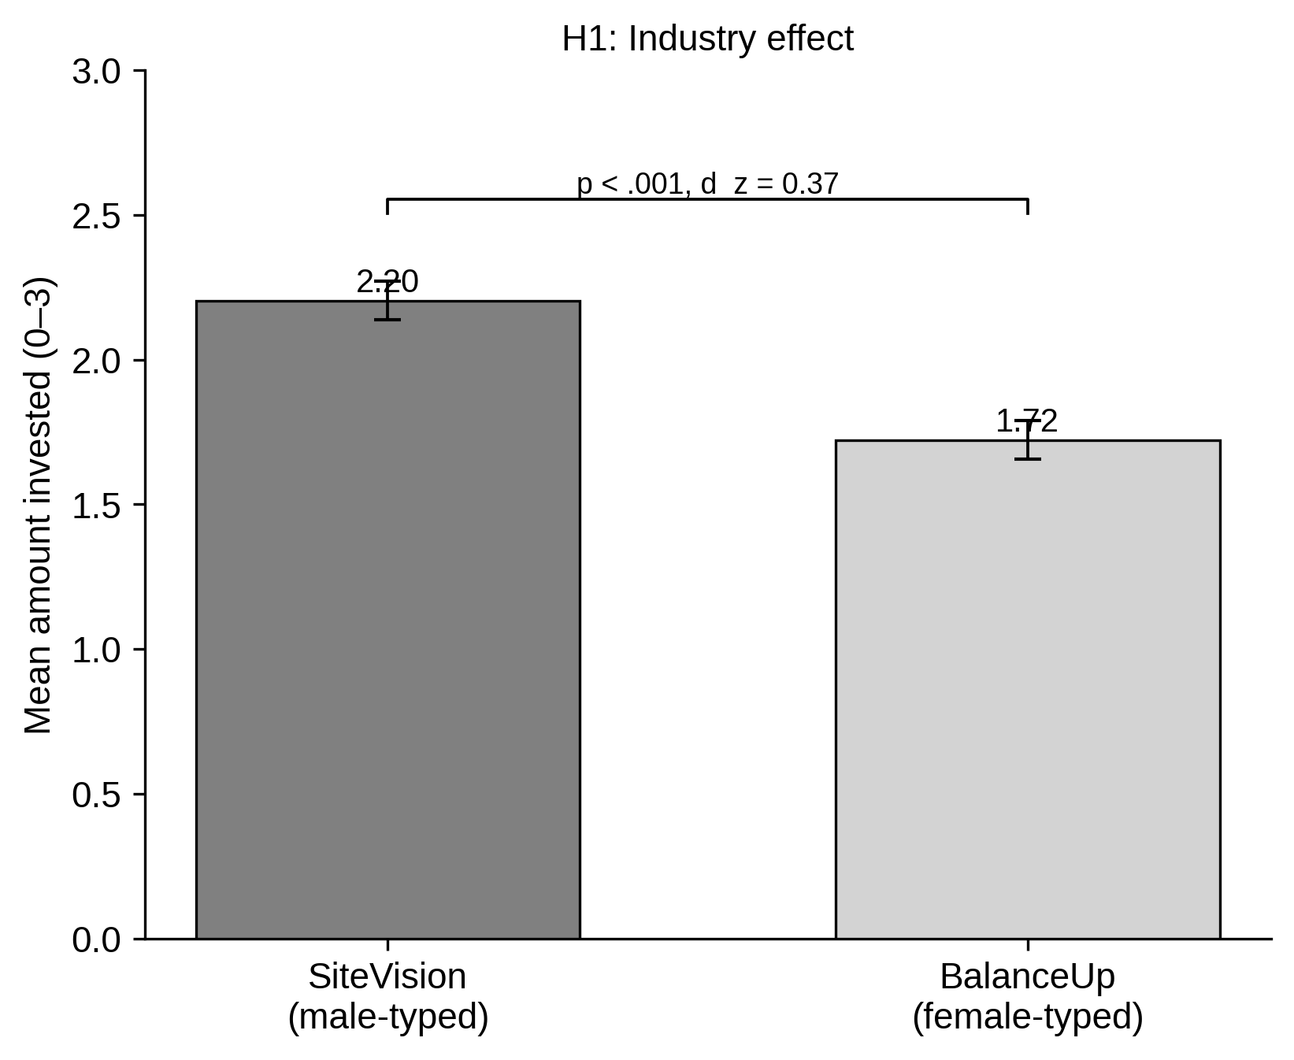
Note. Bars show mean amount invested (0–3) with ±1 SE; bracket reports the paired test. Interpret as a within-person preference for the male-typed venture. x-axis: startup / industry typing; y-axis: mean amount invested.
Implications. The result is consistent with role-congruity and lack-of-fit accounts at the industry level: the male-typed industry is read as more viable. It locates gender bias in the gender-typing of the sector rather than in founder gender per se, consistent with Tonoyan and Strohmeyer (2021) and Sperber and Linder.

H2 — Male Founders in Male Industries > Female Founders in Female Industries
Verdict: Not supported (two-tailed); partially / directionally supported only.
Interpretation. Comparing the two gender-congruent cells — a male founder in the male-typed industry (masculine-congruent) versus a female founder in the female-typed industry (feminine-congruent) — the masculine-congruent venture attracted numerically more capital, but the difference was not significant on a conventional two-tailed test. The non-parametric test was significant, so the evidence is suggestive rather than conclusive. This congruent-cell contrast should not be confused with the incongruent-cell comparison reported elsewhere (female-in-male vs male-in-female industry, t = 3.34, p = .001), which is the genuinely significant founder-by-industry result.
Statistical results. Masculine-congruent M = 2.13 (SD = 0.91, n = 62); feminine-congruent M = 1.85 (SD = 0.91, n = 55). Difference = 0.274, SE = 0.169, Welch t(113) = 1.62, two-tailed p = .107, one-tailed p = .054, 95% CI [−0.060, 0.609], Cohen's d = 0.30. Mann–Whitney U one-sided p = .041. N = 117.
Methodological considerations. The result is fragile: significant only under a directional or rank-based test and not under the standard two-tailed t. It is a between-subjects comparison, so it carries less power than the within-person H1; with n ≈ 60 per cell, power to detect d = 0.30 is only about .37, so the null is partly a power limitation. No influential outliers were detected.
Potential confounds and controls. Perceived success does not explain this contrast (adjusted b = −0.074, p = .602), unlike H1. Pitch order again moderates strongly: the masculine-congruent × order interaction is b = 1.51, p < .001, so the difference is concentrated in the SiteVision-first order. Participant gender and experience do not change the conclusion.
Figure H2 Investment in Masculine- versus Feminine-Congruent Startups
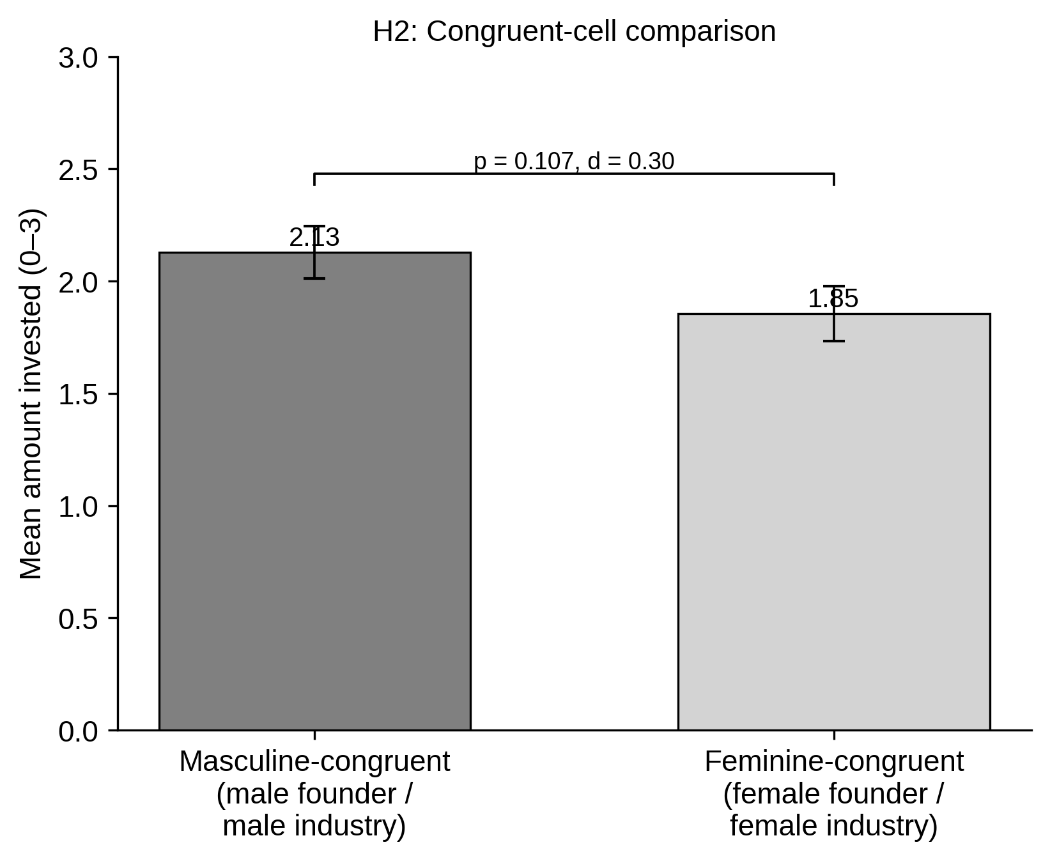
Note. Bars show mean amount invested (0–3) with ±1 SE; bracket reports the two-tailed Welch test and effect size. Interpret cautiously: the gap is small and significant only under directional/rank tests. x-axis: congruent cell; y-axis: mean amount invested.
Implications. Role-congruity theory predicts an advantage for gender-congruent founders. The direction is consistent with this, but the magnitude is small and unreliable, indicating that any pure founder-level congruity premium is weak once the dominant industry effect (H1) is set aside.

H3 — Lower-EI Investors Show a Larger Masculine-Congruent Preference
Verdict: Not supported (interaction non-significant; direction as predicted).
Interpretation. The hypothesis is that the masculine-versus-feminine congruence gap shrinks as EI rises. The estimated EI × congruence interaction is in the predicted direction — the gap is larger at lower EI (0.46) than at higher EI (0.10) — but it does not approach significance. A simple low-EI subgroup comparison is directionally significant (one-tailed p = .032), but the formal moderation test, which is what H3 asserts, is null.
Statistical results. OLS focal investment ~ congruence × EI (mean-centred), mixed condition excluded. Interaction b = −0.143, SE = 0.239, t(113) = −0.60, p = .553, 95% CI [−0.617, 0.332]. Model R² = .026, adjusted R² ≈ .000. N = 117. Median-split congruence gap: lower-EI = 0.46, higher-EI = 0.10.
Methodological considerations. The interaction is far from significant and the model explains essentially no variance. Re-running the moderation for each WLEIS dimension separately yields no significant interaction (smallest p = .328 for ROE; SEA p = .931, wrong-signed). Interaction tests are inherently low-powered, so a small true effect cannot be excluded, but the present data provide no support. No multicollinearity concern (predictors mean-centred; VIFs near 1).
Potential confounds and controls. Controlling for perceived success and pitch order leaves the interaction non-significant (b = −0.082, p = .671). The earlier low-EI subgroup effect is itself absorbed by perceived success, so the apparent EI patterning likely reflects success perception rather than EI-specific debiasing.
Figure H3 Congruence Gap at Lower versus Higher EI
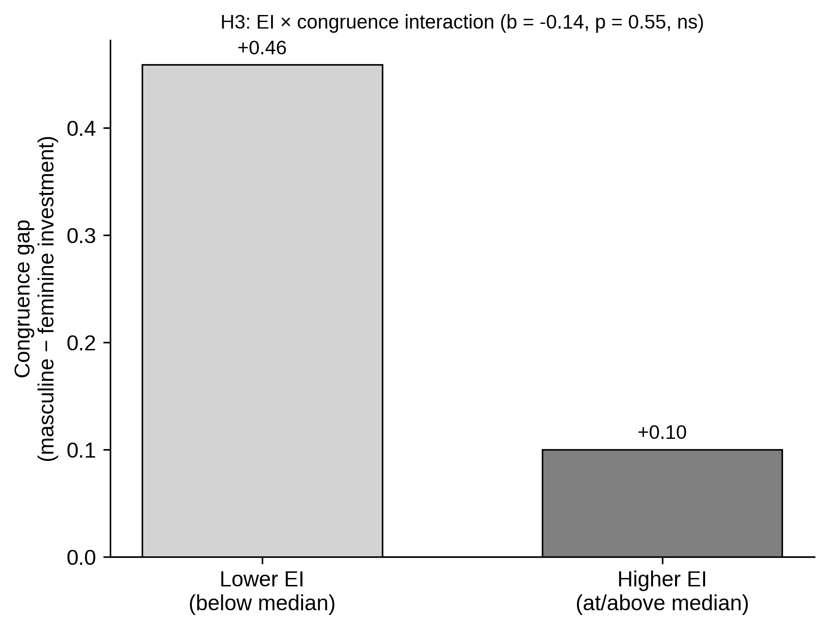
Note. Bars show the masculine-minus-feminine congruence gap (0–3 scale) within each EI half. A debiasing effect would appear as a much smaller bar at higher EI; the interaction is non-significant. x-axis: EI group; y-axis: congruence gap.
Implications. Emotional-intelligence theory predicts that higher EI attenuates stereotype-driven allocation. The direction is consistent but the effect is not statistically reliable, so the data do not support EI as a moderator of congruence bias in this sample.

H4 — Male Participants Score Lower on EI than Female Participants
Verdict: Supported (robust; concentrated in the appraisal dimensions).
Interpretation. Female participants reported significantly higher emotional intelligence than male participants, driven by the two appraisal facets (self- and others' emotion appraisal), with no difference on use or regulation of emotion.
Statistical results. Total EI: male M = 4.97 (SD = 0.71, n = 84), female M = 5.32 (SD = 0.77, n = 100). Difference = −0.348, SE = 0.109, Welch t(180) = −3.19, p = .002, 95% CI [−0.564, −0.133], Cohen's d = −0.47. By dimension: SEA d = −0.59, p < .001; OEA d = −0.66, p < .001; UOE d = −0.19, p = .206; ROE d = +0.11, p = .462. N = 184 (gendered respondents).
Methodological considerations. The effect is robust and well-powered. It is unchanged after adjusting for age and STEM field of study (adjusted gender b = 0.355, p = .002), and the two groups are well matched on these covariates (mean age 23.3 vs 23.6; STEM 23% vs 13%). No assumption violations of note.
Potential confounds and controls. Age and field do not account for the difference. Note a design implication: because EI is correlated with participant gender, any analysis that conditions EI moderation on participant gender operates on a restricted EI range within each gender and loses sensitivity.
Figure H4 WLEIS Scores by Participant Gender
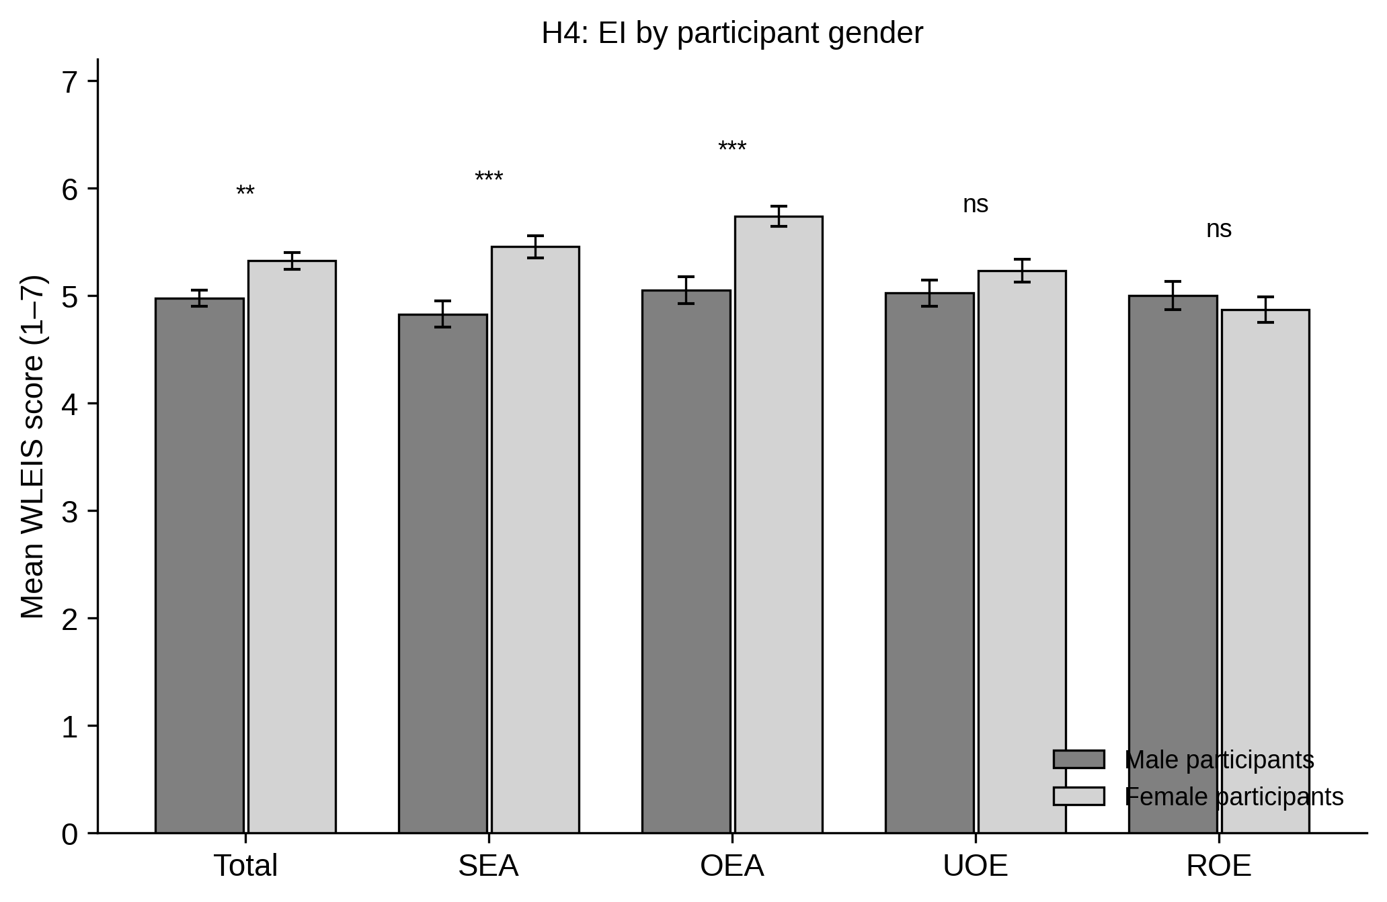
Note. Bars show mean WLEIS scores (1–7) with ±1 SE for male and female participants across the total scale and four dimensions. * p < .05, ** p < .01, *** p < .001, ns = not significant. x-axis: EI dimension; y-axis: mean score.
Implications. The pattern matches the broader EI literature: women score higher on perceiving and appraising emotions, with negligible differences in regulation and instrumental use. It also provides an ironic counterpoint to the "women are more emotional / less rational" stereotype discussed in the review, since women here showed higher measured emotional ability.

H5 — Among Low-EI Investors, Experience Shrinks the Congruence Gap
Verdict: Not supported (interaction non-significant; direction as predicted).
Interpretation. Within the low-EI subgroup, the masculine-versus-feminine congruence gap was numerically smaller among investors with prior investment experience (0.35) than among those without (0.63), consistent with the idea that experience dampens stereotype-driven allocation. However, the moderation is not statistically significant and the subgroup is small.
Statistical results. OLS within low-EI: focal investment ~ congruence × experience. Interaction b = −0.283, SE = 0.509, t = −0.56, p = .580, 95% CI [−1.304, 0.737]. Model R² = .067, adjusted R² = .014. N = 57 (no-experience n = 22; experience n = 35). Congruence gap: no experience = 0.63, experience = 0.35.
Methodological considerations. This is the least powered test in the set: a three-way contingency (low-EI × congruence × experience) estimated on 57 observations split into four cells as small as 10–20. Power to detect even a moderate interaction is very low, so the non-significant result is uninformative about a true effect. The wide confidence interval reflects this. No outlier or assumption issues beyond the sample-size limitation.
Potential confounds and controls. Given the negligible power, formal confound adjustment is not informative; the descriptive direction is consistent with experience as a secondary debiasing factor, but the data cannot establish it. Pitch order again underlies the broader congruence effect.
Figure H5 Congruence Gap by Investment Experience (Low-EI Investors)
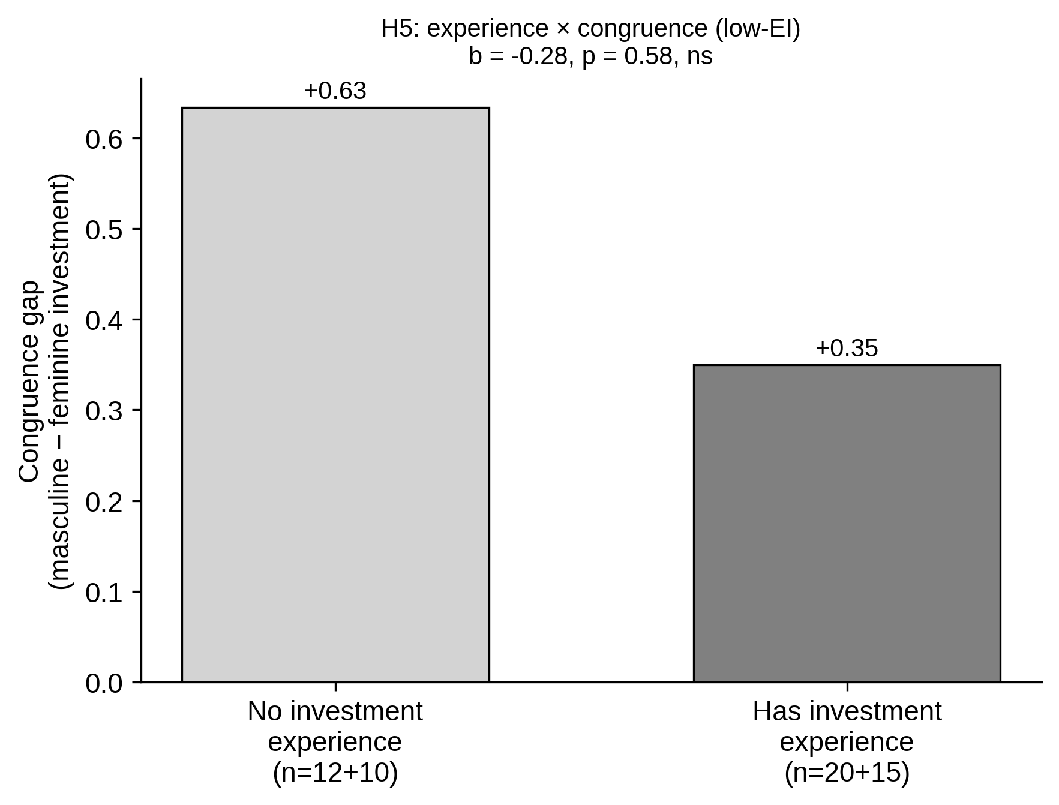
Note. Bars show the masculine-minus-feminine congruence gap (0–3 scale) within the low-EI subgroup, split by prior investment experience. A smaller bar for experienced investors would support H5; the interaction is non-significant. x-axis: experience group; y-axis: congruence gap.
Implications. The descriptive pattern is compatible with learning- or expertise-based debiasing accounts, whereby experienced investors rely less on gender-typed heuristics. The study is underpowered to test this, so it is best framed as a direction for future, adequately powered research.

Summary of Outcomes
Hypothesis | Key statistic | Outcome
H1 Industry effect | t(186) = 5.08, p < .001, d_z = 0.37 | Supported (order-moderated)
H2 Congruent cells | t(113) = 1.62, p = .107; MW p = .041, d = 0.30 | Not supported (directional only)
H3 EI moderation | b = −0.14, p = .553 | Not supported
H4 EI by gender | t(180) = −3.19, p = .002, d = −0.47 | Supported
H5 Experience × congruence | b = −0.28, p = .580 | Not supported (underpowered)

Overall, the two reliable findings are the industry effect (H1) and the EI gender difference (H4). The founder-level congruence comparison (H2) is only directionally supported, and the two EI-moderation hypotheses (H3, H5) are not supported, although both interactions point in the predicted direction and are limited by the low power of interaction tests on between-subjects cells. Across the significant results, perceived success and pitch order are the two variables that most materially shape interpretation: success perception mediates the effects, and presentation order moderates them.

