Spill-Over in Consumption Systems: Negativity Dominance in Holistic Appraisal but Symmetric Transfer to Component-Specific Evaluations
Results and Discussion

Abstract
We examine evaluative spill-over between the components of a consumption system—a bundled mobile telecommunications service and the mobile phone through which that service is necessarily consumed. In a scenario-based, between-subjects experiment (N = 258), we held the valence of one component constant and introduced a second, oppositely valenced component. A poorly performing phone significantly reduced evaluations of an otherwise excellent service, and an excellent phone significantly improved evaluations of an otherwise poor service, on both satisfaction and loyalty/word-of-mouth (|d| = -.39–-.63). Critically, the data reveal a dissociation. When consumers appraised the situation as a whole, the negative component dominated: a bad phone shifted holistic appraisal nearly twice as far as a good phone (d = -1.88 vs. 1.03), p = .001. Yet when consumers evaluated the focal service specifically, the two spill-overs were statistically indistinguishable in magnitude (all ps > .70). Negativity dominance therefore characterizes the integration of components into a global impression, but not the cross-component transfer that shapes component-specific evaluations. We discuss implications for the separability of spill-over and negativity dominance, and for complement investment in consumption-system design.

The Present Research
Consumers increasingly acquire goods and services as interdependent bundles—consumption systems—in which the experience of one component is inseparable from another. A streaming subscription is consumed through a device; a mobile data plan is experienced through a handset. When the components of such a system diverge in quality, how does the evaluation of one component shape the evaluation of the other? Two literatures offer competing predictions. Research on negativity bias and negativity dominance holds that “bad is stronger than good”: negative information is weighted more heavily and is more diagnostic than equally extreme positive information (Baumeister, Bratslavsky, Finkenauer, & Vohs, 2001; Rozin & Royzman, 2001; Ahluwalia, 2002). This predicts an asymmetric spill-over—a weak component should damage a strong one more than a strong component repairs a weak one. By contrast, accounts grounded in information integration and evaluative consistency (Anderson, 1971; Yadav, 1994) treat cross-component transfer as an anchoring-and-adjustment process whose magnitude need not differ by valence, predicting symmetric spill-over.
We test these predictions in a setting that holds the spill-over relationship fixed while varying the valence of the transferring component, and—crucially—we distinguish two judgment targets: a holistic appraisal of the consumption situation as a whole, and evaluations of the focal service specifically (satisfaction, loyalty, and word-of-mouth). As we show, the answer to “which spill-over is stronger?” depends entirely on which target one measures, yielding a theoretically informative dissociation.

Method

Participants and Design
Members of a university research pool completed the study online via Qualtrics over an 11-day field period (November 2025). Of 265 records, 7 did not reach the experimental manipulation and were excluded, yielding a final sample of N = 258 (women = 134, men = 122; Mₐₑₑ = 21.3 years, SD = 2.3). Participants were randomly assigned by the survey engine to one of four between-subjects conditions in a single-factor design (cell ns = 64, 73, 50, and 69 for conditions A–D, respectively; randomization did not enforce equal cell sizes).

Procedure and Stimuli
Participants read an experience report describing a bundled offering: a mobile phone and a mobile-phone provider purchased together as a package, such that “you cannot use your cell phone without the services of your mobile phone provider, and you cannot use the services… without your cell phone.” The report then characterized component quality. In the two single-component (baseline) conditions, only the service was described—positively (condition A, Service+) or negatively (condition B, Service−). In the two incongruent conditions, a positively described service was paired with a negatively described phone (condition C, Service+/Phone−), or a negatively described service was paired with a positively described phone (condition D, Service−/Phone+). All dependent measures referred to the service/provider, never the phone. The two focal contrasts therefore isolate cross-component spill-over: A vs. C tests whether a negative phone drags down an otherwise positive service (negative spill-over), and B vs. D tests whether a positive phone lifts an otherwise negative service (positive spill-over).

Measures
A single bipolar item assessed the holistic situation appraisal (“How do you assess this situation?”; 1 = positive to 6 = negative; reverse-scored such that lower numbers indicate more positive appraisal). Satisfaction with the service was measured with five 7-point Likert items (α = .97), and loyalty/word-of-mouth with seven 7-point items (α = .95). A two-item perceived value scale was also administered. As detailed below, an export anomaly rendered the value items effectively binary with substantial missingness; value results are therefore reported for completeness but interpreted with caution. Higher scores indicate more favorable evaluations on all dependent measures.

Results

Analytic Strategy and Measurement Quality
Multi-item scales were averaged after confirming their structure. A maximum-likelihood confirmatory factor analysis of the five satisfaction items (one factor, n = 256) fit well by incremental and residual-based criteria, CFI = .971, SRMR = .017, with standardized loadings of .88–.94, average variance extracted = .85, and composite reliability = .97. (The model χ² and RMSEA were inflated by the near-singular inter-item correlation matrix, det = .002—a known artifact when items are highly correlated—so CFI and SRMR are the appropriate indices here.) The loyalty scale was constructed after correcting a survey-programming error in which one condition repeated a single word-of-mouth item and omitted an online-word-of-mouth item; we built a seven-item, content-aligned scale comparable across conditions (α = .95). For the two-item value scale, only the scale endpoints were exported (yielding three possible mean values, 1/4/7) with ~50% missingness; the underlying items were near-redundant (tetrachoric ρ = 1.00, KR-20 = .92, n = 63 complete cases), precluding meaningful confirmatory modeling.
Because Levene’s test indicated heterogeneity of variance across conditions, we report Welch’s t-test (which does not assume equal variances) as the primary inferential test for all focal contrasts, accompanied by Cohen’s d and 95% confidence intervals; Mann–Whitney U tests provide a nonparametric robustness check and serve as the primary test for the ordinal/binary value scale. Cell descriptive statistics for all measures appear in Table 1.
Table 1. Means (Standard Deviations) by Experimental Condition.
Measure | A: Service+ | B: Service− | C: Service+/Phone− | D: Service−/Phone+
Situation appraisal (1–6)ᵃ | 2.50 (1.31) | 5.07 (0.97) | 4.60 (0.81) | 3.89 (1.30)
Satisfaction (1–7) | 4.96 (1.43) | 2.48 (1.52) | 4.16 (1.70) | 3.13 (1.78)
Loyalty/WOM (1–7) | 4.89 (1.42) | 2.31 (1.14) | 4.07 (1.60) | 3.21 (1.69)
Value (1–7)ᵇ | 6.17 (2.10) | 2.38 (2.41) | 6.16 (2.03) | 3.60 (2.92)
Repurchase intention (1–7) | 5.19 (1.64) | 2.21 (1.64) | 3.98 (2.03) | 3.07 (1.97)
n (satisfaction) | 64 | 73 | 50 | 69
Note. ᵃ Situation appraisal is scored 1 = positive to 6 = negative (lower = more favorable). ᵇ Value items were exported as endpoints only with ~50% missingness; cell n for value = 36, 37, 25, 30 for A–D.

Manipulation Check: Holistic Situation Appraisal
The service manipulation strongly affected the holistic appraisal of the situation, F(3, 254) = 64.24, p < .001, η² = .43. Collapsing across the phone factor, service-positive conditions were appraised far more favorably than service-negative conditions, t = 6.00, p < .001. All four conditions differed from the scale midpoint (all ps < .05). Notably, Tukey-adjusted comparisons showed that the only nonsignificant pairwise difference was between the negative-service baseline (B) and the positive-service/negative-phone condition (C), p = .11: a single negative component (the phone) pulled the holistic appraisal of an otherwise positive service down to the level of a wholly negative service. This previews the asymmetry analyzed below. Figure 1 displays the pattern.
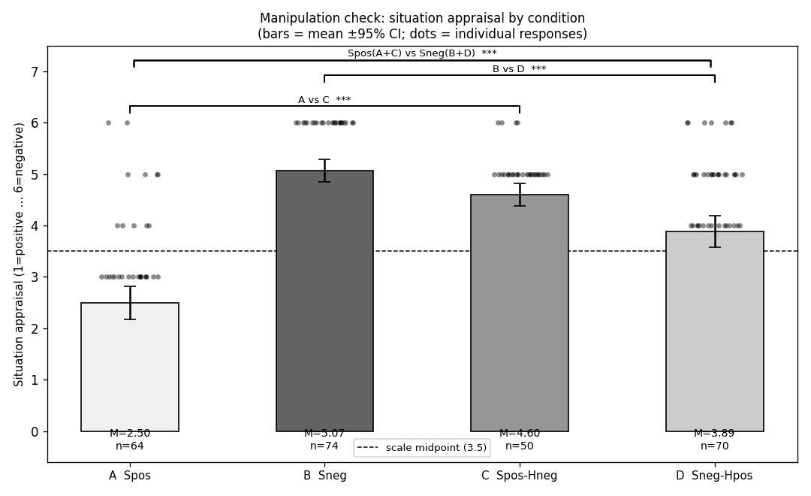
Figure 1. Holistic situation appraisal by condition (1 = positive to 6 = negative). Bars are means with 95% confidence intervals; points are individual responses.

Omnibus Effects on Service Evaluations
Condition reliably affected both focal service evaluations, with large effects: satisfaction, F(3, 252) = 31.06, p < .001, η² = .27; loyalty/WOM, F(3, 252) = 38.53, p < .001, η² = .31. Means ordered monotonically from the fully positive service (A) through the two incongruent conditions to the fully negative service (B): on satisfaction, 4.96 (A) > 4.16 (C) > 3.13 (D) > 2.48 (B). The intermediate position of the incongruent conditions indicates that each evaluation was pulled toward the valence of the added phone—the signature of spill-over.

Focal Spill-Over Contrasts
Negative spill-over (A vs. C). Introducing a negative phone alongside a positive service significantly reduced service evaluations. Satisfaction fell from M = 4.96 to 4.16, a difference of 0.80, 95% CI [0.20, 1.39], t(95) = 2.66, p = .009, d = .51; loyalty/WOM fell from 4.89 to 4.07, t(99) = 2.83, p = .006, d = .54. Both effects held under the nonparametric test (ps = .012 and .008). Value did not differ (p = .990).
Positive spill-over (B vs. D). Introducing a positive phone alongside a negative service significantly improved service evaluations. Satisfaction rose from M = 2.48 to 3.13, a difference of -0.65, 95% CI [-1.20, -0.10], t(134) = -2.33, p = .021, d = -.39; loyalty/WOM rose from 2.31 to 3.21, t(118) = -3.69, p < .001, d = -.63. Both effects held nonparametrically (ps = .029 and .001). Value again did not reach significance (p = .071). Table 2 summarizes both contrasts; Figure 2 displays the comparisons.
Table 2. Focal Spill-Over Contrasts (Welch's t-test; Mann–Whitney robustness).
Contrast / Scale | n₁ | n₂ | M₁ / M₂ | Diff [95% CI] | t | p | d | MWU p
Negative (A vs. C)
Satisfaction | 64 | 50 | 4.96 / 4.16 | +0.80 [+0.20, +1.39] | 2.66 | .009 ** | .51 | .012
Loyalty/WOM | 64 | 50 | 4.89 / 4.07 | +0.81 [+0.24, +1.39] | 2.83 | .006 ** | .54 | .008
Valueᵇ | 36 | 25 | 6.17 / 6.16 | +0.01 [-1.07, +1.08] | 0.01 | .990 n.s. | .00 | .877
Positive (B vs. D)
Satisfaction | 73 | 69 | 2.48 / 3.13 | -0.65 [-1.20, -0.10] | -2.33 | .021 * | -.39 | .029
Loyalty/WOM | 73 | 69 | 2.31 / 3.21 | -0.90 [-1.38, -0.42] | -3.69 | .000 *** | -.63 | .001
Valueᵇ | 37 | 30 | 2.38 / 3.60 | -1.22 [-2.55, +0.11] | -1.84 | .071 n.s. | -.46 | .074
Note. M₁/M₂ are the means of the first/second condition in each contrast. d = Cohen’s d. ᵇ Value rests on compromised binary/partial data and should be interpreted with caution. * p < .001, p < .01, * p < .05.
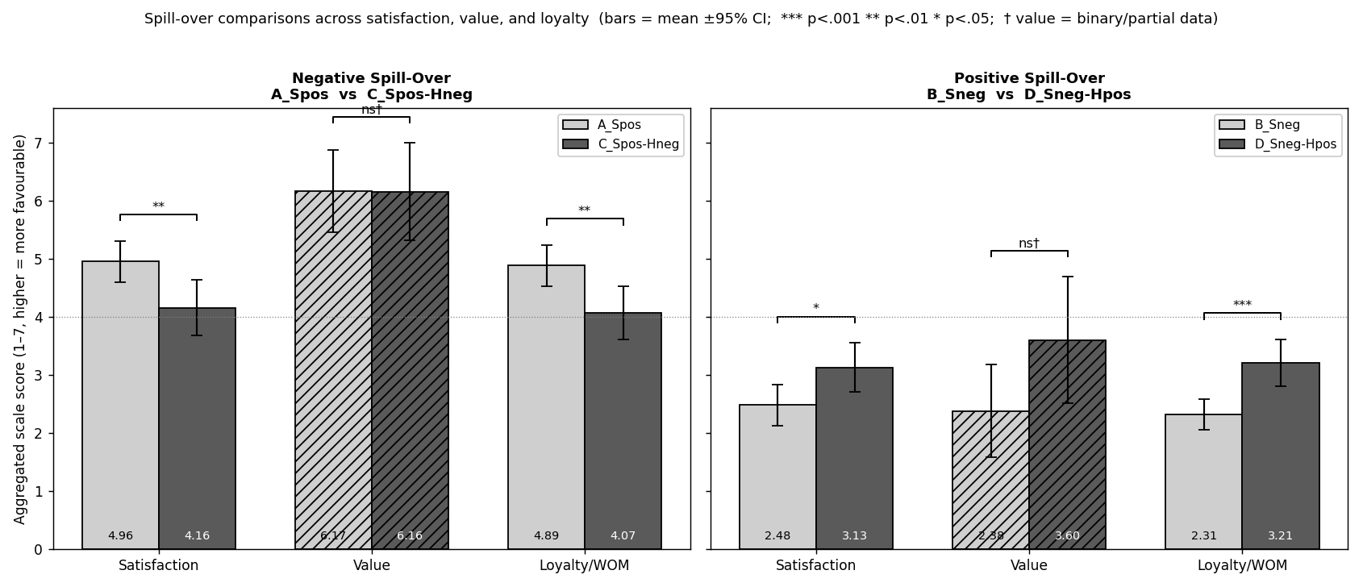
Figure 2. Spill-over comparisons across satisfaction, value, and loyalty/WOM. Left: negative spill-over (A vs. C). Right: positive spill-over (B vs. D). Bars are means with 95% confidence intervals; hatched value bars rest on compromised data.

Is One Spill-Over Stronger? A Test of Symmetry
To test directly whether the negative and positive spill-overs differed in magnitude, we computed a difference-in-differences contrast across the four cells, |A − C| − |D − B|, for each measure (Table 3). On the service-specific evaluations the two spill-overs were statistically indistinguishable: satisfaction, 0.80 vs. 0.65 points, t(216) = 0.36, p = .717; loyalty/WOM, 0.81 vs. 0.90 points, t(203) = -0.22, p = .829. In sharp contrast, on the holistic situation appraisal the negative component moved judgments markedly more than the positive component did (2.10 vs. 1.18 points; d = -1.88 vs. 1.03), t(230) = 3.31, p = .001. The asymmetry that defines negativity dominance thus emerged for the global appraisal but vanished for the component-specific evaluations.
Table 3. Test of Spill-Over Symmetry (Difference-in-Differences).
Measure | Negative spill-over | Positive spill-over | Difference | t (df) | p
Situation appraisalᵃ | 2.10 | 1.18 | +0.92 | 3.31 (230) | .001 **
Satisfaction | 0.80 | 0.65 | +0.15 | 0.36 (216) | .717 n.s.
Loyalty/WOM | 0.81 | 0.90 | -0.08 | -0.22 (203) | .829 n.s.
Valueᵇ | 0.01 | 1.22 | -1.21 | -1.42 (106) | .158 n.s.
Note. Entries are spill-over magnitudes in scale points. ᵃ For situation appraisal, magnitudes are |C − A| and |B − D| (lower = more positive). ᵇ Compromised data. ** p < .01.

Discussion
Across two focal contrasts, the components of a consumption system spilled over onto one another: a deficient phone significantly eroded satisfaction and loyalty toward an otherwise excellent service, and an excellent phone significantly bolstered satisfaction and loyalty toward an otherwise deficient service. Both spill-overs were medium-sized, directionally consistent, and robust to nonparametric tests. These results establish that evaluations of a focal offering are systematically contaminated by the perceived quality of an inseparable complement, even when consumers are asked exclusively about the focal offering.

The Central Dissociation: Asymmetric Appraisal, Symmetric Transfer
The study’s most theoretically consequential finding is a dissociation in where negativity dominance appears. When participants rendered a holistic appraisal of the consumption situation, the negative component dominated: a poor phone moved the global judgment almost twice as far as an excellent phone did, and a single negative component was sufficient to drag the appraisal of an otherwise positive system down to the level of a wholly negative one. This is a textbook expression of “bad is stronger than good” (Baumeister et al., 2001; Rozin & Royzman, 2001). Yet when the very same manipulation was evaluated through the lens of the focal service—satisfaction, loyalty, and word-of-mouth—the asymmetry disappeared: positive and negative components transferred onto the service in equal measure. Negativity dominance, in other words, was a property of the global integration of components into a single impression, not of the cross-component transfer itself.
We see at least four, non-mutually-exclusive mechanisms for this dissociation, each generating testable predictions.
First, the level of judgment changes what is being integrated. A holistic appraisal asks the consumer to combine all components into one gestalt. In such integration, the worst element is disproportionately diagnostic of the whole—one defective part can spoil an entire system—so negative information is over-weighted (a min-like or negatively accelerated integration rule). A component-specific judgment, by contrast, takes the focal component as the anchor and treats the complement as an adjustment. Anchoring-and-adjustment (Yadav, 1994) and averaging models (Anderson, 1971) imply that the adjustment can be symmetric in valence, because the complement is not being asked to define the category membership of the target.
Second, diagnosticity is target-dependent (Herr, Kardes, & Kim, 1991; Skowronski & Carlston, 1989). For the question “Is this whole situation good?” a negative cue is highly diagnostic—negative information more sharply distinguishes a bad system from a good one—producing the appraisal asymmetry. For the narrower question “Is the service good?” the phone is only moderately diagnostic in either direction, so neither valence enjoys a diagnosticity advantage and the transfer is symmetric. On this account, the asymmetry should grow as the judgment target broadens from the component to the system, and shrink as it narrows.
Third, the dissociation may reflect distinct processes with different signatures. Cross-component transfer onto a focal evaluation may operate through a relatively automatic, valence-symmetric route—affect transfer or evaluative conditioning from complement to target—whereas the holistic appraisal additionally recruits a deliberative, diagnosticity-weighted integration in which negativity dominance lives. If so, manipulations that constrain deliberation (e.g., cognitive load, time pressure) should attenuate the appraisal asymmetry while leaving the symmetric component transfer intact.
Fourth, and more cautiously, the symmetry on service evaluations is a null result and is partly bounded by design. Because the negative-spill-over contrast added a negative phone to a positive-service baseline while the positive-spill-over contrast added a positive phone to a negative-service baseline, the two tests differ not only in the valence of the transferring component but also in their baseline level. Floor and ceiling dynamics, or regression toward the scale midpoint, could in principle mask a true asymmetry on the focal evaluations. We regard this as a spur to stronger designs (below) rather than a threat to the appraisal asymmetry, which is large, directional, and internally replicated across pairwise comparisons.
Taken together, these results argue for separating two ideas that are often conflated. Spill-over—the fact that one component’s perceived quality colors another’s—is not intrinsically asymmetric. Negativity dominance is layered on top of spill-over specifically when consumers must compress a multi-component system into a single overall verdict. The practical upshot is that “which spill-over is stronger?” has no scale-free answer: it depends on whether the outcome of interest is a holistic impression or a targeted evaluation.

Theoretical and Managerial Implications
Theoretically, the dissociation refines negativity-dominance accounts by locating the asymmetry at the stage of global integration rather than in the transfer of valence per se, and it connects the consumption-systems perspective (in which offerings are experienced as interdependent bundles) to the diagnosticity and information-integration traditions. Managerially, the symmetric transfer onto component-specific evaluations is encouraging for firms: investing in a complementary product can lift satisfaction and loyalty toward a struggling core offering about as much as a weak complement can erode them for a strong one. At the same time, the asymmetric holistic appraisal is a warning: the overall, top-of-mind impression of a system—the kind that drives summary reputation and category-level word-of-mouth—remains disproportionately hostage to its weakest component. Firms that own a consumption system should therefore manage the weakest link to protect the gestalt impression, while recognizing that targeted complement investments pay symmetric dividends on focal-product metrics.

Limitations and Future Directions
Several limitations qualify these conclusions and motivate next steps. First, the perceived-value measure was compromised by a data-export anomaly that reduced it to effectively binary responses with substantial missingness; its consistently null spill-over could be genuine or an artifact of low power and restricted variance, and it should be re-examined with a properly captured, full-range scale. Second, the design was not fully crossed: it lacked congruent two-component cells (positive–positive and negative–negative) and a phone-present baseline, so the valence of the transferring component is confounded with baseline service valence across the two contrasts. A complete 2 (service valence) × 2 (phone valence) design—ideally with an equivalence-testing plan for the symmetry hypothesis—would isolate valence asymmetry from baseline and regression effects. Third, the holistic appraisal relied on a single item; multi-item holistic measures would sharpen the comparison. Fourth, the study used hypothetical scenarios and a student pool; field and behavioral replications would establish external validity. Finally, the proposed mechanisms—diagnosticity weighting, level-of-judgment integration rules, and dual-route transfer—were inferred rather than measured; future work should test them directly via mediation and via moderators such as processing constraints and the breadth of the judgment target.

References (indicative)
Ahluwalia, R. (2002). How prevalent is the negativity effect in consumer environments? Journal of Consumer Research, 29(2), 270–279.
Anderson, N. H. (1971). Integration theory and attitude change. Psychological Review, 78(3), 171–206.
Baumeister, R. F., Bratslavsky, E., Finkenauer, C., & Vohs, K. D. (2001). Bad is stronger than good. Review of General Psychology, 5(4), 323–370.
Herr, P. M., Kardes, F. R., & Kim, J. (1991). Effects of word-of-mouth and product-attribute information on persuasion: An accessibility-diagnosticity perspective. Journal of Consumer Research, 17(4), 454–462.
Rozin, P., & Royzman, E. B. (2001). Negativity bias, negativity dominance, and contagion. Personality and Social Psychology Review, 5(4), 296–320.
Skowronski, J. J., & Carlston, D. E. (1989). Negativity and extremity biases in impression formation: A review of explanations. Psychological Bulletin, 105(1), 131–142.
Yadav, M. S. (1994). How buyers evaluate product bundles: A model of anchoring and adjustment. Journal of Consumer Research, 21(2), 342–353.

