

Open UAS
TechClass

Course Project:
API Design for a service provider
Independent Test Organization REST API Design Instances

Submitted by:
Arnel Imperial

Instructor:
Farhad Eftekhari

A project submitted to TechClass and credentialing to Metropolia Open UAS

In partial fulfillment of the Requirements for the Subject
Mastering the Fundamentals of RESTful API Design
Date:

Project links for reference:

- REST-API app (Heroku with Mlab for database): https://dataindustries.herokuapp.com/api

- Project Repository (Github): https://github.com/arnelimperial/RESTful-API-Design

I - API Base URL

- The API design was simulated in an independent test type of organization named Data Industries as service provider.
- It has a baseurl: https://dataindustries.heroku.com/api and was hosted in Heroku and MLAB for testing.
- The organization provides independent testing and verification of environmental matrices such as water, wastewater, soil, air, hazardous waste, agricultural produced etc. for compliance and standardization.

II – API Consumers

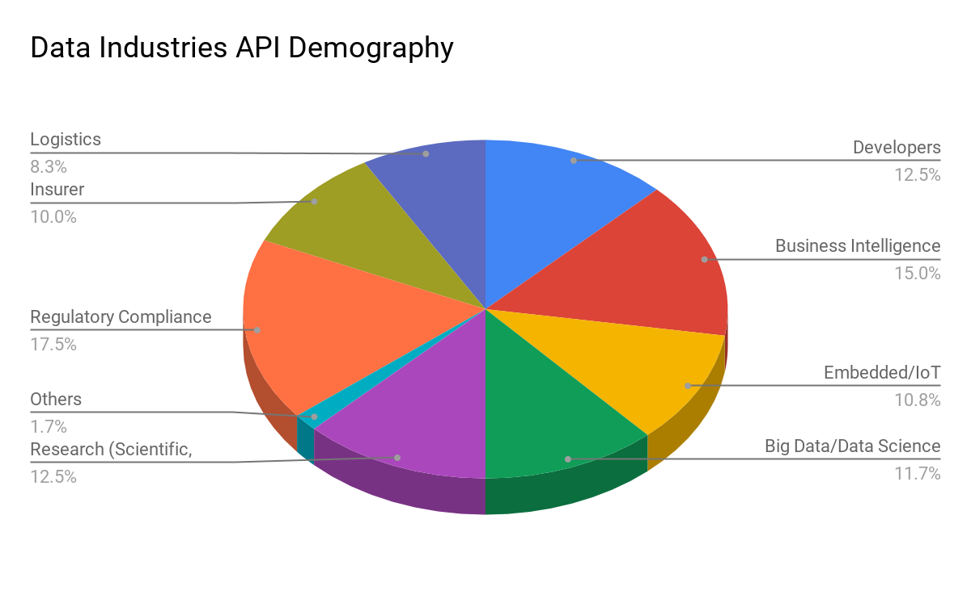Fig. 2: API Consumers of Data Industries

As a third-party testing firm, it is deemed to develop a collection of data from the results of laboratory services. The company has an agreement to its clients to publish the results as open data. The use of REST API can leverage the dissemination of data for public use on certain resources.
Possible consumers of its API are:
- Technical group: Developers of API, software, websites and technical designers
Good documentation to ease the integration and developments are the main goal for its design. This is the area that is continuously being improved and targeted for revision to promote clarity of implementation.
The API provider also values in applying best practices in communicating to this group such as major changes, problems, and further improvements. Using a mailing list, blog and social media are most likely a part of its strategy.
- Data Scientist, Statistician, Informatician

- University Researchers group: Professors and students
The API provider wants to target this group by bringing data into better use. The data can be incorporated in their basic researches for comparison, exploration and forming statistical data sets for sampling. This group expects easy to use API because of their lack of technical knowledge in this field in which the company wants to assimilate. The documentation can be design for users with limited technical abilities and simplify its intricacy.
- R&D team in a private company: Product Developers, Technical Sales, Entrepreneurs
This demography has the same also same user experience with Researchers group but the data can be used in applied discipline and in business problems.
- Civilian group: Hobbyist of programming or web development
This group might have a low number of users depending on the interest of the users but still counts in the demography because the API provider aims for simplicity, clarity, data-driven and good documentation practices. At least the users must have a basic grasp of computation and technology may suffice to be included as a consumer of this API. Further development in terms of user-friendliness will be likely implemented in order for non-developers or non-technical people included in the demography.
- Data Industries as API provider/user, and as industry partners
In actuality, the main user of the API is the one who developed and designed the API.

III - API Style
Remote Procedure Call (RPC) is a way to describe a mechanism that lets you call a procedure in another process and exchange data by message passing. It typically involves generating some method stubs on the client process that makes making the call appear local, but behind the stub is logic to marshall the request and send it to the server process. The server process unmarshall the request and calls the required method before iterating the process in reverse to get whatever the method returns back to the client. HTTP is sometimes used as the protocol for message passing, but nothing about RPC is inherently bound to HTTP. Remote Method Invocation (RMI) is closely related to RPC, but it takes remote invocation a step further by making it object-oriented and providing the capability to keep references to remote objects and invoke their methods.

Hypermedia is a generalization of hypertext for content other than HTML. Hypermedia can be HTML in a browser, with all links, buttons, and everything that's rendered so we can browse a website, or it can be an XML or JSON document intended to be parsed by an automated client who will also follow links and actions in a browser, clicking rendered links and buttons.

HATEOAS means the interaction of a client with a REST application must be driven by hypermedia, or to put it simply, the client should obtain all URIs for every resource it needs by following links in the representation of resources themselves, not by relying on out-of-band information, like URI patterns given in documentation, as many APIs do.

This is simpler than it sounds. It just means that the interaction between a client and a REST application should be exactly like a human browsing a website. Take some of the social media web applications itself for example. There are Users, Questions and Answers. When you want to see a list of your questions, you don't go to a documentation website, get a URI template for listing your questions, fill a placeholder with your user id and paste it on your browser. You simply click on a link to another document described as the list of questions, and you don't even care about what the exact URI is. That's what HATEOAS means in practice.

SOAP(Simple Object Access Protocol)
SOAP brings its own protocol and focuses on exposing pieces of application logic (not data) as services. SOAP exposes operations. SOAP is focused on accessing named operations, each operation implements some business logic. Though SOAP is commonly referred to as web services this is a misnomer. SOAP has a very little if anything to do with the Web. REST provides true Web services based on URIs and HTTP.
- SOAP is not very easy to implement and requires more bandwidth and resources.
- SOAP message request is processed slower as compared to REST and it does not use web caching mechanism.
- WS-Security: While SOAP supports SSL (just like REST) it also supports WS-Security which adds some enterprise security features.
- WS-AtomicTransaction: Need ACID Transactions over a service, you’re going to need SOAP.
- WS-ReliableMessaging: If your application needs Asynchronous processing and a guaranteed level of reliability and security. Rest doesn’t have a standard messaging system and expects clients to deal with communication failures by retrying.
- If the security is a major concern and the resources are not limited then we should use SOAP web services. Like if we are creating a web service for payment gateways, financial and telecommunication related work then we should go with SOAP as here high security is needed.

Representational State Transfer (REST) is an architectural style that introduced a particular set of constraints on an interface to accomplish a set of intentions. REST enforces a client/server model, where the client is interested in gaining information and acting on a set of resources that are managed by the server. The server tells the client about resources by providing a representation of one or more resources at a time and providing actions that can either get a new representation of resources or manipulate resources. All communication between the client and the server must be stateless and cachable. Implementations of a REST architecture are said to be RESTful. REST is not REST without Hypermedia and HATEOAS. This means that a client only knows the entry point URI and the resources are supposed to return links the client should follow

Why REST for Data Industries?
- SOAP has been preferred for services within the enterprise and REST has been preferred for services that are exposed as public APIs. Data Industries wants its API and data resources to be public to be used not only for producing data but to transform data into a piece of useful information.
- Less duplication (HTTP already represents operations like DELETE, PUT, GET etc.
- More standardized - HTTP operations are well understood and operate consistently. Creating clients, developing APIs, the documentation is much easier to understand
- REST permits many different data formats. JSON usually is a better fit for data and parses much faster. REST allows better support for browser clients due to its support for JSON.
- Exchanging data over the web that only deal with code, no extensive standards to follow, and no overhead.

IV - API Blue Print

V - API Value Chain

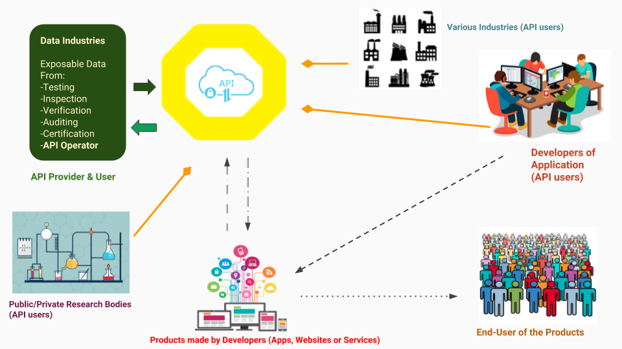Fig. 1: Data Industries activity model to create services with the aid of API

VI. API Features
- API was designed and documented in RAML. HTML documentation generator using Raml2html.
- It is coded in Javascript and developed in NodeJS runtime environment.
- NoSQL Database: MongoDB(local machine) and MLAB (MongoDB Hosting).
- Restify frameworks as the main server of the application.
- Mongoose for MongoDB Object modeling tooling.
- Set of constructors that can be used to new up Error objects with default status codes by Restify-error module.
- Handling CORS errors using Restify-cors-middleware.
- Implementation of JSON Web Token (JWT) by Jsonwebtoken package.
- Object schema description language and validator for JavaScript objects using Joi.
- Validators of JSON Web Tokens using Restify-JWT-Community middleware.
- The createdAt and updatedAt date attribute that gets auto-assigned to the most recent create/update timestamp using Mongoose-timestamp plugin.
- Joi validation for Mongoose models provided by Joigoose module.
- Version control using Git.
- The API can be search and deployed in the cloud with Heroku.
- It can serve static files.
- Encryption of user information (password etc.) handled by Bcryptjs library.
- Parse incoming request bodies available under the req.body property (plugin.bodyParser).
- Parses URL query paramters into req.query(plugin.queryParser).
- Development-dependent utilities such automatic restarting of application (Nodemon), HTTP request logger middleware (Morgan) and Twelve-Factor App methodology for storing configuration in the environment separated from code (Dotenv).

