Requirements and Analysis Document for Desktop Hipster

Version: 0.1

Date: 2013-03-20

Author : Edvard Hübinette

This version overrides all previous versions.

Introduction 1
Purpose of application 1
General characteristics of application 2
Scope of application 2
Objectives and success criteria of the project 2
Definitions, acronyms and abbreviations 2
Requirements 2
Functional requirements 2
Non-functional requirements 2
Usability 3
Reliability 3
Performance 3
Supportability 3
Implementation 3
Packaging and installation 3
Legal 3
Application models 3
Use case model 3
Use cases priority 4
Domain model 4
User interface 4
References 4

Introduction

Desktop software for managing pictures, applying basic filters and upload to social media sites.

Purpose of application
To simplify editing and managing pictures on the users computer and offer a streamlined solution for uploading the finished images to social media websites like tumblr or flickr. Currently the most widely-used key paths to do so uses several applications in the chain of events as well as separate, online uploading tools for each site.

General characteristics of application
A minimalistic and streamlined application designed for simple usage, with a gentle learning curve designed with a main focus on simplicity for the user.

Scope of application
The application only provides simple, pre-designed filters and uploading to sites of the developers’ choice. The application is developed for OS X.

Objectives and success criteria of the project
- It should be possible to browse imported pictures and add tags for identification
- It should be possible to upload a picture to at least one image website
- It should be possible to add at least basic image enhancements to a picture

Definitions, acronyms and abbreviations

Requirements

In this section we specify all requirements

Functional requirements

The user should be able to:
- Import an image form the file system via system dialog
- Browse imported images’ thumbnails
- Select an image and take it to the editing stage
- Apply a basic filter
- Either:
  - Save image locally
  - Upload image to online host
- Exit application will save the image library

Non-functional requirements

Usability
Usability is prioritized; application should be self-explanatory and have an easy learning curve. Simple UI and helpful butcons will contribute to fulfilling this. Safe exploration enabled through filter previews and preserved original images.

Reliability
There should not for the user to lose his/her work, the image library should always be saved when application exits. Shutdown hook will ensure application can always exit gracefully.

Performance
Any actions should not lead to perceived lag over 2 seconds. Uploading stage allowed to differ from this.

Supportability
Application is developed in Java, which makes portability to other platforms simple.

There will be automated test for verifying use cases. GUI-testing performed manually. GUI tests will be recorded and included in final documentation.

Implementation
Application will create its own library folder for output files in the users file system. Reasoning for this is that we never interfere with the original image, we don’t want the .jar to get bigger and we want central image storage. Users need JRE installed and configured for the application to work.

Packaging and installation
The aim is to follow OS X standards application will be delivered as a .dmg volume, containing an .app file for the user to drag into the Applications folder.

Legal
We do not see any legal issues regarding the application if we write the filters on our own or use GPL-licensed software. Tumblr, flickr or similar logos are fine to use when it’s in combination with their API and their services.

Application models

Use case model
Use case UML for application:
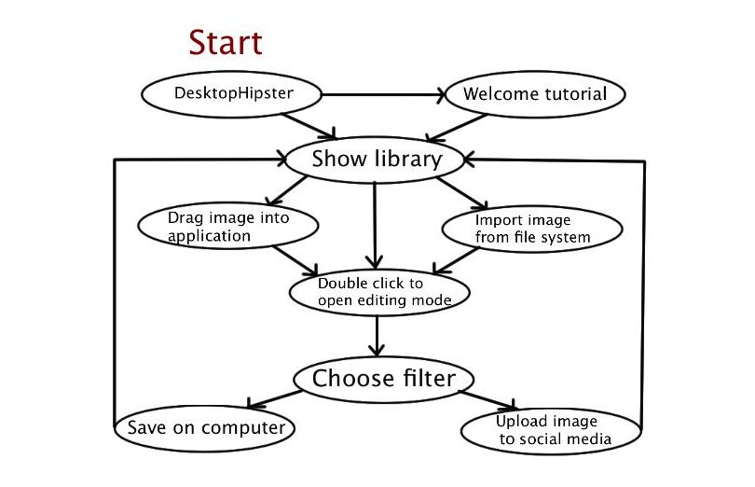
Use case names:
- Normal application flow
- User not authenticated for upload
- User saves image to default library
- User saved image to custom directory
- User imports file through file-system browser
- User directly selects image
- Application welcome tutorial

Use cases priority

- User directly selects image
- User imports file through file-system browser
- User saves to default library
- User saved image to custom directory
- Application welcome tutorial
- Normal application flow

Domain model

UML, possible some text.

User interface

Text to motivate a picture.

References

APPENDIX

GUI

Domain model

Use case texts

