Code::Blocks configuration
of
MSVC compiler tools and Windows SDK

Carsten Arnholm
2016.01.23
Table of Contents
Introduction 3
Motivation 3
Toolsets 4
A systematic configuration pattern 5
Code::Blocks global variables for MSVC 5
Universal MSVC compiler and SDK setup 6
MSVC version & architecture dependent definitions 8
cpde_msvc2010_x86 9
cpde_msvc2013_x86 10
cpde_msvc2013_x64 11
Building libraries using selected MSVC toolchain 12
Building boost 64bit 13
Building wxWidgets 64bit 14
Setting up Tools menu for debugging 15
Using CDB.exe for debugging within Code::Blocks 16
Other useful ideas 17

Introduction
Code::Blocks is an open source cross platform IDE for C++ development. It can be used with many different compilers and it runs on Windows, Linux and Mac. The reasons for using Code::Blocks are several. For example, it provides
- Ways of doing cross platform C++ development using a universal IDE
- Ways of targeting different compilers in one and the same project
- Ways of collecting related and dependent projects in workspaces
- Ways of separating project configuration from compiler/toolset configuration
- A useful 'global variable' concept with many practical uses
- The wxSmith RAD tool for wxWidgets GUI development
- and more
This document aims to explain a way to configure Code::Blocks on Windows using different Visual Studio C++ compilers and Windows SDKs. Where relevant it is discussed how to compile for x86 (32bit) and x64 (64bit) executables.
The general approach taken is to employ the Code::Blocks global variables for configuration of the compiler and related tools, i.e. set the global variable values according to the needs of the compiler, SDK and target processor architecture. Examples are provided for MSVC2010 and MSVC2013. By extension, it should be feasible to reconfigure for other MSVC versions.
It should be noted that there isn't a very clear-cut way to specify compilation to x64 (64 bit) using the MSVC command line tools, using only command line options is not enough. This affects how to set up and use Code::Blocks for 64bit compilation with MSVC, so a chapter is set aside discussing this issue.

Motivation
We need to configure the Compiler and Windows SDK with Code::Blocks, but the question is how. To explore the answer, we must first describe the challenges in some detail. Understanding the problem is key to finding a good solution.
There are several combinations of MSVC tools makes it rather confusing. For example, if we look at a small subset:
- Visual Studio 2010 – x86 mainly
  - Visual Studio 2010 Express + Windows 7.0A SDK (free)
  - Visual Studio 2010 Enterprise + Windows 7.0A SDK (non-free)
- Visual Studio 2013 – x86, x64, (arm)
  - Visual Studio 2013 Express for Windows Desktop + Windows Kit 8.1 (free)
  - Visual Studio 2013 Professional + Windows Kit 8.1 (non-free)

The scenarios for installing SDKs for these combinations are somewhat unique with respect to what toolkits are available, which SDK's to use and where things end up in the filesystem. Even the names of MS IDE is variable . A nice little mess!!

With MSVC2010, the SDK is a separate install. With the MSVC2013 Express/Professional versions you don't need to explicitly install an SDK for ordinary “desktop” development, the SDK is now called a “Windows Kit”. The Windows Kits are found in places like
C:\Program Files (x86)\Windows Kits\8.1

Also, the structure of this “kit” is different from the former SDK, and this must be taken into account when configuring Code::Blocks for use with MSVC.

The location of the 7.0A SDK is confirmed by the the tooltip in Visual Studio 2010 Express IDE:
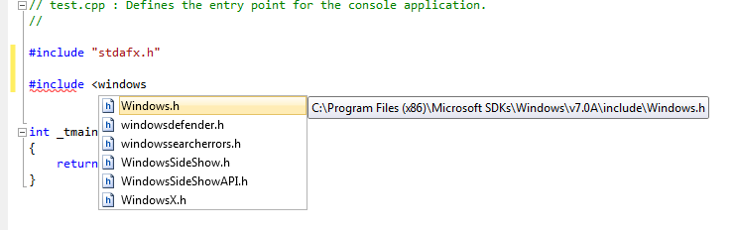
The location of the Windows Kit is confirmed by the the tooltip in Visual Studio 2013 Express IDE:
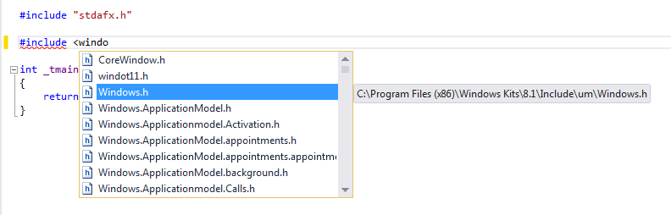
The above illustrates some of the differences that need to be managed and “configured away”. There are more differences, but the above should be enough to motivate a need for some way to configure Code::Blocks for these variants.

Toolsets
It is important to also understand the existence of so-called 'toolsets', consisting of compiler (cl.exe), linker (link.exe) and other related programs. A toolset typically targets a certain type of processor, e.g. 'x86', 'amd64', 'arm' etc. The implication is that a Visual Studio installation will contain several different variants of cl.exe, link.exe and we must make sure to use the correct ones in combination with the corresponding toolset-dependent compiler and SDK libraries. This adds to the requirements to the configuration system.

A systematic configuration pattern
The seemingly complex and ever-changing state of the compiler and SDK tools for MSVC, needs a configuration pattern to be manageable in Code::Blocks.
We choose a configuration pattern with the following characteristics:
- Always use a “universal compiler” called MSVC, never a specific version. This makes the projects independent of specific MSVC versions. The effect is that the Code::Blocks projects are unaffected by changing MSVC version or target platform.
- Use Code::Blocks global variables to manage the specifics of the compiler/SDK versions. These settings are stored in XML files ( C:\Users\<user>\AppData\Roaming\CodeBlocks\default.conf ) and can therefore be backed up or copied to other users/machines.
- Configure MSVC compiler toolchain and SDK paths via the global variables only
Once set up, the system becomes predictable and reasonably easy to maintain, even when changing MSVC version or targeting a different processor architecture.

Code::Blocks global variables for MSVC
To support the various flavours of MSVC in Code::Blocks, we must manage the MSVC toolchain and the SDK locations separately. We will do this by introducing three key C::B global variables for use with a universal MSVC compiler (called MSVC) in Code::Blocks:
C::B Global Variable | Description
MSVC_TOOLCHAIN | Defines MSVC IDE, compiler/linker and related tools
MSVC_SDK | Windows shared SDK corresponding to installed toolchain
MSVC_SDK_ARCH | Windows architecture-specific SDK corresponding to installed toolchain

Example values for some MSVC versions
C::B Global Variable | MSVC 2010 Express and Enterprise definition
MSVC_TOOLCHAIN | C:\Program Files (x86)\Microsoft Visual Studio 10.0
MSVC_SDK | C:\Program Files (x86)\Microsoft SDKs\Windows\v7.0A
MSVC_SDK_ARCH | Not used, only x86 supported

C::B Global Variable | MSVC 2013 and Professional definition
MSVC_TOOLCHAIN | C:\Program Files (x86)\Microsoft Visual Studio 12.0\VC
MSVC_SDK | C:\Program Files (x86)\Windows Kits\8.1 (see more below)
MSVC_SDK_ARCH | C:\Program Files (x86)\Windows Kits\8.1 (see more below)
For MSVC2013, more details are explained later in this document.

Universal MSVC compiler and SDK setup
In theory, the following are universal settings regardless of compiler toolchain and SDK version. The actual locations of tools, SDK etc. are defined in global variables. The order of the included paths should be regarded as significant.

Toolchain and paths:
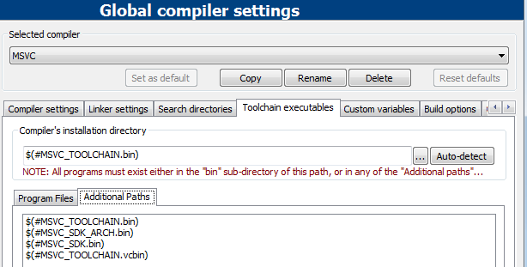

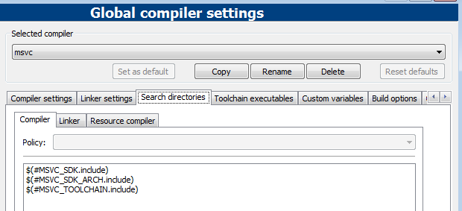
Compiler include paths:
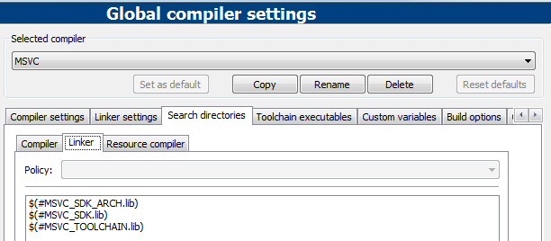
Linker paths:

Resource compiler include paths:
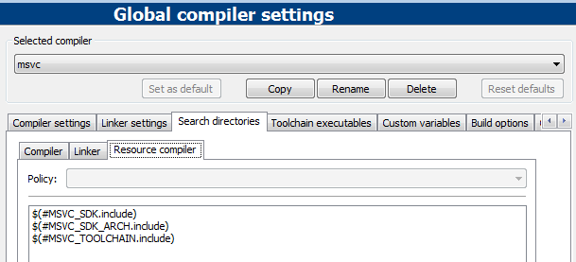

MSVC version & architecture dependent definitions
With this we mean
- Which version of Visual Studio is used
- Which version of the Windows SDK/Kit is used
- Which MSVC compiler toolchain variant is ('toolset') used for building
- Which target architecture is chosen (e.g. x86 vs x64)
Generally, the version of Visual Studio installed will dictate which version of the SDK to use, but sometimes the SDK is updated, and we need to tell Code::Blocks which one to use anyway.
With MSVC2013 there are several compiler toolset to choose from, so we need to say which one to use. And finally we need to set the selected target architecture for building our programs. In the following, we list the detailed settings for some relevant configurations.

A half-related feature is the compiler option /FS which allows using many compiler threads in Code::Blocks. This is needed in MSVC2013 but does not exist in MSVC2010.
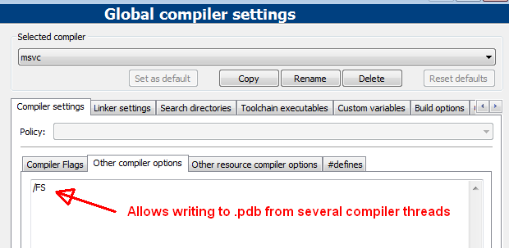
By enabling this option and tell Code::Blocks to use as many processes for parallel build as there are CPU kernels, the compilation can be improved significantly:
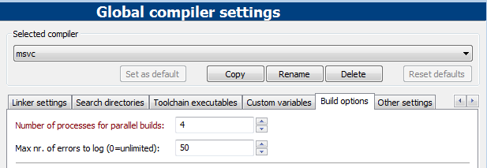

cpde_msvc2010_x86
Settings for MS Visual Studio 2010, targeting x86
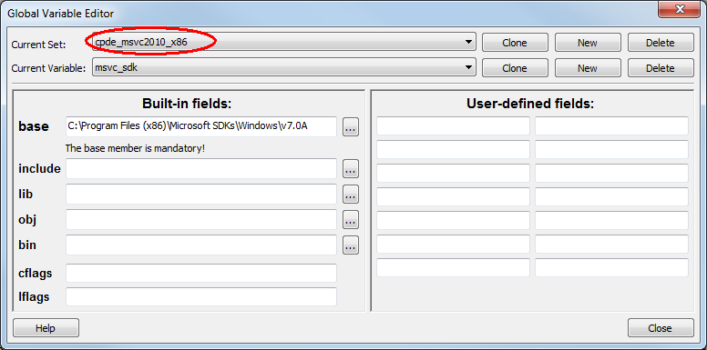
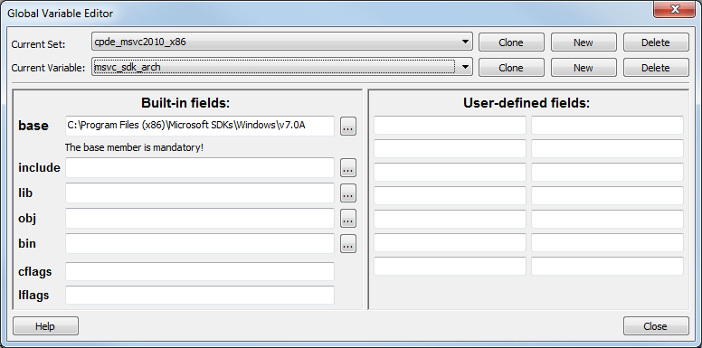
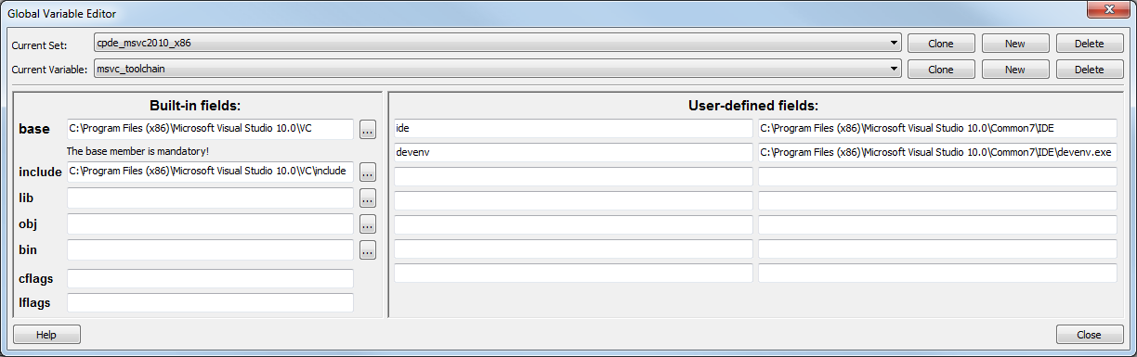

cpde_msvc2013_x86
Settings for MS Visual Studio 2013, targeting x86 (32bit)
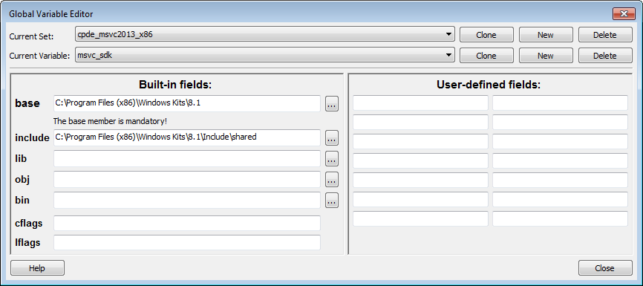
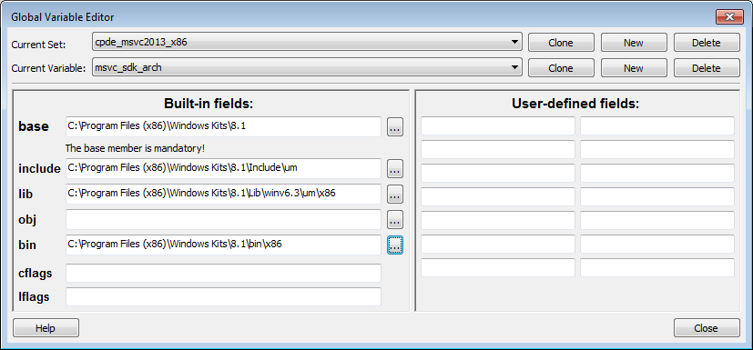
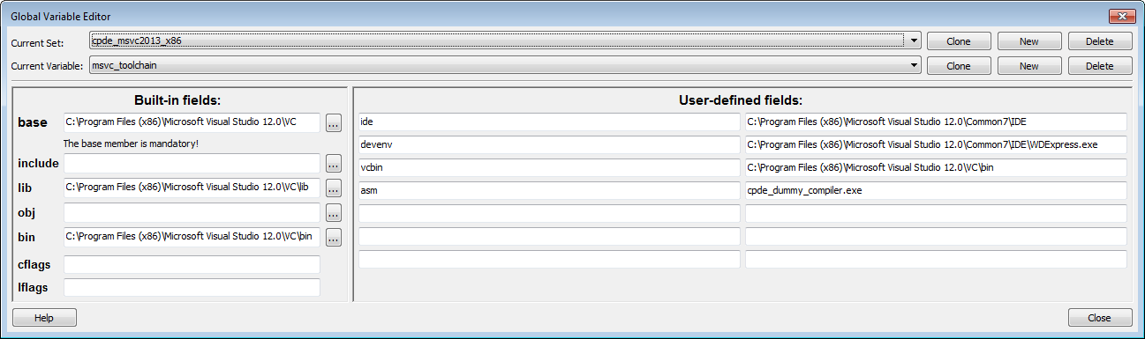
( Above shown for for MSVC2013 Express, for non-express change WDexpress.exe to devenv.exe )

cpde_msvc2013_x64
Settings for MS Visual Studio 2013, targeting x64 (64 bit) using x64 native compiler.
The bin directory ends with 'amd64' in the example below, indicating the native compiler toolset. For the free Express version of MSVC2013, the native toolset 'amd64' may not be available. You can then use the 'x86_amd64' cross compiler toolset instead.
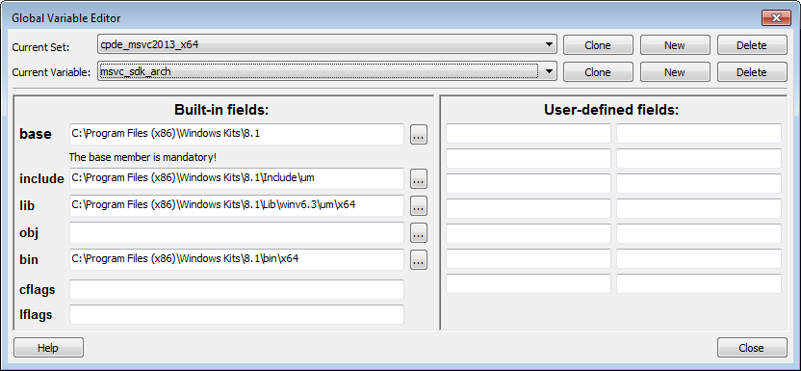
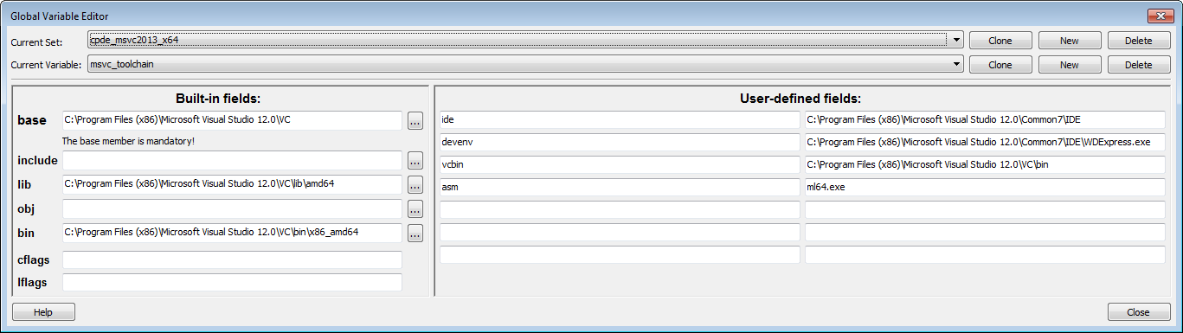

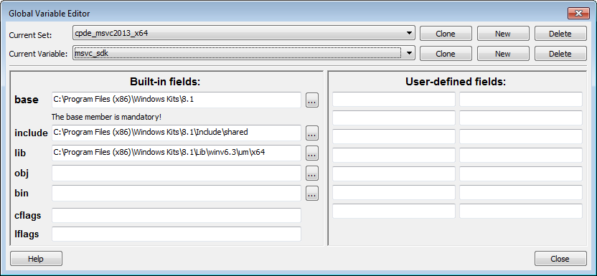

Building libraries using selected MSVC toolchain
When targeting a specific platform, we must also build the libraries targeting the same platform. Usually, this means we use the same toolchain when building the libraries as we use within Code::Blocks for our own application development.
One way to select compiler toolchain when building from command line is to use the relevant “Command Prompt” for the installed compiler, accessible from the start menu
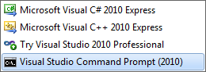
MSVC2010 Express:

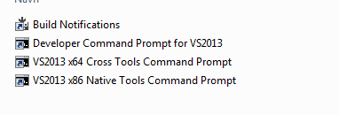
MSVC2013 Express:

However, this is often not sufficient. A more predictable way to compile libraries such as boost and wxWidgets is to do it from a .bat file and calling the MSVC procedure for setting up the toolchain environment and setting the correct parameters according to the build system in use. This makes things easier, as we don't need to use the cumbersome and specialised “Command prompts” above, because environment variables pointing tp the MSVC installation are always available

For example, if MSVC2010 (a.k.a 'VS100') and MSVC2013 (a.k.a 'VS120') are installed, the following environment variables will be available:
VS100COMNTOOLS=C:\Program Files (x86)\Microsoft Visual Studio 10.0\Common7\Tools\
VS120COMNTOOLS=C:\Program Files (x86)\Microsoft Visual Studio 12.0\Common7\Tools\
We can then exploit this in calls within .bat files to select the required toolchain:
call "%VS120COMNTOOLS%..\..\VC\vcvarsall.bat" x86_amd64
Thie example selects MSVC2013 (Express) cross compilation from x86 targeting x64

Building boost 64bit
The example is for MSVC2013 (Express) cross compilation from x86 targeting x64 of boost 1.59.0
-----
REM By using 'call' we can call other batch files,
REM without aborting the execution of the calling batch file,
REM and using the same environment for both batch files.
REM 32bit builds
REM For MSVC2013 Express/Professional: x86
REM 64bit builds
REM MSVC2013 Express : x86_amd64 (cross-compiler)
REM For MSVC2013 Professional: amd64 (native compiler)
REM
call "%VS120COMNTOOLS%..\..\VC\vcvarsall.bat" x86_amd64
REM We assume this batch procedure is placed one level above the boost package,
REM So we change the directory to bootstrap and build the boost libraries.
REM Bootstrap will generate the b2 build system, .\b2 will do the actual build
cd boost_1_59_0
REM Before running bootstrap, remember to edit the line
REM from "set toolset=msvc"
REM to "set toolset=msvc : 120 ;"
call bootstrap.bat
REM Set address-model=32 for x86 32-bit builds
REM Set address-model=64 for x86_amd64 cross compiler or native amd64 build
REM Set architecture=x86 in all cases
.\b2 -j8 toolset=msvc-12.0 address-model=64 architecture=x86 ^
link=static threading=multi runtime-link=shared –build-type=minimal
echo "==== boost_1_59_0 build completed ====="
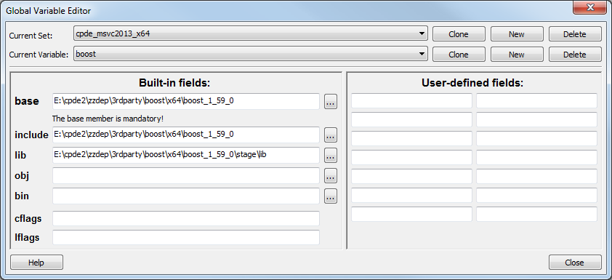
A corresponding C::B global variable definition for boost:

Building wxWidgets 64bit
The example is for MSVC2013 (Express) cross compilation from x86 targeting x64 of wxWidgets 3.0.2
-----
REM This procedure builds wxWidgets on Windows using MSVC and NMAKE
REM Run from "Visual Studio Command Prompt"
REM Visual Studio tools -> VS2013 x64 Cross Tools Command Prompt
REM
REM change dir to build\msw folder, for example
REM ...\wx\x64\3.0.2\lib\build\msw
REM
REM make sure foreign makeflags don't interfere (QNX does this)
set MAKEFLAGS=
REM Call Visual Studio 2013 to set up the 64bit cross-compiler toolkit.
REM (MSVC2013 Express does not contain the native 'amd64' toolkit)
call "%VS120COMNTOOLS%..\..\VC\vcvarsall.bat" x86_amd64
REM Build release libraries
nmake -f makefile.vc TARGET_CPU=amd64 BUILD=release DEBUG_INFO=1 ^
RUNTIME_LIBS=dynamic SHARED=0
REM Build debug libraries
nmake -f makefile.vc TARGET_CPU=amd64 BUILD=debug DEBUG_INFO=1 ^
RUNTIME_LIBS=dynamic SHARED=0
echo "==== wxWidgets 3.0.2 build completed ====="

Setting up Tools menu for debugging
A possibility is to set up the CDB.exe gdb-like debugger for MSVC in Code::Blocks, but this is really a separate research issue. Instead we rely on starting the MSVC IDE for debugging an open project, using the C::B Tools menu:
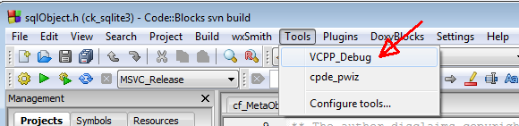
defined as below for MSVC2013 Express (the non-free MSVC version requires a slightly different setup for the “Parameters” line):
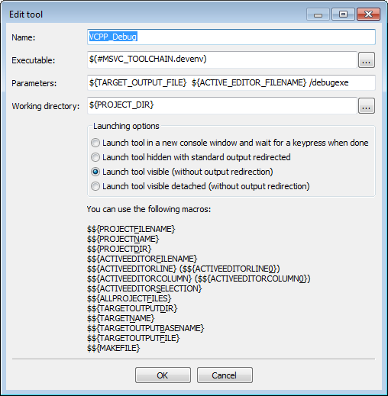

When we build a Debug target in Code::Blocks, we can open the file we want to debug, then use the Tools menu to trigger the MSVC IDE/debugger with all the usual debugger features. While an integrated debugger is more elegant, the MSVC debugger is quite good, so this simple setup works quite well in practice.
The same thing done using VC Professional (next page). Notice the parameters are different.
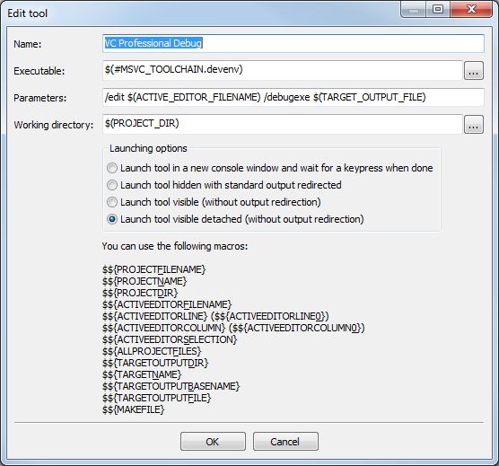

Using CDB.exe for debugging within Code::Blocks
If you don't like the Tools menu approach using the Visual Studio IDE as external debugger, there is also a “proper way”, using the x86 and the x64 dbg-like debuggers:
C:\Program Files (x86)\Windows Kits\8.1\Debuggers\x64\cdb.exe
C:\Program Files (x86)\Windows Kits\8.1\Debuggers\x86\cdb.exe
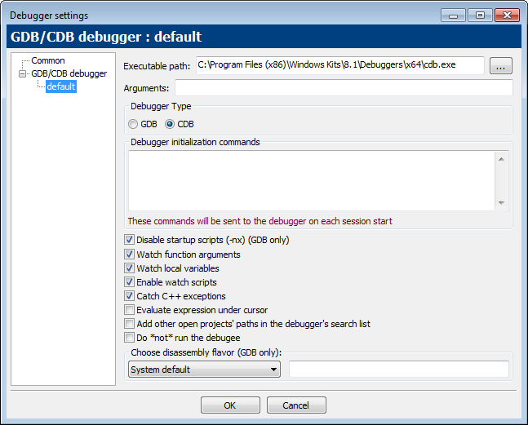
As shown.
The MSVC debugger is however more complete.

Other useful ideas
It is possible to use XML Notepad 2007 or equivalent to edit the configuration fil at
C:\Users\<user>\AppData\Roaming\CodeBlocks\default.conf
as it really is an XML file. Be very careful doing this as you can easily corrupt your installation.
The global variable definitions are found under <gcv>
