LINUX WEATHER STATION

This procedure explains how to install and use software for WH-1080 weather station on a Linux Kubuntu PC. The software collects weather data from the weather station at regular intervals, stores it in a database and produces plots that are uploaded over FTP to a website for display.

Prerequisites
To use the software you must have the following
- A weather station unit, model WH-1080 (or compatible), incl. indoor receiver with USB PC connection. This unit is available as art.no. 36-3240 at Clas Ohlson in Norway
http://www.clasohlson.no/Product/Product.aspx?id=167399209
- A dedicated PC with Linux Kubuntu 11.10 installed (Ubuntu/Xubuntu etc. also ok). Other distros have not been tested, but might be ok.
- Suitable space on a web server (minimal space required), and FTP file upload access (you will need to use your FTP username and password)
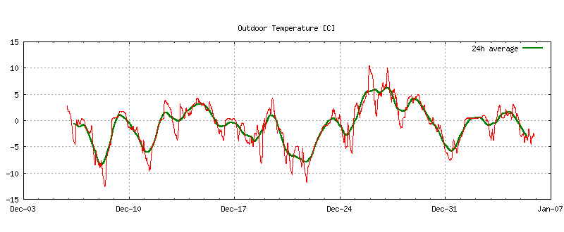
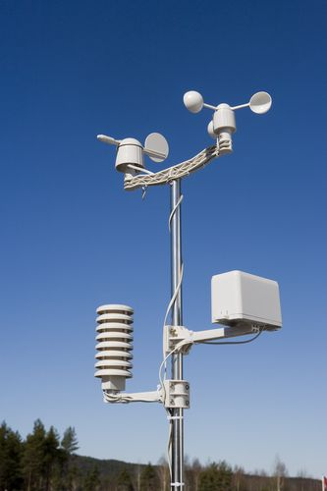
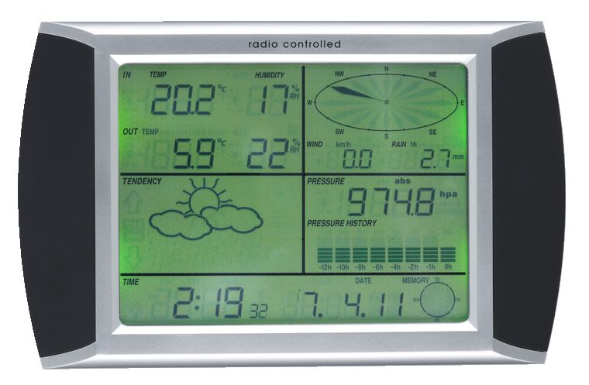




Software description
Before discussing how to install the software, we briefly describe how it works, the command line parameters are as follows
Usage: wstation [-i] [-l] [-s] [-xd <num>] [-xp <str>] [-xr <str>] [-xh <str>] [-xu] [-co <str>] <database filename>
-i, --init_db Initialise new database
-l, --latest Show latest data on screen (1 entry)
-s, --store Store latest data to database (1 entry)
-xd, --xdays=<num> Export <num> days to standard output
-xe, --xelev=<str> Export: Elevation above sea level, <str>=[m]
-xr, --xrdat=<str> Export: Rain level datum, <str>=[mm]
-xh, --xhtml=<str> Export: latest numeric values to html file, <str>=[filename]
-xu, --xutc Export: use UTC time instead of local time
-co, --conv=<str> Convert old data <str>=WStest1

Do-once items (manual)
These items are things you must do once to set up the system.
- Prepare data collection on the dedicated PC
  - Configure reading weather data over USB (see below)
  - Extract supplied file structure under ~/Weather, and edit the files
    - Initialise the database in the ~/Weather folder, see below
    - edit script/ws_upload.sh, values for options -xp and -xr, see below. Make sure the database name is correct.
    - edit script/ftp_upload.txt. Set <ftp_user> and <ftp_password>. Edit also the target folder name as required.
- Prepare web server folder
  - create the target folder for weather station upload files. It must be consistent with the specification in the file script/ftp_upload.txt.ftp.
  - Copy the supplied www/index.htm to the web server folder. This file does never change (unless you create new plotfiles), so it is copied only once.
- Test USB connection and FTP upload
  - Manually execute script/ws_upload.sh, check if ok, see below
- When ok, start automatic acquisition of data
  - Edit crontab file for automatic execution of ws_upload.sh, see below

Repeated items (automatic)
The software does the following at regular intervals, e.g. every 5 min:

ws_upload.sh
- wstation
  - reads sensor data (indoor and outdoor) over USB from the indoor unit
  - Each reading, including the time, is stored in an SQLite database
  - Data time series are exported from the database to 3 text files: ws_day.txt, ws_week, ws_month.txt
  - Also exported is latest.htm, which contains numeric values of latest data
- gnuplot
  - produces png plot files of weather station data, by reading the gnuplot-ws.txt input file, which refers to the ws_day.txt, ws_week, ws_month.txt files.
- ftp
  - uploads *.png and latest.htm to a web server folder dedicated to showing weather data. The folder is typically called "wstation" and contains already index.htm referring to the named *.png and latest.htm.

Configure reading weather data over USB
First, do NOT connect the PC and the indoor unit yet, wait until you are told to do so :-) Instead, do as follows:
- Install rules file from ~/Weather/usb folder
$ sudo cp 55-meteo.rules /etc/udev/rules.d
- Set user access permission
The rules file declares the weather station to belong to the 'video' group. To allow your user
to access the weather station device, the user must be added to the 'video' group, see also
https://help.ubuntu.com/community/AddUsersHowto#Graphical_Kubuntu
$ sudo adduser <username> video
- Reboot the computer
- Check usb connection
Connect the USB cable between weather station indoor unit and the PC, and then type:
$ dmesg
(... lots of output omitted )
The last line should be something like, observe the numbers in red.
[ 1038.217354] generic-usb 0003:1941:8021.0005: hiddev0,hidraw0: USB HID v1.00 Device [HID 1941:8021] on usb-0000:00:1d.0-2/input0
- The last output line is typically the last USB unit connected. Observe [HID 1941:8021], which is the vendor id and product id the software will be looking for. If you see these exact numbers, you are good to go!

Edit files under ~/Weather
The folder structure on the weather station PC should become
~/Weather /doc
/www
/script
/usb
The program executable "wstation" is in the main folder.

Initialise the database
Open a terminal in that folder and initialise the database:
$ ./wstation weather_station.db -i

Edit ws_upload.sh
Go to the script subfolder and edit ws_upload.sh. Make sure the database name referred is the same as used when initialising above. Also set the -xe and -xr option values
-xe=152 | This option is for specifying altitude adjustments of raw pressure down to sea level pressure.  The value 152 shown here corresponds to an elevation of 152m of the weather station. The raw pressure is adjusted according to temperature and elevation, using the Barometric "equation 2"  http://en.wikipedia.org/wiki/Barometric_formula
-xr=36.3 | This option is for specifying rain level datum [mm]  You can ignore this option if you don't have any earlier values in the database, i.e. you only need it if the database originally was created with the now obsolete WScollect. WScollect was unable to read rain data.  The value to be specified is the last rain sensor level (in [mm]) before registration of rain levels began in the database. The value is subtracted in rain intensity calculations, thus avoiding artificial large jumps at the start of the rain intensity series.  This value does not affect the accumulated rain series itself (orain), so the datum value can be found by producing a test time series export for the time around installation (option -xd). The datum is then the first non-zero value in the orain column.  If the value is not specified correctly, the initial rain plot can become odd-looking and scaled wrongly. Eventually, it will still adjust itself nevertheless.

Edit ftp_upload.txt
Go to the script subfolder and edit ftp_upload.txt, first 2 lines. Set the website FTP address and also your username and passoword
open www.<website>.org
user <ftp_user> <ftp_password>
Observe that FTP passive mode has been set in the input (command "passive"). This may or may not be good for your configuration, but passive mode is supposed to work around firewall problems. See http://www.ncftp.com/ncftpd/doc/misc/ftp_and_firewalls.html
More on active vs. passive mode FTP http://slacksite.com/other/ftp.html
Notice also the command
cd www/wstation
This command specifies the path on the web server to the weather station data after logging in via FTP. Edit as required.

Prepare web server folder
Using FTP or other means, create the folder on the web server corresponding to the specification in the ftp_upload.txt file ('cd' command).
Edit index.htm and change "My Weather Station" to your own name (two places). Copy the supplied index.htm to this folder.

Test USB connection and FTP upload
You are now be ready to test the USB connection and the FTP upload.
$ ./wstation weather_station.db -l

The output should be similar to:
PC time now:
tstmp: 1325792028
UTC: 05-Jan-2012 19:33:48
local: 05-Jan-2012 20:33:48
Latest weather station data:
tstmp: 1325791980 timestamp
UTC: 05-Jan-2012 19:33:00 Coordinated Universal Time
local: 05-Jan-2012 20:33:00 Local Time
itemp: 20.1 C Indoor temperature
ihumi: 28.0 % Indoor humidity
otemp: -2.5 C Outdoor temperature
ohumi: 72.0 % Outdoor humidity
opres: 966.6 hPa Pressure
owspd: 0.0 m/s Average wind speed
owgus: 0.0 m/s Gust wind speed
owdir: 315.0 deg Wind dir in degrees, clockwise from North
orain: 48.9 mm Rain gauge
osens: Ok Outside sensor contact

Collect data once from weather station to database. In main folder, do
$ ./wstation weather_station.db -s
Successful run should give no terminal feedback. Next, list the data from the newly initialised database:
$ ./wstation weather_station.db -xd=1
The output should be similar to (line wraps here)
# wstation Gnuplot export file. UTC offset used [sec] = 3600. Pressure offset = 0
# timestamp itemp[C] ihumi[%] otemp[C] ohumi[%] opres[mbar] owspd[m/s] owgus[m/s] owdir[deg] orain[mm] irain1[mm/h] irain24[mm/24h] timestamp24h itemp24h[C] otemp24[C] osens[1/0] Time
1325795520 20.1 28 -2.5 72 966.6 0 0 0 48.9 0 0 1325795520 -nan -nan 1 20120105 20:32:00

If all is well, try to run a complete data collection/upload step. Go to the script subfolder and type:
$ ./ws_upload.sh
Observe the messages and check the contents of local folder ~/Weather/www and the target web server folder. Try viewing the plots on the web server with your web browser. If you see the recently created files (notice the time), then you are ready to enable automatic exectution.

Edit crontab file for automatic execution
cron is a utility for scheduling jobs under Linux, similar to Scheduled Tasks on Windows. Jobs are controlled by editing the so called "crontab" file.
Crontab – Quick Reference: http://adminschoice.com/crontab-quick-reference
To edit the crontab file in a terminal:
$ crontab -e
This opens a small editor (nano). Add the following 2 lines at bottom
MAILTO=""
*/5 * * * * /home/<username>/Weather/script/ws_upload.sh
exit the editor with Ctrl-X
The first line prevents cron from emailing you whenever the job is executed. This could otherwise fill up your disk with useless emails, causing everything to stop.
The second line specifies that the ws_upload.sh script is to be executed every 5 minutes.
Now everything should be done, watch and enjoy!

