# Python and the Jupyter Notebook

## Installation of Python

We recommend the Anaconda distribution from Continuum Analytics.

Installation:

<https://www.continuum.io/downloads>

You should install the version for Python 3.5.

## The Jupyter Notebook Intro

Although you can write code in a text editor and run it at the command line, it’s simpler and more fun to use the Jupyter Notebook, which runs in your web browser. You will also use the Notebook to do your homework.

Use this video for an overview of how to use the notebook – The notebook was formerly called the IPython notebook, but the main functionality is the same as describe here around minute 4.30+ (You can skip ahead):

[**https://www.youtube.com/watch?v=IsXXlYVBt1M&list=PL5-da3qGB5ICeMbQuqbbCOQWcS6OYBr5A&index=2**](https://www.youtube.com/watch?v=IsXXlYVBt1M&list=PL5-da3qGB5ICeMbQuqbbCOQWcS6OYBr5A&index=2)

You can also review this:

<https://nbviewer.jupyter.org/github/ipython/ipython/blob/3.x/examples/Notebook/Notebook%20Basics.ipynb>

## Finding a Notebook and Opening It

If you start the notebook from the Anaconda Navigator, it will show you the list of folders (“directories”) at the top of your User Directory, to start with. If you need to find the User directory on your machine, try clicking on your hard drive, and finding USER or Users, and your name under it. On my Mac, it’s here where you see “cherny” and the house icon:

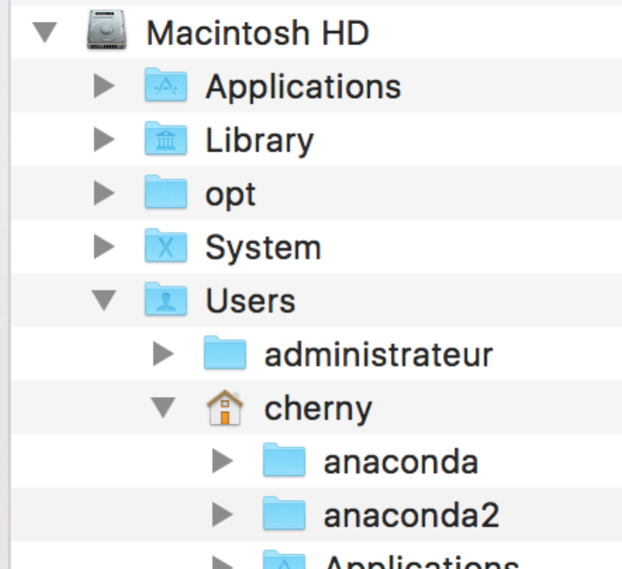

I dragged the house to my favorites to make it easier to find it.

When you start up the notebook, you will see a tab in your browser showing the contents of the current folder (usually your top level directory under “Users”). It might look like this:

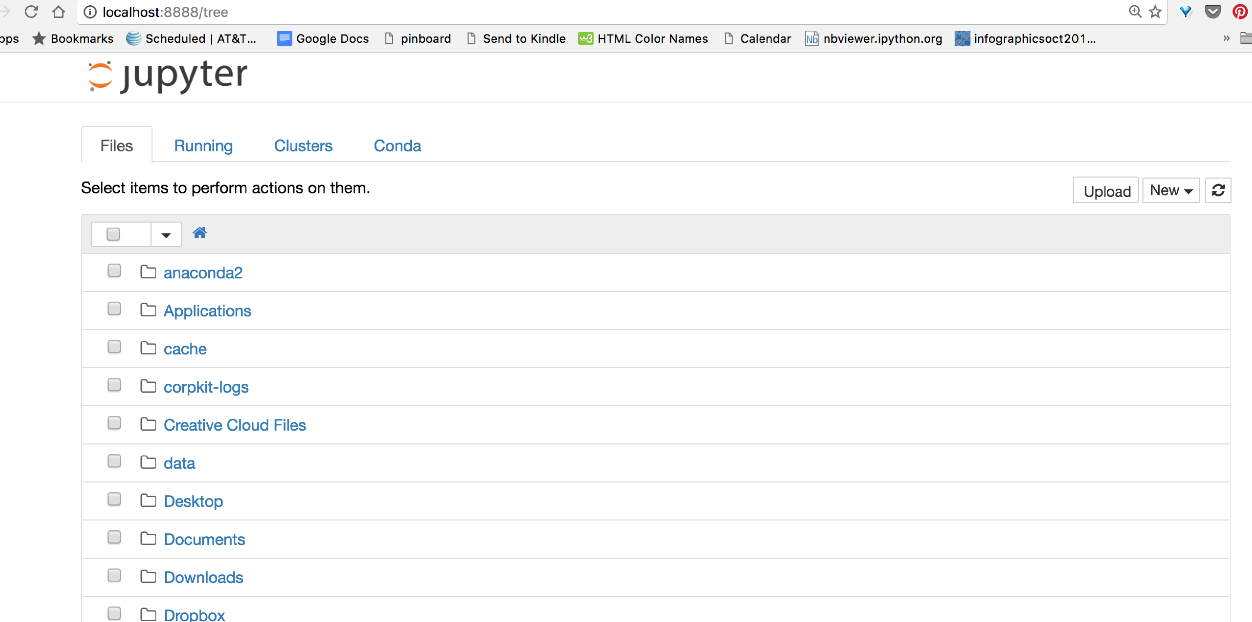

Each of those folder icons can be clicked on to navigate to a new location.

Wherever you are when you click the NEW button to create a new notebook is the location that notebook will be saved in.

The notebook will show your folders and files based on where you start it from. You can click on a folder name (or create one using the NEW button) to navigate to where you want to save your notebook.

This is also how you will find your notebooks for the homework assingments.

Here I have navigated into the course file and here is the Week1 notebook:

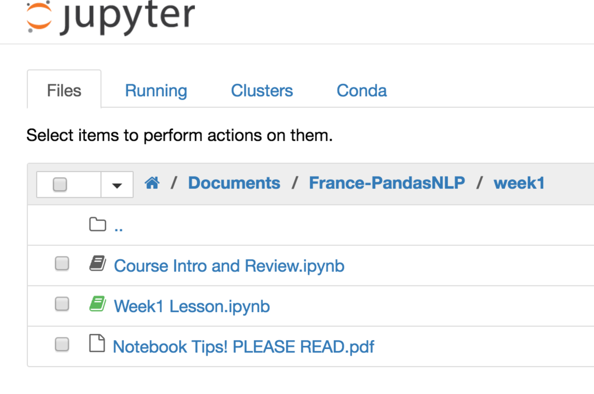

## Create a New Notebook

Create a new notebook using the NEW button on the right side – pick Python [root]:

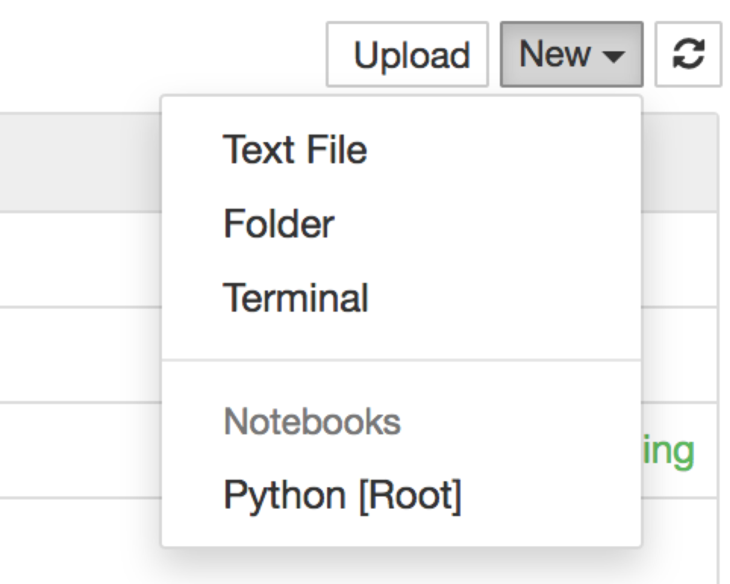

## Using the Notebook for Code

* Add a new “cell” to the notebook with the + icon

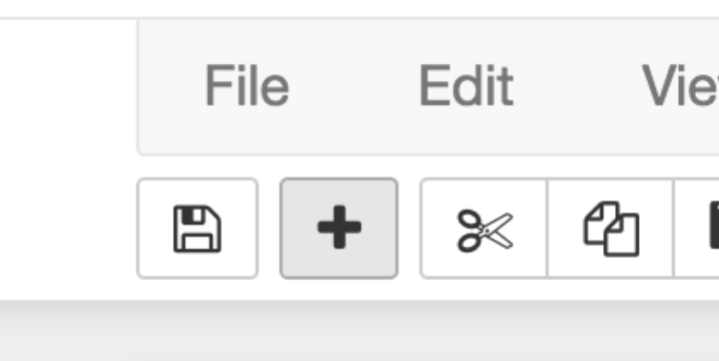

* “Run” or evaluate a cell by clicking in the cell and pressing SHIFT-ENTER (at the same time) (it will display any results and create a new empty cell).
* To see values of variables or print, you can either put a variable alone in a cell and execute it, or use a “print(var)” statement (replacing “var” with the name of your variable). In this example, we defined var as the string of characters “hi” and then we checked it by using 2 methods, evaluating it in a cell (2, which has the output below in “Out[2]”) and by printing it (3).

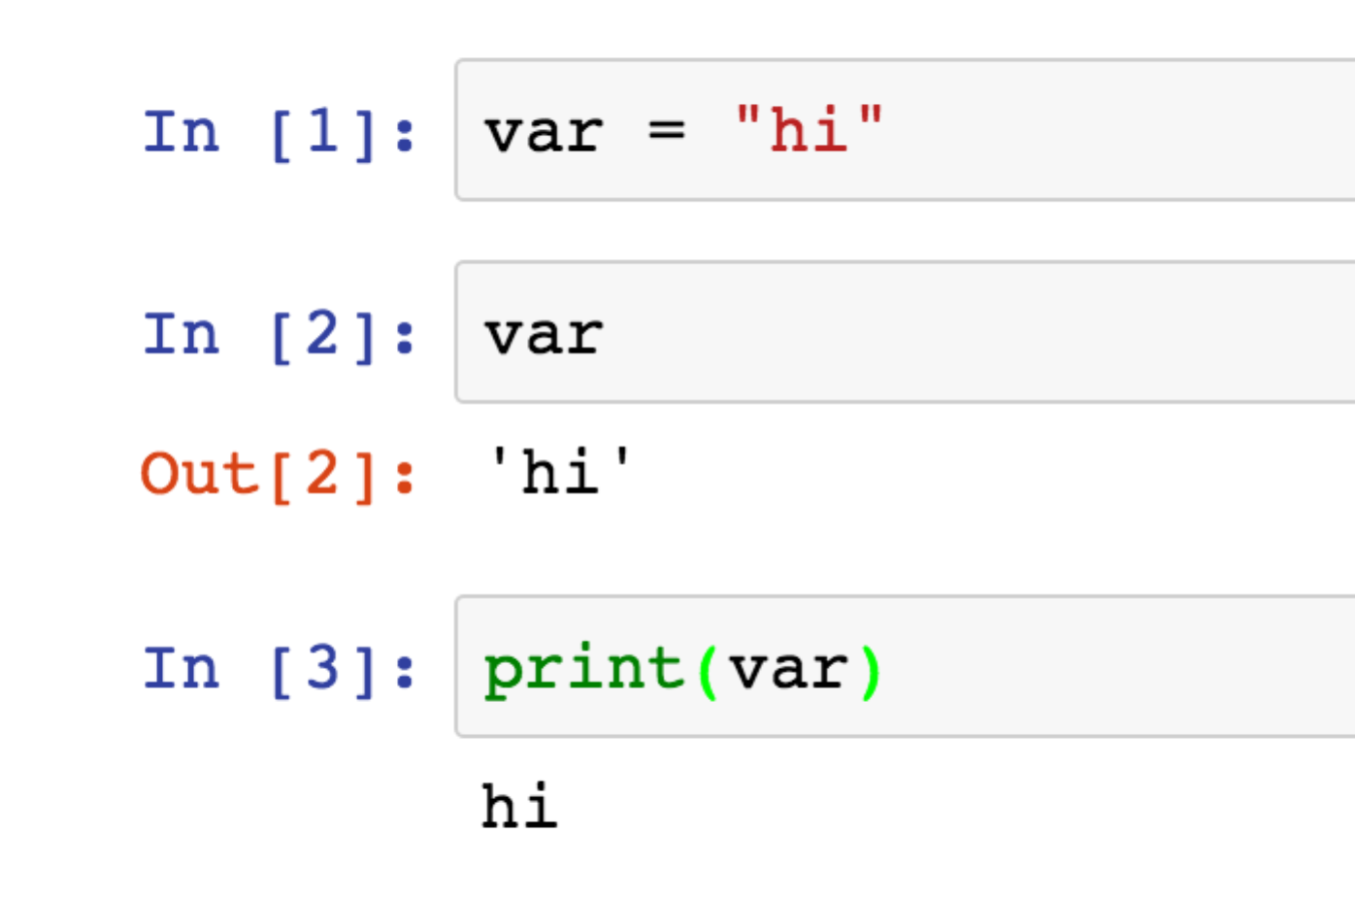

### Text Cells in the Notebook

You can create text in the notebook too. For example, do this by typing “Question 1” in a new cell, and then changing the type at the top using the dropdown menu that shows “Code” by default:

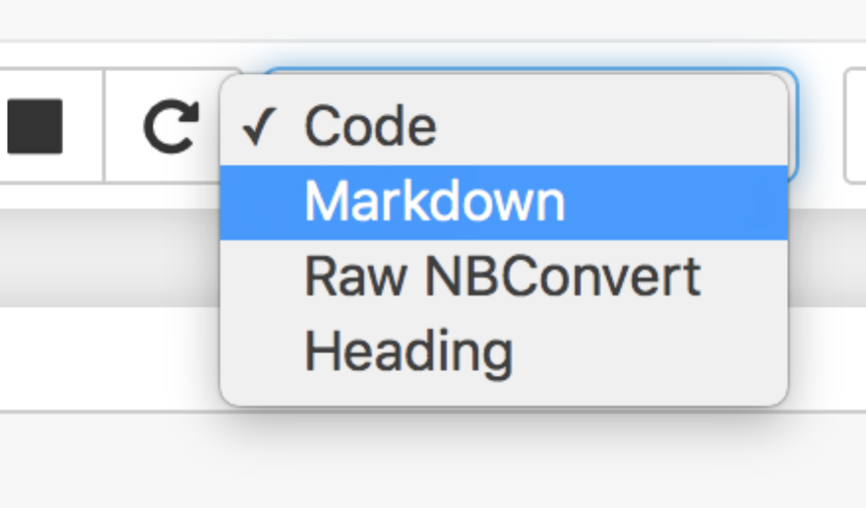

After you evaluate this cell using markdown (or Heading), you will see it change into plain text:

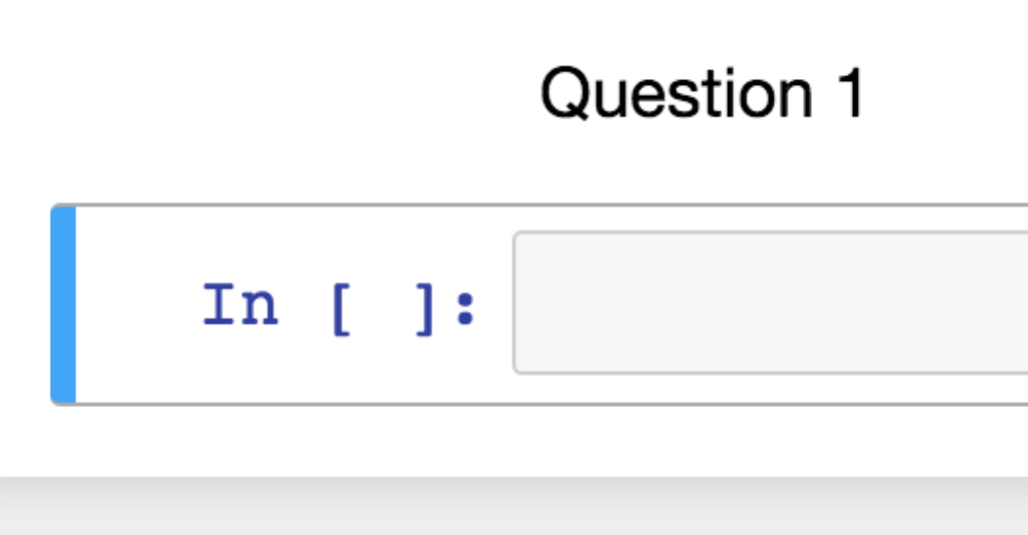

### The Notebook Files You Turn In

Save your work using the save button on the notebook toolbar:

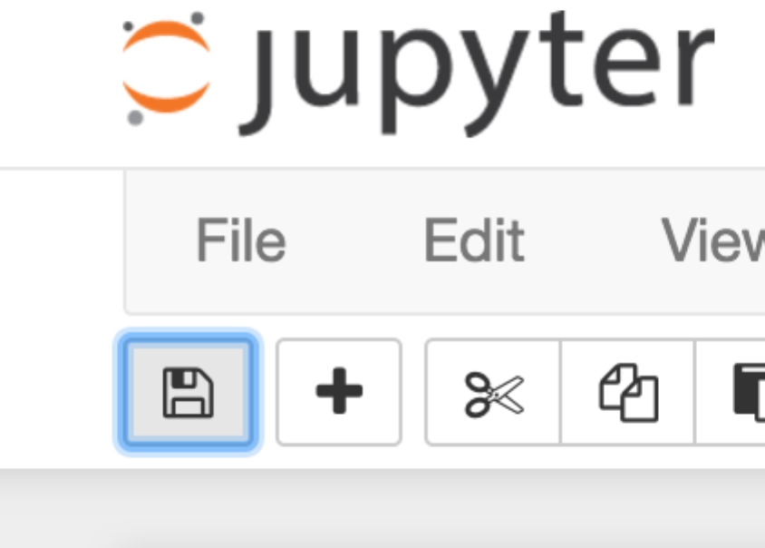

DO NOT SAVE THE NOTEBOOK FILE FROM THE WEB BROWSER FILE MENU.

The notebook, when you save it, will be a file ending in “.ipynb”. You will submit this as your homework each week.

If you started the notebook from the Anaconda dialog, your notebook files will be in the root directory for your operating system. If you navigated into a folder before you opened the file or created it, it will be in the directory you navigated to.

The root directory, if you did not navigate somewhere, is your folder under “Users” and “User”.

On Windows, this is wherever your User directory is. Click on your C drive and navigate to it. Look for the files that end with “.ipynb” at the end.

On Mac, this is probably the top of your Users directory too. Use the finder to navigate.

Upload the .ipynb file to the Dropbox.

### Installing Python Packages

If you get an error during import, it means a package isn’t installed yet.

Open a terminal window. It must be a **new terminal window** (“nouvelle fenetre”) not the one that is showing the code for the notebook that is running….

For instance, try “conda install seaborn”:

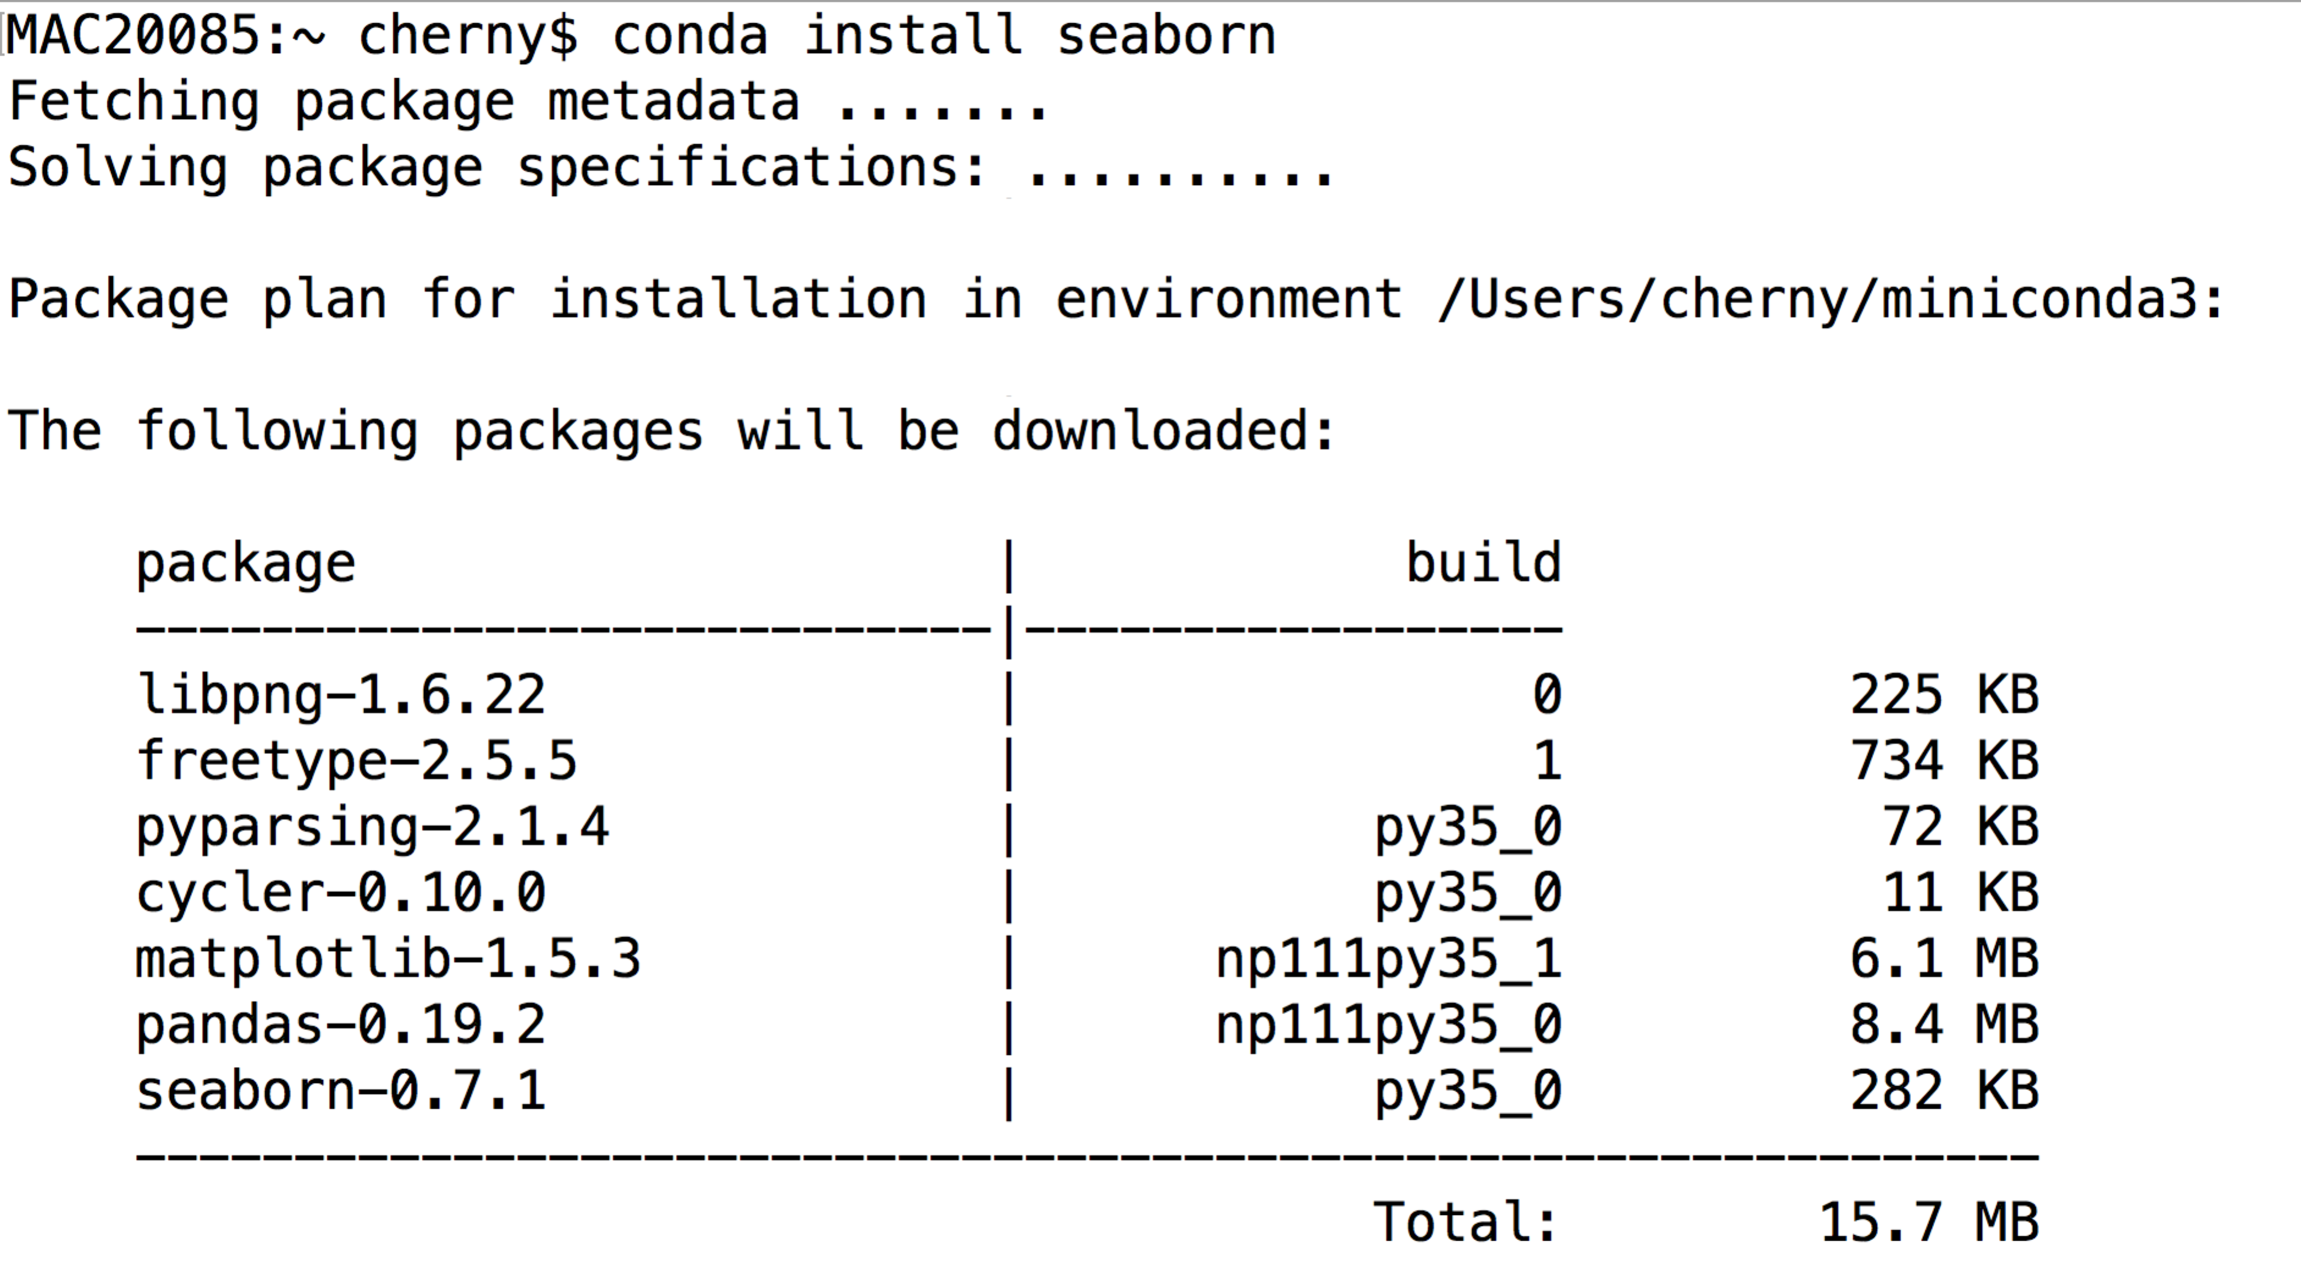

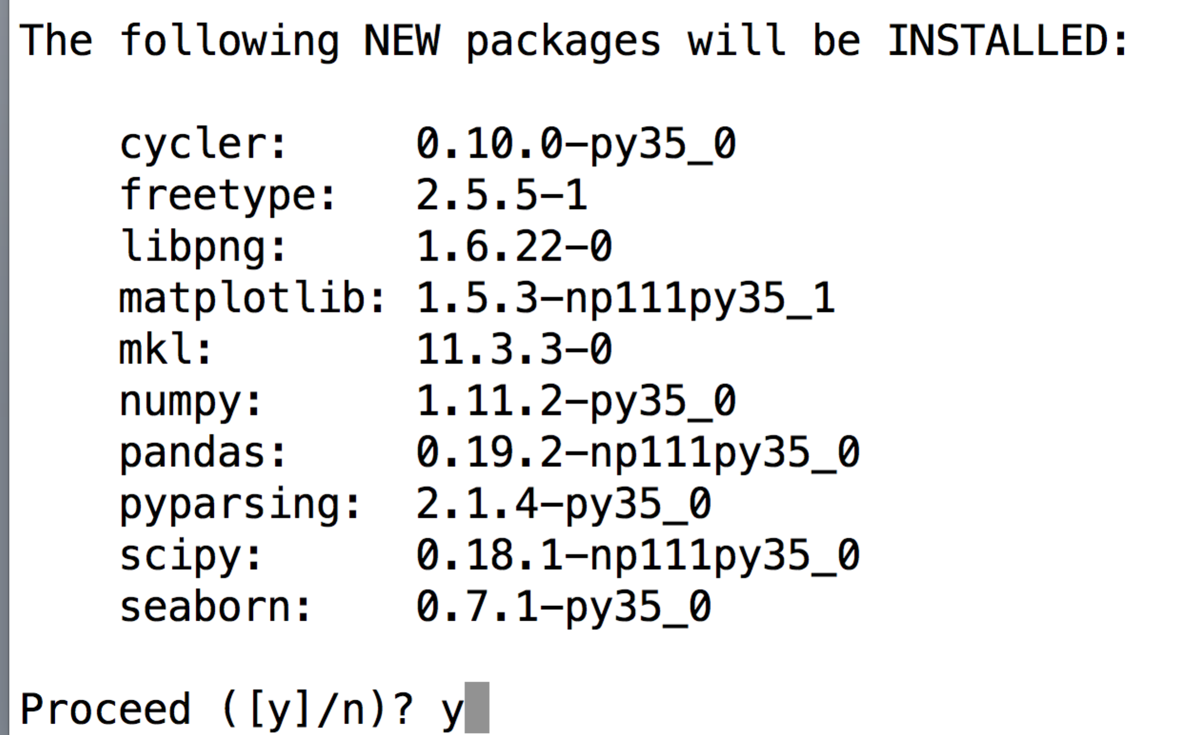

Type “y” and it will install for you.

Now you will be able to “import seaborn” when we need it.

If a “conda install <packagename>” fails… you can try “pip install <packagename>” instead. The packages may not all be listed in the conda online repository, but most of them are in “pip.” We prefer conda because they work best with Anaconda.