

Creating Customer Invoices

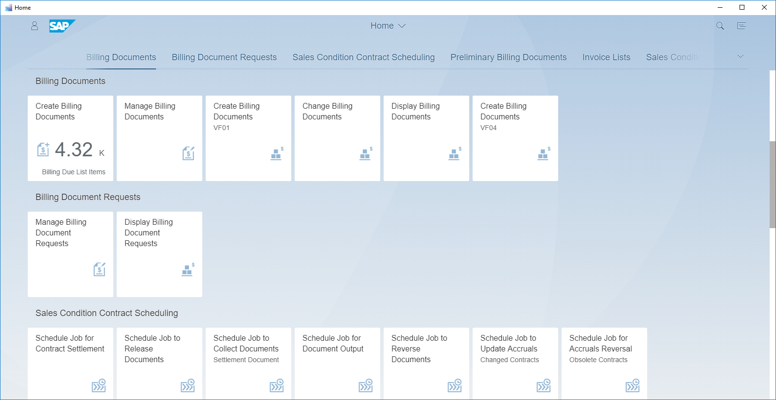

|  | Would you like to know more about how a billing clerk creates a customer invoice?    If so, follow this interactive tutorial. |
| --- | --- |

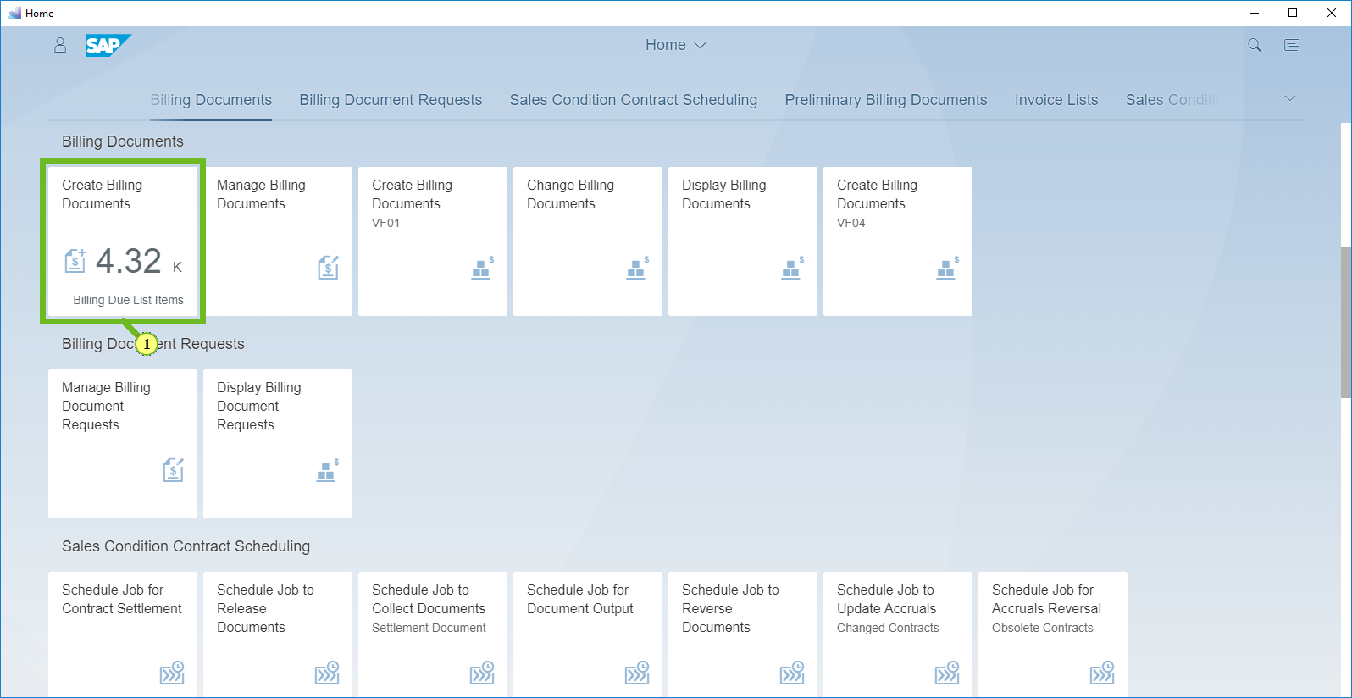

(1) To open the app, select the *Create Billing Documents tile.*

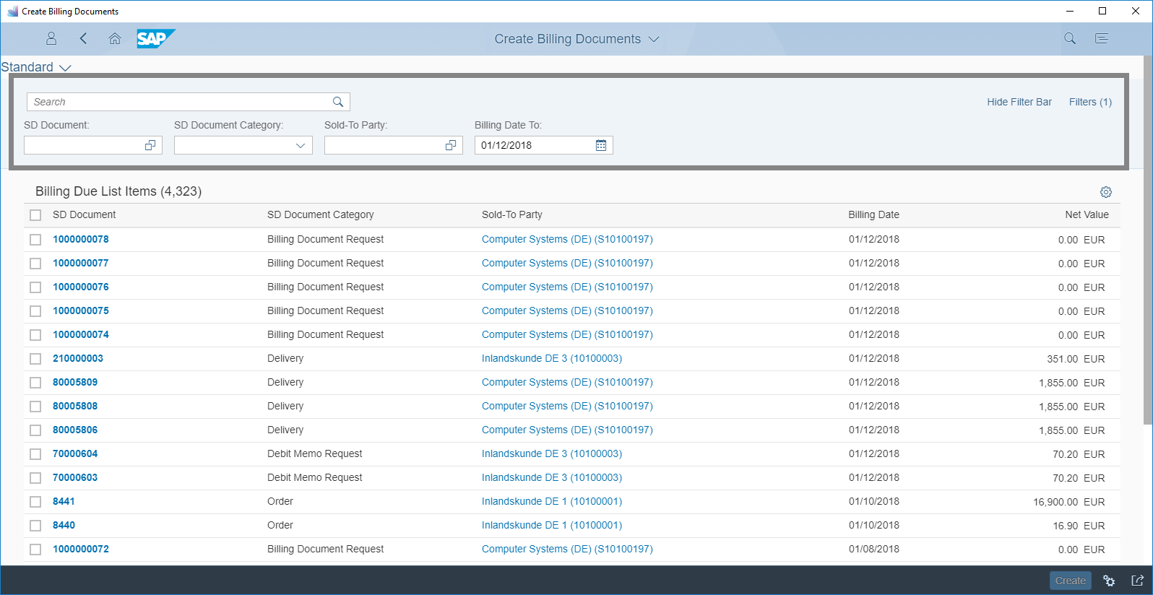

|  | In this section of the screen, you can filter for your delivery-related billing due items. |
| --- | --- |

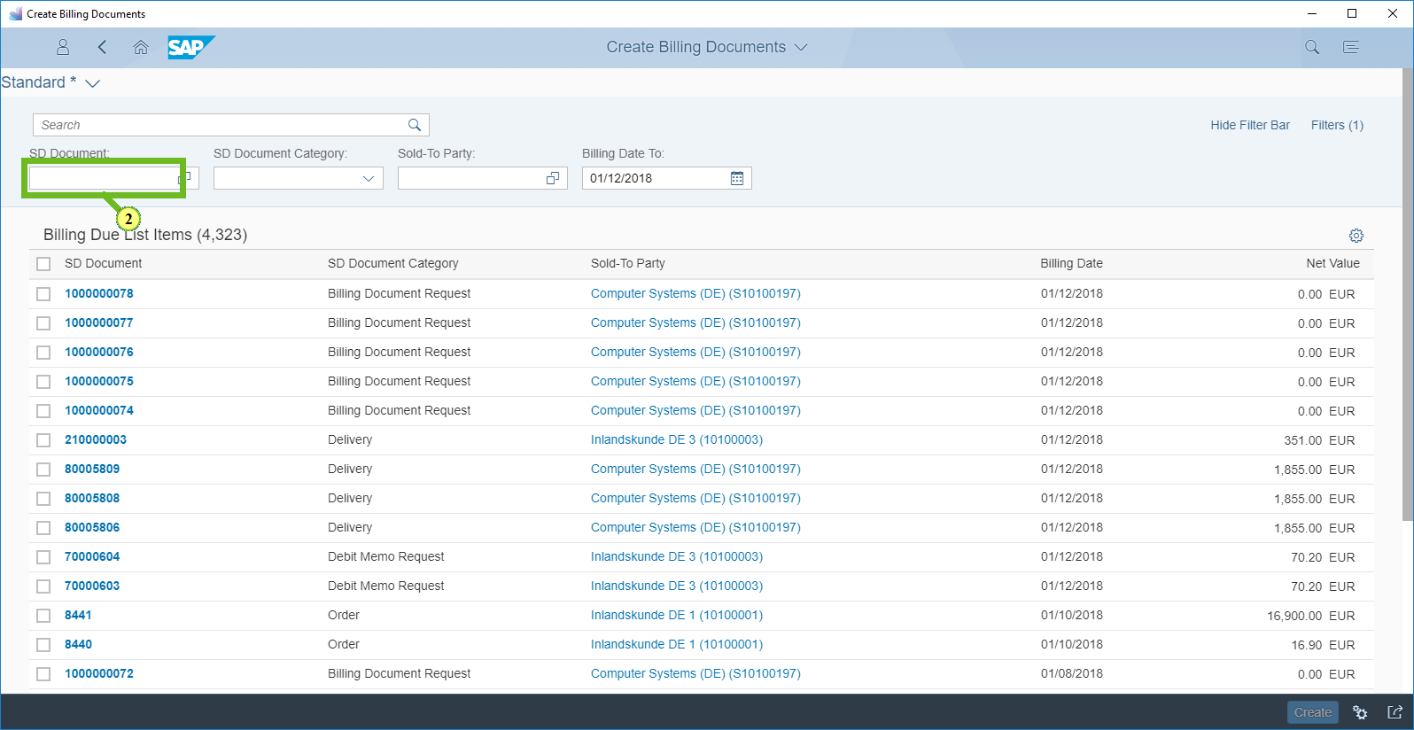

(2) To filter for your delivery, in the *SD Document field, enter* ***210000003 and press Enter.***

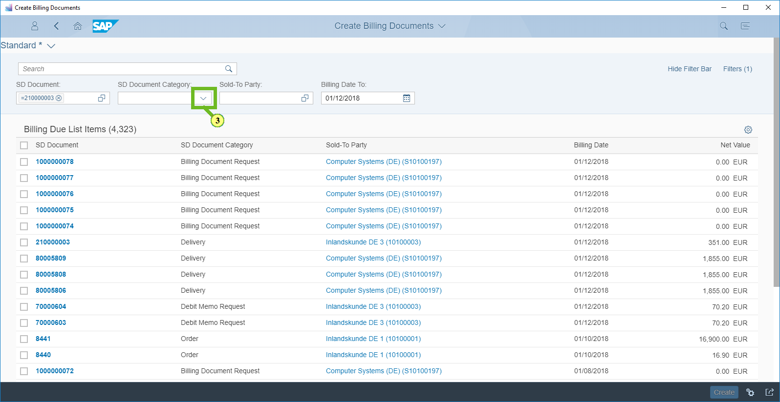

(3) Open the *SD Document Category list.*

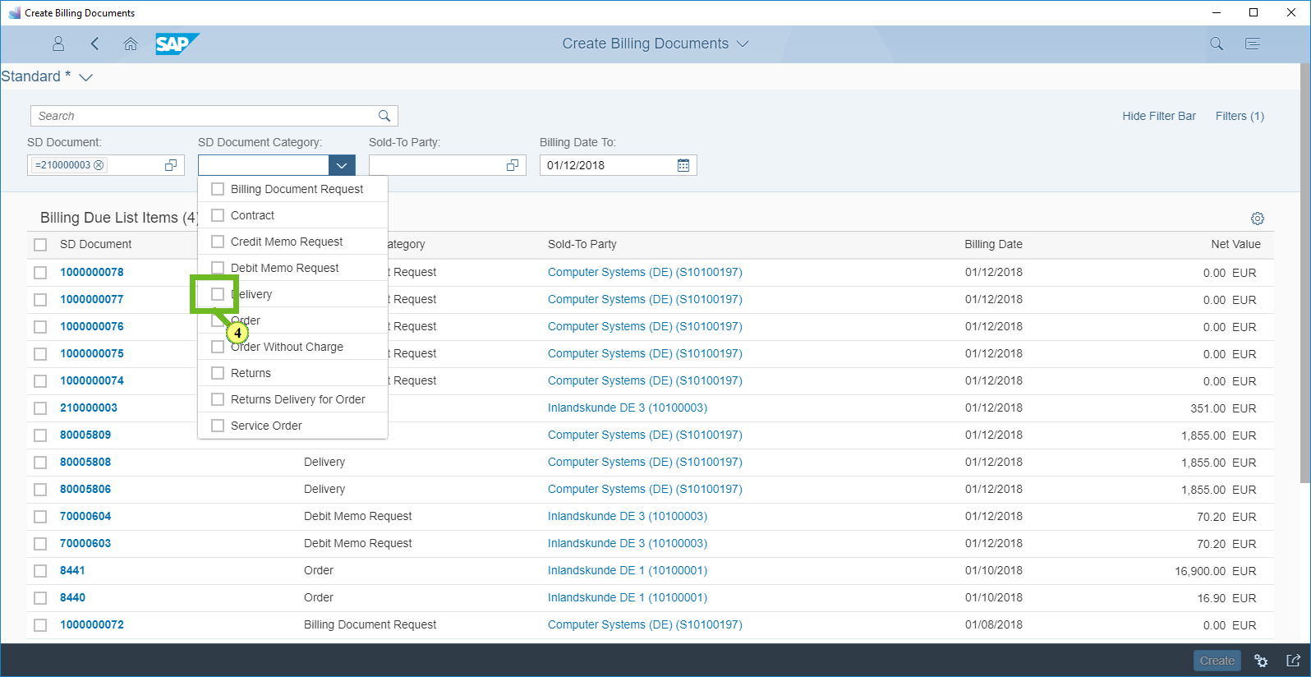

(4) Select *Delivery.*

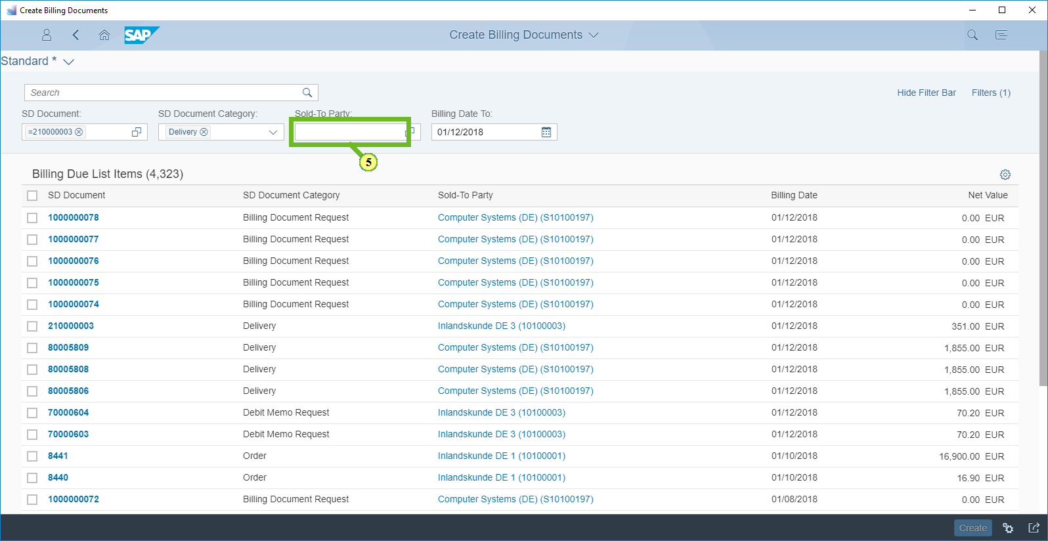

(5) In the *Sold-To-Party field, enter* ***10100003 and press Enter.***

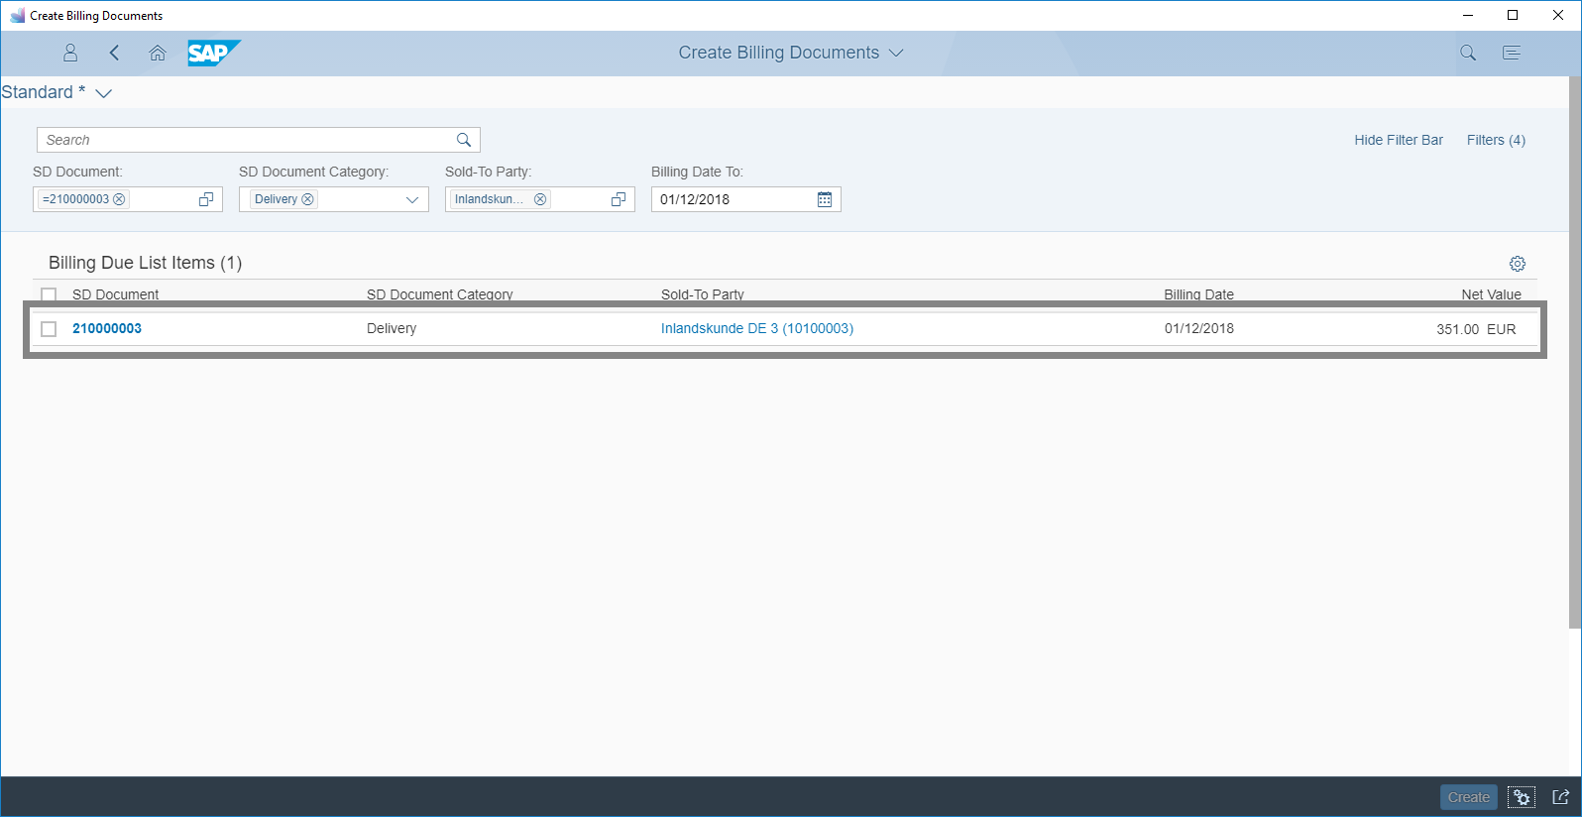

|  | Your delivery-related billing due list item appears. |
| --- | --- |

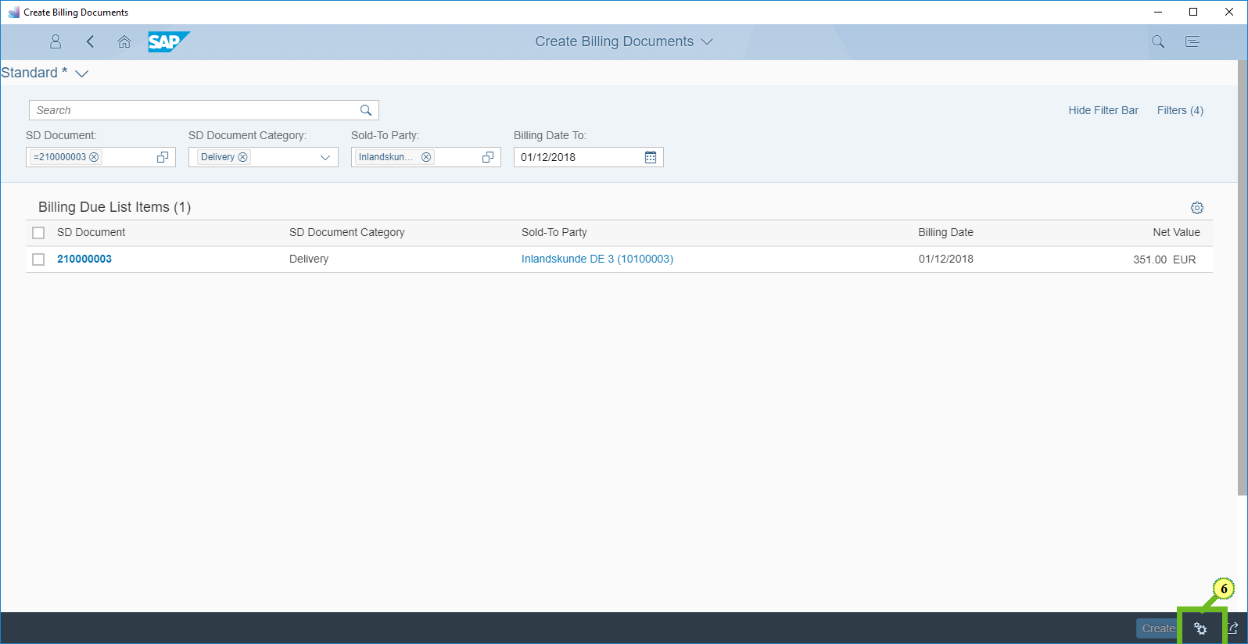

(6) Choose *Billing Settings.*

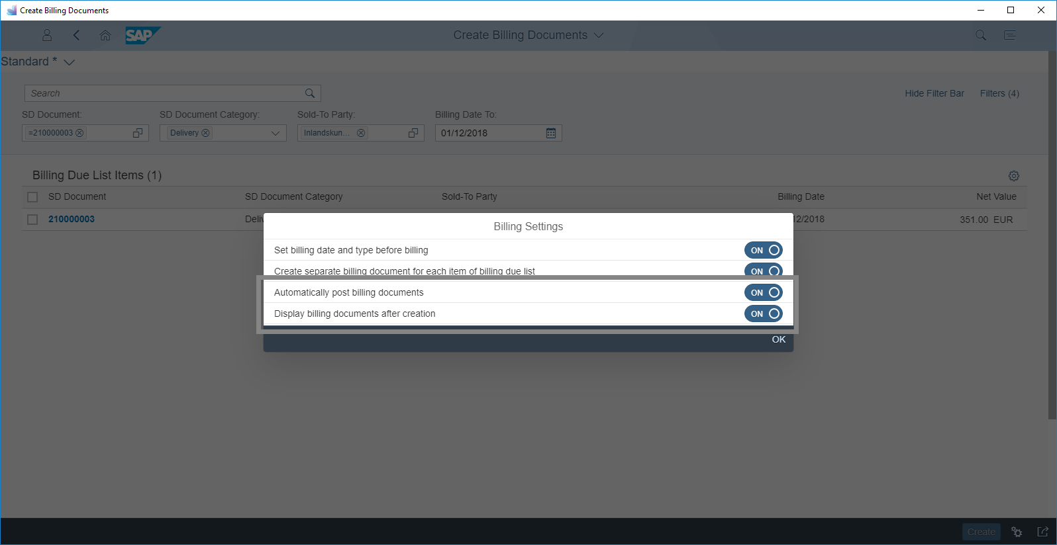

|  | Check that the *Automatically post billing documents and the Display billing documents after creation settings are set to On.*    For this tutorial, the settings have already been selected for you. |
| --- | --- |

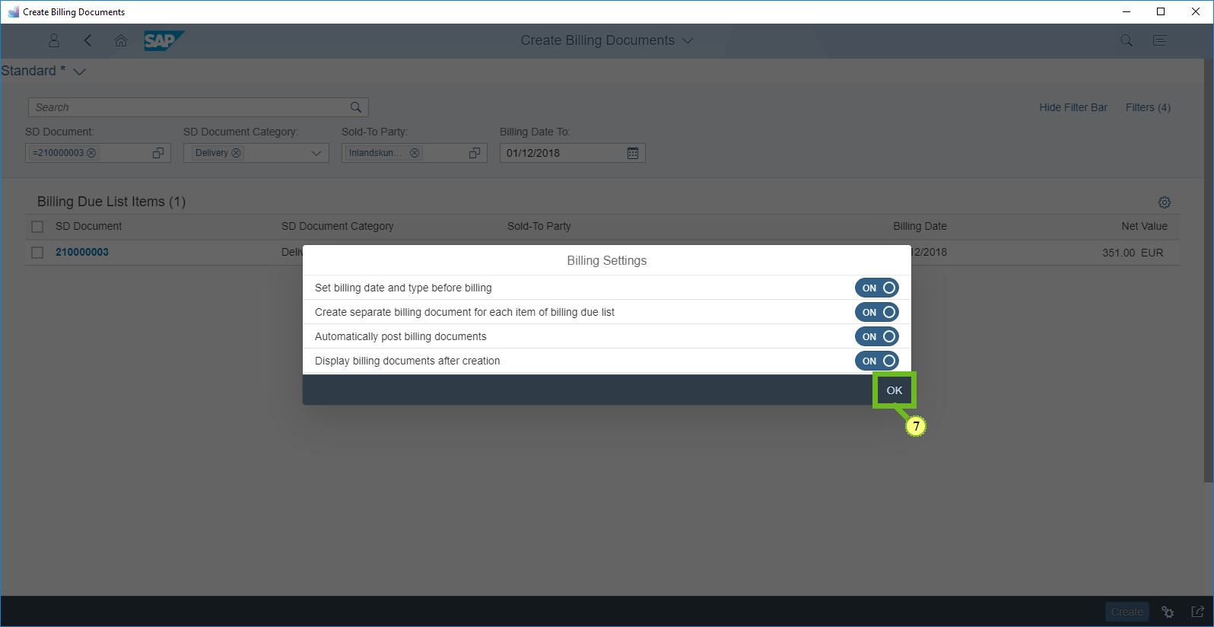

(7) Choose *OK.*

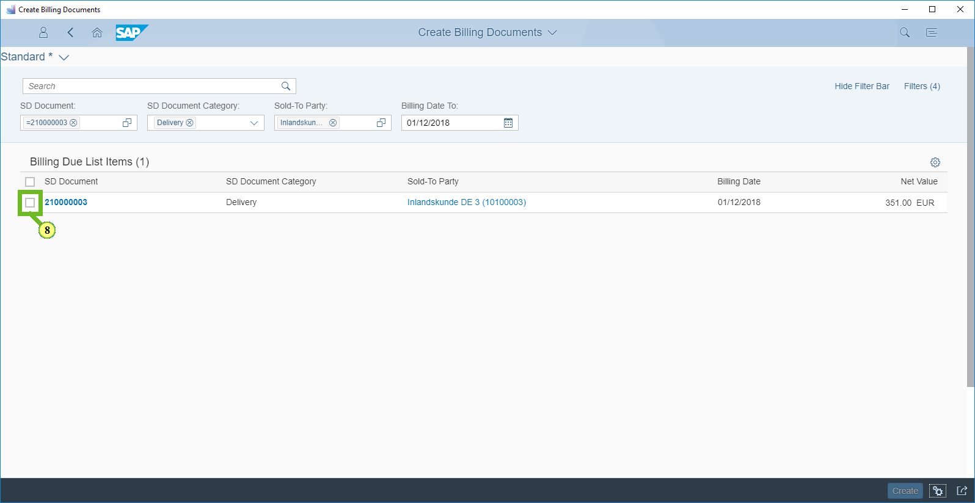

(8) Select *210000003.*

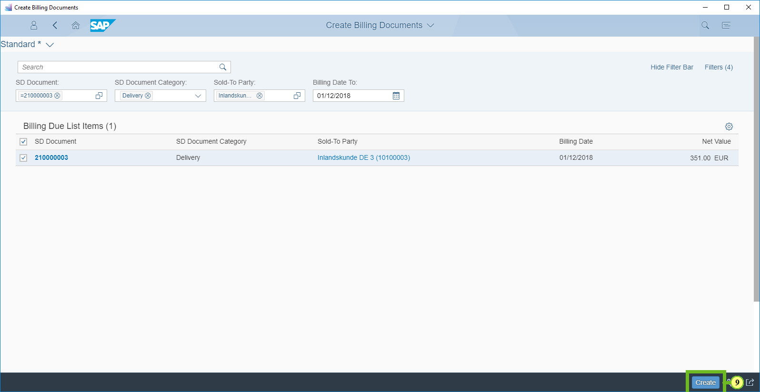

(9) To create the billing document for the selected item, choose *Create.*

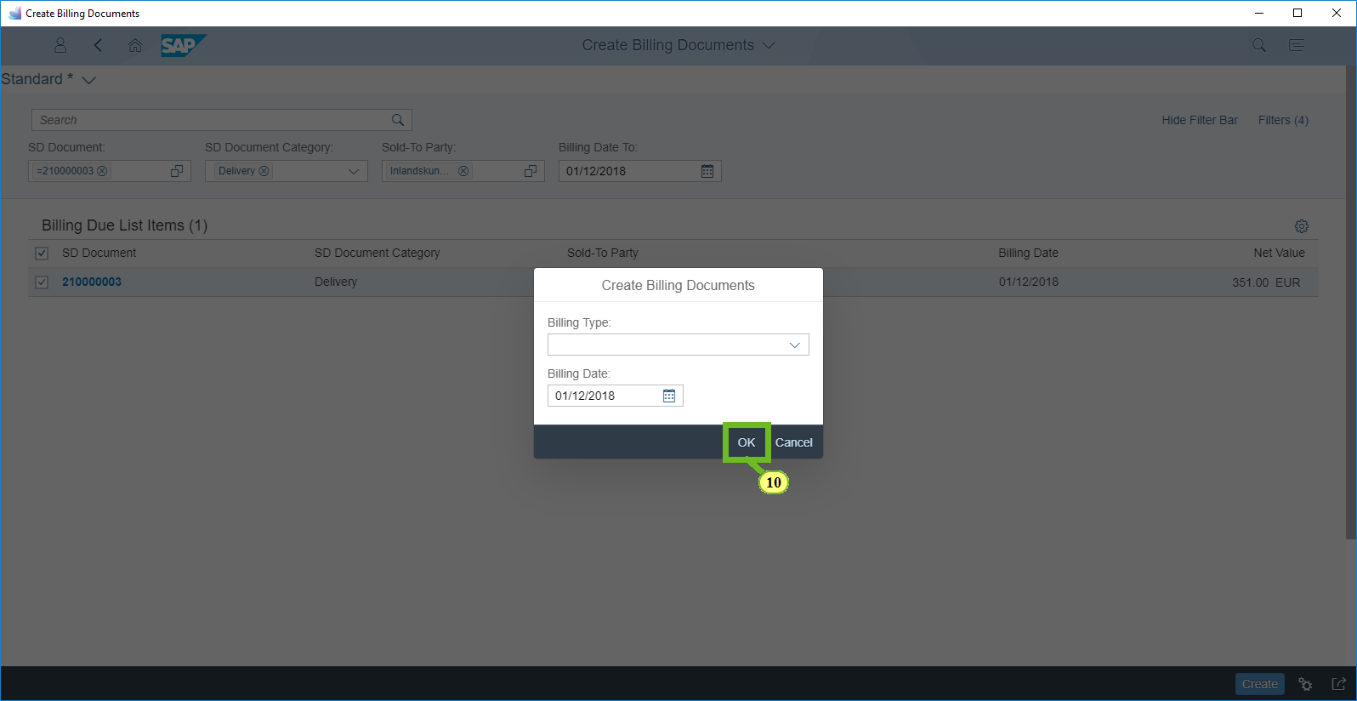

(10) Choose *OK.*

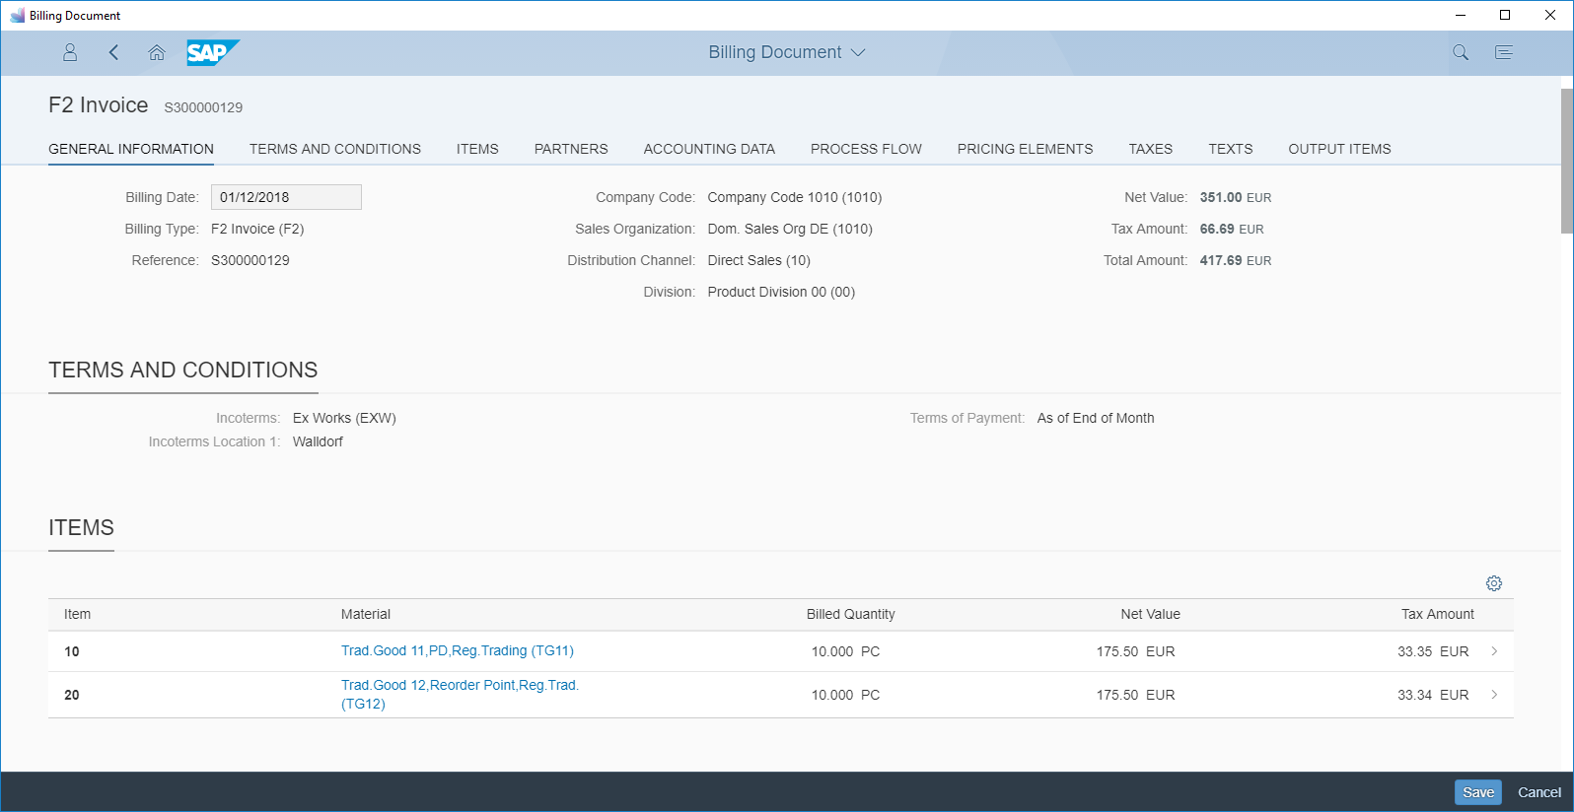

|  | The system generates a customer invoice and displays the invoice details. |
| --- | --- |

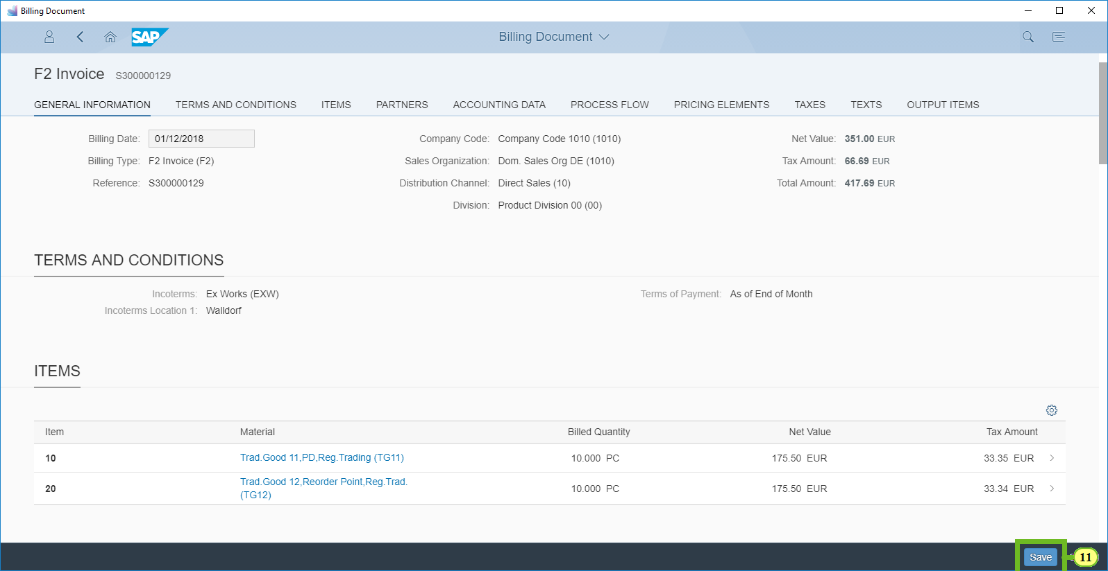

(11) Choose *Save.*

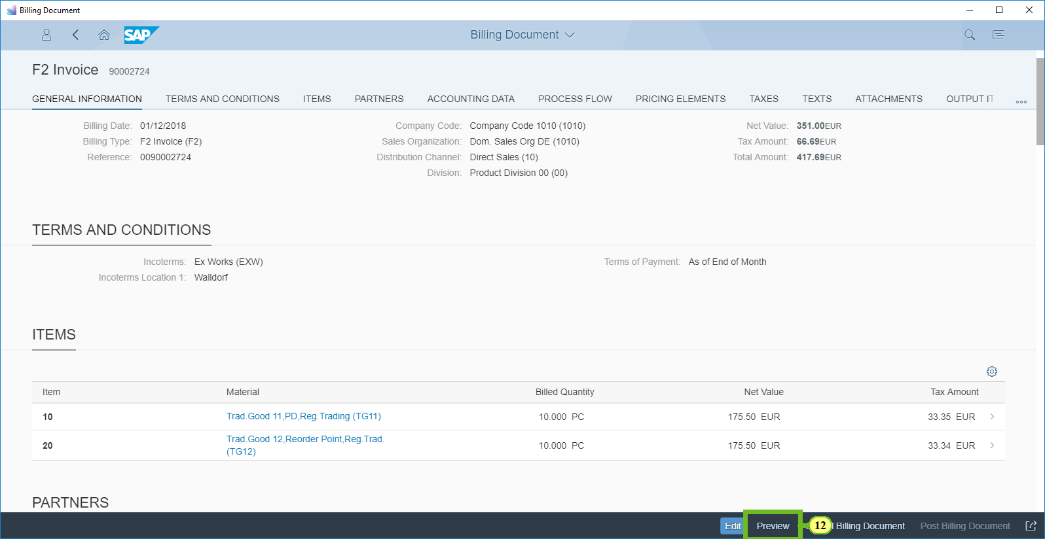

(12) To display a preview of the invoice document in PDF form, choose *Preview.*

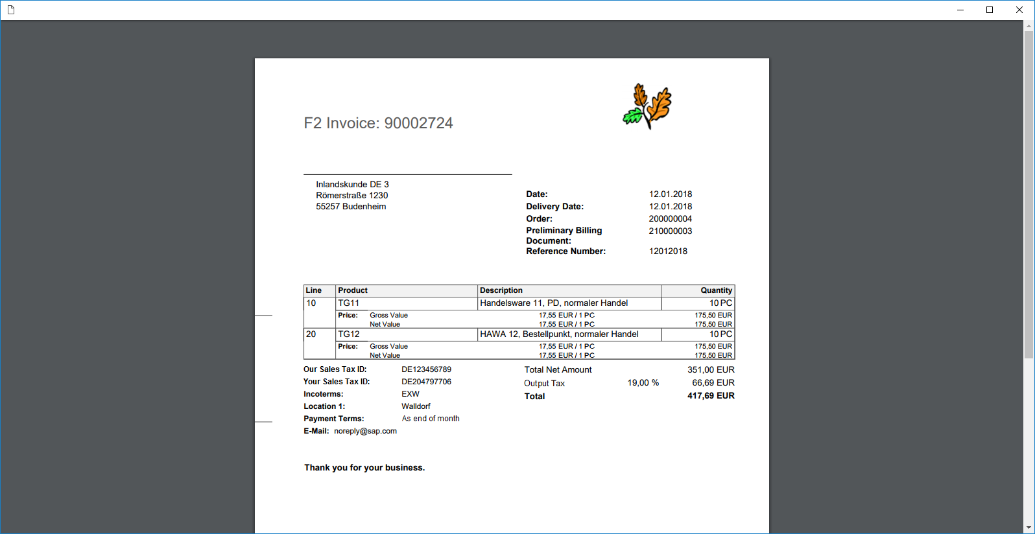

|  | A preview of the invoice document in PDF form appears in a new window. |
| --- | --- |

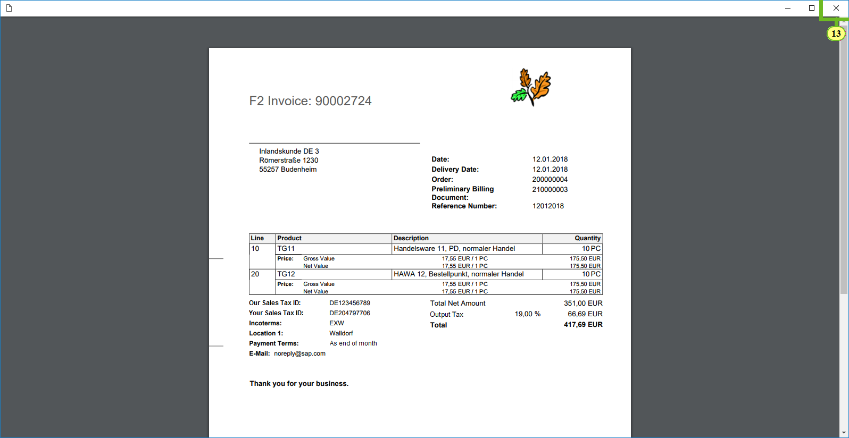

(13) Choose *Close.*

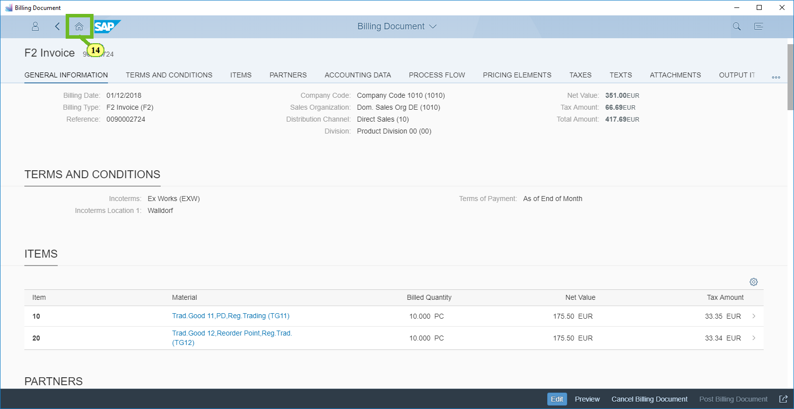

(14) To return to the launchpad, choose *Home*.



|  | You have successfully created a customer invoice.    This concludes the interactive tutorial. |
| --- | --- |