U.S. Investment-Grade Corporate Bonds
Asset Class Analysis Report
Arnav Mathur
March 28, 2026

Executive Summary
This report analyzes U.S. investment grade corporate bonds as an asset class. Investment grade corporate bonds are debt securities issued by large, financially stable corporations that are rated BBB- or higher by Standard and Poor's. Investors purchase these bonds in exchange for fixed coupon payments and the return of face value at maturity. To benchmark and evaluate performance, we use the Bloomberg U.S. Corporate Bond Index as our primary reference, with the iShares iBoxx Investment Grade Corporate Bond ETF (LQD) serving as our accessible proxy throughout the report.
From a performance standpoint, the data tells two different stories depending on the time horizon. Over 10 years, LQD returned 3.58% annualized, consistently outperforming both the Bloomberg U.S. Aggregate Bond Index (2.29%) and U.S. Treasuries (2.28%). This confirms that the credit spread premium on corporate bonds adds real value over the long run. In the near term, the picture is more complicated. The Federal Reserve's decision to hold interest rates steady, combined with crude oil prices surging above $95 a barrel as a result of the conflict in Iran, has created meaningful headwinds for the asset class. That said, LQD's year to date decline of 1.76% compares favorably to the S&P 500's drop of 6.69%, reinforcing the role investment grade bonds play as a stabilizing force in a portfolio during periods of equity market stress.
On the valuation side, credit spreads remain relatively tight at 70 to 90 basis points, while yields sit in the 5% to 7% range. This means investors are receiving solid income but limited extra compensation for the credit risk they are taking on. The Chapman University 2025 Economic Forecast projects the Federal Funds rate to average between 3.4% and 4% by the end of 2026, which points to a gradual easing in the rate environment that could serve as a tailwind for bond prices going forward (Doti, 2025).
Our overall recommendation is neutral to cautious. We favor higher quality issuers within the investment grade space, specifically A rated bonds and above, selective sector exposure toward technology firms funding AI infrastructure, and shorter maturities in the 2 to 5 year range to limit interest rate sensitivity in the current environment.
Market Overview
U.S. investment grade corporate bonds are one of the most important asset classes in global financial markets. These bonds are issued by large, financially stable corporations that need to raise capital for a wide range of purposes, from funding day-to-day operations to financing major investments like the AI data centers discussed later in this report. To qualify as investment grade, a bond must carry a credit rating of BBB- or higher from Standard and Poor's, or Baa3 or higher from Moody's.
The market is dominated by some of the largest and most well known companies in the United States. JPMorgan Chase, Apple, and UnitedHealth Group are among the biggest issuers, and their financial strength is precisely what makes their bonds attractive to investors. On the demand side, the market is largely institutional. Large insurance companies are the dominant buyers of investment grade corporate bonds because the steady, predictable coupon payments align well with their long term liabilities such as insurance claims. Retail investors represent a much smaller portion of the market, with older individuals making up the bulk of that group given their preference for stable income.
What makes this asset class particularly important to understand is where it sits in the broader fixed income landscape. Investment grade corporate bonds occupy a middle ground. They offer more yield than risk free U.S. Treasuries while carrying significantly less default risk than high yield or junk bonds. This positioning is reflected in the return data throughout this report, where LQD consistently sits between IEF (Treasuries) and SPY (equities) across nearly every time horizon. The extra yield over Treasuries, known as the credit spread, is the core value proposition of this asset class, and monitoring that spread is central to understanding how the market is performing at any given point in time.
On the issuance side, the market has seen a significant uptick in activity heading into 2026. Bank of America increased its forecast for investment grade debt sales by technology firms, known as hyperscalers, by 25% to $175 billion for the year, driven by the massive capital requirements of artificial intelligence infrastructure (Roy, 2026). Large tech firms are expected to spend approximately 70% more on data centers this year compared to last, totaling $600 billion. This surge in supply is an important backdrop for understanding current market conditions and is something we address directly in both our article analysis and recommendations.

Description of the Asset Class
Investment-grade U.S. corporate bonds are debt securities issued by businesses in order to raise capital. Investors purchase these bonds in exchange for fixed interest payments (coupon payments) and the bond's face value at maturity. Investment-grade U.S. corporate bonds are classified as investment-grade because they have a lower risk of default than other bonds. The default risk of these bonds falls between U.S. Treasury Bonds (low risk) and U.S. high-yield bonds (higher risk). Standard and Poor's Global Ratings provide an accurate way to classify corporate bonds. Any bond with a rating of BBB- or higher is classified as investment grade, as it is far less likely to default. On the other hand, bonds with a rating below BBB- are known as speculative or "junk bonds." Speculative corporate bonds have much higher yields than investment-grade bonds but carry greater default risk. Larger, more financially powerful firms are the most common issuers of investment-grade corporate bonds. For example, some of the largest issuers of U.S. investment-grade corporate bonds are JPMorgan Chase, Apple, and UnitedHealth Group. Since these firms are financially stable, they are much less likely to default on their bonds, unlike smaller companies. In the market for investment-grade U.S. corporate bonds, retail investors and households own a small minority. Among these retail investors, older investors hold more of these bonds due to the bonds' safe, consistent fixed interest payments. The majority of investment-grade U.S. corporate bonds are held by large insurance companies. These U.S.-based insurance companies tend to hold large amounts of these bonds because of their steady cash flows. These predictable cash flows allow insurance companies to pay off their long-term liabilities (insurance claims).
Appropriate Index to Analyze
When analyzing US investment grade corporate bonds, the most appropriate benchmark to use is the Bloomberg US Corporate Bond Index. This index tracks the US Dollar-denominated, investment-grade, fixed-rate corporate bonds and requires that any bond included carries a rating of at least BBB- by S&P or Baa3 by Moody's, has at least one year left to maturity, and has a minimum of $300 million in face value outstanding. With over 6,000 bonds across multiple sectors, it gives a broad and accurate picture of the overall investment-grade corporate bond market.
We believe that this index is the right choice because it directly reflects the market we are analyzing. The bonds issued by companies like JPMorgan, Apple, and UnitedHealth Group are all constituents on this index. It also captures the macro forces that we will cover later in our report, including debt issuance, the Fed's decisions to hold rates steady, and the credit pressures stemming from the conflict in Iran.
For the purposes of our report however, we have used the iShares iBoxx $ Investment Grade Corporate Bond ETF (LQD) as a proxy. We chose this because LQD closely tracks the Markit iBoxx USD Liquid Investment Grade Index and is one of the most widely followed investment-grade bond ETFs in the market. Using LQD allowed us to pull accessible return data for all horizons required for this report.
For our return data in the following sections, we also benchmark against three additional indices:
- S&P 500: To compare against equities and illustrate risk/return tradeoff
- AGG: Broader bond market baseline that includes Treasuries and mortgage-backed securities
- IEF: Risk-free baseline that allows us to isolate how much additional returns investors earn from taking on corporate credit risk rather than simply holding government bonds

Historical Returns and Benchmark Comparison
To evaluate the performance of US Investment-Grade Corporate bonds, we reference the Bloomberg US Corporate Bond Index and use LQD as the accessible proxy. The returns are benchmarked against the S&P 500 (SPY), the Bloomberg US Aggregate Bond Index (AGG), and the US Treasury 7-10 Year ETF (IEF) as of March 27, 2026.
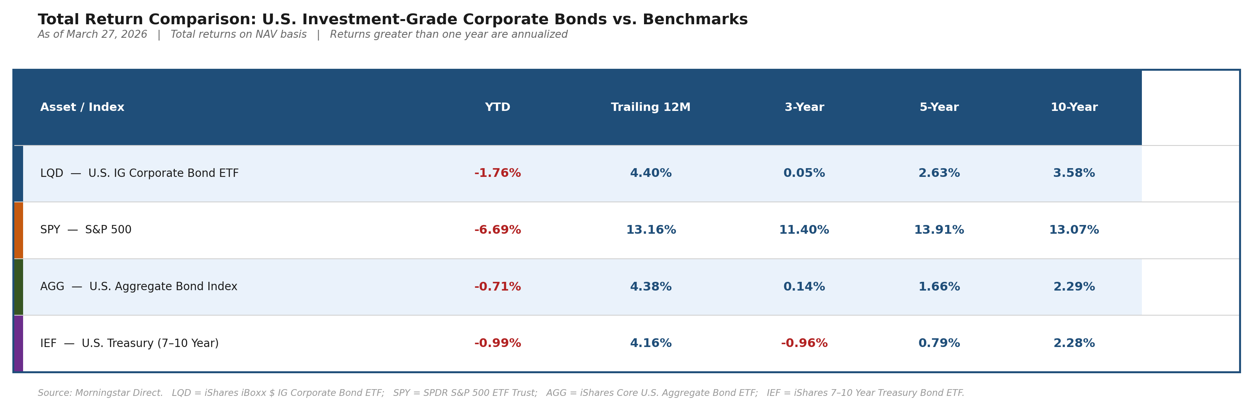
Figure 1. Total Return Comparison: U.S. Investment-Grade Corporate Bonds vs. Benchmarks. Source: Morningstar Direct, as of March 27, 2026.
Long-Term Performance (5 and 10 Year)
Over the long run, the S&P 500 has significantly outperformed investment-grade corporate bonds. The S&P had 13.07% annualized returns compared to 3.58% for LQD. This is an expected gap as equity investors take on more risk and the market rewards them for that over time. However, if we look more closely at the comparisons between LQD, AGG, and IEF, we see that LQD has been consistently beating the other 2 over 10 years. This difference is the credit spread premium, which is the extra return investors earn for holding corporate bonds instead of government bonds or a broad bond index. Over a long enough horizon, that premium adds up.
Short-Term Performance (YTD and Trailing 12 Month)
The short-term numbers tell a much more interesting story. If we look at the YTD, we see that LQD is down 1.76%, but SPY is down 6.69%. The equity market is taking a significantly harder hit to start 2026, and IG bonds are holding up considerably better in comparison. This is exactly the role the asset class is supposed to play during periods of market stress. The trailing 12-month shows LQD at 4.40%, nearly in line with AGG (4.38%) and IEF (4.16%), which makes sense as they are all investment-grade fixed income and tend to move together when driven by the same interest rate environment.
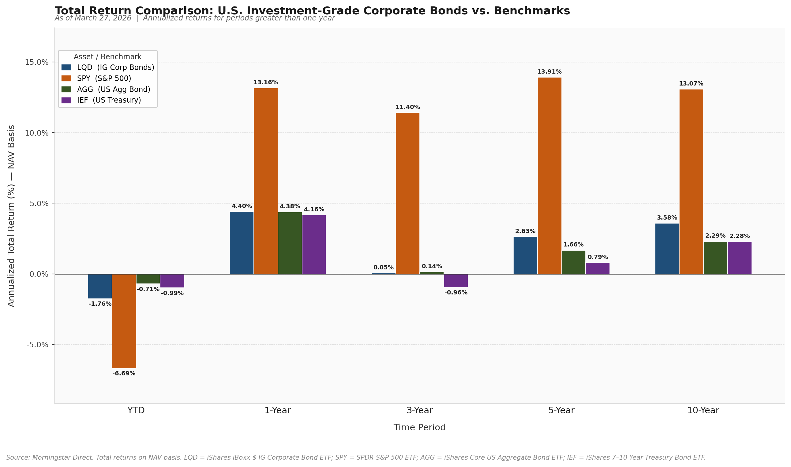
Figure 2. Total Return Bar Chart: U.S. Investment-Grade Corporate Bonds vs. Benchmarks. Source: Morningstar Direct, as of March 27, 2026.
The 3-Year Window
The 3-year column is the most telling in the entire table. We see that every single asset is either flat or negative, with LQD sitting at 0.05%, IEF at -0.96%. This reflects the damage done by the Federal Reserve's aggressive rate hiking cycle that began in 2022. When rates rise sharply, bond prices fall; and that is exactly what happened across the entire fixed income market. Even Treasuries, which carry zero credit risk, lost ground over this period. The fact that LQD barely stayed positive while IEF turned negative shows that the credit spread on corporate bonds provided just enough of a cushion to offset the rate-driven price decline.
Credit Spreads and What They Signal
One of the most useful tools for understanding IG bond performance beyond the raw returns are Option Adjusted Spreads. These are the yield premiums investors demand to hold corporate bonds over equivalent Treasuries. When these spreads widen, the market is pricing in more credit risk, which pushes bond prices down. When spreads tighten, confidence is high, and prices rise. Given the current environment with the Fed holding rates, oil above $95 a barrel, and corporate profit margins under pressure, credit spreads have been elevated relative to their historical average. This widening spread is a direct contributor to LQD's underperformance in the near term and is something we monitor closely in our recommendations later.

Valuation Metrics
In order to correctly value investment-grade corporate bonds, you must compare their yield to U.S. Treasury bonds, which are considered to be risk-free. The key measure that will be used is the credit spread, which illustrates to the investor how much extra return investors are compensated for taking on extra risk. Looking at Bloomberg, it is evident that spreads are relatively tight (roughly 70-90 basis points), suggesting that as of this moment investors are not receiving a large amount of extra return for taking on this risk, while the market also believes that these companies are financially stable. On the other hand, the yields in which investors are receiving are still high, remaining around 5%-7%, due to interest rates being higher. This allows investors to still be able to receive a good income, but since spreads are tight, there is not much extra reward for taking risk. We still believe, however, that these bonds are fairly valued.
Another very important factor is duration, which shows how sensitive bond prices are to changes in interest rates. Bloomberg displays duration being around 6-7, which means that if interest rates were to go up by 1%, then bond prices would respond by falling around 6%-7%. This explains why corporate bonds have experienced negative returns in recent times, even though companies have illustrated no major signs of financial stress and credit spreads have remained quite stable. The reason for the decrease in these returns is due to interest rates climbing, since interest rates and bond prices move inversely.
Interest rates are changed in response to the economy, referred to as monetary policy. With this in mind, we believe that the Chapman University 2025 Economic Forecast provides important context for the current bond market. According to Dr. Doti, real M2 money supply growth is increasing and beginning to approach around 6%, which appears to be slightly above its long-term average and is considered to be mildly positive for the economy. This illustrates that liquidity is improving after a period of contraction. In addition to this, the forecast for interest rates is expected to stabilize, while the Federal Funds rate is expected to average between 3.4% and 4% by the end of 2026. With this being said, it is evident that this reflects a shift away from a previous tight monetary policy and is beginning to transition to a more neutral or even a slightly expansionary stance. The fiscal policy on the other hand is expected to have a limited overall impact, since the recent tariffs are acting as a tax, which as a result, offsets the new government spending. Overall, the forecast pointed to a stable economy that is growing modestly, while conditions are beginning to improve but are still not strong. All of these factors in conjunction have allowed for inflation to keep stable at 3%, slightly above the Fed’s target of 2% (due to aggressive tightening by the Federal Reserve) following a period of a large increase which was due to the expansion in money supply.
Some important ideas to keep in mind are that corporate bond returns are driven by two main factors, which are interest rates and credit spreads. As previously stated, interest rates affect all bonds, while spreads display the reward investors receive for the extra risk taken. Now applying these topics in this scenario, interest rates have increased, as a result, bond prices have seen a decrease in price, while spreads have stayed relatively stable, meaning credit risk has not significantly worsened. This leads to an important conclusion, which is that recent bond performance has been driven more by changes in interest rates than by changes in credit conditions.
In terms of investment-grade corporate bonds, it is very important to consider downgrade risk and macroeconomic risk, since this poses a great threat to the value of these bonds. Firstly, downgrade risk occurs when a company’s credit rating (independent assessment of a bond issuer’s financial strength and their ability to pay back debt) is lowered, which as a result can cause bond prices to decline and potentially force institutional investors to begin to sell their holdings. This risk is especially relevant in today’s current economic environment, due to tight spreads providing a limited amount of protection if the economic conditions were to take a downturn. In addition, macroeconomic risk remains very important, since any changes in the economy may affect both interest rates and credit spreads. In the event that growth were to slow or any uncertainty increases, spreads as a result may widen, ultimately causing a negative impact on bond prices. This makes it evident that monitoring economic conditions and credit quality is imperative when investing in corporate bonds.
Some important global events to consider, which could potentially have negative effects on these bond prices, would be the ongoing conflict involving Iran, which may have significant detrimental impacts on investment-grade corporate bonds. Recent developments have led to sharp increases in oil prices, accompanied by greater uncertainty in global markets. The reason why this is important to take into account would be that higher energy prices may contribute to rising inflation, which may result in interest rates staying elevated, consequently negatively affecting bond prices. Overall, these events may also reduce market liquidity and increase volatility. Since spreads are currently observed to be tight, any escalation in global tensions may result in a more pronounced negative impact on bond performance.
Based on all of these factors and my analysis of the current market, investment-grade corporate bonds appear to be fairly valued in the current environment. With elevated yields providing solid income, tight credit spreads limit the amount of extra return investors receive for taking on extra risk. On the other hand, duration risk is another factor that remains important, since bond prices are still sensitive to changes in interest rates. In today’s environment, global uncertainty is important to take into consideration, since it may potentially lead to negative effects on investment-grade corporate bonds (downgrades, interest rate risk, etc.), such as geopolitical tensions in Iran, resulting in reduced performance if conditions were to worsen. With all of this in consideration, our stance is cautious, focusing on shorter-duration bonds in order to reduce interest rate risk and waiting for spreads to widen before taking on any additional credit exposure. The purpose of this approach would be to allow investors to be able to earn income while maintaining the flexibility necessary to protect themselves from any potential downside risks.

Risk Analysis
While investment grade corporate bonds are considered a relatively safe asset class, they are not without risk. Understanding what can go wrong is just as important as understanding the return potential. Below we outline the four key risks relevant to this asset class, each of which is directly reflected in the market conditions covered throughout this report.
1. Interest Rate Risk
Interest rate risk is the most significant and immediate risk facing investment grade corporate bonds right now. When interest rates rise, bond prices fall. The degree to which a bond's price moves in response to rate changes is measured by its duration. As discussed in Section 4, Bloomberg currently shows duration for the investment grade corporate bond market at around 6 to 7. This means that a 1% increase in interest rates would result in roughly a 6 to 7% decline in bond prices. The Federal Reserve's decision to hold rates steady rather than cut as expected has been a direct headwind for the asset class, and it is the primary reason the 3 year return across all fixed income assets in our return table is either flat or negative.
2. Credit and Downgrade Risk
Credit risk refers to the possibility that a bond issuer is unable to make its scheduled coupon or principal payments. Within the investment grade universe, the more relevant version of this risk is downgrade risk, where a company's credit rating is lowered below BBB, pushing its bonds out of the investment grade index entirely. As our recommendations in Section 7 point out, nearly half of the Bloomberg U.S. Corporate Bond Index sits at BBB, the lowest tier before junk status. With oil prices above $95 a barrel compressing corporate profit margins, particularly for manufacturers and consumers, the risk of downgrades is elevated for companies in energy exposed sectors (Barbuscia, 2026). A downgrade to high yield forces institutional investors to sell, which drives prices down sharply and quickly.
3. Geopolitical and Macroeconomic Risk
The conflict in Iran has introduced a layer of uncertainty that cuts across the entire investment grade market. West Texas Intermediate crude oil topped $95 a barrel in March 2026, up from $57.42 at the end of last year (Barbuscia, 2026). Higher energy prices act as a cost increase for virtually every company that manufactures, ships, or consumes goods, which covers a wide portion of investment grade bond issuers. This reduces profitability and makes it harder for companies to service their debt. At the same time, elevated oil prices feed into inflation, which limits the Fed's ability to cut rates. As noted in Section 4, current inflation sits approximately 1% above the Fed's 2% target (Doti, 2025). Any further escalation in global tensions could widen credit spreads meaningfully, pushing bond prices lower even without a single default occurring.
4. Liquidity Risk
Liquidity risk is the risk that an investor cannot sell a bond quickly without accepting a significant discount on its price. U.S. investment grade corporate bonds are generally more liquid than high yield or emerging market bonds, but they are not as liquid as U.S. Treasuries. During periods of market stress, such as the current environment driven by geopolitical uncertainty, liquidity in the corporate bond market can deteriorate. Bid ask spreads widen, and large institutional sellers can move prices against themselves if they need to exit a position quickly. This is particularly relevant given the current backdrop of elevated oil prices and Fed uncertainty, both of which have the potential to trigger broad risk off selling across credit markets.

Market Outlook: Article Analysis
Article 1 (Hyperscaler Issuance and AI Infrastructure)
Roy, Y. (2026, March 16). Bank of America increases hyperscaler issuance forecast to $175B. Bloomberg.
According to Yash Roy at Bloomberg, "Bank of America Corp. increased its 2026 forecast for investment-grade debt sales by so-called hyperscalers by 25% to $175 billion, with an expectation of $65 billion in new issuance still expected this year" (Roy). This reveals a massive increase in the need for capital. This need for capital stems from the rapid growth of artificial intelligence. Artificial Intelligence is run on AI processing facilities that cost immense amounts of capital to build and maintain. Therefore, firms such as Meta, Microsoft, and Apple are issuing debt in order to fund these facilities. Furthermore, large tech firms are expected to spend around 70% more on data centers compared to last year, totaling $600 billion (Roy). As for the outlook for U.S. investment-grade corporate bonds, there are multiple scenarios. First, the rapid growth in demand for AI could further increase, prompting tech firms to continue issuing debt. This would cause the prices of these bonds to rise while their yields remain unchanged or decline slightly. However, if technology firms overinvest in data centers, it could lead to a bubble. This would result in the price of investment-grade bonds to sharply decline as yields increase.
Article 2 (Signs of Slowing AI Momentum)
Kingsbury, K., et al. (2026, March 13). From Amazon to Airbnb, US blue-chip bond sales flirt with record. Bloomberg.
Kevin Kingsbury and others at Bloomberg argue that there may be signs of slowing in the growth of artificial intelligence. In their article, they bring up Salesforce's recent sale of U.S. investment-grade corporate bonds. Salesforce sold $25 billion in investment-grade bonds to fund share repurchases (Kingsbury). While Salesforce did issue new debt, the purpose of that issuance is concerning. They did not issue bonds to further invest in AI and to strengthen the business. Rather, they are simply attempting to buy back shares. From the bondholder's perspective, they want their cash used for revenue-generating activities. When the debt issuer is generating consistent revenue, bondholders are more likely to receive their coupon payments on time. In this instance, however, Salesforce is not using the capital raised to directly generate revenue. This may cause bondholders to doubt an increase in credit risk. This negative public sentiment could cause a dip in the price of Salesforce's investment-grade corporate bonds, while increasing yields.
Article 3 (Geopolitical Risk and the Iran Conflict)
Barbuscia, D., et al. (2026, March 21). State Street, Voya seek shelter from default risk: Credit weekly. Bloomberg.
There are also other factors that are having an effect on the investment-grade U.S. corporate bond market. As of now, the most glaring event is the war in Iran. As the war in Iran is waging, the price and oil and gas has skyrocketed. According to Davide Barbuscia and others at Bloomberg, "West Texas Intermediate futures topped the $95-a-barrel range this week, compared with $57.42 at the end of last year" (Barbuscia). The futures market is expecting the price of crude oil to increase as there are little signs of the war in Iran stopping anytime soon. The increase in oil prices acts as a tax on large manufacturers and consumers, which hurts their profits (Barbuscia). Companies who issue high-grade corporate bonds in the United States are negatively affected by the war. As their profits decrease, it will be more difficult for them to pay off their debt on time. The war has also affected the Fed's decision in leaving interest rates at where they are currently. The Federal Reserve's interest rate has a direct effect on U.S. investment-grade bonds. As rates rise, bond prices fall. And as rates fall, bond prices typically rise. Since the Fed did not lower the interest rate as expected, the demand for bonds has declined. Therefore, bond prices have fallen while yields have risen, signaling market doubt.

Statistical Analysis and Forecast
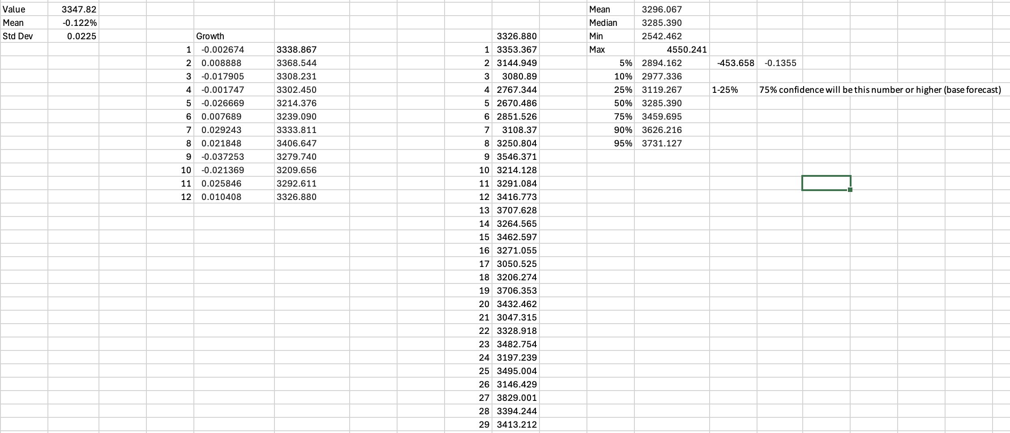
Figure 3. Monte Carlo Simulation of LUCATRUU from Feb 2021 – Feb 2026
The Monte Carlo simulation was used in order to estimate the performance of Investment-Grade Corporate Bonds. Ten-thousand different “what-if” scenarios were run based on the Bloomberg US Corporate Index (LUACTRUU) from February 2021 until February 2026. This period was chosen, due to it being able to include many interest rate hikes, which as a result helps illustrate how these bonds respond to various stresses. On average, the monthly return during this period was -0.12%, while the monthly returns displayed a standard deviation of 2.25%.
The simulation illustrates a 5% probability that the bond index price could fall to 2894.16, which is approximately a 13.5% loss and a 10% probability it could fall to 2977.34, which is an 11% loss. These values represent the danger zone, although they are not the most likely outcomes, these figures prove that if the economy were to take a downturn or interest rates were to spike, the current high yield of 5% to 7% might not be enough to protect investors from a significant drop in their initial investment. Looking at the optimistic portion, the 95th percentile displays a potential price of 3731.13, (this would represent a gain of roughly 11.5%) which tells us that in a perfect scenario where inflation drops quickly and interest rates fall there is still room for these bonds to grow in value. The median outcome (50th percentile) suggests a price of 3,285.39, representing a moderate assumption for the index. This indicates that in a typical market environment, these investment-grade corporate bonds will hold a stable value, slightly below the starting point, which supports the notion that the asset class is fairly valued, suggesting that there is a lack of a strong “upside” catalyst to push prices significantly higher in the near future.
In conclusion, if we were to compare these ranges, we would see that the potential for a poor year is slightly larger than the potential for a great year, which as a result makes it evident that our stance on being cautious is the correct approach. This is due to the downside risk being heavier than the upside reward, while credit spreads are too thin to provide much extra protection, which supports our previous statement that staying in short-term bonds is one of the safest ways to earn income while avoiding these extreme negative scenarios.

Recommendations
Based off our analysis, our overall stance on US Investment-grade corporate bonds heading into the rest of 2026 is neutral to cautious. The asset class is not broken, but there are enough headwinds that investors should be thoughtful about how they are positioned within it.
1. Favor Quality within the Investment-Grade Space
Not all investment-grade bonds are created equal. The index runs from AAA all the way down to BBB-, and nearly half of the Bloomberg US Corporate Bond Index sits at BBB, the lowest tier before a bond becomes junk. In a healthier macro environment, this is fine. However, with oil prices above $95/barrel squeezing corporate profit margins and the Fed showing no signs of cutting rates, companies at the lower end of the investment-grade spectrum are the most vulnerable. A downgrade from BBB to BB forces institutional investors to sell, which will drive prices down sharply. For that reason, we recommend tilting towards A-rated bonds and above, accepting slightly lower yields in exchange for meaningfully lower downgrade risk.
2. Be Selective on Sectors
The hyperscale story from the section above is a positive for parts of our market. Large tech companies like Microsoft, Meta, and Apple are constantly issuing investment-grade debt to fund AI infrastructure, and these are some of the strongest balance sheets in the world. Bonds from these issuers carry very low default risk and reliable cash flows, making them attractive holdings within the IG space. On the other hand, sectors with heavy exposure to energy input costs like manufacturing, transportation, and consumer goods would face real margin pressures from the Iran-driven oil spike.
3. Keep Duration Short
Duration is a key measure to how sensitive a bond is to interest rate changes. The longer the bond's maturity, the harder it gets hit when rates rise or stay elevated. Since the Fed is holding rates steady and may not cut for some time, especially with inflation being pushed higher by oil prices, long-dated bonds carry more risk right now than they are worth. Sticking to shorter maturities in the 2-to-5-year range limits that exposure while still capturing the yield advantage that IG bonds offer over Treasuries.
4. Understand What This Asset Class Is For
If we look back at the return tables in Section 3, we see that the SPY has nearly outperformed LQD across nearly every time horizon. This is obviously expected; equities carry a higher risk and reward investors accordingly over the long run. However, if we look at the YTD numbers, we see a different story. We see that as of March 2026, the S&P 500 is down 6.69%, while LQD is only down 1.76%. This is an important gap, as it tells us that when the equity markets get volatile, investment-grade bonds act as a cushion. For investors, especially insurance companies and institutional holders, that stability and consistent coupon income is exactly what makes this asset class valuable. The goal is not to beat the market, but to provide steady income and reduce overall portfolio risk, and on that front, we believe investment-grade bonds still do their job.

Conclusion
U.S. investment grade corporate bonds remain a relevant and important asset class, but the current environment requires investors to be thoughtful about how they are positioned within it. The long-term case for the asset class is intact. Over 10 years, LQD has delivered 3.58% annualized returns, consistently outperforming both Treasuries and the broader bond market, which confirms that the credit spread premium is real and earnable over time. At the same time, the near term picture is more challenging. The Federal Reserve holding rates steady, crude oil above $95 a barrel, and tightening credit spreads all point to a market where caution is warranted.
The three Bloomberg sources analyzed in Section 5 paint a mixed picture. The surge in hyperscaler debt issuance from technology firms is a positive signal for the quality end of the investment grade market, as companies like Microsoft, Meta, and Apple have the balance sheets to back up the debt they are issuing (Roy, 2026). On the other hand, Salesforce issuing $25 billion in bonds simply to fund share repurchases rather than productive investment is a sign that not all issuance in this market is created equal (Kingsbury, 2026). And the macroeconomic pressure from the Iran conflict is a real risk that cannot be ignored, particularly for companies in sectors that are sensitive to energy prices (Barbuscia, 2026).
From a valuation standpoint, the analysis in Section 4 makes clear that these bonds are fairly valued but not cheap. Yields in the 5% to 7% range provide solid income, but tight spreads of 70 to 90 basis points mean investors are not being overly compensated for the risks described above. The Chapman University forecast's expectation of a Federal Funds rate between 3.4% and 4% by end of 2026 is an encouraging sign, as any movement lower in rates would be a direct tailwind for bond prices (Doti, 2025).
Putting it all together, our recommendation is to stay in the asset class but stay disciplined. Favor higher quality issuers at the A rating level and above, focus on technology sector bonds backed by strong cash flows, keep maturities short to manage interest rate sensitivity, and use this asset class for what it is designed for, which is stable income and portfolio protection, not market beating returns. As the YTD data already shows, when equity markets sell off hard, investment grade bonds do their job. That is the value of this asset class, and that is why it belongs in a well-constructed portfolio.

Glossary
Coupon: The fixed interest payment made to a bondholder at regular intervals.
Credit Spread: The extra yield an investor earns for holding a corporate bond over an equivalent risk-free Treasury bond.
Duration: A measure of how sensitive a bond's price is to changes in interest rates. A duration of 6 means the bond price falls roughly 6% for every 1% rise in rates.
Investment Grade: A credit rating of BBB- or higher by S&P, indicating a lower risk of default.
Junk Bond: A bond rated below BBB-, also called a speculative or high-yield bond, carrying higher default risk.
Option-Adjusted Spread (OAS): The yield premium of a corporate bond over Treasuries, adjusted for any embedded options.
Par Value: The face value of a bond, typically $1,000, returned to the investor at maturity.
Yield to Maturity (YTM): The total returns an investor expects if the bond is held until it matures, accounting for coupon payments and the difference between purchase price and face value.
References
Barbuscia, D., et al. (2026, March 21). State Street, Voya seek shelter from default risk: Credit weekly. Bloomberg. https://www.bloomberg.com/news/articles/2026-03-21/state-street-voya-seek-shelter-from-default-risk-credit-weekly
Doti, J. (2025). Chapman University 2025 Economic Forecast. Chapman University.
Kingsbury, K., et al. (2026, March 13). From Amazon to Airbnb, US blue-chip bond sales flirt with record. Bloomberg. https://www.bloomberg.com/news/articles/2026-03-13/from-amazon-to-airbnb-us-blue-chip-bond-sales-flirt-with-record
Roy, Y. (2026, March 16). Bank of America increases hyperscaler issuance forecast to $175B. Bloomberg. https://www.bloomberg.com/news/articles/2026-03-16/bank-of-america-increases-hyperscaler-issuance-forecast-to-175b
Board of Governors of the Federal Reserve System. (2026). Federal Open Market Committee: Meeting calendars, statements, and minutes. Federal Reserve. https://www.federalreserve.gov/monetarypolicy/fomccalendars.htm
Federal Reserve Bank of St. Louis. (2026). ICE BofA US Corporate Index Option-Adjusted Spread [BAMLC0A0CM]. Federal Reserve Economic Data (FRED). https://fred.stlouisfed.org/series/BAMLC0A0CM
BlackRock. (2026). iShares iBoxx $ Investment Grade Corporate Bond ETF (LQD): Fund overview, holdings, and performance. iShares by BlackRock. https://www.ishares.com/us/products/239566
Morningstar. (2026). LQD, SPY, AGG, IEF: Trailing total return performance data (NAV basis). Morningstar Direct. https://www.morningstar.com
S&P Global Ratings. (2023). S&P Global Ratings definitions. S&P Global. https://www.spglobal.com/ratings
Securities Industry and Financial Markets Association. (2026). U.S. bond market issuance and outstanding statistics. SIFMA. https://www.sifma.org/resources/research/us-bond-market-issuance-and-outstanding

