Manual Testing Plan

# Page 2: Displays User Prompts For Setting Up Game

# Page 3: Error Messages

# Page 4: Initial Board Set-Up

# Page 5: Clicking Piece

# Page 6: Moving Piece

# Page 7: Taking a Piece

# Page 8: Restart Page

# Page 9: Stale Mate

# Page 10: Check

# Page 11: Check Mate

# Page 12: Forfeit

# Page 13: Undo

# Page 14: Custom Pieces

## User Prompts for Setting Up:

When the game launches, there are three prompts. The first asks for Team 0’s name, the second asks for Team 1’s name, and the third asks whether to play with custom pieces or regular pieces.

Team 0 Name:

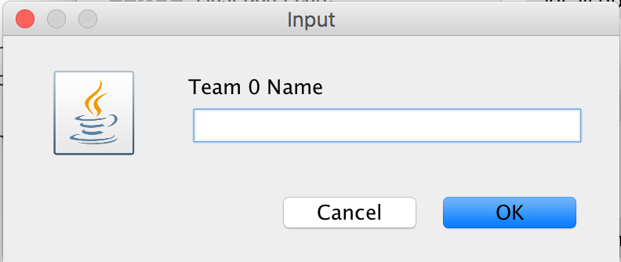

Team 1 Name: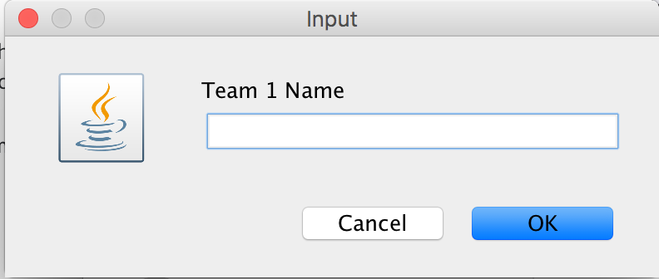

Custom Pieces:

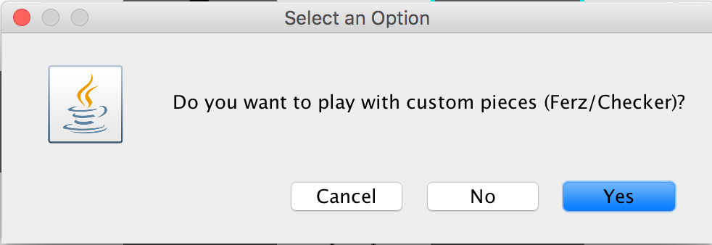

## Error Message for Clicking Empty Square

When making a move, if you start out by clicking an empty space, the game will give you this warning because you have to click on a piece to move.

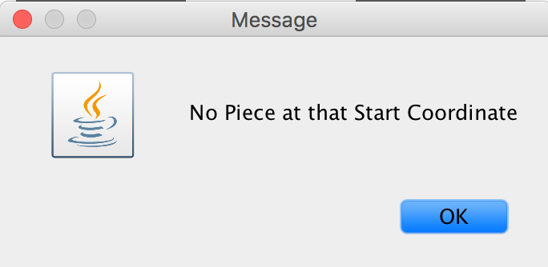

## Error Message for Incorrect Team’s Piece

When making a move, you have to click one of your own pieces or else this prompt will display.

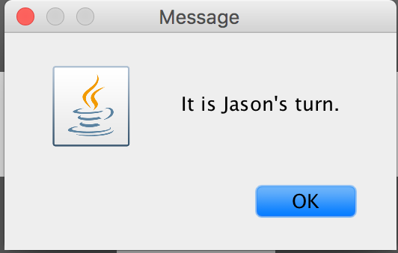

Initial Board

The initial board begins with the White team at the bottom and the Black team at the top. The squares alternate colors and the board should start with a White square at the top right. At the very bottom, the score is displayed with the format White – Black. In this case, John is the White player with a score of 0 and Jason is the Black player with a score of 0.

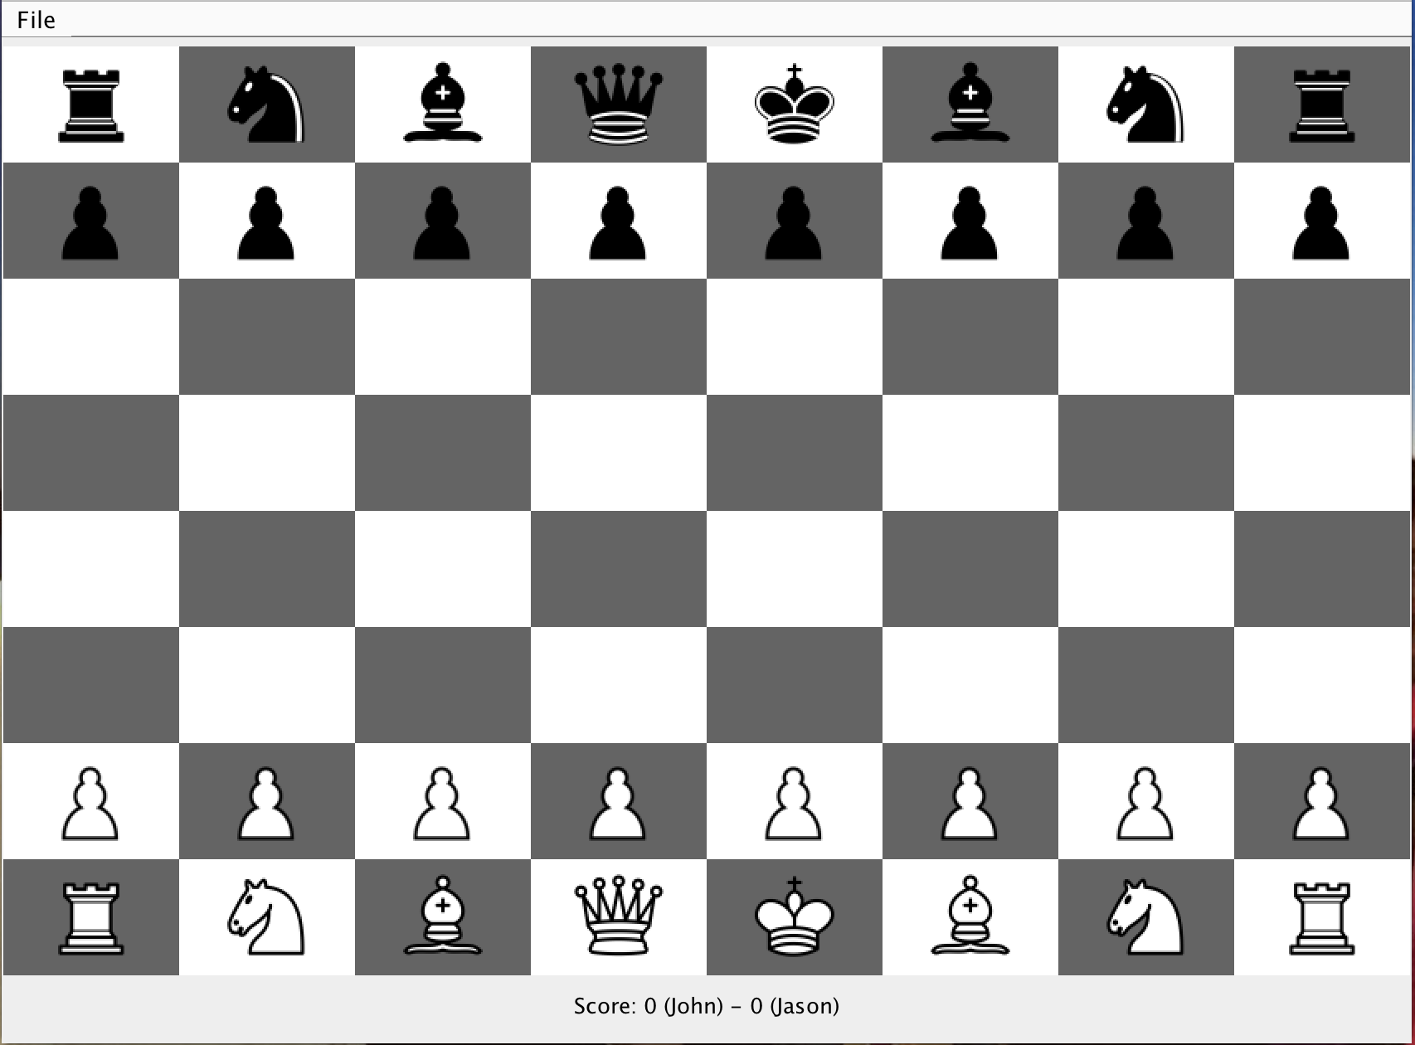

## Click Piece

When you click on a piece, the piece will have a red border and all available spaces will be cyan. In this case, the pawn can move forward either 1 or 2 spaces since it hasn’t moved yet.

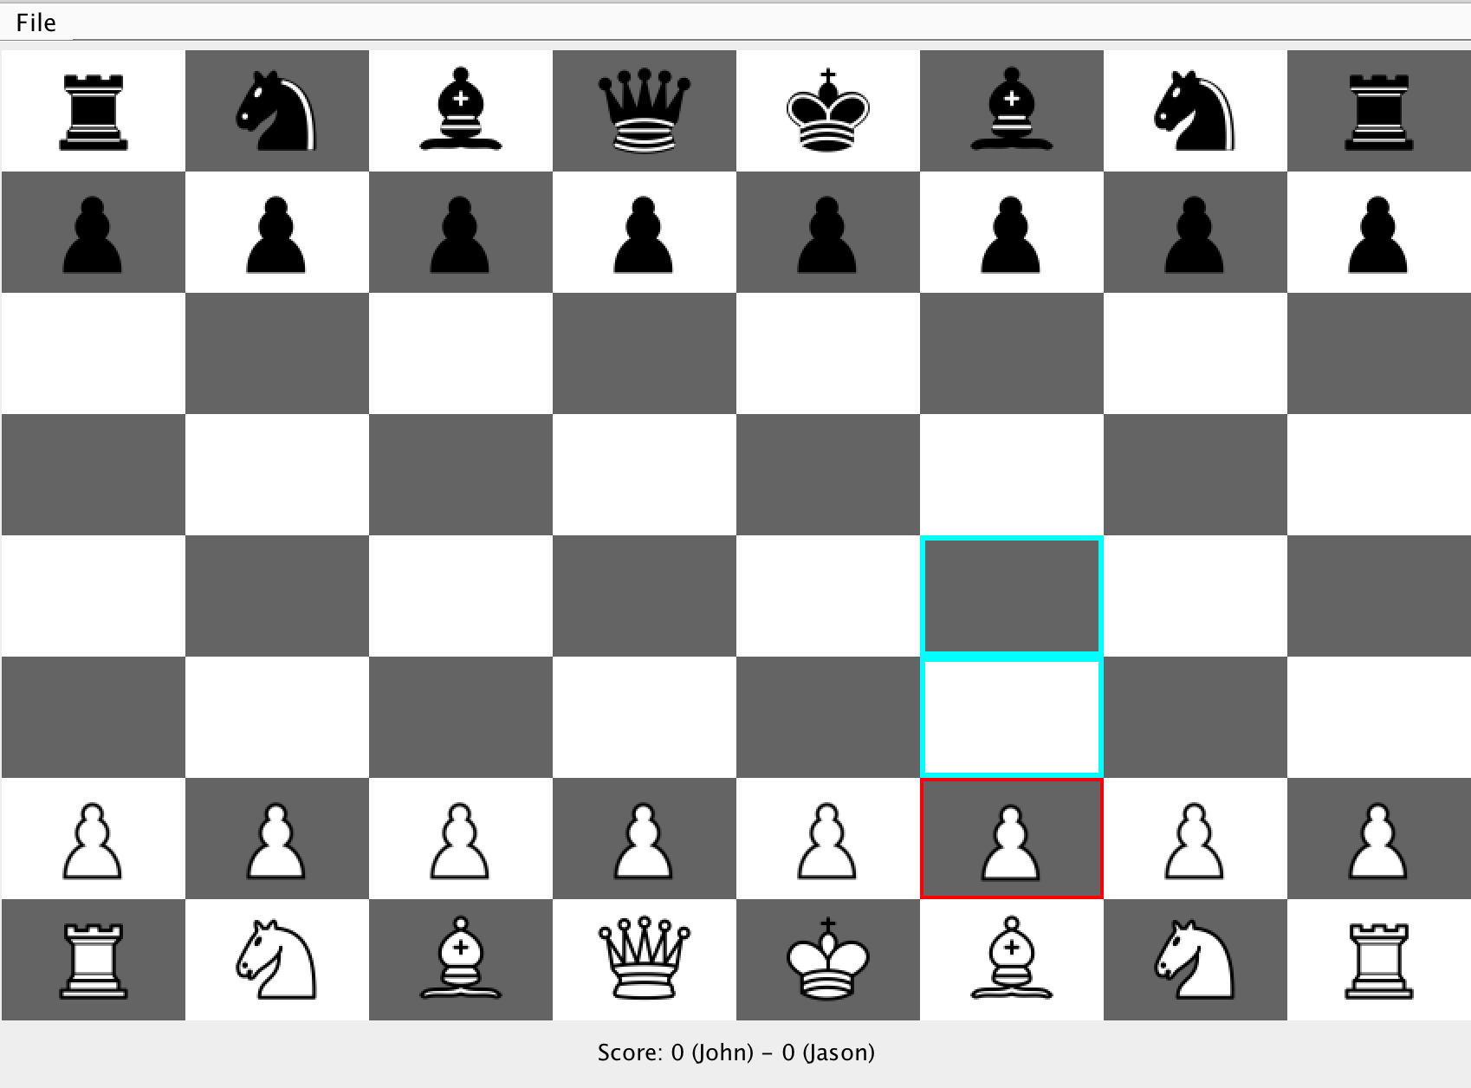

## Move Piece

After moving the pawn from the previous diagram up, the GUI reflects this by removing the colored borders and moving the pawn to the appropriate location.

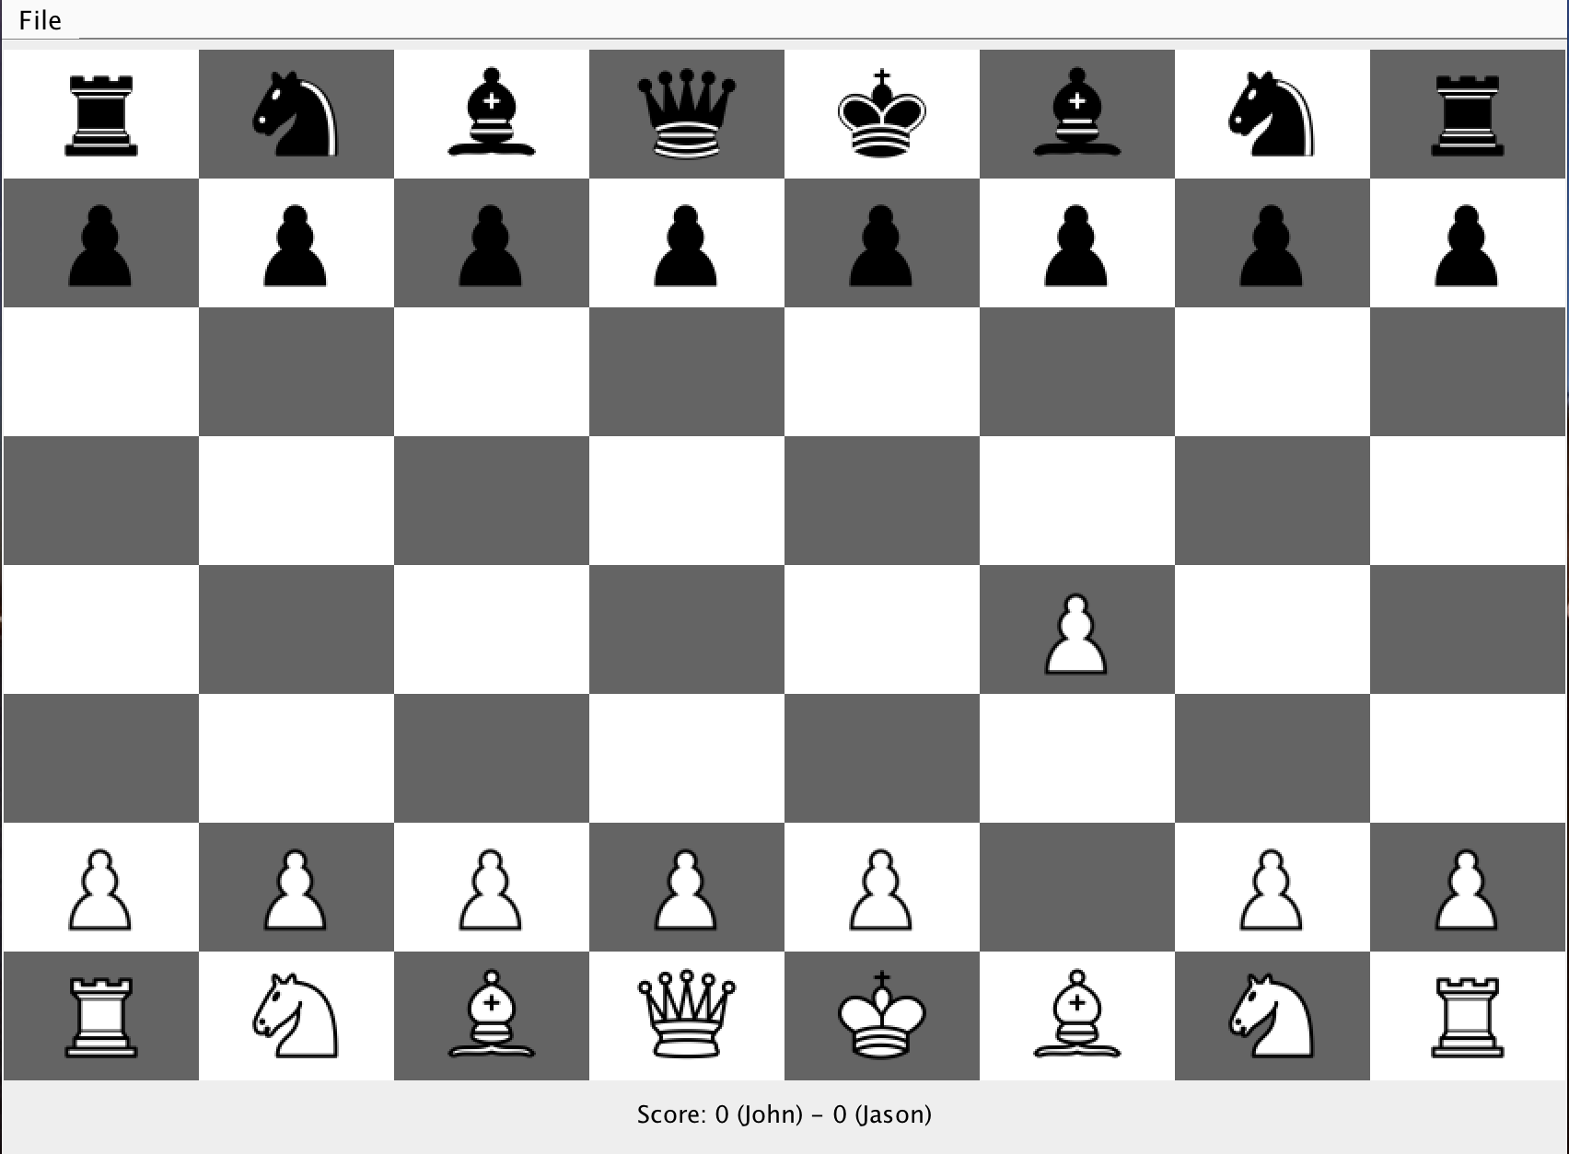

## Take a piece

Taking a piece is displayed below with a before and after. The white pawn takes the black pawn as seen in the 2nd screenshot where the black pawn no longer exists.

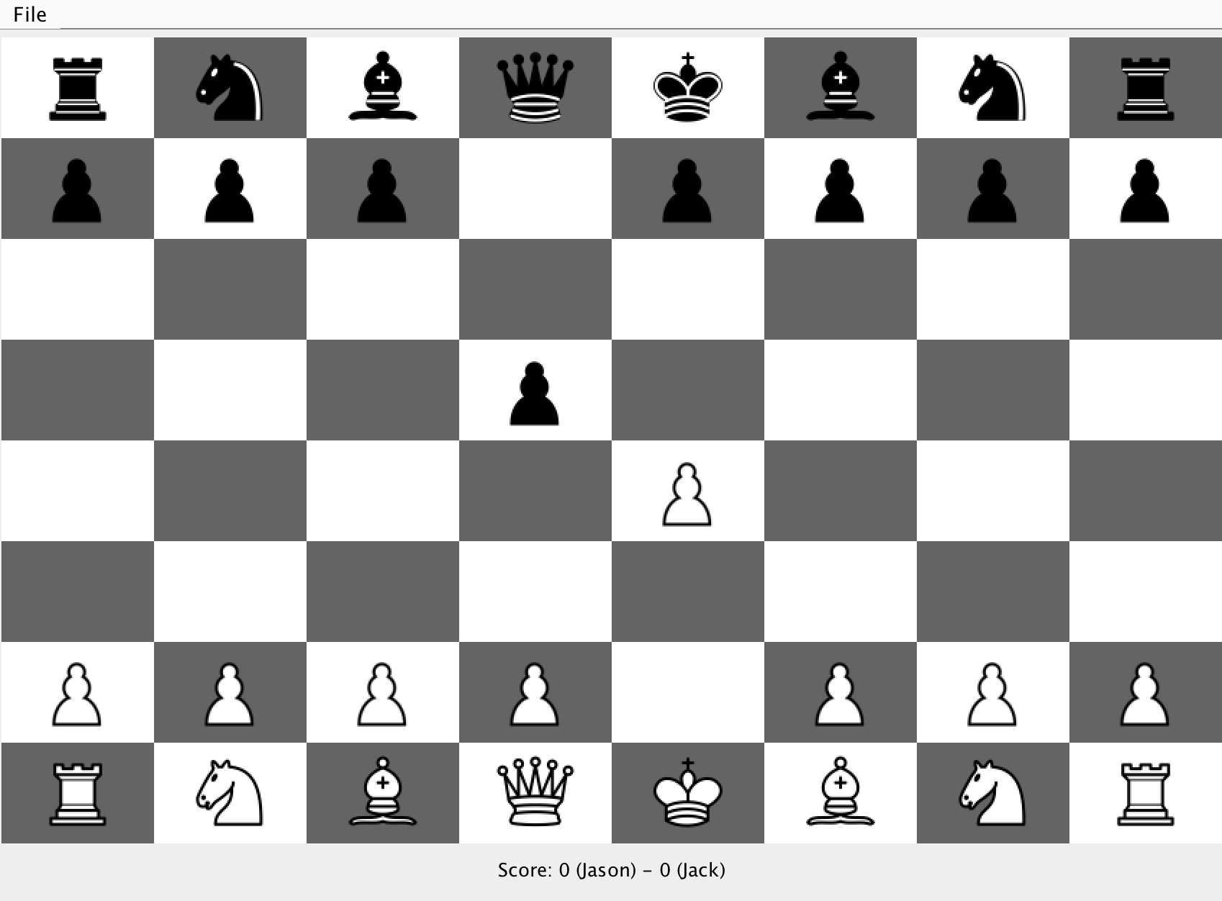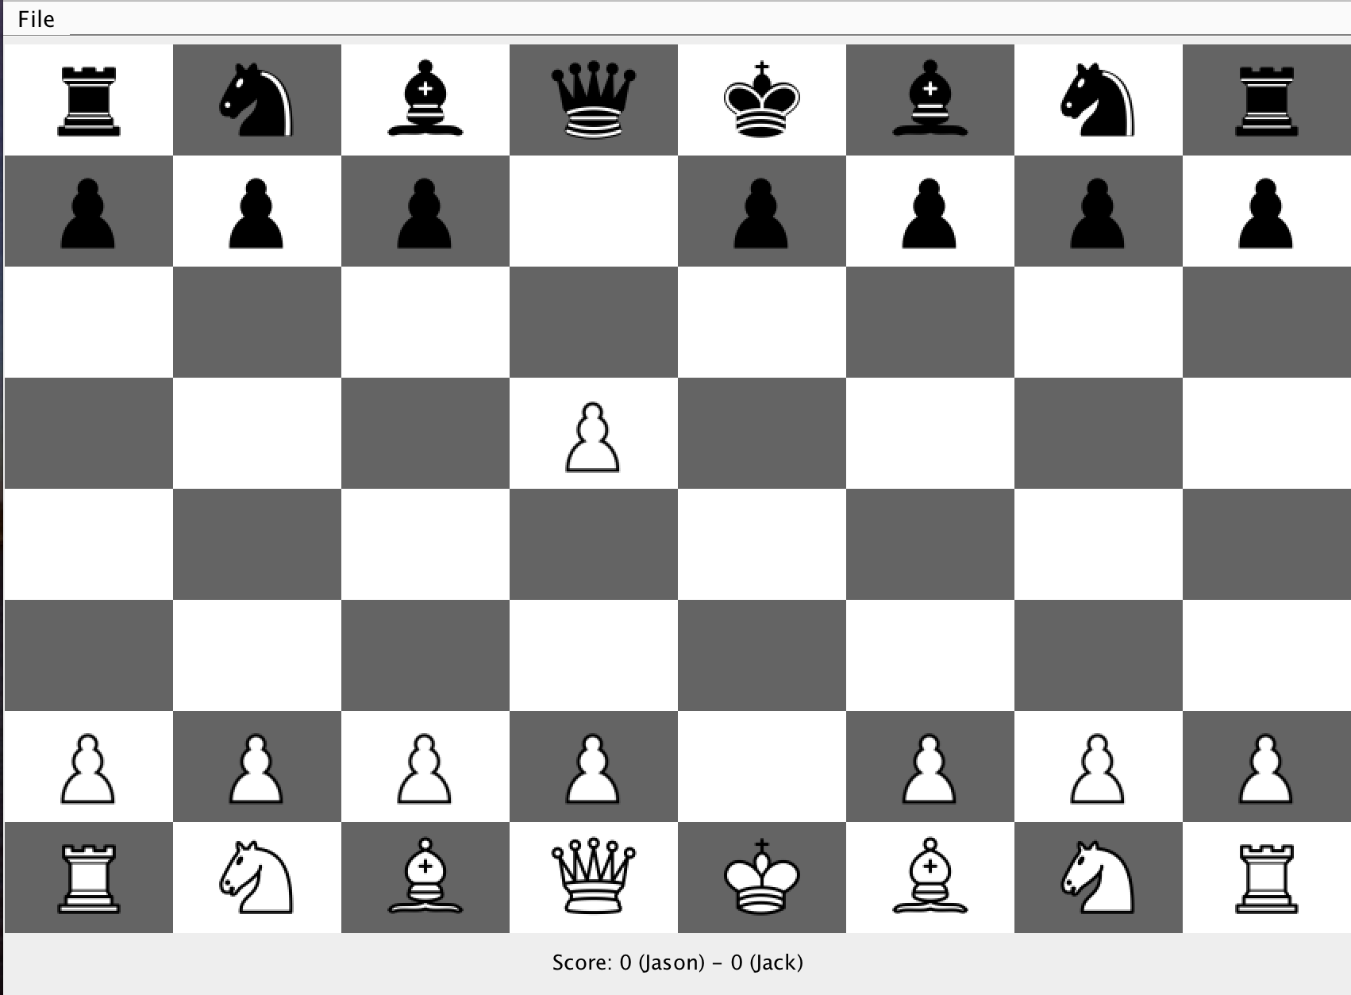

Restart Game

To restart a game, first you click on the File button and choose restart (screenshot 1), then the game prompts the users to confirm that both agree (screenshot 2), and finally if you say yes, the entire board resets (screenshot 3), though the score is not affected.

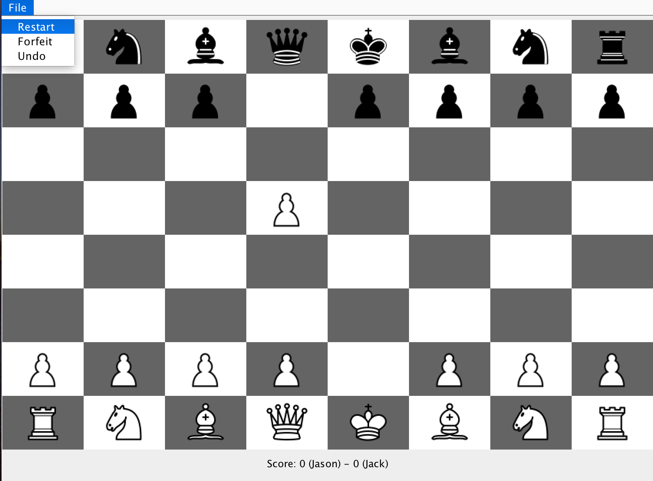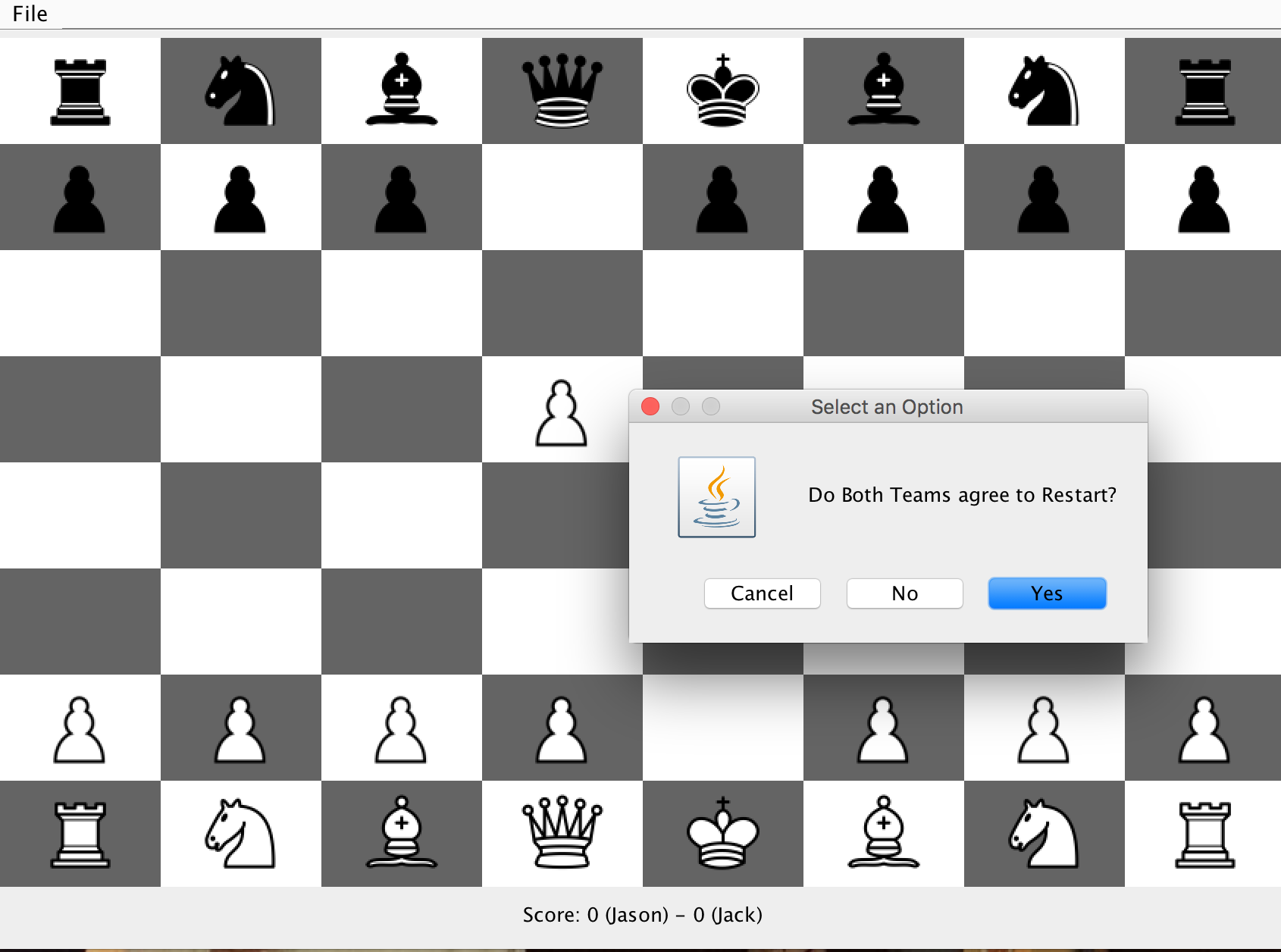Stale Mate

If the game reaches a point where there is nowhere for a team to move, then the game has hit stalemate. In this case, the Black Team cannot move anywhere and it is black’s turn. Therefore, the game has hit a stale mate and the board will reset after clicking the “Ok”.

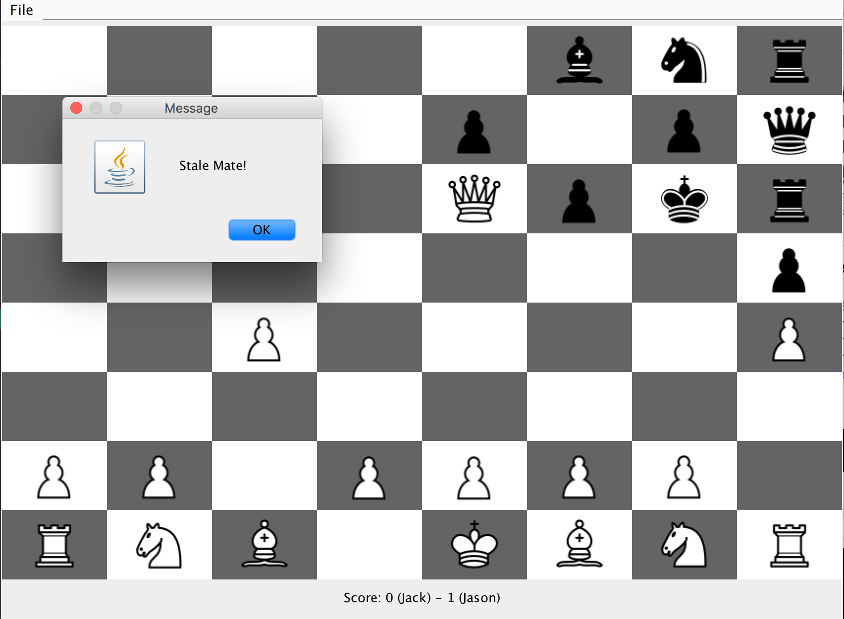Check

When a team is in Check, there is a prompt that notifies everyone. Jack, the White player, is now in Check because the Black Queen just moved to attack the King.

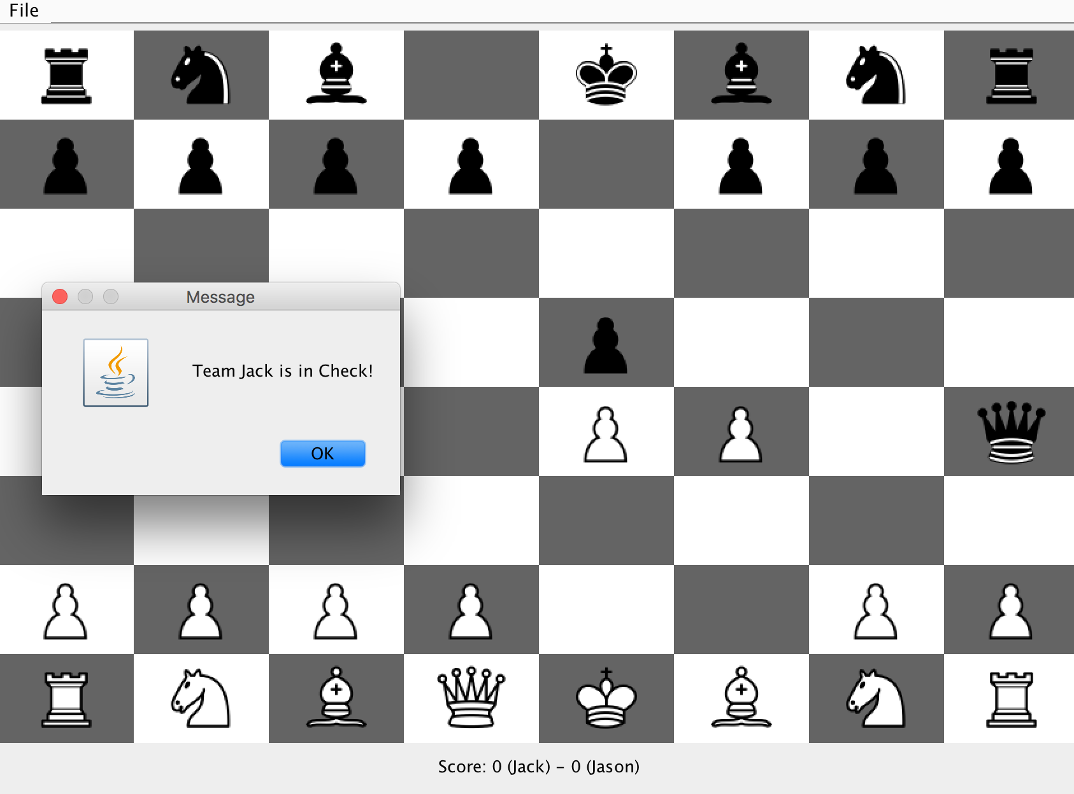

## Check Mate

Below, we see the Fool’s Mate Check Mate. Jack, the Black player, just moved his Queen, and now the White King has no where to move and no piece can come between the Black Queen and the White King. Therefore, the game is in Check Mate. In screenshot 2, we see that the score for Jack increments after the game resets.

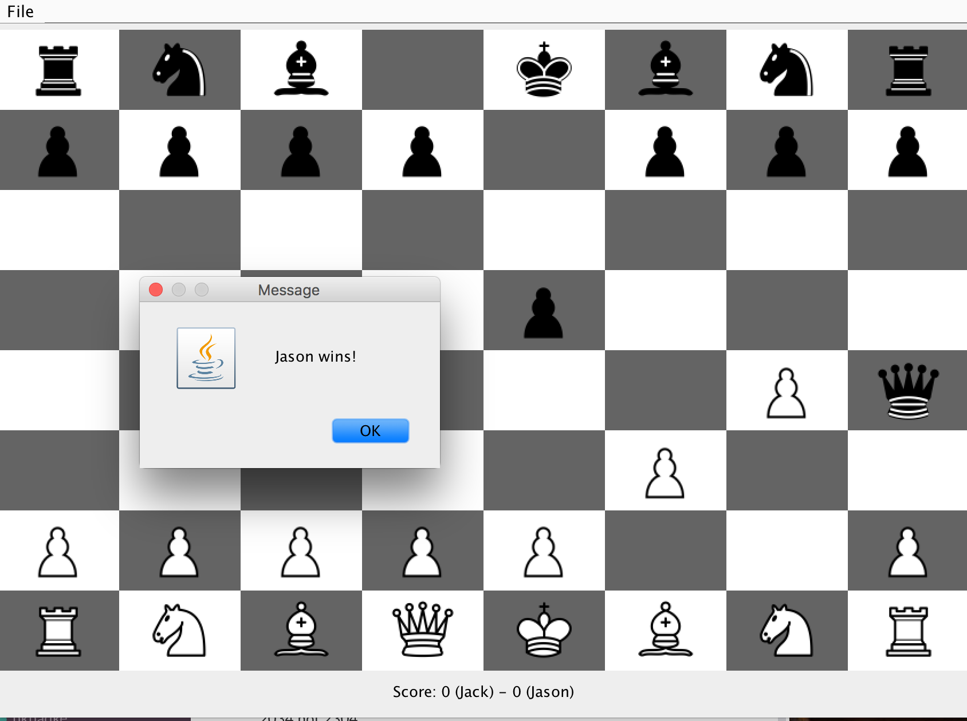

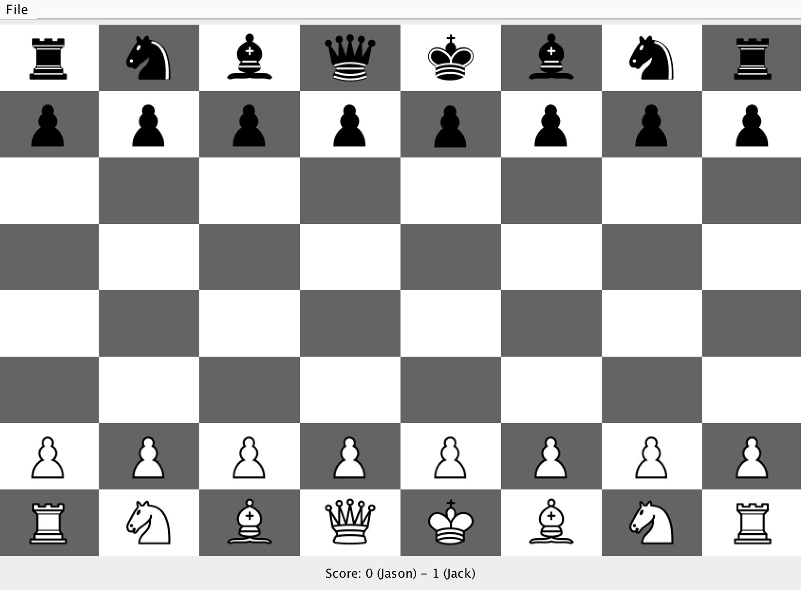

## Forfeit

Any player can always forfeit if they feel like they’ve lost. In this case, it is Jason’s turn, but he lost his Queen, so he is forfeiting the game. After forfeit, Jack’s score goes up 1 because Jason essentially lost.

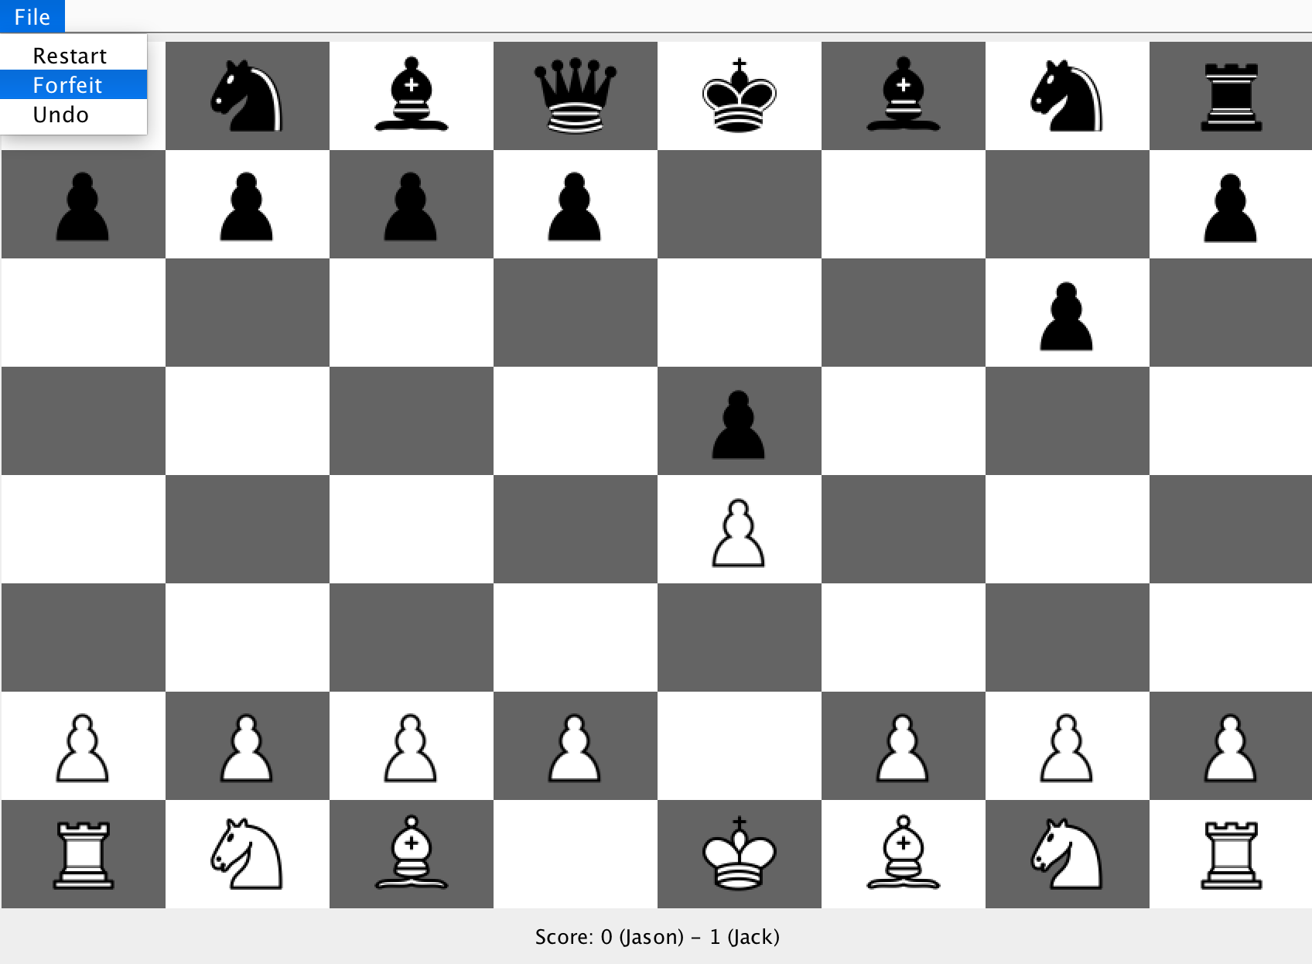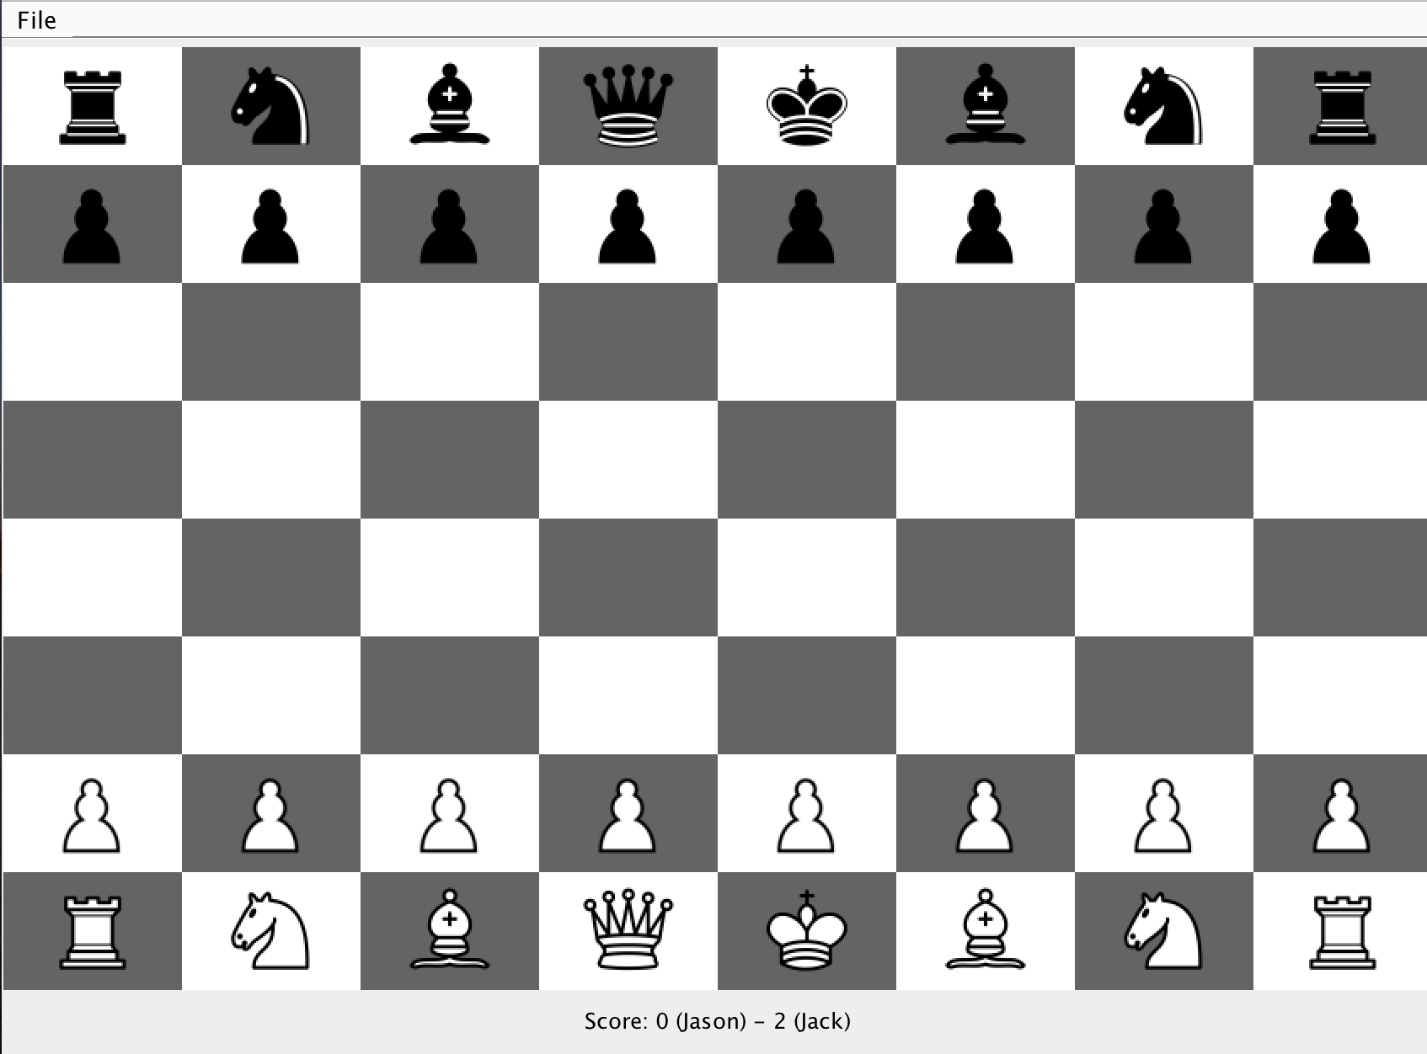

## Undo

Any player can always Undo a move (you can essentially continue to Undo all the way back to the initial board). If you choose to undo, both your opponent’s last move and your last move are undone. In this situation, both pawn movements are undone.

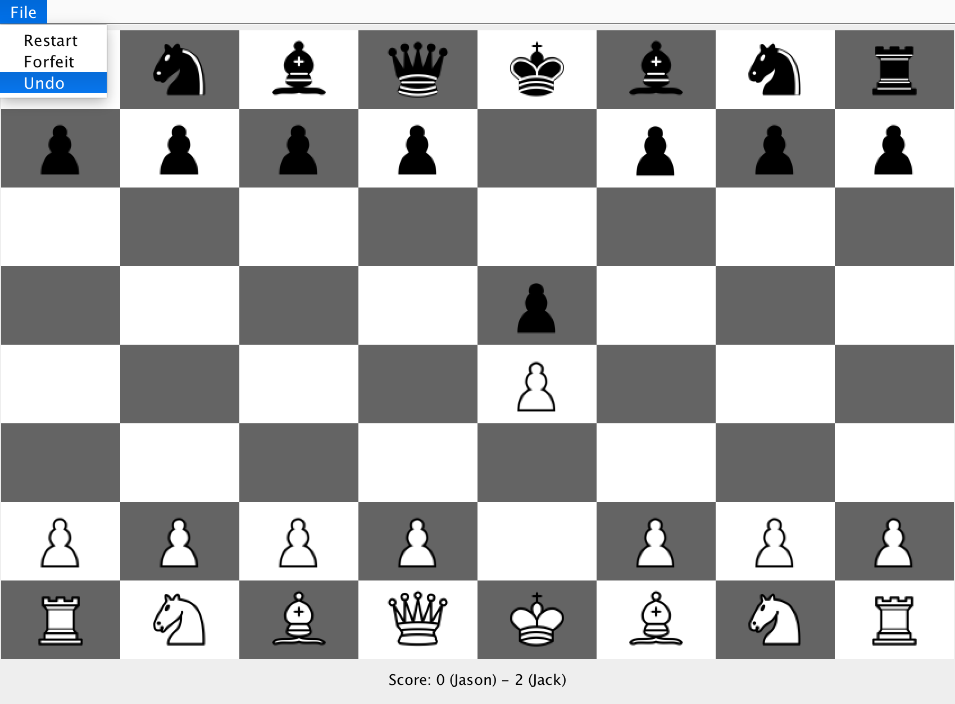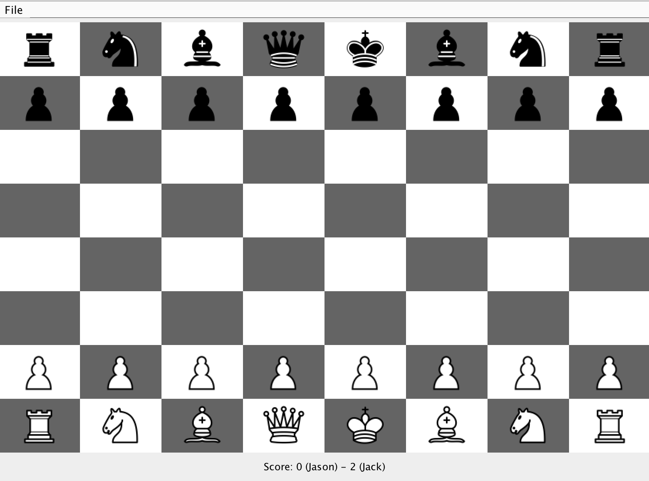

## Custom Pieces:

If you choose to play with custom pieces (prompt shown on Page 2 of this testing plan), then 2 pieces will be replaced. The Knights are replaced with Checkers because both of those pieces types can jump over pieces. The Bishop is replaced by a Ferz because both of these pieces can move diagonally in any direction.

