**How would an image on the cortex look on the scalp?**

Step 1. Fit of a sphere to the brain mesh

Step 2. More accurate projection (not deformed) of image on sphere (like a clothe landing on a sphere).

Step 3. Placing the image on the spherical mesh

Step 4. Relocating and scaling the image to a desired location

Step 5. Projecting image on Cortex

Step 6. Refining mesh resolution and smoothing

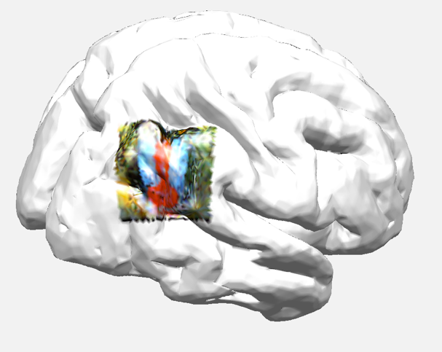

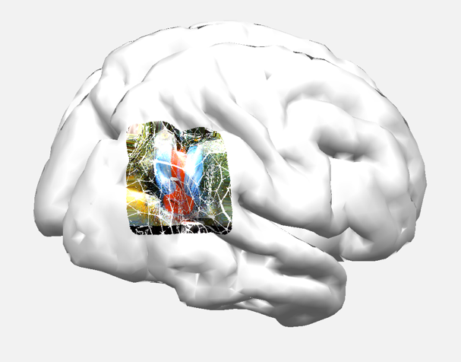

Step 7. Aligning mesh (source model) with head model

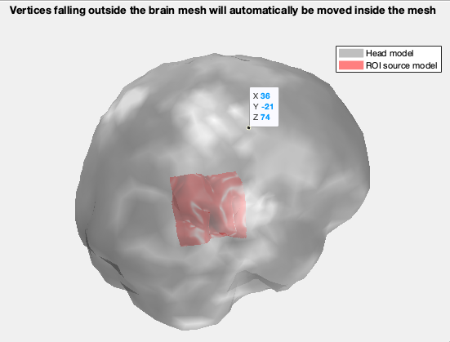

Step 8. Computing forward solution and projecting on 345 channels (headplot) and 1042 vertices (custom code)

Step 9. Projecting all 3 colors on a head mesh

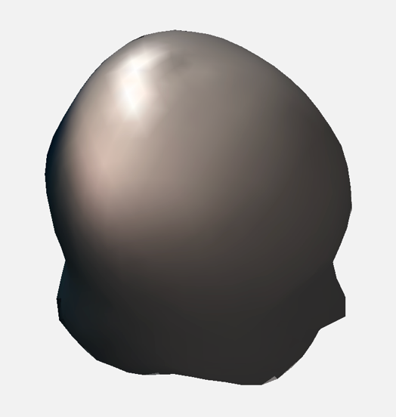

Same as above, separated by color channels

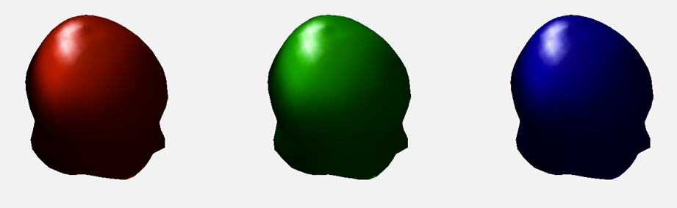

**Limitation**

* Source orientation is always (1,1,1) and not radial or normal. That could potentially create issues with projection. However, I tried other fixed orientation and the result was almost the same.

**Perspectives:**

* Activate larger areas of cortex so we can differentiate on the scalp
* Visualize projected movies (see movie folder)
* Have 2 sources and mix them at the vertex level, then project them
  + Try to separate them using ICA
  + Test their distance and overlap
  + Test their focus (very local or larger)
  + Test adding noise
* With enough data, simulate a simple 20 x 20 image (400 sources), project it on the brain mesh, then on the scalp and try to reconstruct them using ICA. Grey color equals spectral power.

