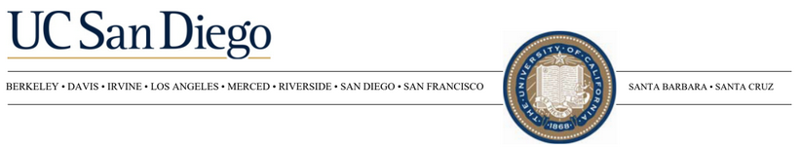

Arnaud Delorme
Research Scientist
Institute for Neural Computation
University of California San Diego
9500 Gilman Drive
La Jolla CA 92093-5553
United States of America
Tel: 858-405-7952
Email: adelorme@ucsd.edu

February 17th, 2026

RE: Science of Consciousness Conference 2026 – UCSD / IONS

To Whom It May Concern:
We are requesting a proposal for hosting the Science of Consciousness Conference, jointly organized by the University of California San Diego and the Institute of Noetic Sciences. The conference is expected to take place in September or October 2026, with potential flexibility into early November depending on venue availability and overall fit. This request is being issued later than usual due to a change in venue planning, and we are now moving forward with a confirmed organizing team and program structure. Exact dates will be finalized in coordination with the selected venue.
Based on prior years, attendance is substantial. At our most recent conference, we fully booked approximately 400 guest rooms at the primary hotel, and additional attendees overflowed into nearby hotels as early as two months before the event. We therefore anticipate a similar or higher level of room demand and would like to secure an adequate room block of 400 rooms in advance to help limit accommodation costs for attendees.
Room block expectations are as follows. Attendees may begin arriving on Sunday. Workshops are planned for Monday potentially with slightly reduced room demand for one of those nights. The main conference runs Tuesday through Friday noon. Most attendees depart on Saturday. We anticipate peak occupancy from Tuesday night through Friday night.
Programmatically, the conference will require the following meeting spaces. One plenary room with seating capacity for approximately 700 participants. Eight breakout rooms for parallel sessions. Poster and exhibitor space sufficient for a large poster session and sponsor exhibits. Workshop space will include three to four parallel rooms during the day and one larger room in the evening for a featured workshop. Workshops are considered part of the main conference program rather than a separately registered event.
We would appreciate information on guest room availability and rates, meeting room capacities and configurations, audiovisual capabilities, poster and exhibit space options, catering options, and any relevant concessions. Please also indicate whether your property can support flexibility in room block adjustments as registration numbers evolve.
The primary contact for this RFP is Arnaud Delorme. The Institute of Noetic Sciences will be the contracting and paying organization for this event. We would be happy to provide additional details or clarify any aspect of the program as needed.
Thank you for your consideration. We look forward to your proposal.
Sincerely,

Arnaud Delorme
858-405-7952
On behalf of the Science of Consciousness Conference
University of California San Diego
Institute of Noetic Sciences

