Conference approval by department director Terry Sejnowski
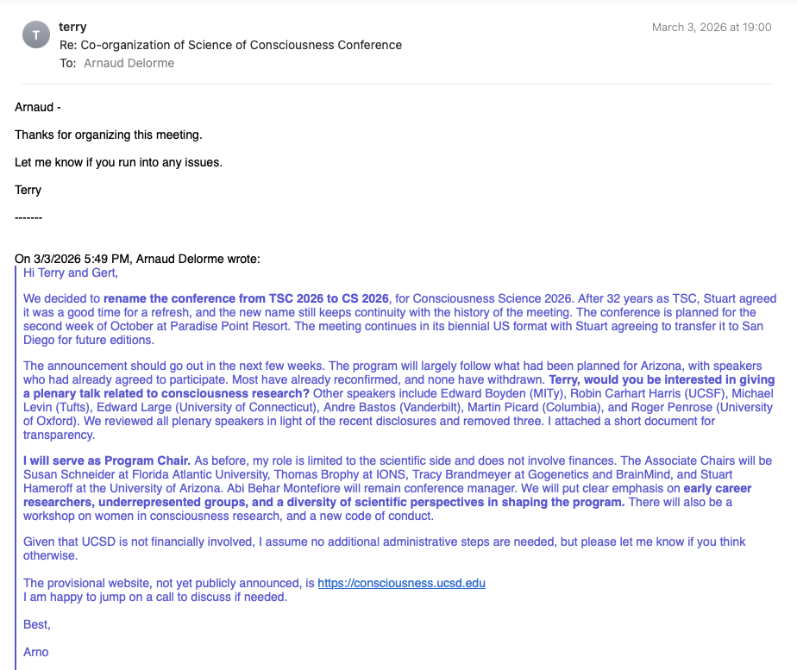
Conference approval by department co-director Gert Cauwenberghs
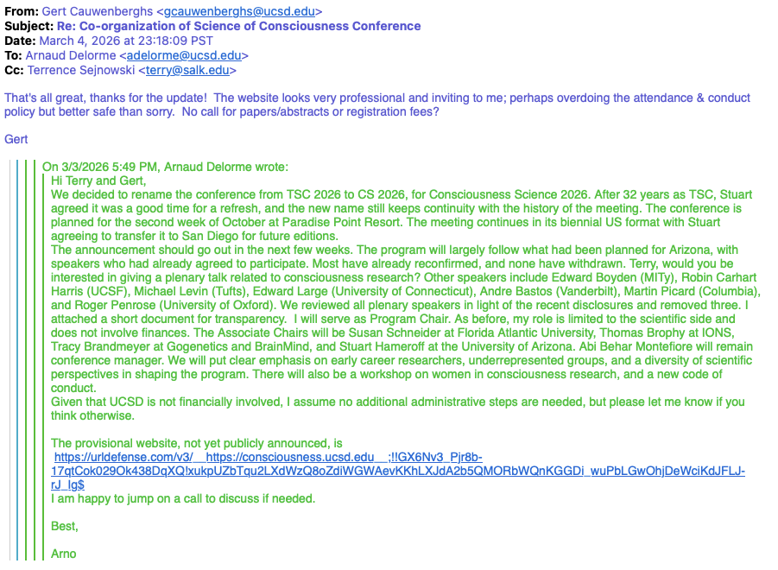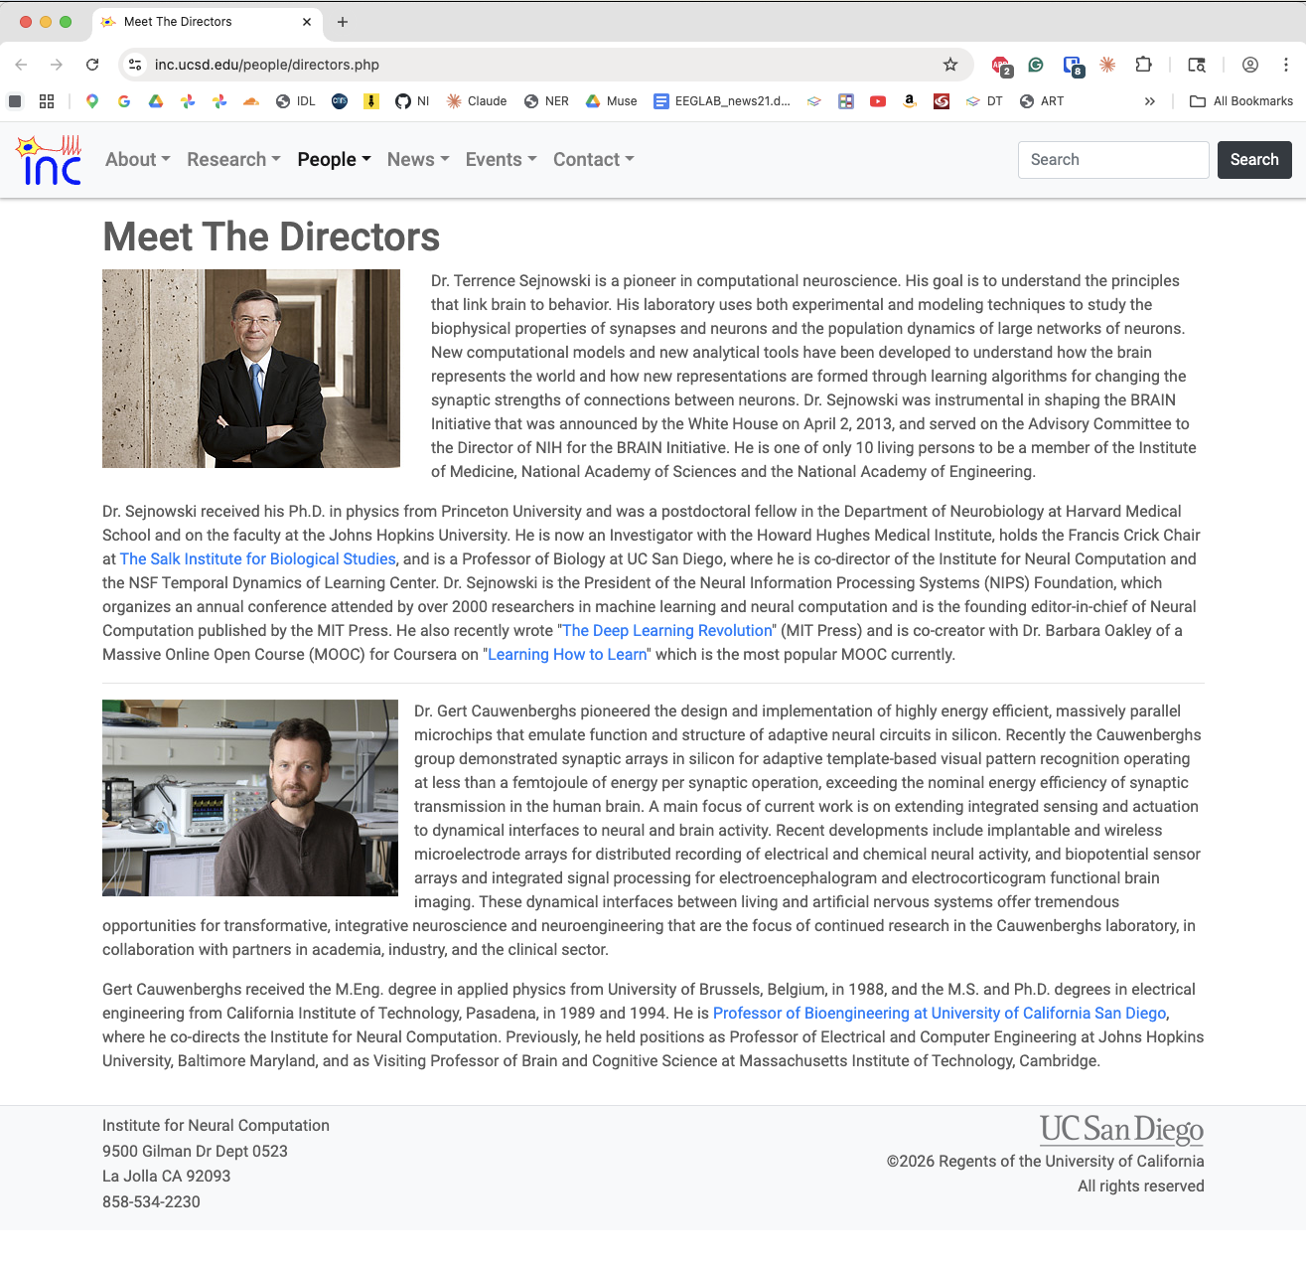

Terry Sejnowski
If Terry approves of the conference, UCSD will consider it acceptable, as he has a strong reputation there.
Cited work is the way scientist reputations are compared. For example, Dante Lauretta, the director of the astrobiology department at UA, has 21,000 citations. By contrast, Terry Sejnowski, the director of the INC department, has 189,000 citations.
The Brain Prize (2024) was shared between Terry Sejnowski, Larry Abbott and Haim Sompolinsky, this award is worth 10 million DKK (approximately $1.5 million).
Sejnowski was elected to the National Academy of Medicine in 2008. In 2010, he was elected a Member of the National Academy of Sciences (NAS), and elected to the National Academy of Engineering in 2011. In 2017, he was elected to the National Academy of Inventors. These achievements place him in a group of only three living people to have been elected to all four of the national academies.
Sejnowski with Obama at the white house
