$50k donation Cyan Banister
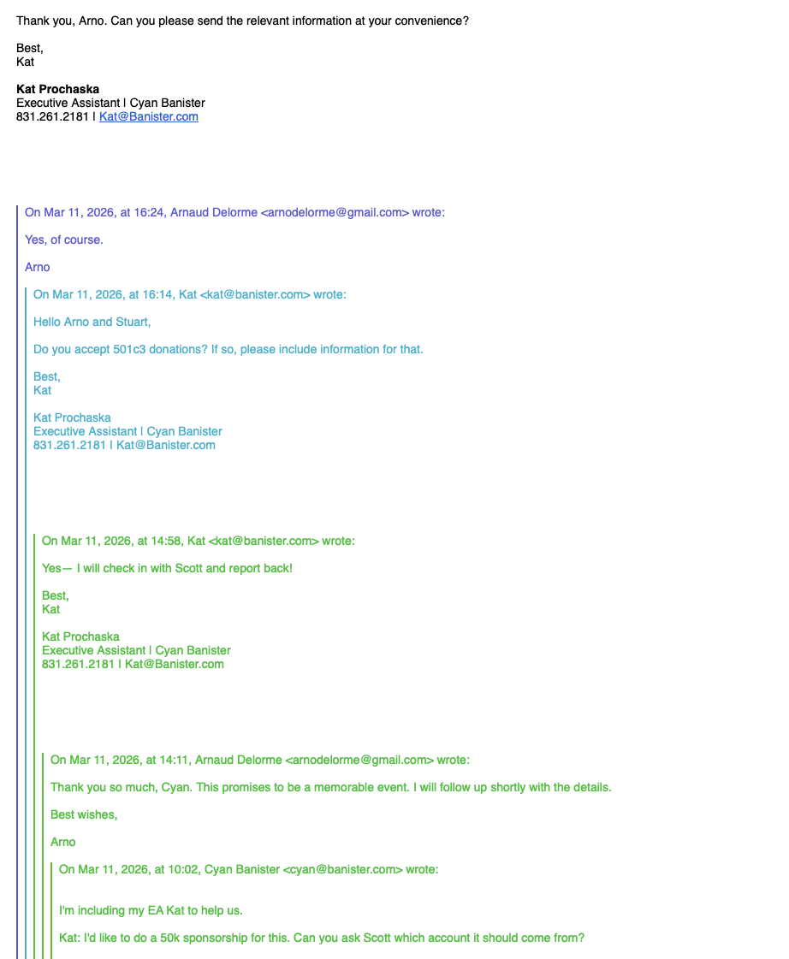
$200k conference underwriting by Eugene Jhong
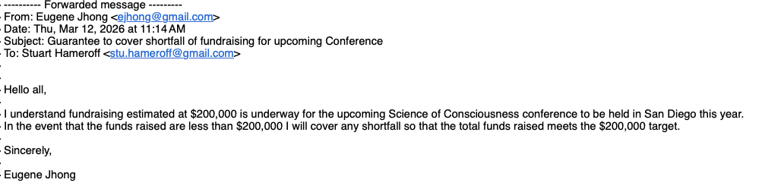

Interest expressed by June Gomila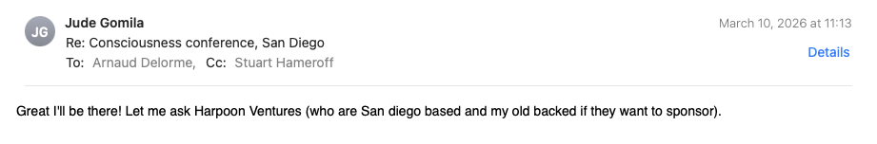

Interest expressed by Winslow Strong
