Consciousness Science 2026 budget

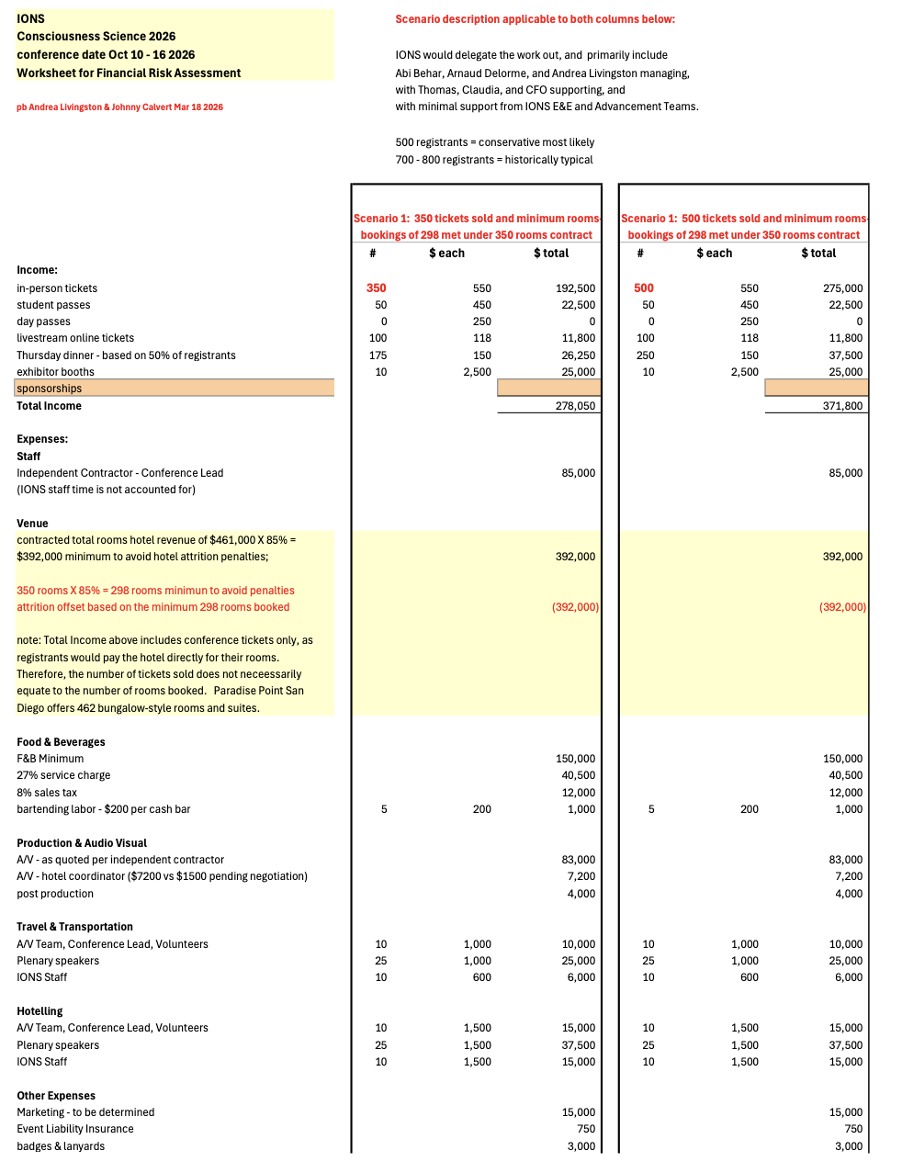

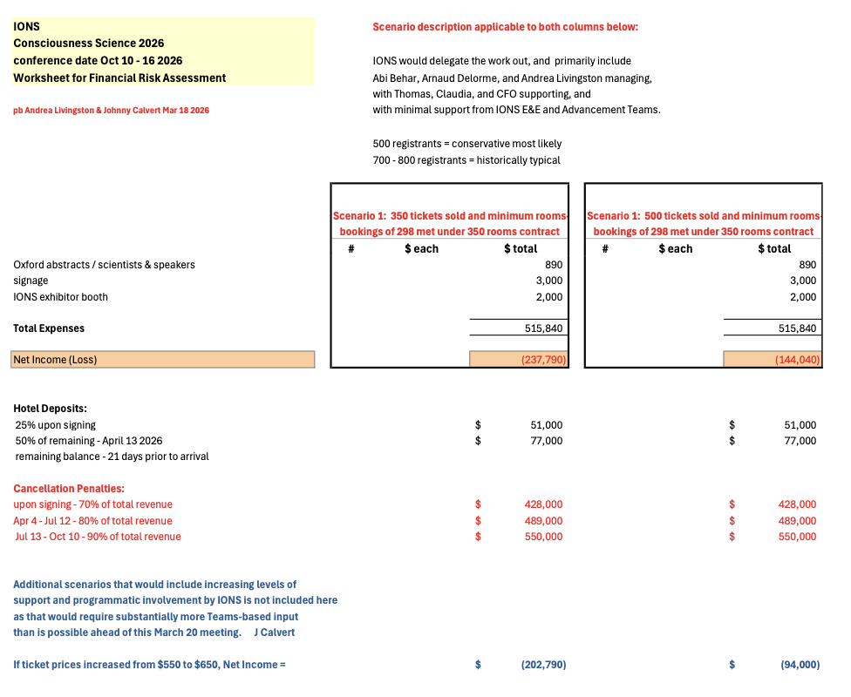
Summary of the table with the $650 ticket price
- Loss of $203k for 350 participants
- Loss of $94k for 500 participants
Remediation 1: removing optional expenses
- Budget includes $41,000 optional IONS related expense (marketing, staff travel)
- Contractor for 1 year ($85k) but 1/2 year is possible in worst case scenario ($42.5k)
- Budget includes ~$20k for volunteer travel and hotel (volunteers can be local)
- With these removed, the budget is balanced at 500 tickets (profit of $9.7k)
Remediation 2: more than 500 participants
- The conference usually brings more than 700 people (this is without IONS advertising it to its constituents) and has always made money
- With 200 people more, the conference will bring an additional $130k
Remediation 3: bring in fully vetted sponsors
- Cyan Banister has pledged $50k (see Sponsor tab)
- Eugene Jhong has pledge to balance the budget up to $200k loss (see Sponsor tab)

