**Individual and Population Level Uncertainty Interact to Determine Performance of Outbreak Detection**

Callum R.K. Arnold1,2,*, Alex C. Kong³, Amy K. Winter⁴, William J. Moss3,5, Bryan N. Patenaude³,

Matthew J. Ferrari1,2

¹ Department of Biology, Pennsylvania State University, University Park, PA, USA 16802

² Center for Infectious Disease Dynamics, Pennsylvania State University, University Park, PA, USA 16802

³ Department of International Health, Johns Hopkins Bloomberg School of Public Health, Baltimore, MD, USA 21205

⁴ Department of Epidemiology, College of Public Health, University of Georgia, Athens, GA, USA 30602

⁵ Department of Epidemiology, Johns Hopkins Bloomberg School of Public Health, Baltimore, MD, USA 21205

* Corresponding author. Callum R.K. Arnold. Address: Department of Biology, Pennsylvania State University, University Park, PA, USA 16802. Email: contact@callumarnold.com.

# Abstract

## Background

Infectious disease surveillance and outbreak detection systems often utilize diagnostic testing to validate case identification. The metrics of sensitivity, specificity, and positive predictive value are commonly discussed when evaluating the performance of diagnostic tests, and to a lesser degree, the performance of outbreak detection systems. However, the interaction of the two levels’ (the test and the alert system) metrics, is typically overlooked. Here, we describe how equivalent regions of detection accuracy can exist over a range of diagnostic test characteristics, examining the sensitivity to background noise structure and magnitude.

## Methods

We generated a stochastic SEIR model with importation to simulate true measles and non-measles sources of febrile rash (noise) daily incidence. We generated time series of febrile rash (i.e., measles clinical case definition) by summing the daily incidence of measles and either independent Poisson noise or non-measles dynamical noise (consistent with rubella virus). For each time series we assumed a fraction of all cases were seen at a healthcare clinic, and a subset of those were diagnostically confirmed using a test with sensitivity and specificity consistent with either a rapid diagnostic test (RDT) or an enzyme-linked immunosorbent assay (ELISA). From the resulting time series of test-positive cases, we define an outbreak alert as the exceedance of a threshold by the 7day rolling average of observed (test positive) cases. For each threshold level, we calculated percentages of alerts that were aligned with an outbreak (analogous to the positive predictive value), the percentage of outbreaks detected (analogous to the sensitivity), and combined these two measures into an accuracy metric for outbreak detection. We selected the optimal threshold as the value that maximizes accuracy. We show how the optimal threshold and resulting accuracy depend on the diagnostic test, testing rate, and the type and magnitude of the non-measles noise.

## Results

The optimal threshold for each test increased monotonically as the percentage of clinic visits who were tested increased. With Poisson-only noise, similar outbreak detection accuracies could be achieved with imperfect RDT-like tests as with ELISA-like diagnostic tests (c. 93%), given moderately high testing rates. With larger delays (14 days) between the ELISA test administration and result date, RDTs could outperform the ELISA. Similar numbers of unavoidable cases and outbreak alert delays could be achieved between the test types. With dynamical noise, however, the accuracy of ELISA scenarios was far superior to those achieved with RDTs (c. 93% vs. 73%). For dynamical noise, RDT-based scenarios typically favored more sensitive alert threshold than ELISA-based scenarios (at a given testing rate), observed with lower numbers of unavoidable cases and detection delays.

## Conclusions

The performance of an outbreak detection system is highly sensitive to the structure and the magnitude of background noise. Under the assumption that the noise is relatively static over time, RDTs can perform as well as ELISA in a surveillance system. However, when the noise is temporally correlated, as from a separate SEIR process, imperfect tests cannot overcome their accuracy limitations through higher testing rates.

**Key words:** Rapid-Diagnostic Tests; ELISA; Infectious Disease Surveillance; Outbreak Detection.

## Background

At the heart of an outbreak detection system is a surveillance program, often utilizing individual diagnostic tests as required components of case detection and epidemiological investigations before an outbreak can be declared [1–5]. For diseases with non-specific symptoms, accurate measurement tools are often necessary to confidently and correctly ascribe changes in symptom prevalence within a population to a particular disease, and therefore detect outbreaks of specific pathogens. As a result, it has been commonplace for surveillance systems to be developed around high-accuracy tests, such as Polymerase Chain Reaction (PCR) tests and immunoglobulin (Ig) tests, when financially and logistically feasible [6–11]. Depending on the disease in question, either sensitivity (the ability to correctly detect a true positive individual) or specificity (the ability to correctly discount a true negative) will be prioritized, as they often are at odds with each other [12–14]. This balance is commonly defined within the Target Product Profile (TPP) of a test [15], which is a set of minimum characteristics that should be met for production and widespread use, helping to guide research and development. For example, in the wake of the 2013 Ebola outbreak in Guinea a TPP was developed that listed the minimum acceptable values of sensitivity and specificity as 95% and 99%, respectively [16]. Recognizing that Ebola is not the major cause of fever and other non-specific symptoms in the region, it is arguably more important to prioritize the specificity of the disease; however, the authors note that the disease severity requires a high level of sensitivity, as the consequences of a missed case are dire at an individual and population level [16].

Much like the accuracy of an individual test, outbreak detection systems face the same issue regarding the prioritization of sensitive or specific alerts [17–19]. For many disease systems, particularly in resource constrained environments where the burden of infectious diseases is typically highest [20,21], cases are counted and if a pre-determined threshold is breached, be that weekly, monthly, or some combination of the two, an alert is triggered that may launch a further investigation and/or a response [4,18]. In effect, this discretizes a distinctly continuous phenomenon (observed cases) into a binary measure, outbreak or no outbreak, for decision making purposes. For reactive management approaches, such as vaccination campaigns and non-pharmaceutical based interventions that are designed to reduce transmission or limit and suppress outbreaks, early action has the potential to avert the most cases [22–27]. While this framing would point towards a sensitive (i.e., early alert) surveillance system being optimal, each action comes with both direct and indirect financial and opportunity costs stemming from unnecessary activities that limit resources for future response capabilities. Just as the balance of sensitivity and specificity of a test for an individual must be carefully evaluated, so must the balance at the outbreak level.

The concept of using incidence-based alert triggers to define the discrete event of an “outbreak” with characteristics analogous to individual tests has been well documented in the case of meningitis, measles, and malaria [4,19,26,28–31]. However, an overlooked, yet critical, aspect of an outbreak detection system is the interplay between the individual test and outbreak alert characteristics. With their success within malaria surveillance systems, and particularly since the COVID-19 pandemic, rapid diagnostic tests (RDTs) have garnered wider acceptance, and their potential for use in other disease systems has been gaining interest [32]. Despite concerns of their lower diagnostic accuracy slowing their adoption until recently [33], the reduced cold-chain requirements [34] and faster speed of result provided by RDTs has been show to outweigh the cost of false positive/negative results in some settings [32,35–37].

In this paper we examine how the use of imperfect diagnostic tests affects the performance of outbreak detection for measles outbreaks in the context of a febrile rash surveillance system that includes both measles and non-measles cases. Because measles symptoms are non-specific, it is important to account for non-measles sources of febrile rash e.g., rubella, parvovirus, varicella, etc., producing the potential for false positive results in the context of imperfect tests. Currently, measles outbreaks are declared on the basis of either suspected measles cases (i.e., an individual with fever and maculopapular rash [38]) alone, cases confirmed by enzyme immunoassay / enzyme-linked immunosorbent assay, from here-on in referred to as ELISA, to detect the presence of measlesspecific IgM antibodies, or a combination of the two. Countries at or near elimination status are encouraged to primarily use PCR or ELISA diagnostic tests for the confirmation of suspected cases [38]. Each of these detection systems have its flaws. Although clinical case definition is very fast and requires minimal resources, it is highly sensitive, and in the face of high “background noise” from non-measles sources of febrile rash, can lead to low positive predictive value (PPV), i.e., the probability that an alert accurately reflects the outbreak status [39]. And while ELISA confirmation is the standard diagnostic test for measles surveillance and has higher specificity [38], the training and facility requirements generally mean that samples must be transported from the point of care to a separate laboratory, which incurs both costs and delays [4,11,34]. In resource-poor settings these delays may be days to weeks [34]. A rapid diagnostic test may meet the WHO’s definition and requirements for using in a surveillance setting, if not for individual patient care [40]. Recent developments show encouraging signs in the field, as well as in theory, providing a compromise between diagnostic accuracy and timeliness in most [32,34,41], though not all [42], settings.

By examining the combination of alert threshold and individual test characteristic in a modeling study that explicitly incorporates dynamical background noise, we aim to illustrate the need to develop a TPP for the whole detection system, not just one component. To evaluate the alert system performance, we develop a set of outbreak definition criteria and surveillance metrics, drawing inspiration from acceptance sampling, ecological surveillance systems, and epidemiological surveillance system guidelines and reviews [43–48]. Using these metrics we overcome issues encountered by early warning systems that rely solely on dynamical values such as 𝑅effective in defining outbreaks [49–53], for example, characterizing the end of an epidemic period is important in a time series where multiple outbreaks will occur.

## Methods

### Model Structure

We constructed a stochastic compartmental non-age structured Susceptible-Exposed-Infected-Recovered (SEIR) model of measles, and simulated using a modified Tau-leaping algorithm with a time step of 1 day that utilizes binomial draws to ensure compartment sizes remained positive valued [54,55]. We assumed that the transmission rate (𝛽𝑡) is sinusoidal with a period of one year and 20% seasonal amplitude. 𝑅0 was set to 16, with a latent period of 10 days and infectious period of 8 days [6,56]. The population was initialized with 500,000 individuals with Ghana-like birth and vaccination rates, and the final results were scaled up to the approximate 2022 population size of Ghana (33 million) [57]. We assumed commuter-style imports at each time step to avoid extinction; the number of imports each day were drawn from a Poisson distribution with mean proportional to the size of the population and 𝑅0 [58]. The full table of parameters can be found in Table 1. All simulations and analysis was completed in Julia version 1.10.5 [59], with all code stored at [https:// github.com/arnold-c/OutbreakDetection](https://github.com/arnold-c/OutbreakDetection).

|  |  |  |
| --- | --- | --- |
| **Parameters** | **Measles** | **Dynamical noise** |
| R0 | 16 | 5 |
| Latent period (s) | 10 days | 7 days |
| Infectious period (g) | 8 days | 14 days |
| Seasonal amplitude | 0.2 | 0.2 |
| Vaccination rate at birth (r) | 80% | (5-85)% |
| Birth rate (m) | 27 per 1000 per annum | |
| Importation rate | 1.06∗𝜇∗𝑅0  √  𝑁 | |
| Population size (N) | 500,000, scaled to 33M | |
| Initial proportion susceptible | 0.05 | |
| Initial proportion exposed | 0.0 | |
| Initial proportion infected | 0.0 | |
| Initial proportion recovered | 0.95 | |

*Table 1: Compartmental model parameters*

To examine the sensitivity of the detection system to background noise, we layered the measles incidence time series with a noise time series: either Poisson-only noise, or dynamical noise with rubella-like parameters. For Poisson-only noise, the time series of non-measles febrile rash cases each day was constructed by independent draws from a Poisson distribution. For dynamical noise, we generated time series of cases from an SEIR model that matched the measles model in structure, but had 𝑅0 = 5, mean latent period of 7 days, and mean infectious period of 14 days, and added some additional Poisson noise to account for non-rubella sources of febrile rash [60,61]. This noise was constructed by independent draws from a Poisson distribution with mean equal to 15% of the average daily rubella incidence (Table 1). The seasonality for the rubella noise was simulated to be in-phase with measles, anti-phase with measles (peak timing 6 months later), or non-seasonal. Only dynamical in-phase noise and Poisson-only noise are presented in the main text; the anti-phase and non-seasonal dynamical noise scenarios are presented in the supplement.

For each noise structure, we simulated five magnitudes of noise (Λ), representing the average daily noise incidence. Λ was calculated as a multiple (𝑐) of the average daily measles incidence (⟨Δ𝐼𝑀⟩): Λ = 𝑐 ⋅ ⟨Δ𝐼𝑀⟩ where 𝑐 ∈ {1,2,4,6,8}. Noise magnitudes will be denoted as Λ(𝑐) for the rest of the manuscript e.g., Λ(8) to denote scenarios where the average noise incidence is 8 times that of the average measles incidence. For the Poisson-noise scenarios, independent draws from a Poisson distribution with mean 𝑐 ⋅ ⟨Δ𝐼𝑀⟩ were simulated to produce the noise time series i.e., Λ(𝑐) = Pois(𝑐 ⋅ ⟨Δ𝐼𝑀⟩). For the dynamical noise scenarios, the rubella vaccination rate at birth was set to 85.38%, 73.83%, 50.88%, 27.89%, or 4.92% to produce equivalent values of Λ (to within 2 decimal places): Λ(𝑐) = ⟨Δ𝐼𝑅⟩ + Pois(0.15 ⋅ ⟨Δ𝐼𝑅⟩). 100 time series of 100 years were simulated for each scenario, before summarizing the distributions of outbreak detection methods.

### Defining Outbreaks

It is common to use expert review to define outbreaks when examining empirical data, but this is not feasible in a modeling study where tens of thousands of years are being simulated. To account for this, many studies only simulate a single outbreak within a time series (repeating this short stochastic simulation multiple times to ensemble results), define an outbreak as a period where 𝑅effective > 1 (or 𝑅t), or use a threshold of > 2 standard deviations (s.d.) over the mean seasonal incidence observed in empirical data (or from a ‘burn-in’ period of the simulation)

[46,49,51,53,62,63]. Each method has its uses, but to evaluate the performance of an outbreak detection system in an endemic region where multiple sequential epidemics are expected it is important to clearly define the bounds of the outbreak, which can only be achieved by 2 s.d. > mean

(𝑅effective and 𝑅t will be less than 1 after an outbreak’s peak, but still within what can be reasonably defined as the outbreak’s bounds). This, however, assumes strong seasonal forcing and regular periodicity of incidence to produce a smooth enough baseline, which is not present as countries near measles elimination status [64]. Here we define a measles outbreak as a region of the time series that meets the following three criteria:

* The daily measles incidence must be greater than, or equal to, 5 cases
* The daily measles incidence must remain above 5 cases for greater than, or equal to, 30 consecutive days
* The total measles incidence must be great than, or equal to, 500 cases within the bounds of the outbreak

Only events meeting all 3 criteria are classified as outbreaks. The incidence of non-measles febrile rash (i.e., noise) does not affect the outbreak status of a region but may affect the alert status triggered by the testing protocol.

Each day, 60% of the measles and non-measles febrile rash cases visit the clinic for treatment, and a percentage (P) of these clinic visits are tested, as all clinic visits are deemed to be suspected measles cases because they meet the clinical case definition. The percentage of clinic visits (P) that are tested is varied between 10% and 60%, in 10% increments, for all combinations of diagnostic test and alert threshold, defining the “testing scenario”. Each testing scenario uses one of the following tests:

* An RDT equivalent with 85% sensitivity and specificity, and 0-day lag in result return.

That is, 85% of true measles cases will be correctly labelled as positive, and 15% of non-measles febrile rash individuals that are tested will be incorrectly labelled as positive for measles. This acts as a lower bound of acceptability for a new measles RDT [65] ***NOTE: TPP document used here was potentially influenced by the prelim results of this paper***

* An RDT equivalent with 90% sensitivity and specificity, and 0-day lag in result return [34]
* An ELISA-like perfect test with 100% sensitivity and specificity, and a 0-day test result delay. This is more accurate than is observed for current ELISA tests [66], but it used to evaluate the theoretical best-case scenario
* An ELISA-like perfect test with 100% sensitivity and specificity, and a 14-day test result delay

The time series of “test-positive cases” is the daily count of those tested cases that return a positive test result. Thus, for each non-measles noise (Figure 1 a) and measles (Figure 1 b) time series, we have 1 time series of outbreaks (Figure 1 c) and 5 possible time series of test-positive cases (Figure 1 c) (all clinically compatible cases, plus the 4 testing scenarios), which will include false positive and negative cases resulting from imperfect diagnostic tests, that can be used to trigger outbreak alerts.

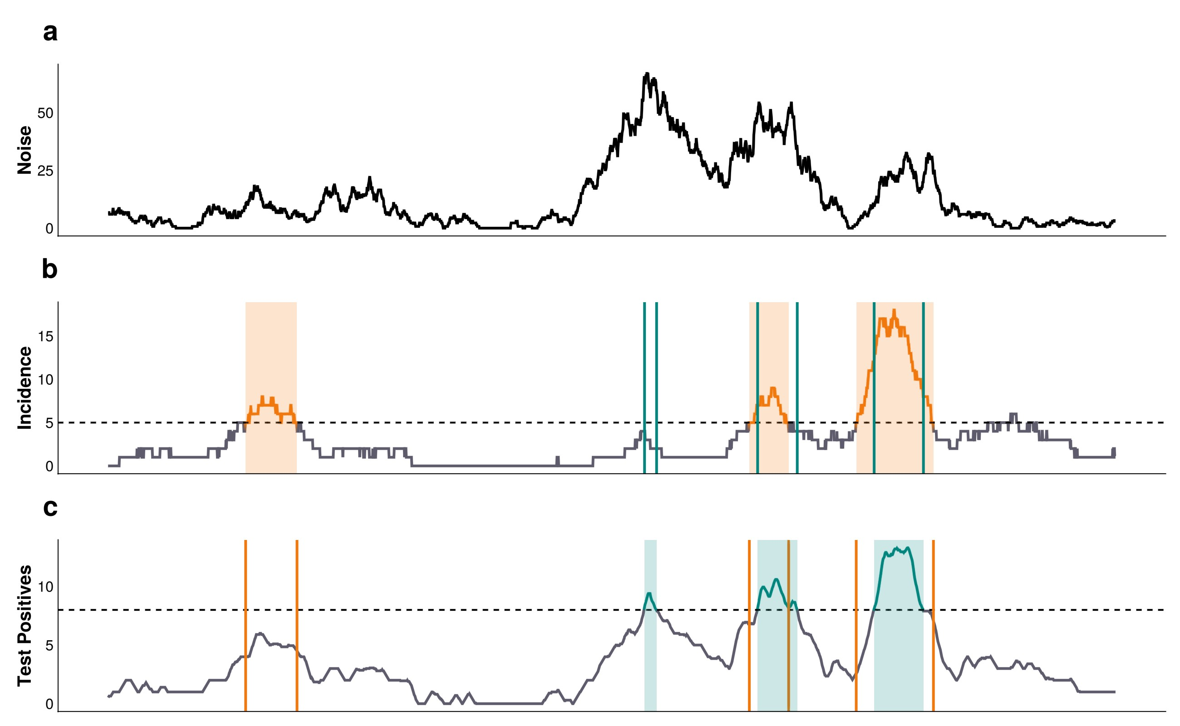

*Figure 1: Test A schematic of the outbreak definition and alert detection system. A) Noise time series. B) Measles incidence time series. C) Observed time series resulting from testing noise & measles cases that visit the healthcare facility. The orange bands/vertical lines represent regions of the measles time series that meet the outbreak definition criteria. The green bands/vertical lines represent regions of the observed (measles - noise) time series that breach the alert threshold (the horizontal dashed line), and constitute an alert.*

### Triggering Alerts

We define an “alert” as any consecutive string of 1 or more days where the 7-day moving average of the test-positive cases is greater than, or equal to, a pre-specified alert threshold, T. For each time series of test-positive cases, we calculate the percentage of alerts that are “correct”, defined as any overlap of 1 or more days between the alert and outbreak periods (Figure 1 b and c). This is analogous to the PPV of the alert system, and will be referred to as such for the rest of the manuscript. Note that it is possible to have multiple alerts within a single outbreak if the 7-day moving average of test positive cases drops below the threshold, T, and each would be considered correct. For all outbreaks in the measles time series, we calculate the percentage that contain at least 1 alert within the outbreak’s start and end dates (Figure 1 b and c). We refer to this as the sensitivity of the alert system. We also calculate the detection delay as the time from the start of an outbreak to the start of its first alert. If the alert period starts before the outbreak and continues past the start date of the outbreak, this would be considered a correct alert with a negative delay i.e., an early warning triggered by false positive test results. Finally, for each time series we calculate the number of unavoidable and avoidable outbreak cases. Avoidable cases are defined as those that occur within an outbreak after a correct alert is first triggered i.e., cases that could theoretically be prevented with a perfectly effective and timely response. Unavoidable cases are the inverse: those that occur before a correct alert, or those that occur in an undetected outbreak. In practice, not all cases deemed avoidable are (due to imperfect and delays in responses), but to minimize the sensitivity of the results to the response implementation and operational constraints we are counting them as such.

We define the accuracy of the surveillance system for a given time series as the mean of the system’s sensitivity and PPV. To examine the interaction of the test with the surveillance system’s characteristics (i.e., testing rate, and noise structure and magnitude), we varied the alert threshold, T, between 1 and 15 cases per day. Each of the 100 simulations per scenario produces an accuracy, and we identified the optimal alert threshold, TO, as the value that produced the highest median accuracy for a given scenario. We then compare testing scenarios at their respective optimal alert threshold. This allows for conclusions to be made about the surveillance system as a whole, rather than just single components.

## Results

The threshold that maximized surveillance accuracy depends on diagnostic test characteristics, the testing rate, and the structure of the non-measles noise (Table 2). When the average noise incidence was 8 times higher than the average measles incidence (Λ(8)), the optimal threshold ranged between 1 and 7 test-positive cases per day. Not surprisingly, the biggest driver of this difference was the testing rate; as a large fraction of suspected cases are tested, the optimal threshold increases monotonically for all test and noise types (Table 2).

The maximal attainable surveillance accuracy at the optimal threshold depends strongly on the structure and magnitude of the background noise. For Poisson noise, at all magnitudes, the maximum surveillance accuracy increases rapidly from 65% at 10% testing of suspected cases, to ≈ 90% accuracy at ≥ 20% testing, for all test types (Figure 2). For dynamical SEIR noise, the ELISA-like perfect tests perform identically to the Poisson noise case at all magnitudes (Figure 2). For RDT-like tests, which have lower individual sensitivity and specificity, the maximal attainable accuracy is lower than the ELISA-like tests for all testing rates (P) at noise magnitude ≥ Λ(2) (Figure 2). Notably, the surveillance accuracy declines with increasing noise and, at all noise levels, is not improved with higher testing rates as the signal becomes increasingly dominated by false positive test results (Figure 2).

|  |  |  |  |  |  |  |  |  |
| --- | --- | --- | --- | --- | --- | --- | --- | --- |
|  | **Test Characteristic** | |  | **Testing Rate** | | | |  |
| Noise Type | Test Type | Test Lag | 10% | 20% | 30% | 40% | 50% | 60% |
| Dynamical noise: in-phase | RDT Equivalent (85.0%) | 0 | 1 | 2 | 3 | 4 | 4 | 5 |
| Dynamical noise: in-phase | RDT Equivalent (90.0%) | 0 | 1 | 2 | 3 | 4 | 4 | 5 |
| Poisson noise | RDT Equivalent (85.0%) | 0 | 1 | 3 | 4 | 5 | 6 | 7 |
| Poisson noise | RDT Equivalent (90.0%) | 0 | 1 | 2 | 4 | 5 | 5 | 6 |
| All noise structures | Perfect Test | 0 | 1 | 2 | 3 | 4 | 4 | 5 |
| All noise structures | Perfect Test | 14 | 1 | 2 | 3 | 4 | 4 | 5 |

*Optimal threshold for RDT-like, ELISA-like, and perfect tests, under dynamical and*

*Poisson-like noise structures where the average daily noise incidence is 8 times the average daily measles incidence*

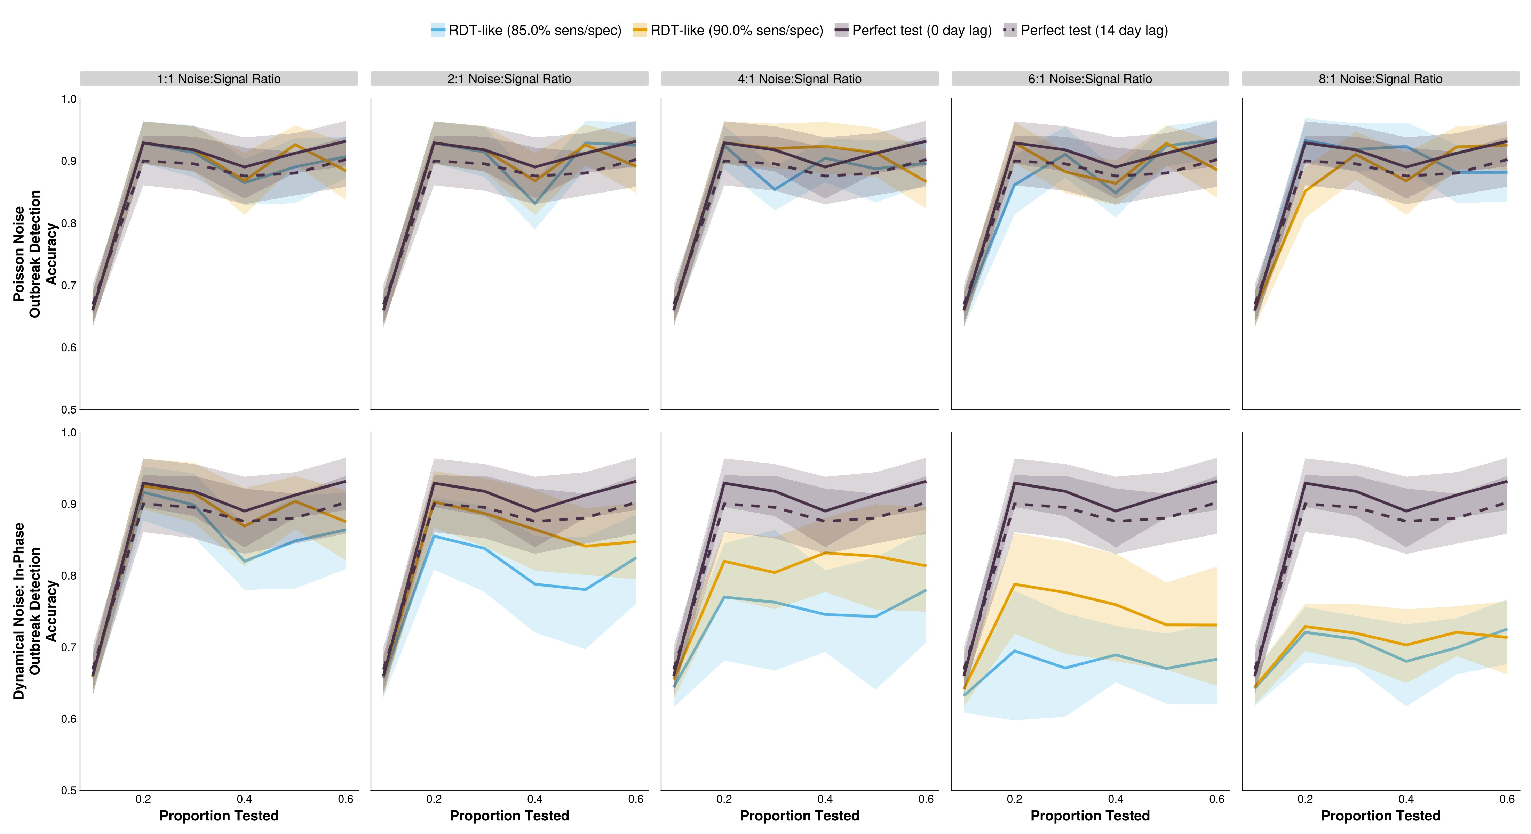

*Figure 2: The accuracy of outbreak detection systems under different testing rates and noise structures.The shaded bands illustrate the 80% central interval, and the solid/dashed lines represent the mean estimate. Solid lines represent tests with 0-day turnaround times, and dashed lines represent tests with result delays.*

Introducing a lag in test result reporting necessarily decreases surveillance accuracy because an alert can only begin once the test results are in-hand, which increases the chance that an outbreak will end before results can be translated to an alert. For the conditions simulated here, introducing a 14day lag in test reporting for an ELISA-like test reduces the surveillance accuracy by ≈ 3%. For all simulated scenarios, this is consistent with, or higher than, the accuracy achievable with an RDTlike test. This always leads to an increase in the median delay from outbreak start to alert, relative to an ELISA-like test with no result delays, as well as RDT-like tests (Figure 3).

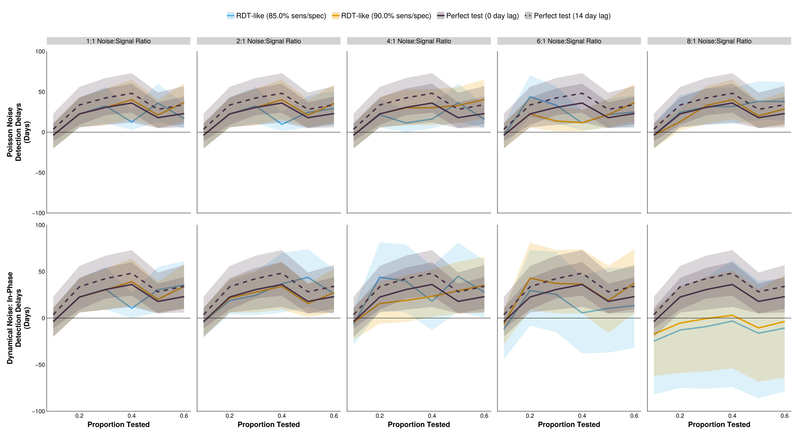

*Figure 3: The detection delay of outbreak detection systems under different testing rates and noise structures. The shaded bands illustrate the 80% central interval, and the solid/dashed lines represent the mean estimate. Solid lines represent tests with 0-day turnaround times, and dashed lines represent tests with result delays.*

It is notable that surveillance metrics do not change monotonically with an increase in testing rate, and this holds regardless of the type of test. This effect is exaggerated for some metrics (detection delays, proportion of time in alert, and number of unavoidable cases) than others (accuracy). In general, the increase in accuracy with higher testing rates is accompanied with longer testing delays. This reflects the change from highly sensitive systems with low thresholds to more specific systems with higher thresholds at higher testing rates. For Poisson noise, similar detection delays are observed for all test and noise magnitudes, with most of the variation attributable to the change in the testing rate (means of −3.7 to 36.1 days). Under dynamical noise, there are clearer differences in the performance of ELISA and RDTs, with the separation of outcomes occurring later than observed for surveillance accuracy (Λ(8) vs Λ(2) — Figure 3 and Figure 2 — respectively). With large amounts of dynamical noise (Λ(8)), the mean detection delay of the 90% and 85% RDTs range from −17.5 days to 3.2 days, and from −25.2 days to −3.4 days, respectively. Negative delays indicate that alerts are being triggered before the start of the outbreak and is correlated with the proportion of the time series that is under alert, with larger negative delays associated with more and/or longer alert periods (Figure 4, Supplemental Figures 2 and 3). Long detection delays manifest as large numbers of unavoidable cases (i.e., cases that occur between the outbreak start and its detection) (Figure 5). Given the exponential trajectory of infections in the initial phase of an outbreak, the pattern of unavoidable cases follows the same shape as for detection delays, but more exaggerated.

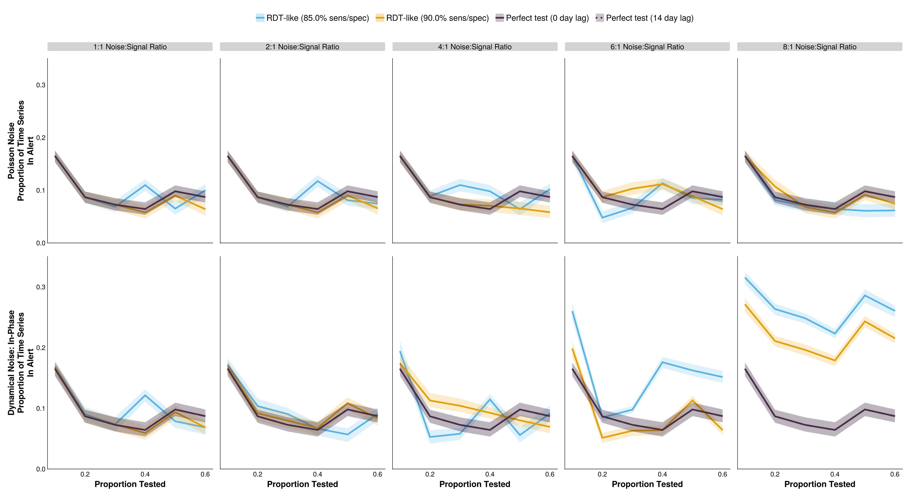

*Figure 4: The difference between proportion of the time series in alert for outbreak detection systems under different testing rates and noise structures. The shaded bands illustrate the 80% central interval, and the solid/dashed lines represent the mean estimate. Solid lines represent tests with 0-day turnaround times, and dashed lines represent tests with result delays.*

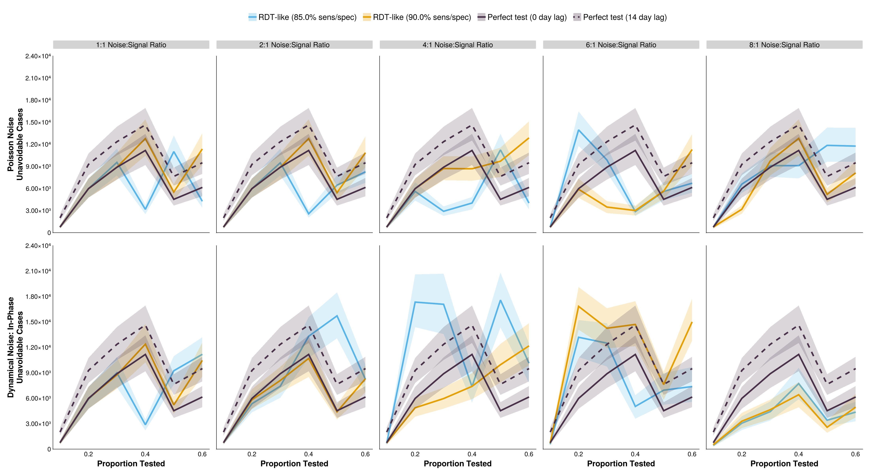

*Figure 5: The number of unavoidable cases of outbreak detection systems under different testing rates and noise structures. The shaded bands illustrate the 80% central interval, and the solid/dashed lines represent the mean estimate. Solid lines represent tests with 0-day turnaround times, and dashed lines represent tests with result delays.*

## Discussion

The performance of an outbreak detection system is highly sensitive to the structure and level of background noise in the simulation. Despite the mean daily noise incidence set to equivalent values between the dynamical and Poisson-only simulations, drastically different results are observed.

Under the assumption that non-measles febrile rash is relatively static in time (Poisson noise scenarios), RDTs can perform as well, if not better than ELISA tests at moderate to high testing rates, and at a fraction of the cost [34]. However, if it is expected that the noise is dynamic, imperfect tests cannot overcome their accuracy limitations through higher testing rates, saturating at c. 74% accuracy, relative to ELISA’s 93%. This discrepancy occurs because, despite the same average incidence of noise in each (comparable) scenario, the relative proportion of measles to noise on any one day varies throughout the dynamical noise time series, exacerbating the effects of imperfect diagnostic tests that produce higher rates of false positives and negatives than ELISA-like diagnostics.

For all noise structures and diagnostic tests, increasing testing rate was not accompanied by a monotonic change in the associated metrics. The reason behind this unintuitive result stems from the use of integer-valued alert thresholds. For a given diagnostic test, increasing the testing rate will result in an increase in the number of observed (test positive) cases. This, however, may not translate to an integer increase in the moving average of test positive results, which is used to trigger an alert. Even with a perfect test, the alert system must discriminate between endemic/ imported cases and epidemic cases. As such, the threshold may stay the same as the optimal value selected for the previous testing rate, providing an overly sensitive system that will be triggered more frequently by endemic cases. Or, it can increase, resulting in a system with a higher PPV per alert, but lower surveillance sensitivity. Both options may translate to a lower surveillance accuracy than observed when fewer individuals are tested. But more importantly, this can result in contiguous testing rates selecting for system sensitivity vs PPV differently, translating to discontinuous changes in the outbreak delays (Figure 3), unavoidable cases (Figure 5), and proportion of the time series in alert status (Figure 4).

Surveillance is counting for action [67]. What actions are taken depend upon the constraints imposed, and the values held, within a particular surveillance context. This analysis is therefore not a complete optimization, which would require explicit decisions to be made about the preference for increased speed at the cost of higher false alert rates and lower PPV (and visa versa). These will be country-specific decisions, and they may change throughout time; for example, favoring RDTs when there are low levels of background infections, and ELISAs during large (suspected) rubella outbreaks. These trade-offs must be explicitly acknowledged when designing surveillance systems, and we present a framework to account for the deep interconnectedness of individual and population-level uncertainties that arise from necessary categorizations.

### Limitations and Strengths

To our knowledge, this is one of the first simulation studies to examine the relationship between individual test characteristics and the wider surveillance program. By explicitly modeling the interaction between the two, we make a case that surveillance systems should take a holistic approach; prematurely constraining one component can lead to drastically different, and suboptimal, results. Additionally, by defining outbreak bounds concretely we have been able to calculate metrics of outbreak detection performance that draw parallels to those used when evaluating individual diagnostic tests. This provides an intuitive understanding and simple implementation of this method in resource-constrained environments, something that may not be possible with many outbreak detection and early warning system simulations in the literature. An evaluation of all outbreak detection algorithms is beyond the scope of this work, but a more computationally expensive approach based on nowcasting incidence may help overcome the shortcomings of RDTs in highnoise scenarios.

For computational simplicity, this paper did not include demography in the model structure. And while a simulation-based approach allows for complete determination of true infection status i.e., measles vs non-measles febrile rash cases, and therefore an accurate accounting of the outbreak and alert bounds, these simulations do not specifically represent any real-world setting. The evaluation of empirical data does provide this opportunity, but at the cost of knowing the true infection status of individuals, confounding of multiple variables, limiting analysis to only those who are observed (i.e., not those in the community who do not visit a healthcare center), and removing the possibility to explore the sensitivity of the results to parameters of interest to a surveillance program e.g., testing rate, and the test itself.

Additionally, is has been well documented that the performance of an individual test is highly sensitive to its timing within a person’s infection cycle [6,36,37,68,69], so it is possible that different conclusions would be drawn if temporal information about the test administration was included in the simulation.

Finally, the optimal threshold for a testing scenario is affected by the use of integer-values; smaller steps could be chosen to potentially minimize discontinuities. Similarly, the optimal threshold depends heavily on the costs ascribed to incorrect actions, be that failing to detect an outbreak or incorrectly mounting a response for an outbreak that doesn’t exist. In the simulations we have weighted them equally, but it is likely that they should not be deemed equivalent; missing an outbreak may result in many thousands of cases, whereas an unnecessary alert would generally launch an initial low-cost investigation for full determination of the outbreak status. This is particularly important in countries with vast heterogeneity in transmission: different weightings should be applied to higher vs. lower priority/risk regions to account for discrepancies in consequences of incorrect decisions.

Given these limitations, the explicit values (i.e., optimal thresholds, accuracies etc.) should be interpreted with caution, and the exact results observed in the real-world will likely be highly dependent on unseen factors, such as the proportion of measles and non-measles sources of febrile rash that seek healthcare. However, the general patterns should hold, and more importantly, the analysis framework provides a consistent and holistic approach to evaluating the trade-off between individual level tests and the alert system enacted to detect outbreaks.

## Funding

• *Something about GAVI/Gates*

This work was supported by funding from the Office of the Provost and the Clinical and

Translational Science Institute, Huck Life Sciences Institute, and Social Science Research Institutes at the Pennsylvania State University. The project described was supported by the National Center for Advancing Translational Sciences, National Institutes of Health, through Grant UL1 TR002014. The content is solely the responsibility of the authors and does not necessarily represent the official views of the NIH. The funding sources had no role in the collection, analysis, interpretation, or writing of the report.

## Acknowledgements

### Author Contributions

*Conceptualization:* CA, MJF

*Data curation:* MJF, CA

*Formal analysis:* CA, MJF

*Funding acquisition:* MJF, WM, AW

*Investigation:* CA, MJF *Methodology:* CA, MJF

*Project administration:* MJF

*Software:* CA

*Supervision:* MJF, WM, AW, BP

*Validation:* CA, MJF

*Visualization:* CA

*Writing - original draft:* CA, MJF

*Writing - review and editing:* all authors.

**Conflicts of Interest and Financial Disclosures** The authors declare no conflicts of interest.

### Data Access, Responsibility, and Analysis

Callum Arnold and Dr. Matthew J. Ferrari had full access to all the data in the study and take responsibility for the integrity of the data and the accuracy of the data analysis. Callum Arnold and Dr. Matthew J. Ferrari (Department of Biology, Pennsylvania State University) conducted the data analysis.

### Data Availability

All code and data for the simulations can be found at [https://github.com/arnold-c/ OutbreakDetection](https://github.com/arnold-c/OutbreakDetection)

## Bibliography

1. Murray J, Cohen A L. Infectious Disease Surveillance. International Encyclopedia of Public

Health 2017:222–9. https://doi.org/[10.1016/B978-0-12-803678-5.00517-8](https://doi.org/10.1016/B978-0-12-803678-5.00517-8)

1. Zhou X-N, Bergquist R, Tanner M. Elimination of Tropical Disease through Surveillance and Response. Infectious Diseases of Poverty 2013;2:1. https://doi.org/[10.1186/2049-9957-2-1](https://doi.org/10.1186/2049-9957-2-1)
2. PAHO. An Integrated Approach to Communicable Disease Surveillance. 2000
3. World Health Organization. Measles Outbreak Guide. Geneva, Switzerland: World Health Organization; 2022
4. Cragg L. Outbreak Response. Applied Communicable Disease Control 2018:134–51
5. Gastanaduy P A, Redd S B, Clemmons N S, Lee A D, Hickman C J, Rota P A, et al. Measles.

Manual for the Surveillance of Vaccine-Preventable Diseases 2019

1. Commissioner O of the. Coronavirus (COVID-19) Update: FDA Informs Public About Possible Accuracy Concerns with Abbott ID NOW Point-of-Care Test 2020. [https://www.fda.gov/newsevents/press-announcements/coronavirus-covid-19-update-fda-informs-public-about-possibleaccuracy-concerns-abbott-id-now-point](https://www.fda.gov/news-events/press-announcements/coronavirus-covid-19-update-fda-informs-public-about-possible-accuracy-concerns-abbott-id-now-point) (accessed February 7, 2024)
2. Grassly N C, Pons-Salort M, Parker E P K, White P J, Ferguson N M, Imperial College COVID-19 Response Team. Comparison of Molecular Testing Strategies for COVID-19 Control: A Mathematical Modelling Study. Lancet Infect Dis 2020;20:1381–9. https://doi.org/[10.1016/S 1473-3099(20)30630-7](https://doi.org/10.1016/S1473-3099(20)30630-7)
3. Ezhilan M, Suresh I, Nesakumar N. SARS-CoV, MERS-CoV and SARS-CoV-2: A Diagnostic Challenge. Measurement (Lond) 2021;168:108335. https://doi.org/[10.1016/j.measurement.2020. 108335](https://doi.org/10.1016/j.measurement.2020.108335)
4. World Health Organization. Cholera 2023. [https://www.who.int/news-room/fact-sheets/detail/ cholera](https://www.who.int/news-room/fact-sheets/detail/cholera) (accessed February 7, 2024)
5. Essential Programme on Immunization (EPI), Immunization, Vaccines and Biologicals (IVB). Clinical Specimens for the Laboratory Confirmation and Molecular Epidemiology of Measles,

Rubella, and CRS. Manual for the Laboratory-based Surveillance of Measles, Rubella, And Congenital Rubella Syndrome 2018

1. Westreich D. Diagnostic Testing, Screening, and Surveillance. Epidemiology by Design: A Causal Approach to the Health Sciences 2019:0. https://doi.org/[10.1093/oso/9780190665760.003. 0005](https://doi.org/10.1093/oso/9780190665760.003.0005)
2. Shreffler J, Huecker M R. Diagnostic Testing Accuracy: Sensitivity, Specificity, Predictive Values and Likelihood Ratios. StatPearls 2024
3. Parikh R, Mathai A, Parikh S, Chandra Sekhar G, Thomas R. Understanding and Using

Sensitivity, Specificity and Predictive Values. Indian J Ophthalmol 2008;56:45–50

1. World Health Organization. Target Product Profiles n.d.. [https://www.who.int/observatories/ global-observatory-on-health-research-and-development/analyses-and-syntheses/targetproduct-profile/who-target-product-profiles](https://www.who.int/observatories/global-observatory-on-health-research-and-development/analyses-and-syntheses/target-product-profile/who-target-product-profiles) (accessed February 6, 2024)
2. Chua A C, Cunningham J, Moussy F, Perkins M D, Formenty P. The Case for Improved Diagnostic Tools to Control Ebola Virus Disease in West Africa and How to Get There. PLOS

Neglected Tropical Diseases 2015;9:e3734. https://doi.org/[10.1371/journal.pntd.0003734](https://doi.org/10.1371/journal.pntd.0003734)

1. German R R. Sensitivity and Predictive Value Positive Measurements for Public Health

Surveillance Systems. Epidemiology 2000;11:720–7

1. World Health Organization. Operational Thresholds. Meningitis Outbreak Response in SubSaharan Africa: WHO Guideline 2014
2. Lewis R, Nathan N, Diarra L, Belanger F, Paquet C. Timely Detection of Meningococcal Meningitis Epidemics in Africa. The Lancet 2001;358:287–93. https://doi.org/[10.1016/S01406736(01)05484-8](https://doi.org/10.1016/S0140-6736(01)05484-8)
3. GBD 2019 Child and Adolescent Communicable Disease Collaborators. The Unfinished Agenda of Communicable Diseases among Children and Adolescents before the COVID-19 Pandemic,

1990–2019: A Systematic Analysis of the Global Burden of Disease Study 2019. The Lancet

2023;402:313–35. https://doi.org/[10.1016/S0140-6736(23)00860-7](https://doi.org/10.1016/S0140-6736(23)00860-7)

1. Roser M, Ritchie H, Spooner F. Burden of Disease. Our World in Data 2023
2. Atkins B D, Jewell C P, Runge M C, Ferrari M J, Shea K, Probert W J M, et al. Anticipating Future Learning Affects Current Control Decisions: A Comparison between Passive and Active

Adaptive Management in an Epidemiological Setting. Journal of Theoretical Biology

2020;506:110380. https://doi.org/[10.1016/j.jtbi.2020.110380](https://doi.org/10.1016/j.jtbi.2020.110380)

1. Tao Y, Shea K, Ferrari M. Logistical Constraints Lead to an Intermediate Optimum in Outbreak Response Vaccination n.d.:20
2. Grais R, Conlan A, Ferrari M, Djibo A, Le Menach A, Bjørnstad O, et al. Time Is of the Essence: Exploring a Measles Outbreak Response Vaccination in Niamey, Niger. J R Soc Interface 2008;5:67–74. https://doi.org/[10.1098/rsif.2007.1038](https://doi.org/10.1098/rsif.2007.1038)
3. Ferrari M J, Fermon F, Nackers F, Llosa A, Magone C, Grais R F. Time Is (Still) of the Essence:

Quantifying the Impact of Emergency Meningitis Vaccination Response in Katsina State,

Nigeria. International Health 2014;6:282–90. https://doi.org/[10.1093/inthealth/ihu062](https://doi.org/10.1093/inthealth/ihu062)

1. World Health Organization. Confirming, Investigating and Managing an Outbreak. Response to Measles Outbreaks in Measles Mortality Reduction Settings: Immunization, Vaccines and Biologicals 2009;3
2. Minetti A, Kagoli M, Katsulukuta A, Huerga H, Featherstone A, Chiotcha H, et al. Lessons and Challenges for Measles Control from Unexpected Large Outbreak, Malawi. Emerg Infect Dis 2013;19:202–9. https://doi.org/[10.3201/eid1902.120301](https://doi.org/10.3201/eid1902.120301)
3. Trotter C L, Cibrelus L, Fernandez K, Lingani C, Ronveaux O, Stuart J M. Response Thresholds for Epidemic Meningitis in Sub-Saharan Africa Following the Introduction of MenAfriVac®. Vaccine 2015;33:6212–7. https://doi.org/[10.1016/j.vaccine.2015.09.107](https://doi.org/10.1016/j.vaccine.2015.09.107)
4. Cooper L V, Stuart J M, Okot C, Asiedu-Bekoe F, Afreh O K, Fernandez K, et al. Reactive

Vaccination as a Control Strategy for Pneumococcal Meningitis Outbreaks in the African Meningitis Belt: Analysis of Outbreak Data from Ghana. Vaccine 2019;37:5657–63. https://doi. org/[10.1016/j.vaccine.2017.12.069](https://doi.org/10.1016/j.vaccine.2017.12.069)

1. Zalwango M G, Zalwango J F, Kadobera D, Bulage L, Nanziri C, Migisha R, et al. Evaluation of Malaria Outbreak Detection Methods, Uganda, 2022. Malar J 2024;23:18. https://doi.org/[10. 1186/s12936-024-04838-w](https://doi.org/10.1186/s12936-024-04838-w)
2. Kaninda A-V, Belanger F, Lewis R, Batchassi E, Aplogan A, Yakoua Y, et al. Effectiveness of

Incidence Thresholds for Detection and Control of Meningococcal Meningitis Epidemics in

Northern Togo. International Journal of Epidemiology 2000;29:933–40. https://doi.org/[10.1093/ ije/29.5.933](https://doi.org/10.1093/ije/29.5.933)

1. Warrener L, Andrews N, Koroma H, Alessandrini I, Haque M, Garcia C C, et al. Evaluation of a Rapid Diagnostic Test for Measles IgM Detection; Accuracy and the Reliability of Visual

Reading Using Sera from the Measles Surveillance Programme in Brazil, 2015. Epidemiology & Infection 2023;151:e151. https://doi.org/[10.1017/S0950268823000845](https://doi.org/10.1017/S0950268823000845)

1. Miller E, Sikes H D. Addressing Barriers to the Development and Adoption of Rapid Diagnostic

Tests in Global Health. Nanobiomedicine (Rij) 2015;2:6. https://doi.org/[10.5772/61114](https://doi.org/10.5772/61114)

1. Brown D W, Warrener L, Scobie H M, Donadel M, Waku-Kouomou D, Mulders M N, et al.

Rapid Diagnostic Tests to Address Challenges for Global Measles Surveillance. Current

Opinion in Virology 2020;41:77–84. https://doi.org/[10.1016/j.coviro.2020.05.007](https://doi.org/10.1016/j.coviro.2020.05.007)

1. McMorrow M L, Aidoo M, Kachur S P. Malaria Rapid Diagnostic Tests in Elimination Settings— Can They Find the Last Parasite?. Clin Microbiol Infect 2011;17:1624–31. https://doi.org/[10. 1111/j.1469-0691.2011.03639.x](https://doi.org/10.1111/j.1469-0691.2011.03639.x)
2. Larremore D B, Wilder B, Lester E, Shehata S, Burke J M, Hay J A, et al. Test Sensitivity Is Secondary to Frequency and Turnaround Time for COVID-19 Screening. Science Advances

2021;7:eabd5393. https://doi.org/[10.1126/sciadv.abd5393](https://doi.org/10.1126/sciadv.abd5393)

1. Middleton C, Larremore D B. Modeling the Transmission Mitigation Impact of Testing for Infectious Diseases 2023
2. Essential Programme on Immunization (EPI), Immunization, Vaccines and Biologicals (IVB).

Measles. Vaccine Preventable Diseases Surveillance Standards 2018:30

1. Hutchins S S, Amler R, Maes E F, Grabowsky M, Bromberg K, Glasglow V, et al. Evaluation of the Measles Clinical Case Definition. The Journal of Infectious Diseases 2004;189:S153–9. https://doi.org/[10.1086/379652](https://doi.org/10.1086/379652)
2. World Health Organization. The Selection and Use of Essential in Vitro Diagnostics: Report of the Third Meeting of the WHO Strategic Advisory Group of Experts on In Vitro Diagnostics, 2020 (Including the Third WHO Model List of Essential in Vitro Diagnostics). Geneva: World Health Organization; 2021
3. Shonhai A, Warrener L, Mangwanya D, Slibinskas R, Brown K, Brown D, et al. Investigation of a Measles Outbreak in Zimbabwe, 2010: Potential of a Point of Care Test to Replace Laboratory Confirmation of Suspected Cases. Epidemiol Infect 2015;143:3442–50. https://doi.org/[10.1017/S 0950268815000540](https://doi.org/10.1017/S0950268815000540)
4. Senin A, Noordin N M, Sani J A M, Mahat D, Donadel M, Scobie H M, et al. A Measles IgM Rapid Diagnostic Test to Address Challenges with National Measles Surveillance and Response in Malaysia. PLOS ONE 2024;19:e298730. https://doi.org/[10.1371/journal.pone.0298730](https://doi.org/10.1371/journal.pone.0298730)
5. Yemshanov D, Haight R G, Liu N, Chen C, MacQuarrie C J K, Ryall K, et al. Acceptance Sampling for Cost-Effective Surveillance of Emerald Ash Borer in Urban Environments. Forestry: An International Journal of Forest Research 2020;93:280–96. https://doi.org/[10.1093/ forestry/cpz028](https://doi.org/10.1093/forestry/cpz028)
6. Christensen J, Gardner I A. Herd-Level Interpretation of Test Results for Epidemiologic Studies of Animal Diseases. Preventive Veterinary Medicine 2000;45:83–106. https://doi.org/[10.1016/S 0167-5877(00)00118-5](https://doi.org/10.1016/S0167-5877(00)00118-5)
7. Murato Y, Hayama Y, Shimizu Y, Sawai K, Yamamoto T. Evaluation of Sampling Methods for

Effective Detection of Infected Pig Farms during a Disease Outbreak. PLOS ONE

2020;15:e241177. https://doi.org/[10.1371/journal.pone.0241177](https://doi.org/10.1371/journal.pone.0241177)

1. Stern L, Lightfoot D. Automated Outbreak Detection: A Quantitative Retrospective Analysis. Epidemiol Infect 1999;122:103–10
2. Calba C, Goutard F L, Hoinville L, Hendrikx P, Lindberg A, Saegerman C, et al. Surveillance

Systems Evaluation: A Systematic Review of the Existing Approaches. BMC Public Health

2015;15:448. https://doi.org/[10.1186/s12889-015-1791-5](https://doi.org/10.1186/s12889-015-1791-5)

1. Guidelines Working Group. Updated Guidelines for Evaluating Public Health Surveillance Systems. Atlanta, Georgia: 2001
2. Jombart T, Ghozzi S, Schumacher D, Taylor T J, Leclerc Q J, Jit M, et al. Real-Time Monitoring of COVID-19 Dynamics Using Automated Trend Fitting and Anomaly Detection. Philosophical Transactions of the Royal Society B: Biological Sciences 2021;376:20200266. https://doi.org/[10. 1098/rstb.2020.0266](https://doi.org/10.1098/rstb.2020.0266)
3. Proverbio D, Kemp F, Magni S, Gonçalves J. Performance of Early Warning Signals for Disease

Re-Emergence: A Case Study on COVID-19 Data. PLOS Computational Biology

2022;18:e1009958. https://doi.org/[10.1371/journal.pcbi.1009958](https://doi.org/10.1371/journal.pcbi.1009958)

1. Stolerman L M, Clemente L, Poirier C, Parag K V, Majumder A, Masyn S, et al. Using Digital Traces to Build Prospective and Real-Time County-Level Early Warning Systems to Anticipate COVID-19 Outbreaks in the United States. Science Advances 2023;9:eabq199. https://doi.org/[10. 1126/sciadv.abq0199](https://doi.org/10.1126/sciadv.abq0199)
2. Brett T S, O’Dea E B, Marty É, Miller P B, Park A W, Drake J M, et al. Anticipating Epidemic Transitions with Imperfect Data. Plos Comput Biol 2018;14:e1006204. https://doi.org/[10.1371/ journal.pcbi.1006204](https://doi.org/10.1371/journal.pcbi.1006204)
3. Salmon M, Schumacher D, Höhle M. Monitoring Count Time Series in \emph{R} : Aberration Detection in Public Health Surveillance. J Stat Soft 2016;70. https://doi.org/[10.18637/jss.v070.i10](https://doi.org/10.18637/jss.v070.i10)
4. Chatterjee A, Vlachos D G, Katsoulakis M A. Binomial Distribution Based τ-Leap Accelerated Stochastic Simulation. The Journal of Chemical Physics 2005;122:24112. https://doi.org/[10.1063/](https://doi.org/10.1063/1.1833357)

[1.1833357](https://doi.org/10.1063/1.1833357)

1. Gillespie D T. Approximate Accelerated Stochastic Simulation of Chemically Reacting Systems.

The Journal of Chemical Physics 2001;115:1716–33. https://doi.org/[10.1063/1.1378322](https://doi.org/10.1063/1.1378322)

1. Guerra F M, Bolotin S, Lim G, Heffernan J, Deeks S L, Li Y, et al. The Basic Reproduction Number (R0) of Measles: A Systematic Review. The Lancet Infectious Diseases 2017;17:e420–8. https://doi.org/[10.1016/S1473-3099(17)30307-9](https://doi.org/10.1016/S1473-3099(17)30307-9)
2. World Bank. Ghana n.d.. <https://data.worldbank.org/> (accessed February 6, 2024)
3. Keeling M J, Rohani P. Modeling Infectious Diseases in Humans and Animals. Princeton: Princeton University Press; 2008
4. Bezanson J, Edelman A, Karpinski S, Shah V B. Julia: A Fresh Approach to Numerical

Computing. SIAM Rev 2017;59:65–98. https://doi.org/[10.1137/141000671](https://doi.org/10.1137/141000671)

1. Papadopoulos T, Vynnycky E. Estimates of the Basic Reproduction Number for Rubella Using

Seroprevalence Data and Indicator-Based Approaches. Plos Computational Biology

2022;18:e1008858. https://doi.org/[10.1371/journal.pcbi.1008858](https://doi.org/10.1371/journal.pcbi.1008858)

1. Morales M, Lanzieri T, Reef S. Rubella. CDC Yellow Book 2024: Health Information for International Travel 2023
2. Teklehaimanot H D, Schwartz J, Teklehaimanot A, Lipsitch M. Alert Threshold Algorithms and Malaria Epidemic Detection. Emerg Infect Dis 2004;10:1220–6. https://doi.org/[10.3201/eid1007. 030722](https://doi.org/10.3201/eid1007.030722)
3. Leclère B, Buckeridge D L, Boëlle P-Y, Astagneau P, Lepelletier D. Automated Detection of Hospital Outbreaks: A Systematic Review of Methods. PLOS ONE 2017;12:e176438. https://doi. org/[10.1371/journal.pone.0176438](https://doi.org/10.1371/journal.pone.0176438)
4. Graham M, Winter A K, Ferrari M, Grenfell B, Moss W J, Azman A S, et al. Measles and the Canonical Path to Elimination. Science 2019;364:584–7. https://doi.org/[10.1126/science.aau6299](https://doi.org/10.1126/science.aau6299)
5. FIND. Target Product Profile for Surveillance Tests for Measles and Rubella. Geneva, Switzerland: 2024
6. Hiebert J, Zubach V, Charlton C L, Fenton J, Tipples G A, Fonseca K, et al. Evaluation of Diagnostic Accuracy of Eight Commercial Assays for the Detection of Measles Virus-Specific IgM Antibodies. Journal of Clinical Microbiology 2021;59:e3161. https://doi.org/[10.1128/JCM. 03161-20](https://doi.org/10.1128/JCM.03161-20)
7. World Health Organization. Surveillance in Emergencies 2024. [https://www.who.int/ westernpacific/emergencies/surveillance](https://www.who.int/westernpacific/emergencies/surveillance) (accessed November 5, 2024)
8. Kissler S M, Fauver J R, Mack C, Olesen S W, Tai C, Shiue K Y, et al. Viral Dynamics of Acute

SARS-CoV-2 Infection and Applications to Diagnostic and Public Health Strategies. PLOS

Biology 2021;19:e3001333. https://doi.org/[10.1371/journal.pbio.3001333](https://doi.org/10.1371/journal.pbio.3001333)

1. Ratnam S, Tipples G, Head C, Fauvel M, Fearon M, Ward B J. Performance of Indirect Immunoglobulin M (IgM) Serology Tests and IgM Capture Assays for Laboratory Diagnosis of Measles. J Clin Microbiol 2000;38:99–104