实验七 机翼断面下轮廓线的数值分析

# 实验目的

1. 加深对各种插值算法的理解
2. 熟悉使用不同类型的插值函数
3. 编程实现对机翼断面下轮廓线的插值仿真和数值分析

# 实验环境

1. 计算机
2. MATLAB集成环境

# 实验内容与代码

## 已知某机翼断面下轮廓线上的部分数据，如表所示

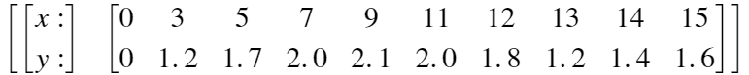

1. 试设计出具有一定光滑度的机翼下轮廓线，并画出图形
2. 以表的形式给出x每增加0.5时的y值
3. 分别用拉格朗日插值，牛顿插值，三次样条插值对上述数据点进行拟合

clc;clear;

x = [0 3 5 7 9 11 12 13 14 15]

x = 1×10

0 3 5 7 9 11 12 13 14 15

y = [0 1.2 1.7 2.0 2.1 2.0 1.8 1.2 1.4 1.6]

y = 1×10

0 1.2000 1.7000 2.0000 2.1000 2.0000 1.8000 ⋯

xi = 0:0.5:15

xi = 1×31

0 0.5000 1.0000 1.5000 2.0000 2.5000 3.0000 ⋯

y1 = zeros(1, 31);

y2 = zeros(1, 31);

for i = 1:31

y1(i) = lagrangeInterpolation(x, y, xi(i));

end

for i = 1:31

y2(i) = newtonInterpolation(x, y, xi(i));

end

y3 = mySpline(x, y, xi);

plot(x, y, 'o', xi, y1, '-')

legend({'data', 'Lagrange Interpolation'})

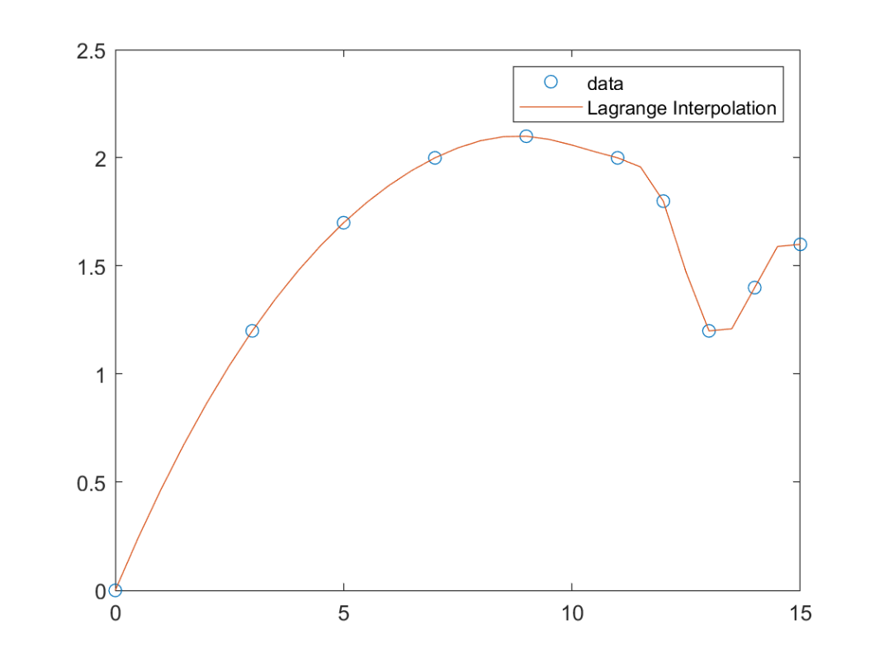

plot(x, y, 'o', xi, y2, '-')

legend({'data', 'Newton Interpolation'})

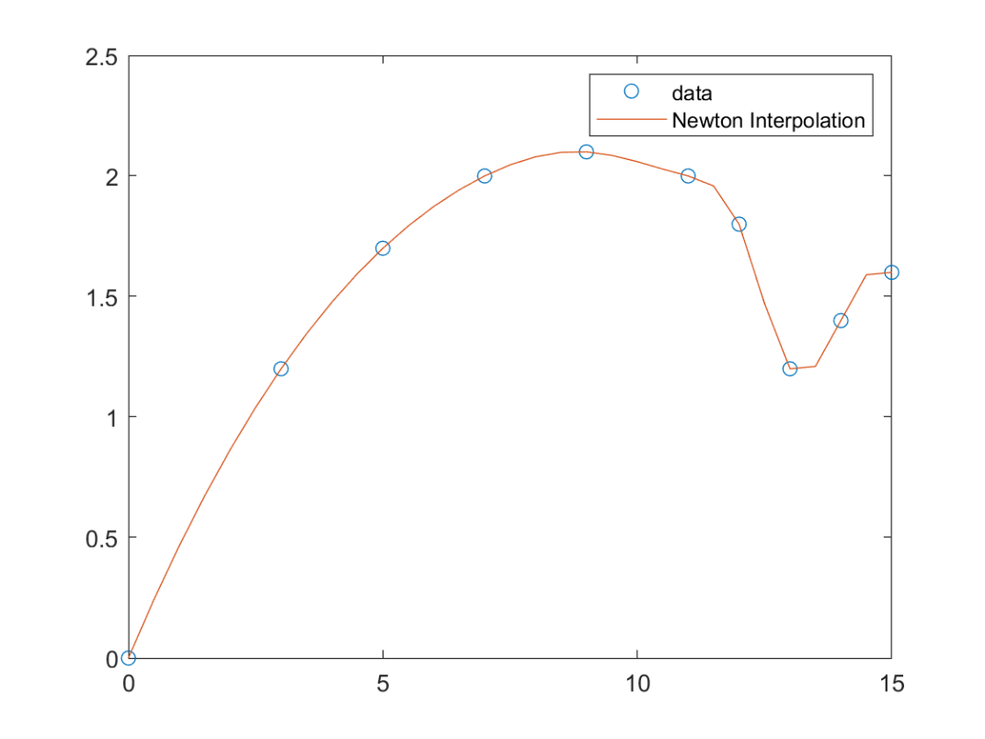

plot(x, y, 'o', xi, y3, '-')

legend({'data', 'Spline'})

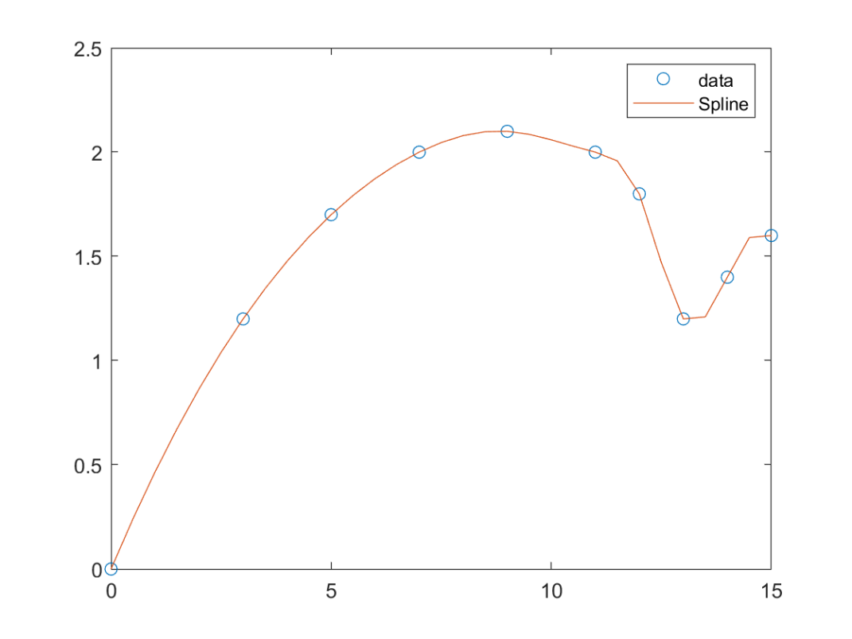

## 此实时脚本中使用的函数：

%{

Solve f(point) using the methods of Lagrange Interpolation

@Title: lagrangeInterpolation

@param x double 1d array, corresponding to the x-lable of knowing points

in the function's plots

@param y double 1d array, corresponding to the y-lable o knowing points

in the function's plots

@param point double the x-lable of the point you want to solve

@return double

%}

function res = lagrangeInterpolation(x, y, point)

res = 0;

n = length(x);

for i=1:n

xp = x([1:i-1 i+1:n]);

res = res + y(i)*prod((point-xp)/(x(i)-xp));

end

end

%{

Solve f(point) using the methods of Newton Interpolation

@Title: newtonInterpolation

@param x double 1d array, corresponding to the x-lable of knowing points

in the function's plots

@param y double 1d array, corresponding to the y-lable o knowing points

in the function's plots

@param point double the x-lable of the point you want to solve

@return double

%}

function res = newtonInterpolation(x, y, point)

n = length(x);

f = zeros(n,n);

% Assign values to the first column of the difference quotient table

for k = 1:n

f(k) = y(k);

end

% Solve the difference quotient table

for i = 2:n % The difference quotient table starts from order 0; but the matrix is stored from dimension 1

for k = i:n

f(k,i) = (f(k,i-1)-f(k-1,i-1))/(x(k)-x(k+1-i));

end

end

% Solve the Newton Interpolation Formular

p=0;

for k=2:n

t=1;

for j=1:k-1

t=t*(point-x(j));

end

p=f(k,k)*t+p;

end

p = f(1,1) + p;

res = p;

end

function output = mySpline(x,y,xq)

%SPLINE Cubic spline data interpolation.

% YQ = MYSPLINE(X,Y,XQ) performs cubic spline interpolation using the

% values Y at sample points X to find interpolated values YQ at the query

% points XQ.

% - X must be a vector.

% - If Y is a vector, Y(j) is the value at X(j).

% - If Y is a matrix or n-D array, Y(:,...,:,j) is the value at X(j).

%

% SPLINE chooses slopes at X(j) such that YQ has a continuous second

% derivative. Thus, SPLINE produces smooth results.

%

% Ordinarily, SPLINE uses not-a-knot conditions for the end slopes at

% X(1) and X(end). However, if Y contains two more values than X has

% entries, then the first and last value in Y are used as the end slopes.

%

% PP = SPLINE(X,Y) returns the piecewise polynomial form PP of the

% interpolant. You can use PP as an input to PPVAL or UNMKPP.

%

% Example: Interpolate a sine-like curve over a finer mesh

%

% x = 0:10;

% y = sin(x);

% xq = 0:.25:10;

% yq = mySpline(x,y,xq);

% figure

% plot(x,y,'o',xq,yq)

%

% Example: Perform spline interpolation with prescribed end slopes.

% Set the slopes to zero at the end points of the interpolant.

%

% x = -4:4;

% y = [0 .15 1.12 2.36 2.36 1.46 .49 .06 0];

% cs = mySpline(x,[0 y 0]);

% xq = linspace(-4,4,101);

% figure

% plot(x,y,'o',xq,ppval(cs,xq));

% Check and adjust input data

[x,y,sizey,endslopes] = chckxywp(x,y);

n = length(x);

yd = prod(sizey);

% Generate the cubic spline interpolant in ppform

dd = ones(yd,1);

dx = diff(x);

divdif = diff(y,[],2)./dx(dd,:);

if n == 2

if isempty(endslopes)

% the interpolant is a straight line

pp = mkpp(x,[divdif y(:,1)],sizey);

else

% the interpolant is the cubic Hermite polynomial

pp = pwch(x,y,endslopes,dx,divdif);

pp.dim = sizey;

end

elseif n == 3 && isempty(endslopes)

% the interpolant is a parabola

y(:,2:3) = divdif;

y(:,3) = diff(divdif')'/(x(3)-x(1));

y(:,2) = y(:,2)-y(:,3)*dx(1);

pp = mkpp(x([1,3]),y(:,[3 2 1]),sizey);

else

% set up the sparse, tridiagonal, linear system b = ?*c for the slopes

b = zeros(yd,n);

b(:,2:n-1) = 3*(dx(dd,2:n-1).*divdif(:,1:n-2)+dx(dd,1:n-2).*divdif(:,2:n-1));

if isempty(endslopes)

x31 = x(3)-x(1);

xn = x(n)-x(n-2);

b(:,1) = ((dx(1)+2*x31)*dx(2)*divdif(:,1)+dx(1)^2*divdif(:,2))/x31;

b(:,n) = (dx(n-1)^2*divdif(:,n-2)+(2*xn+dx(n-1))*dx(n-2)*divdif(:,n-1))/xn;

else

x31 = 0;

xn = 0;

b(:,[1 n]) = dx(dd,[2 n-2]).*endslopes;

end

dxt = dx(:);

c = spdiags([ [x31;dxt(1:n-2);0] ...

[dxt(2);2*(dxt(2:n-1)+dxt(1:n-2));dxt(n-2)] ...

[0;dxt(2:n-1);xn] ],[-1 0 1],n,n);

% sparse linear equation solution for the slopes

mmdflag = spparms('autommd');

spparms('autommd',0);

s = b/c;

spparms('autommd',mmdflag);

% construct piecewise cubic Hermite interpolant

% to values and computed slopes

pp = pwch(x,y,s,dx,divdif);

pp.dim = sizey;

end

if nargin == 2

output = pp;

else

output = ppval(pp,xq);

end

end

# 实验小结

通过此次实验，加深了对各种插值算法的理解，熟悉使用了不同类型的插值函数，并编程实现对机翼断面下轮廓线的插值仿真和数值分析