**南昌航空大学**

**20学年—21学年第 2 学期 医疗软件技术基础 大作业**

专业名称： 生物医学工程 实验学时： 2

学号：18084124 姓名： 杨振宇

大作业题目： WEB数据库编程

大作业环境： VS2017

大作业目的：

1．掌握ADO.NET数据库操作组件；

2．掌握三层网络数据库构架；

3. 掌握CASE工具开发。

4. 开发一个能通过病人信息进行开药的网站后端。

实验内容：

（1）通过powderdesign设计数据库和实体类；

（2）分别建立表示层、业务逻辑层和数据访问层；

（3）实现数据的添加、删除、修改、查询操作；

实验要求：

1. **详细说明数据库和实体类设计。**

本实验老师已提供了access的数据库与对应的实体类。

1. **画出网站结构图。**

**1.登录界面**

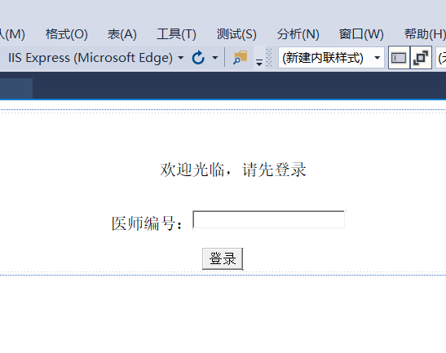

1. **医生界面**

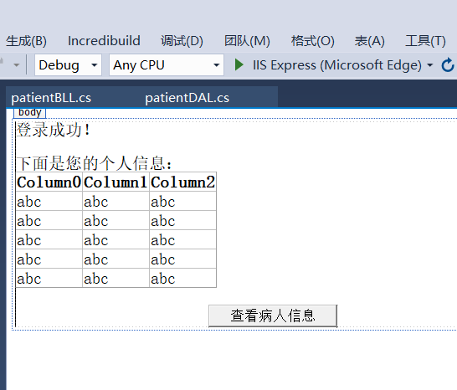

1. **病人界面**

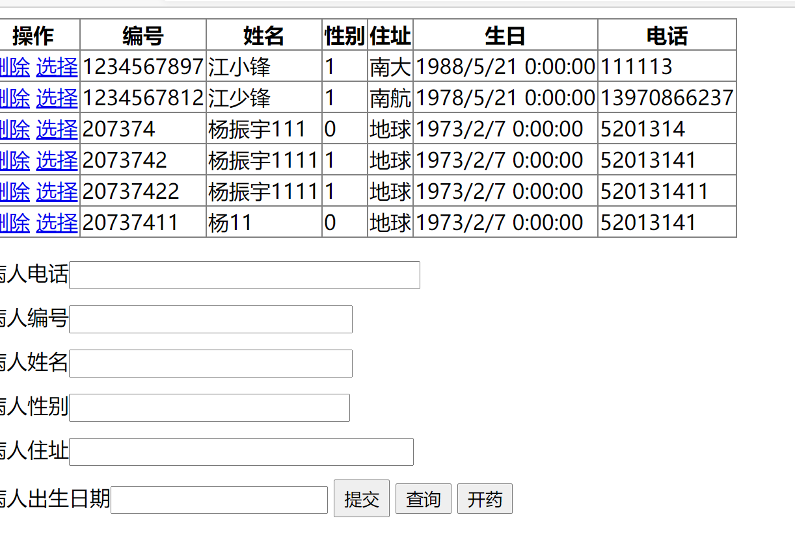

1. **开药界面**

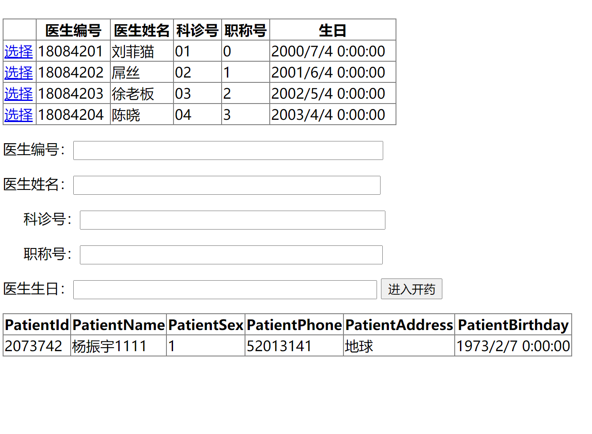

1. **画出操作界面及说明。**

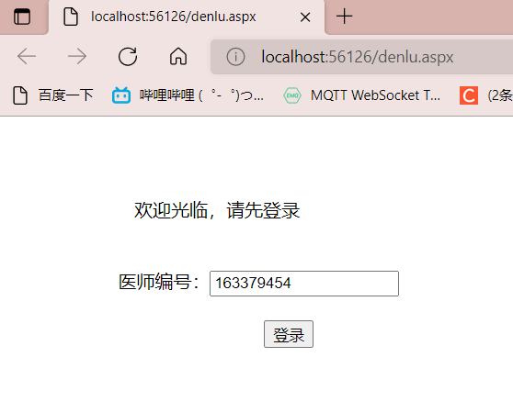

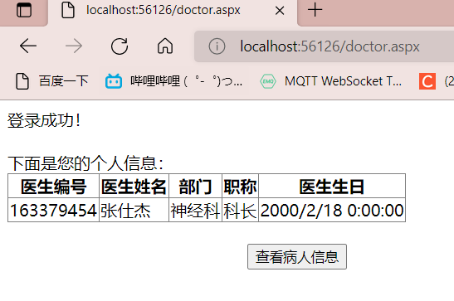

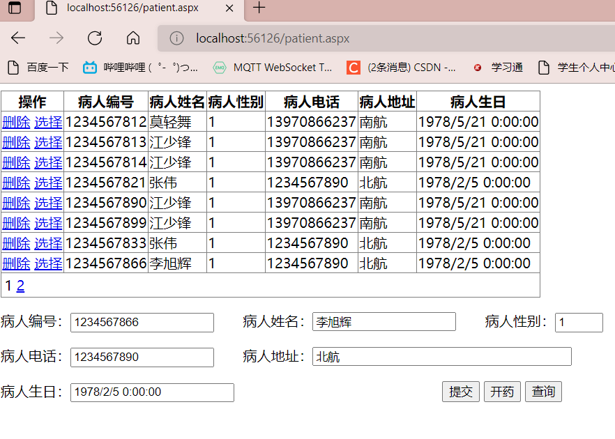

操作栏中删除可实现删除功能，选择可实现查询功能，并将查询结果显示到下面文本框中。

提交键用于修改操作，可更新表中数据。

开药键可跳转至开药界面，并将选中的病人信息保存至开药界面。

查询键可通过文本框中的关键字将病人信息查询出来。

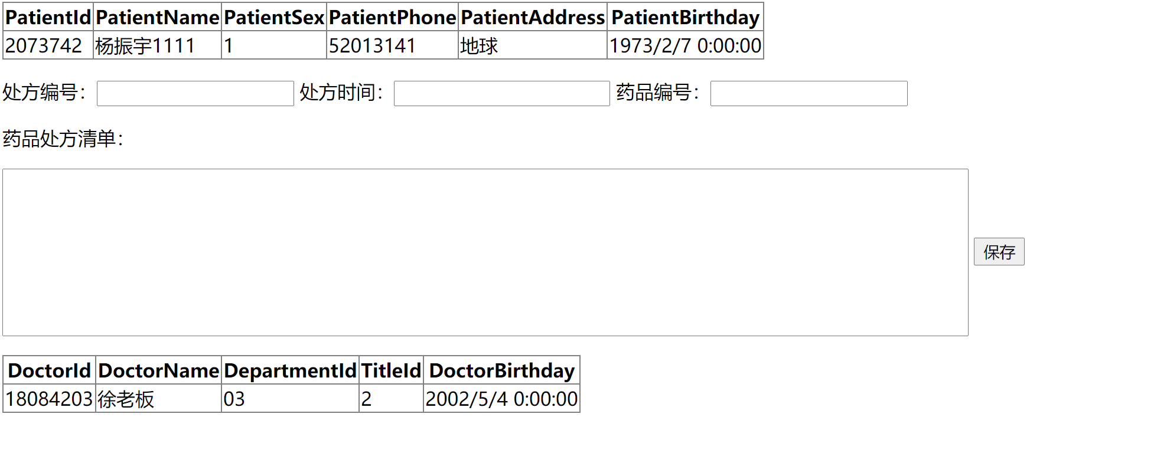

1. **给出代码和注释。**

**病人信息的代码**

**1.UI界面**

using BLL;

using System;

using System.Collections.Generic;

using System.Data;

using System.Linq;

using System.Web;

using System.Web.UI;

using System.Web.UI.WebControls;

public partial class patient : System.Web.UI.Page

{

protected void Page_Load(object sender, EventArgs e)

{

BindPatient();

}

private void BindPatient()

{

PatientBLL pb = new PatientBLL();

DataSet ds = new DataSet();

ds = pb.ListallPatient();

this.GridView1.DataSource = ds;

this.GridView1.DataBind();

}

protected void GridView1_SelectedIndexChanging(object sender, GridViewSelectEventArgs e)

{

string id = GridView1.DataKeys[e.NewSelectedIndex].Value.ToString().Trim();

PatientBLL pbll = new PatientBLL();

DataSet ds = new DataSet();

ds = pbll.getPatientbyId(id);

DataTable dt = ds.Tables[0];

DataRow dr = dt.Rows[0];

this.TextBox1.Text = dr[0].ToString().Trim();

this.TextBox2.Text = dr[1].ToString().Trim();

this.TextBox3.Text = dr[2].ToString().Trim();

this.TextBox4.Text = dr[3].ToString().Trim();

this.TextBox5.Text = dr[4].ToString().Trim();

this.TextBox6.Text = dr[5].ToString().Trim();

}

protected void Button1_Click(object sender, EventArgs e)

{

Patient pt = new Patient();

pt.patientId = this.TextBox1.Text.Trim();

pt.patientName = this.TextBox2.Text.Trim();

pt.patientSex = this.TextBox3.Text.Trim();

pt.patientPhone = this.TextBox4.Text.Trim();

pt.patientAddress = this.TextBox5.Text.Trim();

pt.patientBirthday = Convert.ToDateTime(this.TextBox6.Text.Trim());

PatientBLL ptbll = new PatientBLL();

int n = ptbll.PatientIsIn(pt.patientId);

if (n >0)

ptbll.modifypatientID(pt);

else

ptbll.insertbypatientID(pt);

BindPatient();

}

protected void GridView1_RowDeleting(object sender, GridViewDeleteEventArgs e)

{

string id = GridView1.DataKeys[e.RowIndex].Value.ToString().Trim();

PatientBLL pb = new PatientBLL();

pb.removePatientbyId(id);

BindPatient();

}

public void Button2_Click(object sender, EventArgs e)

{

Session["Pid"] = this.TextBox1.Text.Trim();

//Session["Did"] = "0123456789";

Response.Redirect("kaiyao.aspx", true);

}

protected void Button3_Click(object sender, EventArgs e)

{

Patient pt = new Patient();

pt.patientId = this.TextBox1.Text.Trim();

pt.patientName = this.TextBox2.Text.Trim();

pt.patientSex = this.TextBox3.Text.Trim();

pt.patientPhone = this.TextBox4.Text.Trim();

pt.patientAddress = this.TextBox5.Text.Trim();

PatientBLL pb = new PatientBLL();

DataSet ds = new DataSet();

ds = pb.QueryPatient(pt);

this.GridView1.DataSource = ds;

this.GridView1.DataBind();

}

protected void GridView1_PageIndexChanging(object sender, GridViewPageEventArgs e)

{

GridView1.PageIndex = e.NewPageIndex;

BindPatient();

}

}

1. **BLL**

using patientDAL;

using System;

using System.Collections.Generic;

using System.Data;

using System.Linq;

using System.Text;

namespace BLL

{

public class PatientBLL

{

public DataSet ListallPatient()

{

PatientDAL da = new PatientDAL();

DataSet ds = new DataSet();

ds = da.GetallPatient();

return ds;

}

public void removePatientbyId(string id)

{

PatientDAL da = new PatientDAL();

da.deletepatientbyID(id);

}

public DataSet getPatientbyId(string id)

{

PatientDAL da = new PatientDAL();

DataSet ds = new DataSet();

ds = da.getpatientbyID(id);

return ds;

}

public void modifypatientID(Patient pt)

{

PatientDAL da = new PatientDAL();

da.updatebypatientID(pt);

}

public void insertbypatientID(Patient pt)

{

PatientDAL da = new PatientDAL();

da.insertbypatientID(pt);

}

public DataSet QueryPatient(Patient pt)

{

PatientDAL da = new PatientDAL();

String sqlstr = "select PatientId as 病人编号,PatientName as 病人姓名,PatientSex as 病人性别,PatientPhone as 病人电话,PatientAddress as 病人地址,PatientBirthday as 病人生日 from Patient where ";

int n = 0;

if(pt.patientId.Length > 0)

{

if (n > 0)

sqlstr = sqlstr + " and ";

sqlstr = sqlstr + "PatientId=" + "'" + pt.patientId + "'";

n = n + 1;

}

if (pt.patientName.Length > 0)

{

if (n > 0)

sqlstr = sqlstr + " and ";

sqlstr = sqlstr + "PatientName=" + "'" + pt.patientName + "'";

n = n + 1;

}

if (pt.patientSex.Length > 0)

{

if (n > 0)

sqlstr = sqlstr + " and ";

sqlstr = sqlstr + "PatientSex=" + "'" + pt.patientSex + "'";

n = n + 1;

}

if (pt.patientPhone.Length > 0)

{

if (n > 0)

sqlstr = sqlstr + " and ";

sqlstr = sqlstr + "PatientPhone=" + "'" + pt.patientPhone + "'";

n = n + 1;

}

if (pt.patientAddress.Length > 0)

{

if (n > 0)

sqlstr = sqlstr + " and ";

sqlstr = sqlstr + "PatientAddress=" + "'" + pt.patientAddress + "'";

n = n + 1;

}

if(n == 0)

sqlstr = "select PatientId as 病人编号,PatientName as 病人姓名,PatientSex as 病人性别,PatientPhone as 病人电话,PatientAddress as 病人地址,PatientBirthday as 病人生日 from Patient ";

return da.GetPatientByInfomation(sqlstr);

}

public int PatientIsIn(String id)

{

PatientDAL da = new PatientDAL();

int n = da.PatientIsIn(id);

return n;

}

}

}

1. **DAL**

using System;

using System.Collections.Generic;

using System.Data;

using System.Data.OleDb;

using System.Linq;

using System.Text;

namespace patientDAL

{

public class PatientDAL

{

public DataSet GetallPatient()

{

OleDbConnection connection = new OleDbConnection();

connection.ConnectionString = "Provider=Microsoft.Jet.OLEDB.4.0;Data Source=C:\\Users\\ZSJ\\Desktop\\数据结构\\大作业\\myweb\\myweb\\HIS.mdb;User Id=admin;Password=;";

connection.Open();

OleDbCommand selectCommand = new OleDbCommand();

selectCommand.CommandType = System.Data.CommandType.Text;

selectCommand.CommandText = "select PatientId as 病人编号,PatientName as 病人姓名,PatientSex as 病人性别,PatientPhone as 病人电话,PatientAddress as 病人地址,PatientBirthday as 病人生日 from Patient ";

DataSet ds = new DataSet();

OleDbDataAdapter ad = new OleDbDataAdapter();

ad.SelectCommand = selectCommand;

ad.SelectCommand.Connection = connection;

ad.Fill(ds);

connection.Close();

return ds;

}

public void deletepatientbyID(string id)

{

OleDbConnection connection = new OleDbConnection();

connection.ConnectionString = "Provider=Microsoft.Jet.OLEDB.4.0;Data Source=C:\\Users\\ZSJ\\Desktop\\数据结构\\大作业\\myweb\\myweb\\HIS.mdb;User Id=admin;Password=;";

connection.Open();

OleDbCommand deleteComm = new OleDbCommand();

deleteComm.Connection = connection;

deleteComm.CommandType = CommandType.Text;

deleteComm.CommandText = "delete from Patient where PatientId=@Pid";

deleteComm.Parameters.Add("Pid", OleDbType.Char, 10);

deleteComm.Parameters[0].Value = id;

deleteComm.ExecuteNonQuery();

connection.Close();

}

public DataSet getpatientbyID(string id)

{

OleDbConnection conn = new OleDbConnection();

conn.ConnectionString = "Provider=Microsoft.Jet.OLEDB.4.0;Data Source=C:\\Users\\ZSJ\\Desktop\\数据结构\\大作业\\myweb\\myweb\\HIS.mdb;User Id=admin;Password=";

conn.Open();

OleDbCommand selectComm = new OleDbCommand();

selectComm.Connection = conn;

selectComm.CommandType = CommandType.Text;

selectComm.CommandText = "select PatientId as 病人编号,PatientName as 病人姓名,PatientSex as 病人性别,PatientPhone as 病人电话,PatientAddress as 病人地址,PatientBirthday as 病人生日 from Patient where PatientId=@Pid";

selectComm.Parameters.Add("Pid", OleDbType.Char, 10);

selectComm.Parameters[0].Value = id;

OleDbDataAdapter ad = new OleDbDataAdapter();

ad.SelectCommand = selectComm;

DataSet ds = new DataSet();

ad.Fill(ds);

conn.Close();

return ds;

}

public void updatebypatientID(Patient pt)

{

OleDbConnection conn = new OleDbConnection();

conn.ConnectionString = "Provider=Microsoft.Jet.OLEDB.4.0;Data Source=C:\\Users\\ZSJ\\Desktop\\数据结构\\大作业\\myweb\\myweb\\HIS.mdb;User Id=admin;Password=";

conn.Open();

OleDbCommand updateComm = new OleDbCommand();

updateComm.Connection = conn;

updateComm.CommandType = CommandType.Text;

updateComm.CommandText = "update Patient set PatientName=@Pname,PatientSex=@Psex,PatientPhone=@Pphone,PatientAddress=@Paddress,PatientBirthday=@Pbirth where PatientId=@Pid";

updateComm.Parameters.Add("Pname", OleDbType.Char, 10);

updateComm.Parameters.Add("Psex", OleDbType.Char, 1);

updateComm.Parameters.Add("Paddress", OleDbType.Char, 20);

updateComm.Parameters.Add("Pphone", OleDbType.Char, 15);

updateComm.Parameters.Add("Pbirth", OleDbType.Date);

updateComm.Parameters.Add("Pid", OleDbType.Char, 10);

updateComm.Parameters[5].Value = pt.patientId;

updateComm.Parameters[0].Value = pt.patientName;

updateComm.Parameters[1].Value = pt.patientSex;

updateComm.Parameters[2].Value = pt.patientPhone;

updateComm.Parameters[3].Value = pt.patientAddress;

updateComm.Parameters[4].Value = pt.patientBirthday;

int i = updateComm.ExecuteNonQuery();

conn.Close();

}

public void insertbypatientID(Patient pt)

{

OleDbConnection conn = new OleDbConnection();

conn.ConnectionString = "Provider=Microsoft.Jet.OLEDB.4.0;Data Source=C:\\Users\\ZSJ\\Desktop\\数据结构\\大作业\\myweb\\myweb\\HIS.mdb;User Id=admin;Password=";

conn.Open();

OleDbCommand insertComm = new OleDbCommand();

insertComm.Connection = conn;

insertComm.CommandType = CommandType.Text;

insertComm.CommandText = "insert into Patient (PatientId,PatientName,PatientSex,PatientPhone,PatientAddress,PatientBirthday) values (@Pid,@Pname,@Psex,@Pphone,@Paddress,@Pbirth)";

insertComm.Parameters.Add("Pid", OleDbType.Char, 10);

insertComm.Parameters.Add("Pname", OleDbType.Char, 10);

insertComm.Parameters.Add("Psex", OleDbType.Char, 1);

insertComm.Parameters.Add("Paddress", OleDbType.Char, 20);

insertComm.Parameters.Add("Pphone", OleDbType.Char, 15);

insertComm.Parameters.Add("Pbirth", OleDbType.Date);

insertComm.Parameters[0].Value = pt.patientId;

insertComm.Parameters[1].Value = pt.patientName;

insertComm.Parameters[2].Value = pt.patientSex;

insertComm.Parameters[3].Value = pt.patientPhone;

insertComm.Parameters[4].Value = pt.patientAddress;

insertComm.Parameters[5].Value = pt.patientBirthday;

int i = insertComm.ExecuteNonQuery();

conn.Close();

}

public DataSet GetPatientByInfomation(String sqlstr)

{

OleDbConnection connection = new OleDbConnection();

connection.ConnectionString = "Provider=Microsoft.Jet.OLEDB.4.0;Data Source=C:\\Users\\ZSJ\\Desktop\\数据结构\\大作业\\myweb\\myweb\\HIS.mdb;User Id=admin;Password=;";

connection.Open();

OleDbCommand selectCommand = new OleDbCommand();

selectCommand.CommandType = System.Data.CommandType.Text;

selectCommand.CommandText = sqlstr;

DataSet ds = new DataSet();

OleDbDataAdapter ad = new OleDbDataAdapter();

ad.SelectCommand = selectCommand;

ad.SelectCommand.Connection = connection;

ad.Fill(ds);

connection.Close();

return ds;

}

public int PatientIsIn(String id)

{

OleDbConnection conn = new OleDbConnection();

conn.ConnectionString = "Provider=Microsoft.Jet.OLEDB.4.0;Data Source=C:\\Users\\ZSJ\\Desktop\\数据结构\\大作业\\myweb\\myweb\\HIS.mdb;User Id=admin;Password=";

conn.Open();

OleDbCommand selectComm = new OleDbCommand();

selectComm.Connection = conn;

selectComm.CommandType = CommandType.Text;

selectComm.CommandText = "select count(1) from Patient where PatientId=@Pid";

selectComm.Parameters.Add("Pid", OleDbType.Char, 10);

selectComm.Parameters[0].Value = id;

int n = Convert.ToInt32( selectComm.ExecuteScalar() );

conn.Close();

return n;

}

}

}

**其他界面（登录，医生，开药）的设计与功能实现与病人界面的类似，通过将代码进行一些修改便可实现。**

1. **实验小结**

通过本次大作业，我通过vs2019分别建立了表示层、业务逻辑层和数据访问层，实现了数据的添加、删除、修改、查询操作，掌握了.NET数据库操作组件，成功建立了一个简陋的开药网页，本次实验我学到了很多