**Setting-up the Environment**

**1. Setup Anaconda**

If you don’t already have anaconda installed on your device, please head to <https://www.anaconda.com/products/individual> to download it. During the installation process make sure you don’t add anaconda to path & you install only for the current user, flow the rest of instructions as is.

**2. Setup VSCode [IDE]**

Download and install Visual Studio Code. (Not to be confused with Visual Studio) <https://code.visualstudio.com/download>

After Installation head over to extensions on the left menu and search and install the following packages:

* Python
* Bracket Pair Colorizer 2
* Material Icon Theme
* Prettier

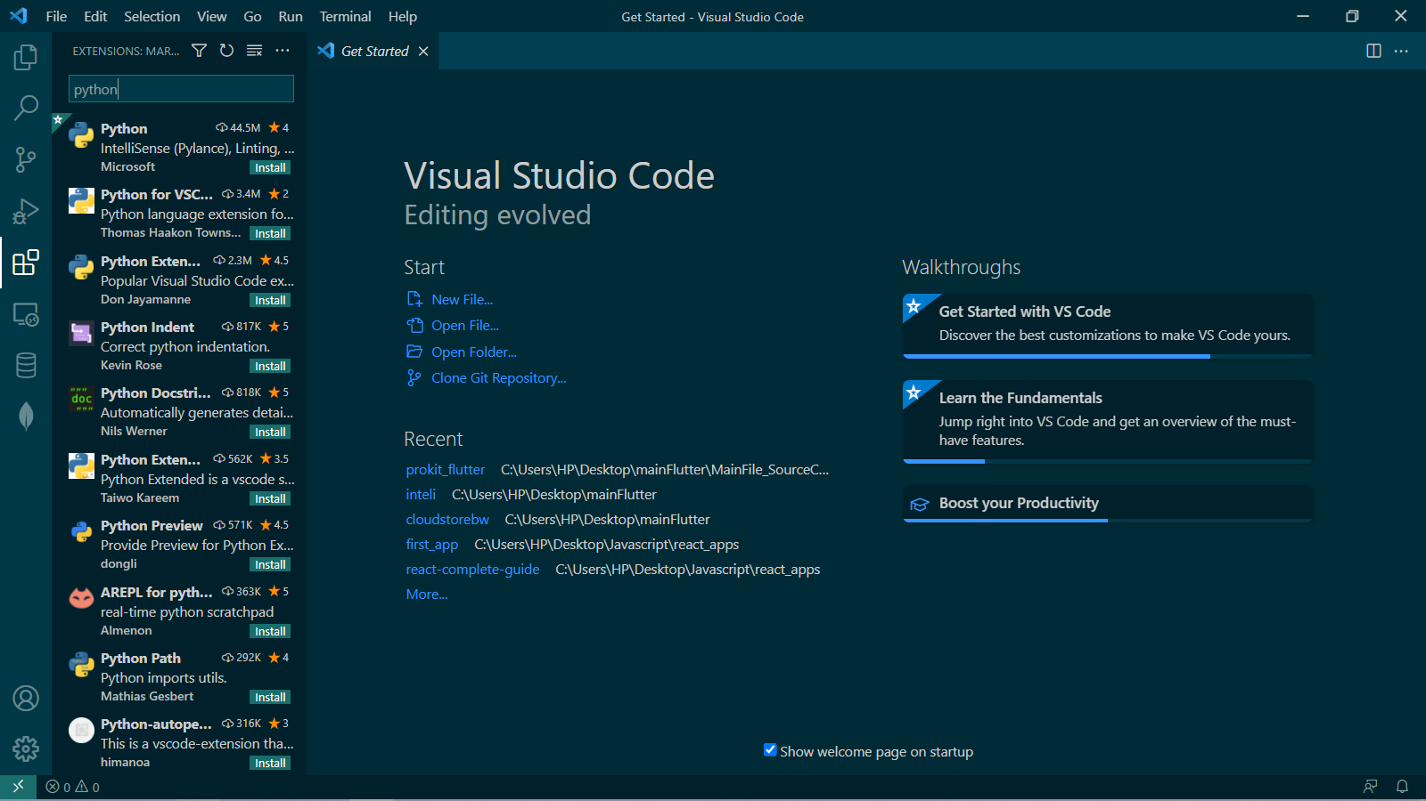

**3. Create Virtual** **Environment**

Open Anaconda Prompt from windows start.

Use the following command to create a new Virtual Environment.

conda create --name [environment name] [python version]

example:

conda create --name venv_deploy python=3.8

Use the following command to activate the environment.

conda activate venv_deploy

**4. Install Dependencies.**

Navigate to this directory where requirements.txt is located using cd command and run the following command to install dependencies.

Pip install -r requirements.txt