From: Arnold Lee
To: Mr. Sparks
Date: May 25th, 2009
Re: Analysis of census data and proposal of survey questions on U.S. demographics

This memo is in response to your request for an analysis on the U.S. census data, and a proposal of question that should be used on the survey that we believe it can provide an accurate modeling of U.S. demographics.

Results of our investigations yields the following variables that U.S distinguishes itself demographically:

- Affluence & Education history
- Household size and the structure of the building they lived in
- Household median age
- Median house price
- Ethnicity

In order for us to generate the indicators above from the census data, we use a technique called “Factor Analysis”.

Factor analysis is a technique for reducing a large number of variables down to a much smaller number of ‘themes’ or factors. We executed factor analysis on a file of Zip code demographic data. The table on Page 2 (Figure 1) shows the five final factors selected and the key questions related to each factor.

The numbers on the table indicate how strongly the question is related to the factor. These numbers range from -100% to 100%. Numbers that are closer to 100% indicates positive association with the factor. Numbers that are closer to -100% indicates inverse association with the factor. Values above -60% and values below 60% are discarded as these values are considered to be weak or no association at all.

A detailed analysis regarding each factor, as well as the rationale behind the selection of sample questions are located in page 3 and onward.

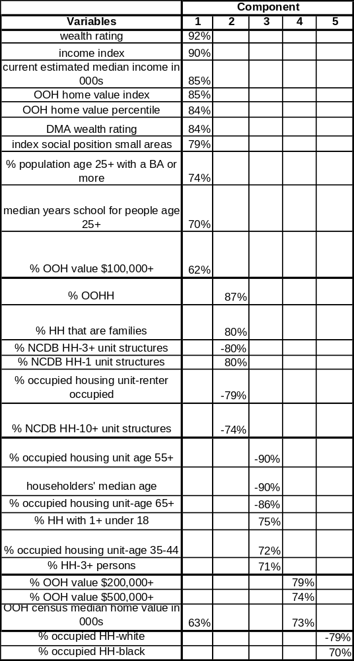

Figure 1. Detail Results from Factor Analysis of U.S. Census Data

Factor I: Affluence and Education History

Partial output of Figure 1 related to the first factor is located below. Note that these indicators with a strong association ‘rating’ are linked to the wealth and the social position, as well as the education background of the individual. Therefore for this factor, we will label it as “Affluence”.

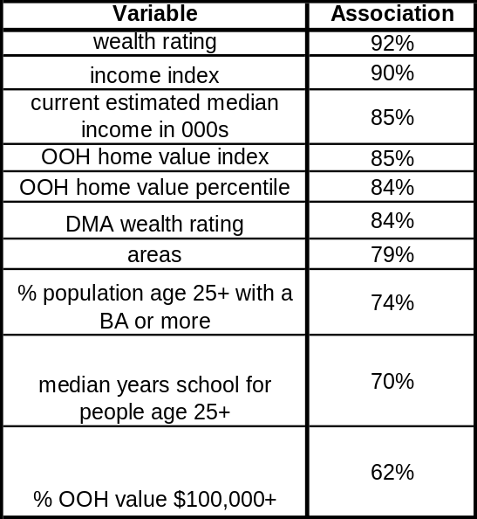

Figure 2. Partial table related to Affluence and Education indicators

Factor II: Household size and Structure

The association rating related with the second factor is given in the table below. These Indicators related to size of the household, as well as the number of units in the structure where the individual resides.

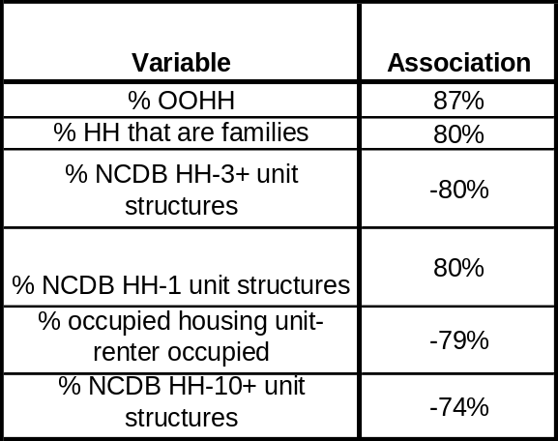

Figure 3. Partial table related to Household size and Structure indicators

Note the strong negative correlation on unit size and whether the unit is occupied by a renter or by an owner. This indicates that the higher number of unit the structure has, the less likely that the occupant has a family, and less likely to be affluent.

Factor III: Household median age

The association rating related with the third factor is given in the table below.

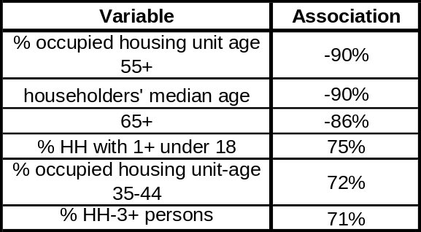

Figure 4. Partial table related to Household median age indicators

Factor IV: Median House Price

The association rating related with the fourth factor is given in the table below.

Figure 5. Partial table related to Median house price indicators

Note that there is also association between Factor I (Affluence) and median house price.

Factor V: Ethnicity

The association rating related with the fifth factor is given in the table below.

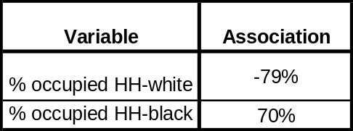

Figure 6. Partial table related to ethnicity indicators

Summary:

As presented in the preceding analysis, the five major indicators that the U.S distinguishes itself demographically are:

- Affluence & Education history
- Household size and the structure of the building they lived in
- Household median age
- Median house price
- Ethnicity

Based on these indicators, here are the potential questions we can use in the survey:

- Your highest level of education
- Your Age
- Number of family members
- Number of rooms your house have
- Number of minors in your household (defined as less than 18 years of age)
- Number of seniors in your household (defined as less than 55 years of age)

Note that we should avoid asking for household value and ethnicity because these are generally considered ‘sensitive’ questions and there is a high chance that the survey respondent will be providing false data.

The appendix to this document contains a discussion of data preparation and statistical steps that were used as part of the analysis.

Appendix I: Technical details

This appendix discusses the technical issues relevant to the factor analysis that were being used in this memo.

The input of the analysis is based on a data table from the census. This table contains 34,297 rows, each row represent a zip code. Each row contains 38 columns; with 32 of them are quantitative variables.

To properly analyze the table given before performing factor analysis, the data must be properly “cleaned up”. The following are the tactics we have used to achieve this purpose:
- There are 781 rows that have at least missing one of the seven major variables (INCMINDX, PERPERHH, MEDSCHYR, ISPSA, HHMEDAGE, CEMI, POPULAT). This contributes 2.27% of the total number of records.
- Rather than ignoring the variable entirely, due to the small percentage of data with missing values, we replace it with the mean value of the variable. This will affect only the records with the missing data, and not with all the records.
- All variables are standardized to a mean of zero and standard deviation of one.

The technical decisions regarding to the factor analysis itself are:
- We only retain factors with an eigenvalue of greater than one, which means that we select only the factors that contribute 3.125% of the variance or more. (There are 32 quantitative variables, and 1/32 = 3.125%.)
- The Varimax method with Kaiser Normalization is employed to maximize the variability and simplify the interpretation of the factors. This method is an orthogonal rotation method that minimizes the number of variables that have high loadings on each factor.
- We did not display association values between -60% to 60% as these are within one SD and may indicate weak or no correlation between factors.

- From the Initial factor analysis, with the restriction of retaining only factors with an eigenvalue of greater than one, it results in the following figure:

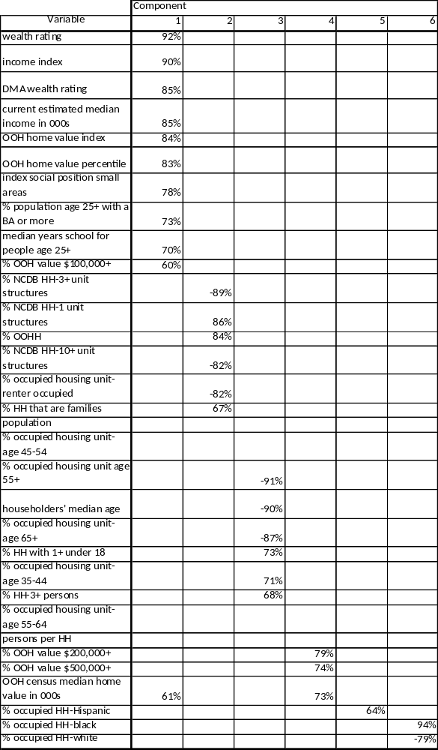

Note that for the last three rows, the type of the variable is the same (ethnicity) and there are no other values for factor component #6, therefore component #5 and #6 can be combined, which result in Figure I.

