From: Arnold Lee
To: Mr. Sparks
Date: May 22nd, 2009
Re: Major demographic segments in America

This memo is in response for your request for an analysis on the U.S. census data, and to identify the major demographic segments in America based on the data available.

Based on the analysis, we have identified six segments, or clusters, as listed below:
- Cluster #1: Upper Middle class with a single house
- Cluster #2: Well off with a expensive house
- Cluster #3: New college graduate
- Cluster #4: Poor Minority families
- Cluster #5: Senior citizens
- Cluster #6: Below average income families

For us to generate the above results, we employed a method called “cluster analysis”. Cluster analysis is used to segment each individual to a particular type. The following is the table produced from the cluster analysis.

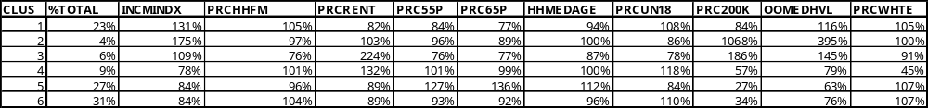

Figure 1. Detail Results from Cluster Analysis of U.S. Census zip code data

The ‘CLUS’ column stands for the cluster number, which represent each segment as listed above. The ‘% Total’ represents the percent of total population from that segment. For all columns from ‘INCMINDX’ to ‘PRCWHTE’, the percent value represents how much the raw value for that data deviates from the mean for that column. As a rule of thumb, a value below 100% means the raw value is below average, and above 100% means above average.

For example, for ‘INCMINDX’ (income index) in Cluster #2, the value is 175%. This means that for the individuals in that segment, the income is 175% of the average of the population.

The next few pages include details on how we identified the six segments based on Figure I.

Segment I: Upper Middle Class with single house

Partial output of Figure I is attached below.

The income index is 31% above the average, and has a slightly low ratio of renters. This implies that most of them live in single houses.

Segment II: Well off and live in expensive houses

This one is very apparent. Income index is 75% above average, and individuals who own a house that are valued $200K or more are 9 times more than the average. Also, there are 3 times more houses than average that has median value greater than $1 million.

Segment III: College Graduate / Newly wed

The percentage of people in this category has slightly above average income, but yet who still live in rental property. Also the amount of household in this category that have children under 18 years of age is only 78% of the average, but the median age of the household is only 87% of average. These suggest a new college graduate.

Segment IV: Poor Minority Families

This cluster represents the minorities because of the low “PRCWHTE” (Percent White) value. Also notice the income index is 22% below normal.

Segment V : Senior Citizens

This cluster has an above average of people that are 65 or older (PRC65P column). The median age is 12% above average.

Segment VI: Below average income families

This cluster contains people with below average income that are not minorities.

Summary:

Based on the preceding analysis, we have identified six segments, or clusters, as listed below:
- Cluster #1: Upper Middle class with a single house
- Cluster #2: Well off with a expensive house
- Cluster #3: New college graduate
- Cluster #4: Poor Minority families
- Cluster #5: Senior citizens
- Cluster #6: Below average income families

The appendix to this document contains technical details and in-depth discussion of the method we used to perform the analysis.

Technical Analysis:

This appendix discusses the technical issues relevant to the cluster analysis that were being used in this memo.

We used K-means clustering instead of hierarchal clustering due to the enormous size of the data. At the end of the clustering process, it yields the possible number of clusters (from 4 to 8 in this case) that were detected, along with the Pseudo-F statistic and the size of the smallest cluster for each choice of possible number of clusters.

To determine the appropriate number of clusters for this model, keep in mind the following principles:
- The segmentation with a larger pseudo F is generally considered better, the higher F value means that the segments are more tightly concentrated around their center
- The difference between the highest and the lowest F value within each number of clusters should be as low as possible. The lower the difference, the higher the stability.

The next two pages will describe the steps that were taken chronologically.

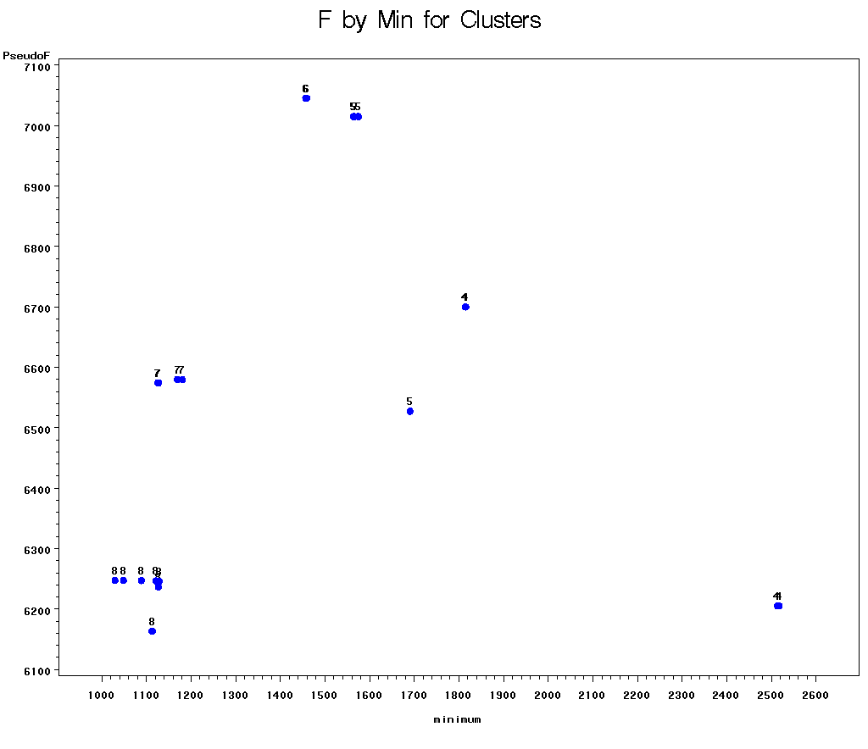
The above is the plot generated by our cluster analysis program. The number above the dots is the number of clusters, the X-axis is the size of the smallest cluster, and the Y-axis is the Pseudo-F score. In general, we want to have a group of dots that are generally tightly centered to each other (minimum variance within the group), and then the group should be closer to the left edge as possible (minimum variance across all cluster groups). If we ignore outliers, cluster 7 and 8 has a looser group than cluster 4, 5 and 6. Therefore, number 4, 5 and 6 are candidate for our choice for number of clusters / segments. Now we need to rely or another view of the data to make a decision on which one to choose.

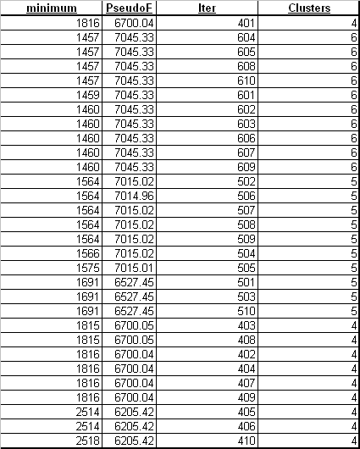

The ‘minimum’ column is the size of the smallest cluster, the ‘PseudoF’ is the Pseudo-F score, the ‘Iter’ represent the number of iteration in the program, and ‘Cluster’ is the number of clusters we choose. We select to show only dataset that has ‘Cluster’ value of 4,5 and 6 because we identified them as the potential candidate for the final number of segments, as indicated in the last page.

Since we want to have a cluster number that has larger Pseudo-F value, cluster number 6 will be a prime choice. Further more, there is virtually no difference in Pseudo-F value inside cluster number 6, while for other choice (4 and 5) there is some variation of Pseudo-F value within a cluster number. Besides, cluster #6 has a lower “minimum” value, indicate lower variance across all clusters.

