From: Arnold Lee
To: Mr. Sparks
Date: June 3rd, 2009
Re: Preferred target for our mailings

This memo is in response for your request for an model that allow us to cut our mailing quantities by 25% and still get a majority of positive responses.

Based on our analysis from past data, we have determined a model that allows us to cut 25% of the mailing to the people that we believe will be LEAST likely to respond, but yet we only lose 4% of the original revenue.

We have compiled the list of characteristics of a “prime” target customer that we believe will have the highest probability of our mailings getting responded:
- Target customer is a farmer
- Target customer is a renter (living on someone else’s property)
- Target customer comes from an affluent family, with average age less than 40
- Target customer is a senior with prestigious social status
- Target customer is a Protestant
- Target customer has a college degree
- Target customer has own 2 or more automobiles
- Target customer has contribution to private insurance
- Target customer has automobile insurance

Each target customer is ranked in our model with the criterion above. The more characteristics match the customer’s profile, the higher the ranking.

We have determined that even if we keep only the top 50% rank of the customers, we still retain about 84% of the revenue.

In the next section we will discuss how we determine the characteristics (“variables”) and its effect to our potential revenue.

Section I: Detail analysis of variables

In here we will briefly discuss the three major variables that account for majority of the influence in our model. For more information about the rest of the variables, along with the definition of the variable names, please see the technical appendix.

- Target Customer is a farmer

The most influential variable in our model is to determine whether the target customer is a farmer.

This is what we have found in our model:

Variable Estimate
MOSHOO_10 0.9318

The parameter name “MOSHOO_10” is a True/False variable that indicates if the target customer is farmer or not. The “estimate” is the probability increase of the response rate if the variable is true. Here, when the variable is true, which indicates that target customer is a farmer, the probability of response increases by 0.9318, or 93.18% then if the target is not a farmer.

- Target Customer is a renter

The second most influential variable in our model is to determine whether the target customer is renting a property.

Variable Estimate
MOSHOO_2 0.5668

Here, when the variable is “true”, which indicates that target customer is a renter, the probability of response increases by 0.5668, or 56.68% then if the target is not a renter.

- Target Customer comes from a young, affluent family

Variable Estimate
mostyp_12 0.9616

Here, when the variable is “true”, which indicates that target comes from an affluent family, the probability of response increases by 0.9616 or 96.16% then if the target is not affluent.

Section II: Response rate of mailings

Based on our model, the following graph describes the estimated response rate for the mailings:

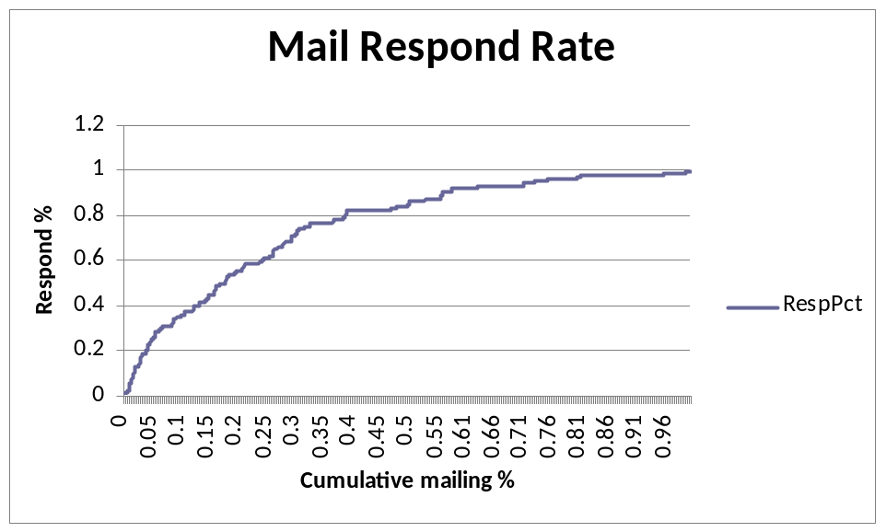

The cumulative mailing percentage represents the amount of our mailings; sort from the most preferred customers (highest ranking) to the least preferred. As you can see on the graph, the final 25% of the mailing (cumulative mailing between 75% to 100%) generates only 4% of the total response.

If we cut half of our mailings from the bottom ranks, we will still generate 84% of the original number of responses. In fact, under our model, the top 25% rank in the group will generate about 60% of the original revenue.

Section III: Summary

Based on our analysis, we rank our potential target customers with the following criteria, from the most influential to the least:
- Whether the target customer is a farmer
- Whether the target customer is a renter (living on someone else’s property)
- Whether the target customer comes from an affluent family, with average age less than 40
- Whether the target customer is a senior with prestigious social status
- Whether the target customer is a Protestant
- Whether the target customer has a college degree
- Whether the target customer has own 2 or more automobiles
- Whether the target customer has contribution to private insurance
- Whether the target customer has automobile insurance

After we made the ranking of the potential customer pool, based on our model, we determined that if you cut mailings for the lowest 25% rank customers, you will still retain 96.22% of the original revenue. If you restrict to only sending mail to the top half rank of the target customers pool, you will still retain about 83.13% of the original revenue.

The three appendix attached to this document contains a technical appendix, the variable description, and the complete listing of variable used for our model.

Appendix I: Technical Appendix

This section contains technical detail about our model selection as well as the method to determine the mailing response rate vs. number of mailings.

- Step I: Determine the right model for each varaible

There are 26 total independent variables in our data. We wish to estimate the behavior of “Response” and “RespHoldOut”, which are dependent variables and indication of whether a specific customer will respond to our mailings. To determine the independent variables that are most relevant, we used the Logistic regression technique. Logistic regression is a regression technique that is adjusted for the fact that the dependent variables are binary.

Before we apply the Logistic Regression, we must transform the variable so that it all becomes binary. For example if we have a variable with 10 possible response, we make a 10-slot array for this variable, each one will only take a Boolean value (True/False). By default, there should be only one “true” value in the array, because each slot represent a category or response, and they are all designed to be mutually exclusive.

In Appendix II, we have included the “data dictionary”, which provides the definition of the variable, among with the variable type and its domain. Most variable have domains other than binary, and it needs to be transformed. Those variables are listed as “L0”, “L1”, “L2”, “L3” and “L4” type. The definition of the type is also located in the end of Appendix II.

Obviously, for any type of regression technique, we need to find out the correct fit for each variable. Each variable are tested with linear, quadratic, cubic, inverse, square root and logarithmic relationships. Appendix III have a list of variables and the model used on the right most column. If the variable name ends in “sq” it is quadratic, “cu” is cubic, “inv” is inverse, “sqrt” is square root, and “log” is logarithmic.

When a variable is put into our SAS program to do the fitting, an model fit statistics report is generated similar to the one below:

Model Fit Statistics

Intercept
Intercept and
Criterion Only Covariates

AIC 1830.722 1832.490
SC 1837.020 1845.086
-2 Log L 1828.722 1828.490

Each variable, for example “MOOSHO_10”, will generate six model fit statistics output above, one each for linear, quadratic, cubic, inverse, square root and logarithmic models. We look for the one model with the lowest Schwartz Criterion score, in the row “SC” and column “Intercept and Covariates”. In the above example, the SC score is 1845.086, as listed in bold type

If the lowest SC score model is a quadratic, then both the quadratic and linear terms of the variable will be included in the final model. If the lowest SC score model is a cubic, then cubic, quadratic and linear terms will be included in the final model. If the lowest SC score is linear, inverse, square root or log, we just use the respective terms only.

- Step II: Create a final model

After all 26 independent variables are analyzed; we end up the table included in Appendix III. The right most columns indicate the variables and models with the lowest SC score. These entire variables then will feed in to the final model for an “ultimate fit” using logistic regression (PROC LOGISTIC procedure in SAS).

This is the output of the final fit:

The LOGISTIC Procedure

Summary of Stepwise Selection

Effect Number Score Wald Variable
Step Entered Removed DF In Chi-Square Chi-Square Pr > ChiSq Label

1 PPERSA2 1 1 86.7563 <.0001
2 PPERSA2sq 1 2 32.6925 <.0001
3 MHHUUR2sqrt 1 3 23.7473 <.0001
4 pwapar2sqrt 1 4 19.0869 <.0001
5 MAUT02 1 5 9.1758 0.0025
6 MOPLHO2sqrt 1 6 7.3970 0.0065
7 MGODPR2log 1 7 6.8282 0.0090
8 MOSHOO_10 1 8 5.0464 0.0247 MOSHOO_ 10
9 mostyp_3 1 9 4.4706 0.0345 mostyp_ 3
10 mostyp_12 1 10 4.0577 0.0440 mostyp_ 12
11 MOSHOO_2 1 11 4.8123 0.0283 MOSHOO_ 2

The variable that “survived” the PROC LOGISTIC are shown above, and this translate to the criteria that were mentioned at the very beginning of this memo. They were ordered from the smallest to the largest P-value (Pr > ChiSq column). Smaller P-Value indicates higher influence in our model.

The dropped variables have P-value greater than 0.05, which means that the SAS system believes that those variables will influence our model with LESS than 95% confidence, and therefore they are removed.

Once we chosen the variables that have major influence in our model, we look at the second part of the PROC LOGISTIC output:

Analysis of Maximum Likelihood Estimates

Standard Wald
Parameter DF Estimate Error Chi-Square Pr > ChiSq

Intercept 1 -4.9721 0.4932 101.6241 <.0001
MGODPR2log 1 0.2604 0.1129 5.3143 0.0212
MOPLHO2sqrt 1 0.0714 0.0279 6.5735 0.0104
MAUT02 1 -0.0140 0.00475 8.6519 0.0033
pwapar2sqrt 1 0.0706 0.0163 18.7813 <.0001
PPERSA2 1 0.000850 0.000174 23.8697 <.0001
PPERSA2sq 1 -1.29E-7 5.069E-8 6.4504 0.0111
MOSHOO_2 1 0.5668 0.2060 7.5741 0.0059
MOSHOO_10 1 0.9318 0.2148 7.2893 0.0141
mostyp_3 1 0.7000 0.2604 7.2273 0.0072
mostyp_12 1 0.9616 0.3756 6.5558 0.0105

The “Estimate” column is the regression coefficient for that variable. What it represents is the probability increase if that variable is “true”. For MOSHOO_10, the coefficient is 0.9318, indicated that if the customer is a farmer, the probability of response increase by 93.18%. If, let say both MOSHOO_10 and MGODPR2log are “true”, meaning that the customer is both farmer AND Protestant, the probability that he will response to our mailings increase by (93.18 + 26.04 = 119.22 %), compare to customers that are in NEITHER of both categories.

- Step III: Determine the response rate for different quartile of customers

Our SAS program will generate a table, called “RespAnal”, which can be used in Microsoft Excel to make a chart, the one that was displayed in Section II. To determine the answer of how much revenue is retained after cutting the lowest quartile of customers, instead of “eye-balling” the graph, we can use the SAS code below:

data cutpoint;
set RespAnal;
lagCountPct=lag(CountPct);
if CountPct ge .75 and lagCountPct lt .75 then output;
run;

This code is to print out the respective data for very first item that exceeds 75% of the count. The output is below:

Resp Count lag
Obs Holdout reccount cumcount cumresp RespPct Pct CountPct

1 0 1 1355 102 0.96226 0.75028 0.74972

So, after 75.028% of the customers are counted (indicated in the “Pct” column, we already have 96.226% of the responses (indicated in the “RespPct” column). This implies that for the remaining 25% of the customers, it will bring only 3.8% of the responses; therefore mailings to these people are considered inefficient and should be cut.

The output below show the result for cutting 50% of the mailings:

Resp Count lag
Obs Holdout reccount cumcount cumresp RespPct Pct CountPct

1 0 1 903 89 0.83962 0.5 0.49945

Cutting half of our mailings reduce our revenue by 16%.

If we just target our mailings to the top quartile ranked customer:

Resp Count lag
Obs Holdout reccount cumcount cumresp RespPct Pct CountPct

1 0 1 452 65 0.61321 0.25028 0.24972

We still retain 61.32% of our original revenue.

