From: Arnold Lee
To: Mr. Sparks
Date: June 3rd, 2009
Re: Preferred target for our mailings

This memo is in response for your request for a model that allow us to cut our mailing quantities by 25% and still get a majority of positive responses.

Based on our analysis from past data, we have determined a model that allows us to cut 25% of the mailing to the people that we believe will be LEAST likely to respond, but yet we only lose 5.5% of the original responses. Also, we have determined that even if we keep only the top 50% rank of the customers, we still retain about 84% of the responses.

We have compiled the list of characteristics of a “prime” target customer that we believe will have the highest probability of our mailings getting responded:
- Target customer is NOT a farmer
- Target customer comes from an affluent family, with average age less than 40
- Target customer is a senior with prestigious social status
- Target customer has least amount of property
- Target customer is a renter (living on someone else’s property)
- Target customer is a Protestant
- Target customer has a college degree
- Target customer has own 2 or more automobiles
- Target customer has contribution to private insurance
- Target customer has automobile insurance

Each target customer is ranked in our model with the criterion above. The more characteristics match the customer’s profile, the higher the ranking.

In the next section we will discuss how we determine the characteristics (“variables”) and its effect to our potential responses.

Section I: Detail analysis of variables

In here we will briefly discuss the three major variables that account for majority of the influence in our model.

In the following table, there are two columns. The “variable” column represents the characteristics listed in the previous page; the “probability” column is the probability of the mailings getting responded, if the variable is true. If the probability is negative, having these characteristics will decrease your chance for your mail to get responded. If the probability is positive, you have an increased chance for getting your mail responded. To see how these probability values are generated, please see the technical appendix.

: 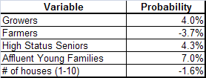

For example, if the target customer is a farmer, the probability of responding to our mail decrease by 3.7%. If the target customer comes from an affluent young family, the probability of response increases by 7%. As for the number of houses, for each one the target user owns, the probability is decreased by 1.6%, capped at 10 houses.

We have included the five most influential variables in the above table; the other variables have absolute probability value of less than 1%.

Section II: Response rate of mailings

Based on our model, the following graph describes the estimated response rate for the mailings:

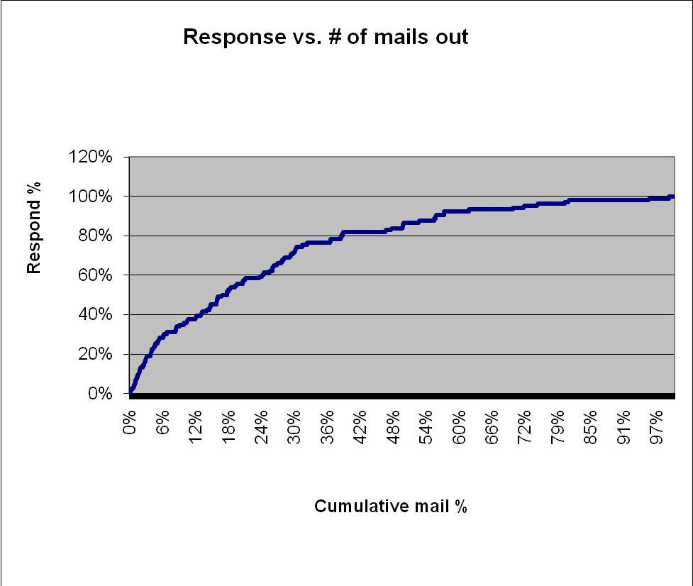

The cumulative mailing percentage represents the amount of our mailings; sort from the most preferred customers (highest ranking) to the least preferred. As you can the top 75% rank contributes to 94.34% of the original response volume.

Mail sent Response Respond%__Total Mail sent %
1355 100 94.34% 75%

Also, cutting the bottom half will still yields 87.74% of the response:

Mail sent Response Respond%__Total Mail sent %_______
903 93 87.74% 50%

Section III: Summary

Based on our analysis, we rank our potential target customers with the following criteria, from the most influential to the least:
- Target customer is NOT a farmer
- Target customer comes from an affluent family, with average age less than 40
- Target customer is a senior with prestigious social status
- Target customer has least amount of property
- Target customer is a renter (living on someone else’s property)
- Target customer is a Protestant
- Target customer has a college degree
- Target customer has own 2 or more automobiles
- Target customer has contribution to private insurance
- Target customer has automobile insurance

After we made the ranking of the potential customer pool, based on our model, we determined that if you cut mailings for the lowest 25% rank customers, you will still retain 94.34% of the original response.

The three appendix attached to this document contains a technical appendix, the variable description, and the complete listing of variable used for our model.

Appendix I: Technical Appendix

This section contains technical detail about our model selection as well as the method to determine the mailing response rate vs. number of mailings.

- Step I: Determine the right form for each variable

There are 26 total independent variables in our data. We wish to estimate the behavior of “Response”, which is the dependent variable and indication of whether a specific customer will respond to our mailings. To determine the independent variables that are most relevant, we used the Logistic regression technique. A logistic regression equation predicts the natural log of the odds of a subject of being one category to another. In addition, the regression coefficients in a logistic regression equation can be used to estimate odds ratio for each of the independent variables

Before we apply the Logistic Regression, we must transform the variable so that there is a binary “true/false” answer for each multi-level variable. For example if we have a variable with 10 possible response, we make a 10-slot array for this variable, each one will only take a Boolean value (True/False). By default, there should be only one “true” value in the array, because each slot represents a category or response, and they are all designed to be mutually exclusive.

In Appendix II, we have included the “data dictionary”, which provides the definition of the variable, among with the variable type and its domain. Most variable have domains other than binary, and it needs to be transformed. Those variables are listed as “L0”, “L1”, “L2”, “L3” and “L4” type. The definition of the type is also located in the end of Appendix II.

Obviously, for any type of regression technique, we need to find out the correct fit for each variable. Each variable is tested with constant, quadratic, cubic, inverse, square root and logarithmic relationships. Appendix III have a list of variables and the model used on the right most columns. If the variable name ends in “sq” it is quadratic, “cu” is cubic, “inv” is inverse, “sqrt” is square root, and “log” is logarithmic.

When a variable is put into our SAS program to do the fitting, a model fit statistics report is generated similar to the one given the next page.

The SAS System

Model Fit Statistics

Intercept
Intercept and
Criterion Only Covariates

AIC 1830.722 1721.627
SC 1837.020 1746.819 ←
-2 Log L 1828.722 1713.627

Each variable, for example “PPERSA2”, will generate six model fit statistics output above, one each for linear, quadratic, cubic, inverse, square root and logarithmic models. We look for the one model with the lowest Schwartz Criterion score. In the above case, the SC score is 1746.819 (indicated by the arrow) and the model is PPERSA2 quadratic.

If the lowest SC score model is a quadratic, then both the quadratic and linear terms of the variable will be included in the final model. If the lowest SC score model is a cubic, then cubic, quadratic and linear terms will be included in the final model. If the lowest SC score is linear, inverse, square root or log, we just use the respective terms only. Therefore, in the above model fit example, we include PPERSA2 and PPERSA2sq into our model, since it is quadratic.

- Step II: Create a final model

After all 26 independent variables are analyzed; we end up the table included in Appendix III. The right most columns indicate the variables and models with the lowest SC score. These entire variables then will feed in to the final model for an “ultimate fit” using logistic regression.

The output of the final fit is located in the next page.

Summary of Forward Selection

Effect Number Score Variable
Entered DF In Chi-Square Pr > ChiSq Label

PPERSA2 1 1 86.7563 <.0001
PPERSA2sq 1 2 32.6925 <.0001
MHHUUR2sqrt 1 3 23.7473 <.0001
pwapar2sqrt 1 4 19.0869 <.0001
MAUT02 1 5 9.1758 0.0025
MOPLHO2sqrt 1 6 7.3970 0.0065
MGODPR2log 1 7 6.8282 0.0090
MOSHOO_10 1 8 5.0464 0.0247 MOSHOO_ 10
mostyp_3 1 9 4.4706 0.0345 mostyp_ 3
mostyp_12 1 10 4.0577 0.0440 mostyp_ 12
MOSHOO_2 1 11 4.8123 0.0283 MOSHOO_ 2
MAANTH 1 12 4.3197 0.0377

The variable that “survived” the PROC LOGISTIC procedure are shown above and this translate to the criteria that were mentioned at the very beginning of this memo. They were ordered from the smallest to the largest P-value (Pr > ChiSq column). Smaller P-Value indicates higher statistical influence in our model. P-Value greater than 0.05 are dropped from the procedure by default.

Once we chosen the variables that have major influence in our model, we run the PROC REG procedure, which attempt to perform a regression fit using the variables chosen. The output is given below:

Parameter Standard
Variable Estimate Error t Value Pr > |t|

MAANTH -0.01587 0.00874 -1.82 0.0694
MGODPR2log 0.00629 0.00231 2.73 0.0065
MOPLHO2sqrt 0.00337 0.00156 2.16 0.0310
MHHUUR2sqrt -0.00280 0.00121 -2.31 0.0209
MAUT02 -0.00050404 0.00022388 -2.25 0.0244
pwapar2sqrt 0.00416 0.00090073 4.62 <.0001
PPERSA2 0.00003305 0.00000418 7.91 <.0001
PPERSA2sq -3.14587E-9 8.12564E-10 -3.87 0.0001
MOSHOO_2 0.03967 0.01433 2.77 0.0057
MOSHOO_10 -0.03679 0.01841 -2.00 0.0458
mostyp_3 0.04287 0.01777 2.41 0.0159
mostyp_12 0.07023 0.02839 2.47 0.0134

The “estimate” column is the probability coefficient (adjustment) when the variable is true. If the coefficient is positive (i.e. mostyp_12), the probability of response increases by the coefficient amount. If the coefficient is negative, the probability of response decreases (i.e. MOSHOO_10)

