From: Arnold Lee
To: Mr. Sparks
Date: June 8th , 2009
Re: Different estimation models of Profit and ROI Analysis

This memo is in response to your request to cut mailing quantities while retain most of the response.

There are two goals here to keep in mind:
- The profit needs to be maximized
- The Return-on-Investment (ROI) needs to be maximized

We have used three techniques to run the analysis: Logistic Regression, Neural Networks, and CHAID (CHi-squared Automatic Interaction Detector). Results shown that using the CHAID will optimize both profit and ROI. Under this technique, the profit that will be earned is $29,510, with an ROI of 141, and it requires mailing 10,990 households or 61% of the available mailing universe.

The following pages describe in detail how we get the results and some background information of the technique we used.

Section I: Profit Analysis

To obtain the results, we obtain the holdout sample, and run the sample through these three techniques to generate a gain chart for each technique used. The following is the gain chart for profit:

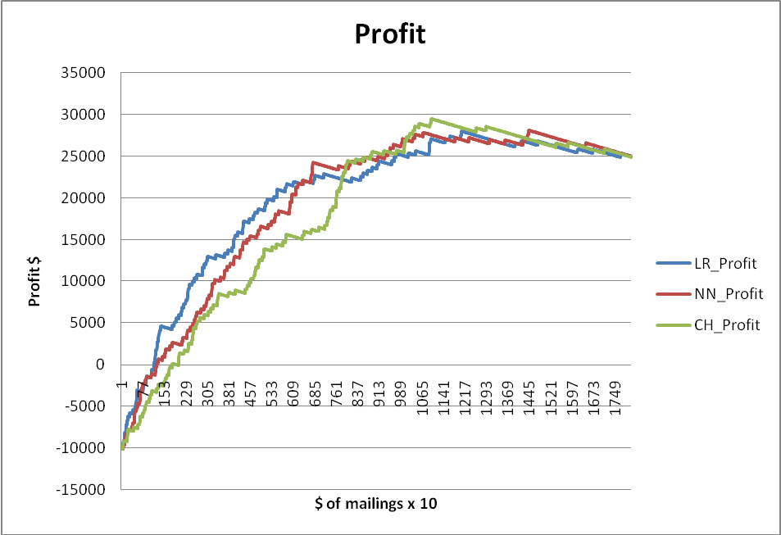

The blue line (LR_Profit) is the Logistic Regression model, the red (NN_Profit) is the neural network model, and the green (CH_Profit) is the CHAID model. The Maximum point is located at 1099 with the green line, indicates that the maximum is achieved by mailing 10990 household with the CHAID model. The profit in this case is $29,510.

Section II: ROI Analysis

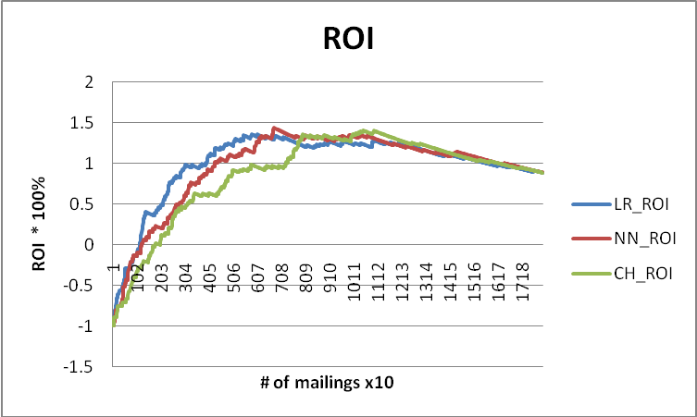

Similar to Profit Analysis, the blue line (LR_ROI) is the Logistic Regression model, the red (NN_ROI) is the neural network model, and the green (CH_ROI) is the CHAID model. The Maximum is achieved by mailing 6790 households under the neural network model. The ROI in this case is 144%.

Section III: Model Analysis

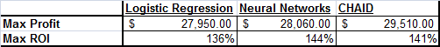

The above table is the summary of the max profit and max ROI for each model used. As we can see CHAID have a better profit, and neural networks have a better ROI. However, by using neural networks, we lose 5% of the max profit possible, achieved by the CHAID model. If we elect to use the CHAID model, we only lose 2% of the max ROI achieved by the neural network model. Therefore, it is clear that CHAID is the better candidate.

Section IV: Background information

The three techniques that were used were Logistic Regression, Neural Networks and CHAID (CHi-squared Automatic Interaction Detector).
Logistic Regression is a regression technique that is adjusted for the fact that the dependent variable is binary (sale or no-sale).
Neural Networks is a Universal approximator which builds model on training sample and assesses fit on test sample. When the fit start dropping it will stop, then the network will assess the overall performance on holdout sample.
CHAID works by finding the independent variable that will split the sample so that subgroups have biggest difference in ‘response rate’, and then look to split the sub-groups again until the difference is below a certain threshold to split.

Section V: Summary

We have used three techniques to run the analysis: Logistic Regression, Neural Networks, and CHAID (CHi-squared Automatic Interaction Detector) to assess the holdout sample. Results shown that using the CHAID will optimize both profit and ROI. Under this technique, the profit that will be earned is $29,510, with an ROI of 141, and it requires mailing 10,990 households or 61% of the available mailing universe.

The appendix to this document contains technical details and in-depth discussion of the three techniques we used.

Appendix I: Technical Analysis

There are three models that were used to determine maximum ROI and profit:
- Logistic Regression
- Neural Networks
- CHAID (CHi-squared Automatic Interaction Detector)

For logistic regression, we used forward selection for variable inclusion with p-values less than 0.05.

For Neural Networks, the original 70% analysis sample was split 50/50 into training and test sets. The Model then is built on training set and evaluated on test set. When performance on training set exceeded performance on the test set the neural network will suspend operation.

For CHAID, for efficiency purposes, we limit the depth of the spilt to 5 levels.

Each model will generate a table at the end, with number of mailings, its ROI, and the profit. These three table are merged into one table, and we use a filter to find the number of mailings that contains the maximum ROI and profit for each model, with the total of six results. These results are compiled into the table shown on Section III.

To find the optimization level we look at which model get the maximum ROI and which model get the max profit. If there are not belong to the same model, then we compare the difference and choose the one with the least amount of loss. In this case, choosing CHAID model over neural networks gives us maximum profit but losing 2% of maximum ROI possible. If we choose neural networks model, we have the maximum ROI but losing 5% of the maximum profit possible. Therefore CHAID is a clear winner.

