From: Arnold Lee
To: Mr. Sparks
Date: June 9th, 2009
Re: S&P 500 investment strategy using time series model

This is in response to your request for evaluation of using time series model strategy to predict the general trend of S&P 500 Index.

Based on our analysis, if we used the time series model strategy using S&P 500 indexes from Jan 1986 to December 2004, our portfolio will be increased 562%. We also compare three different common strategies:
- Investing in U.S. Treasury bond, our portfolio will only be increased by 202%. This is assuming that the annual return of Treasury bond is 6%.
- Or just buy the index at the beginning of the time period and hold it all the way to the end. Our portfolio would have increased by 318% (This is known as Buy & Hold strategy)

The following pages will describe our analysis and these strategies in depth.

Section I. Description of our time series model strategy

In our strategy, we make decisions at the end of the month. If our forecast shows that at the end of next month, the Index will close higher than the end of this month, then we will make the decision to buy the index (going long). If our forecast shows that the index will go down the next month, then we will sell the index (going short).

To determine our forecast number, we use a method called Moving Average, a common time series model approach.

Section II. Determining amount of profit

With the strategy described in section I, we have the following table:

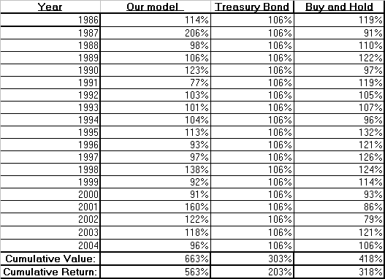

The column “Our model” is the end-of-year performance if we use our model, and “Treasury Bond” is the performance we would get if we invest in treasury bonds, assuming 6% annual yield. For example, in year 1987, our portfolio value would increase by 106% (= 206 % - 100% which is the principal)following the S&P Index using the time series model, while if we put in to U.S. Treasury bond we will be staying at an increase of 6%. To calculate cumulative value every a period of multiple years, you will multiply the end of year value together for each year. The cumulative return is cumulative value minus 100% for the principal.

At the end of December 2004, assume we have not made any modification of our strategy in the middle of the time period, our portfolio value will rise 563%, while if we stick with the Treasury bond our portfolio value increase by only 203%. If we use the Buy & Hold strategy our portfolio will increase by 318%.

Obviously, you would have said “Can we switch to bonds if we lose money the previous year?” We have explored this alternate strategy. We could have switch in the middle, and change to U.S. Treasury immediately after the fact that we lose money in the previous year, and switch back to the original strategy when the previous year model suggest an earnings forecast of more than 6%. The revised strategy is summarized as follows:

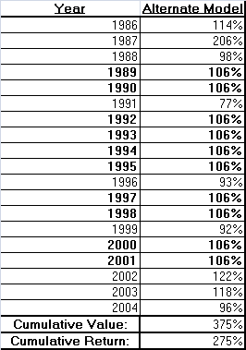

The percentage in Bold type indicates that during the year we have invested in Treasury bonds.

So under this alternate strategy, we will be doing slightly better than investing in bonds, with our portfolio increase by 275%, but this model will have risk a major decrease in value if the market fluctuates greatly year after another, compare to the risk of the Buy & Hold model.

Section III. Summary

Based on our analysis, if we used the time series model strategy using S&P 500 indexes from Jan 1986 to December 2004, our portfolio will be increased 562%, compare to investing in U.S. Treasury bond, our portfolio will only be increased by 202%. This is assuming that the annual return of Treasury bond is 6%. If we use the Buy & Hold strategy our portfolio will increase by 318%.

Under our alternating strategy, where we switch our portfolio to Treasury bonds if we have a yield of less than 6% in the previous year, our portfolio will increase by 275%, which is just slightly greater than risk-free treasury bonds but vulnerable to major fluctuations in the S&P 500 index.

The appendix to this document contains technical details on the time series model used for the forecast.

Appendix I: Technical Appendix

For the time series model, we use moving average with lag of one month, which means we use look at the average of the previous two months when making the decision. Remember that you will need to make decisions in the time series strategy and the alternating strategy.

First we evaluate our series for stationarity, which means it should have a fixed mean and consistent variance. If it is not stationary, we differentiate the series until it becomes one. To check if it is stationary or not, we put the series into stationarity test and the p-value is indeed very low, indicate high significance.

Next step we apply two process to the series separately, AR (Auto Regression) and MA( Moving Average) fit. These function gives you correlation values between time t and time t-1 month (lag =1) , t -2 months (lag = 2) etc. High correlation value at, let say lag = x, indicates the correlation between value at t and the value at t – x months is potentially significant.

In our case, AR ( lag =1) and MA (lag =1) both have the same autocorrelation function value and it is the highest. We choose MA (lag =1) because MA are usually resistant to sudden events.

At last, we perform the chi-square test for correlation in the residuals to make sure the residual values are non-significant.

