From: Arnold Lee
To: Mr. Sparks
Date: June 9th, 2009
Re: S&P 500 investment strategy using time series model

This is in response to your request for evaluation of using time series model strategy to predict the general trend of S&P 500 Index.

Based on our analysis, if we used the time series model strategy using S&P 500 indexes from Jan 1986 to December 2004, our portfolio will be increased 562%. We also compare three different common strategies:
- Investing in U.S. Treasury bond, our portfolio will only be increased by 202%. This is assuming that the annual return of Treasury bond is 6%.
- Or just buy the index at the beginning of the time period and hold it all the way to the end. Our portfolio would have increased by 318% (This is known as Buy & Hold strategy)

The following pages will describe our analysis and these strategies in depth.

Section I. Description of our time series model strategy

In our strategy, we make decisions at the end of the month. If our forecast shows that at the end of next month, the Index will close higher than the end of this month, then we will make the decision to buy the index (going long). If our forecast shows that the index will go down the next month, then we will sell the index (going short).

To determine our forecast number, we use a method called Moving Average, a common time series model approach.

Section II. Determining amount of profit

With the strategy described in section I, we have the following table:

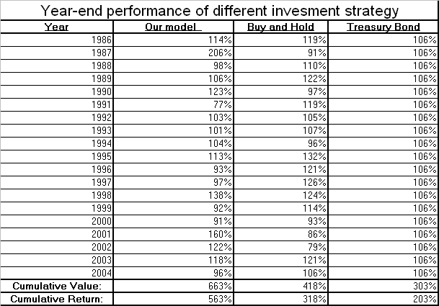

The column “Our model” is the end-of-year performance if we use our model, and “Treasury Bond” is the performance we would get if we invest in treasury bonds, assuming 6% annual yield. “Buy and Hold” is the performance if we bought the index in 1986 and never touch the portfolio until the end of 2004. For example, in year 1986, our portfolio value would increase by 14% (= 114 % - 100% which is the principal)following the S&P Index using the time series model, while if we put in to U.S. Treasury bond we will be staying at an increase of 6%. To calculate cumulative value every a period of multiple years, you will multiply the end of year value together for each year. The cumulative yield is cumulative value minus 100% for the principal.
At the end of December 2004, assume we have not made any modification of our strategy in the middle of the time period, our portfolio value will rise 563%, while if we stick with the Treasury bond our portfolio value increase by only 203%. If we use the Buy & Hold strategy our portfolio will increase by 318%.

Obviously, you would have said “Can we switch to bonds if we lose money the previous year?” We have explored this alternate strategy. We could have switch in the middle, and change to U.S. Treasury immediately after the fact that we lose money in the previous year, and switch back to the original strategy when the previous year model suggest an earnings forecast of more than 6%. The revised strategy is summarized as follows:

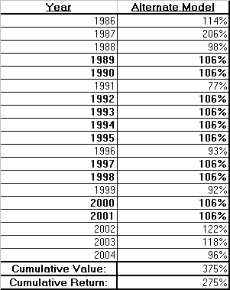

The percentage in Bold type indicates that during the year we have invested in Treasury bonds.

So under this alternate strategy, we will be doing slightly better than investing in bonds, with our portfolio increase by 275%, but this model will risk a major decrease in value if the market fluctuates greatly year after another, compare to the risk of the Buy & Hold model, as we will see from the following section,

Section III. Risk Analysis

To evaluate the risk associated with the return, we calculate the Sharpe’s ratio for each strategy. The Sharpe’s ratio is defined as the cumulative return of strategy used minus the cumulative return of treasury bonds, and then divided by the standard deviation of the strategy used.

The following table list the standard deviation of the return, along with the Sharpe’s ratio of all strategy listed in this memo.

The standard deviation of the return means that 68.2% of the time, the return could fluctuate from within the range of the standard deviation value, either up or down, from the mean return value (the cumulative return). For example, in our time series model, there is a 68.2% probability where our return value will be from 533.7% (563% – 29.3%) to 592.3% (563% + 29.3%). Since there is no fluctuation of return in Treasury bond, the standard deviation is 0%, therefore the Sharpe’s ratio for Treasury bond does not exist.

In general, the higher the Sharpe ratio the better the investment strategy as it gives more return for the same amount of risk. Our time series model have the highest Sharpe’s ratio, therefore it is the best strategy in all the models tested here. As with the alternate model, it made slightly less than Buy & Hold strategy, but incurs 2.5 times more risk ( the Sharpe’s ratio of Buy & Hold is 2.5 times greater than alternate model, for about the same amount of return.)

Section IV. Summary

Based on our analysis, if we used the time series model strategy using S&P 500 indexes from Jan 1986 to December 2004, our portfolio will be increased 562%, compare to investing in U.S. Treasury bond, our portfolio will only be increased by 202%. This is assuming that the annual return of Treasury bond is 6%. If we use the Buy & Hold strategy our portfolio will increase by 318%.

Under our alternating strategy, where we switch our portfolio to Treasury bonds if we have a yield of less than 6% in the previous year, our portfolio will increase by 275%, which is just slightly greater than risk-free treasury bonds but vulnerable to major fluctuations in the S&P 500 index.

Based on the Sharpe’s ratio analysis, our model has been identified to be able to generate the most return while having the least amount of risk.

The appendix to this document contains technical details on the time series model used for the forecast.

Appendix I: Technical Appendix

For the time series model, we use moving average with lag of one month, which means we look at the average of the previous two months when making the decision. Remember that you will need to make decisions in the time series strategy and the alternating strategy.

First we evaluate our series for stationarity, which means it should have a fixed mean and consistent variance. If it is not stationary, we differentiate the series until it becomes one. To check if it is stationary or not, we put the series into stationarity test and the check the p-value tsee if it is significant. The test is called the Augmented Dickey-Fuller Unit Root Tests, and the output is shown below.

Augmented Dickey-Fuller Unit Root Tests

Type Lags Rho Pr < Rho Tau Pr < Tau F Pr > F

Zero Mean 0 -187.611 0.0001 -12.29 <.0001
1 -212.054 0.0001 -10.20 <.0001
2 -174.137 0.0001 -7.90 <.0001
3 -133.583 0.0001 -6.46 <.0001
4 -78.3820 <.0001 -5.00 <.0001
Single Mean 0 -189.945 0.0001 -12.39 <.0001 76.81 0.0010
1 -218.132 0.0001 -10.33 <.0001 53.39 0.0010
2 -182.782 0.0001 -8.03 <.0001 32.26 0.0010
3 -142.622 0.0001 -6.59 <.0001 21.71 0.0010
4 -84.5681 0.0015 -5.14 <.0001 13.22 0.0010
Trend 0 -192.400 0.0001 -12.51 <.0001 78.26 0.0010
1 -224.589 0.0001 -10.48 <.0001 54.92 0.0010
2 -192.755 0.0001 -8.19 <.0001 33.58 0.0010
3 -154.027 0.0001 -6.76 <.0001 22.87 0.0010
4 -91.1928 0.0006 -5.27 0.0001 13.91 0.0010

Note that the P-value is lower than 0.05, indicate statistical significance, which means our series is now stationary.

Next step we apply two process to the series separately, AR (Auto Regression) and MA( Moving Average) fit. These function gives you correlation values between time t and time t-1 month (lag =1) , t -2 months (lag = 2) etc. High correlation value at, let say lag = x, indicates the correlation between value at t and the value at t – x months is potentially significant. We tested lag values from 1 to 24.

The following two outputs describe the rationale behind our selection of our model:

Autocorrelations

Lag Covariance Correlation -1 9 8 7 6 5 4 3 2 1 0 1 2 3 4 5 6 7 8 9 1 Std Error

1 3.035364 0.22070 | . |**** | 0.063888
2 -0.261938 -.01905 | . | . | 0.066927
3 0.511777 0.03721 | . |* . | 0.066949
4 1.269354 0.09229 | . |**. | 0.067034
5 2.324084 0.16898 | . |*** | 0.067550
6 0.0087135 0.00063 | . | . | 0.069254
7 -1.534591 -.11158 | .**| . | 0.069254
8 -0.244029 -.01774 | . | . | 0.069984
9 -0.760932 -.05533 | . *| . | 0.070003
10 -0.345205 -.02510 | . *| . | 0.070181
11 0.673655 0.04898 | . |* . | 0.070217
12 -1.624567 -.11812 | .**| . | 0.070357
13 -0.983142 -.07148 | . *| . | 0.071162
14 -1.656175 -.12042 | .**| . | 0.071454
15 -1.426818 -.10374 | .**| . | 0.072278
16 0.145067 0.01055 | . | . | 0.072883
17 -0.167952 -.01221 | . | . | 0.072889
18 -0.294538 -.02142 | . | . | 0.072897
19 -1.598903 -.11625 | .**| . | 0.072923
20 -1.738637 -.12641 | ***| . | 0.073676
21 -0.616459 -.04482 | . *| . | 0.074556
22 0.336861 0.02449 | . | . | 0.074666
23 0.186266 0.01354 | . | . | 0.074698
24 -0.413069 -.03003 | . *| . | 0.074709

A significant spike on the Autocorrelation function at a certain lag number X suggest that the Xth order MA term is significant and is a potential candidate for inclusion in our model. We can see lag term #1 has highest correlation value. Therefore it is a prime candidate for the inclusion in our model.

The little dots boundary are the 95% confidence bounds.

Partial Autocorrelations

Lag Correlation -1 9 8 7 6 5 4 3 2 1 0 1 2 3 4 5 6 7 8 9 1

1 0.22070 | . |**** |
2 -0.07122 | . *| . |
3 0.06068 | . |* . |
4 0.07244 | . |* . |
5 0.14387 | . |*** |
6 -0.06825 | . *| . |
7 -0.09429 | .**| . |
8 0.00914 | . | . |
9 -0.08971 | .**| . |
10 -0.00629 | . | . |
11 0.07998 | . |**. |
12 -0.12192 | .**| . |
13 -0.00810 | . | . |
14 -0.11793 | .**| . |
15 -0.05838 | . *| . |
16 0.02073 | . | . |
17 0.02291 | . | . |
18 0.02013 | . | . |
19 -0.11795 | .**| . |
20 -0.06831 | . *| . |
21 -0.06695 | . *| . |
22 0.01537 | . | . |
23 0.04017 | . |* . |
24 -0.01252 | . | . |

Similarly, a significant spike on the Partial Autocorrelation function at a certain lag number X suggest that the Xth order AR term is significant and is a potential candidate for inclusion in our model. We can see lag term #1 has highest correlation value. Therefore it is a prime candidate for the inclusion in our model.

Both AR(lag=1) and MA (lag=1) have the same correlation value. Next we look at the Chi-Square test for white noise, which test for structure for the MA, as in the output below:

Autocorrelation Check for White Noise

To Chi- Pr >
Lag Square DF ChiSq

6 21.86 6 0.0013
12 30.29 12 0.0025
18 38.45 18 0.0034
24 47.37 24 0.0030

The P-values are below 0.05, indicate potential significance. For example, “To Lag 6” in the first column saying that autocorrelation values from 0th to 6th lag term are statistically significant. Same thing happens for “To lag 12”, 18, and 24, which represents strong correlation. Therefore MA (lag = 1) will be our choice for the model.

At last, we perform the chi-square test for correlation in the residuals to make sure the P-value of the residual are large, indicate non-significance, as the following output shows:

The ARIMA Procedure

Autocorrelation Check of Residuals

To Pr >
Lag ChiSq

6 0.1836
12 0.0633
18 0.1198
24 0.1606
30 0.1223
36 0.1962
42 0.2973
48 0.4129

