From: Arnold Lee
To: Mr. Sparks
Date: June 12th, 2009
Re: Momentum Investing Strategy for S&P 500

This memo is in response for your request to evaluate the momentum trading strategy and discover ways to generate high returns on the risk-adjusted basis.

There are three types of momentum trading strategies used here: Long Portfolio, Short Portfolio and Total Portfolio. A long portfolio strategy involves buying only the top 10% performers in the S&P 500 Index during the past running 6 months. A short portfolio strategy involves short-selling the worst 10% performers in the index for the past running 6 months. A total portfolio strategy involves short-selling the worst 10% performers as in the short portfolio strategy, and then use the proceedings from the short-selling to buy the top 10% performers as in the long portfolio strategy.

For comparison purposes, we also evaluate the Buy & Hold strategy. The buy & hold strategy involves buying all the components in the S&P 500 index and hold it all the way until the end of the time period.

After evaluation, using the “long portfolio” strategy will generate the most return on the risk-adjusted basis. Closely come in second is the “total portfolio” strategy. Buy & Hold strategy has the least amount of return and “short portfolio” strategy will result in a loss.

The next few pages will describe our method of evaluating and determining the best strategy, along with background information on market efficiency and its role in our decision.

Section I --- Momentum trading method summary

The following table summarizes the return and the Sharpe’s ratio of the four strategies:

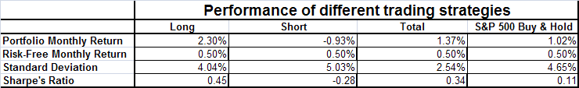

The risk-free monthly return is the return of U.S. treasury bonds, which we assume is 0.5%.

The strategy that gives the most monthly return is the long portfolio (2.30%), followed by total portfolio (1.37%) and buy & hold (1.02%). Short portfolio resulted in a loss (-0.93%).

The standard deviation measures the volatility of the return. This number represents the upper and lower bound from the mean value (the “portfolio monthly return” column). The probability that the real value is contained within the bound is 68.2%. The higher the standard deviation, the more unstable the return.

The standard deviation of the four strategies, from highest to lowest are: short (5.03%), buy & hold (4.65%), long (4.04%), and total (2.54%).

The Sharpe’s ratio is defined as the difference between the portfolio monthly return and the risk-free monthly return, and then divided by the standard deviation. The higher the Sharpe’s ratio, the higher amount of return the strategy will generate given the same amount of risk. In general, a ratio of 1 or better is considered good, 2 and better is very good, and 3 and better is considered excellent.

The accompanying Sharpe’s ratio from highest to lowest are: long (0.45), total (0.34), buy & hold (0.11) and short (-0.28).

Note that for the Buy & Hold strategy, there is a “low side outlier”, meaning that the standard deviation for this strategy is possibly inflated, which in turn deflated the Sharpe’s ratio from where it should be. This information needs to be interpreted with caution.

Based on the above information, we concluded that:
- The Long portfolio strategy and the Total Strategy beat the Buy & Hold strategy in terms of return.
- The Sharpe’s ratio of Buy & Hold strategies is the lowest (with the exception of short portfolio strategies which generates a loss)

The conclusion above indicates that the Index is not weak-form efficiency because, by using our Long or Total portfolio strategy, we are able to perform better than the Buy & Hold strategies that means current price information does not solely reflect on past price alone.

We will describe the definition of efficiency and the rationale behind our strategies.

Section II. Technical Note

Momentum trading strategies are trading practice where a traded instrument is bought at or near opposite cycle swings cause by daily or weekly price volatility. Trading algorithm exists to measure the trends, calculate a set of trade rules which results in entry, exit and stop loss trade points, and then automate the buy/sell action so that the portfolio can be managed more efficiently.

To make our determination on the model, which the algorithm will be based, we take into the account of market efficiency. An efficient market is one where price of securities fully reflect available information. Under this assumption, no investor can get a better rate of return than the market as a whole, given fixed amount of risk.

Weak-form efficiency is where the price of securities reflects all information only from past prices. In this case it is possible to generate abnormally high amount of return by predicting the prices from historical price information. Semi-strong efficiency means that all publicly available information, including past price, Form 10-Q / 10-K information of the index component company, Price/Earnings Ratio etc. is reflected in the price. Strong-form efficiency is where “insider” information, which suppose to be only known by the respective company executives and employees, is also been reflected in the price. A presence of strong-form efficiency may indicate illegal insider-trading activity.

If the market is considered strong efficient, than it is also semi-strong and weak efficient. Conversely, if the market is not weak-efficient, then it is not semi-strong and strong efficient.

In an efficient market, the use of time-series modeling in an investment strategy is no longer effective as enough investors will be using the same model, resulting in higher price of entry. At the end this strategy will do no better than Buy & Hold.

In March 1993, Jegadeesh & Titman et al. wrote a seminal article on momentum investing. They analyzed the stock prices from January of 1965 to December of 1989. They formed 10 groups of stock for each month in the time period. The first group is the top 10% performer in the past running 6 months, and the second group is the second 10% performer in the past running 6 months, and so on.

They found out that buying stocks on the top 10% group will yield greater subsequent average return than short-selling the stocks in the bottom 10% group. This claim affirms that the market at that time is inefficient because they were able to beat the index average growth by just analyzing historical stock prices.

Now if everyone started using the strategy that Jegadeesh & Titman is using in March 1993, then the stock that are on the 10% group as of March 1993 will quickly become overbought, and will have to face much higher resistance to continue to go up. Same thing for the bottom 10% group, which it will be oversold, and the price will have a tendency to bounce back. This indicates that the market should be now weak-efficient again, and no investment strategies will perform better than just buy & hold.

So we investigate the efficiency of the market using three momentum trading strategies:
- Long portfolio, where we buy the top 10% performers in the S&P 500 index component during the past 6 months. In the end of each month, we evaluate the performance again and sell those who drop out of the top 10% and buy the stocks that just joined the top 10%, if any. This gives better returns and slightly less risk than Buy & Hold.
- Short portfolio, where we short-selling the worst 10% performers in the S&P 500 index component during the past 6 months. In the end of each month, we evaluate the performance again and buy back to cover on those who got out of the bottom 10% and short-sell the stocks that just dropped into the bottom 10%, if any.
- Total Portfolio, where we perform the Short Portfolio strategy first, and use the proceeds from the short-selling to execute the Long portfolio strategy. This is basically a form of arbitrage. It gives you slightly lesser returns but a greater amount of cash flow and much smaller standard deviation of return.

In our analysis on Section I, we show that the Long portfolio and Total portfolio still perform better than the buy & hold strategy; therefore the market is not weak-efficient, and also not semi-strong and strong efficient as well.

In the next page we will show the distribution of return for each strategy.

Below is a box plot showing the distribution of monthly return for all four strategies. On the horizontal axis:
- “MonthlyAvgShortRet” is the short portfolio.
- “MonthlyAveLongRet” is the long portfolio.
- “MonthlyTotalRet” is the total portfolio.
- “Value-weighted” return is the buy & hold strategy.

As you can see, long portfolio has a distribution of higher return comparing to the other strategies.

Note that there is a lone “outlier” at the lower end for the buy & hold. This means that the standard deviation of return for buy & hold strategies is possibly inflated, which gives a deflated Sharpe’s ratio. This means that it is possible that the risk for buy & hold is exaggerated. Please consider this when comparing to other trading methods.

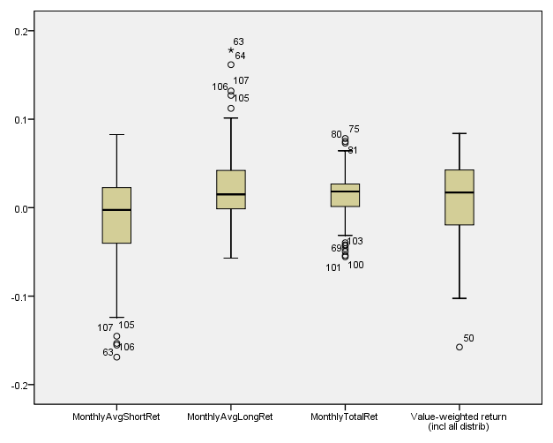

Appendix I: Technical Appendix

Below are four normality plots, each represent a trading strategy used in this memo.
In all instances all four strategies are roughly normal. However, if you look at the Value-weighted return graph (in the bottom right corner), which represents S&P 500 Buy & Hold strategy, you will see a lone outlier on the bottom left corner of the graph, confirm with the box plot shown in the Section II of the memo. This is an indication that for Buy & Hold, the standard deviation might be inflated, which affects the Sharpe’s ratio calculation. The outliers on the three other strategies are ambiguous and not significantly different enough to isolate.

